

D365FO LIMS Release notes



Lab information management system

for

**Microsoft Dynamics 365 for Finance & Operations™**

*D365FO LIMS version* 10.24.1114.9

2023-09-19

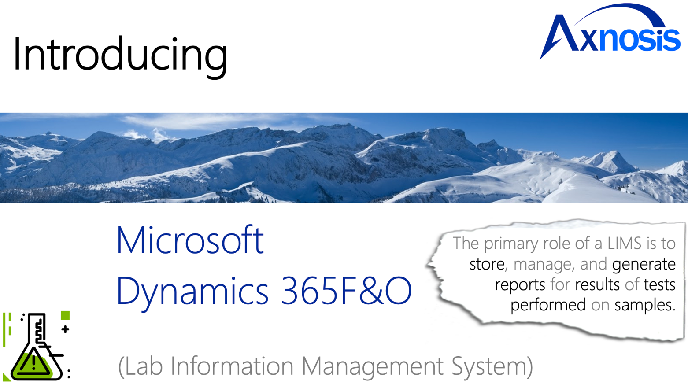

## Dynamics 365 FO LIMS module

LIMS is an add-on for Dynamics 365 suite of business application software.

This software provides integrated functionality for labs. Medical or manufacturing labs. In-house or lab service providers.

Release version

**LIMS Package version:** LIMSDeployablePackage_10_24_1114_9

This package was created on Microsoft Dynamics 365 for Finance and Operations:

|  |  |  |
| --- | --- | --- |
| **Release** | **Version** | **Build number** |
| Application release | 10.0.33 | 10.24.1114 |
| Platform release | Platform update 57 | 7.0.6861 |

# Enhancements:

|  |  |
| --- | --- |
| **Module** | **Description** |
| Analysis Orders | To allow the default of samples to the Analysis order the following was added:   * On the Test Pack Definition setup from a new fast tab has been added for Default Samples on Analysis order. |
| Security | Minor enhancements on security roles |

# Big fixes:

|  |  |
| --- | --- |
| **Module** | **Description** |
| Analysis Journals | * Multiple set of calculations with dependencies were failing. Issue has been resolved. * Completed by field was not being auto populated when the calculation was run. Issue has been resolved. |
| Label Printing | Collection time did not print correctly on sample labels. Issue has been resolved. |

The information contained in this document represents the current view of Axnosis and Microsoft Corporation on the issues discussed as of the date of publication. Because Axnosis and Microsoft must respond to changing market conditions, this document should not be interpreted to be a commitment on the part of Axnosis and Microsoft, and Axnosis and Microsoft cannot guarantee the accuracy of any information presented after the date of publication.

This test script is for informational purposes only. AXNOSIS AND MICROSOFT MAKE NO WARRANTIES, EXPRESS, IMPLIED, OR STATUTORY, AS TO THE INFORMATION IN THIS DOCUMENT.

Complying with all applicable copyright laws is the responsibility of the user. Without limiting the rights under copyright, no part of this document may be reproduced, stored in or introduced into a retrieval system, or transmitted in any form or by any means (electronic, mechanical, photocopying, recording, or otherwise), or for any purpose, without the express written permission of Axnosis and Microsoft Corporation.

Axnosis and Microsoft may have patents, patent applications, trademarks, copyrights, or other intellectual property rights covering subject matter in this document. Except as expressly provided in any written license agreement from Axnosis and Microsoft, the furnishing of this document does not give you any license to these patents, trademarks, copyrights, or other intellectual property.

© 2021 Microsoft Corporation. All rights reserved. Any use or distribution of these materials without express authorization of Microsoft Corp. is strictly prohibited.

Microsoft and Windows are both registered trademarks of Microsoft Corporation in the United States and/or other countries.

The names of actual companies and products mentioned herein may be the trademarks of their respective owners.