
Dynamics HRM Release notes



Human Resource Management

for

Microsoft Dynamics 365 for Finance & Operations™

Dynamics SHR version 10.34.2105.2

2025-11-10



Dynamics 365 FO SHR module  SHR is an add-on for Dynamics 365 suite of business application software.  This software provides compelling functionality to support Human Resource Management. | 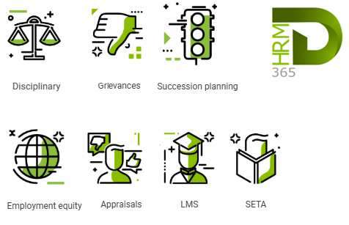

Release version

SHR Package version: SHRDeployablePackage_10_34_2105_2

This package was created on Microsoft Dynamics 365 for Finance and Operations:

Release | Version | Build number
Application release | 10.0.43 | 10.34.2105
Platform release | Platform update 67 | 7.0.7521.60

Enhancements:
Module | Description
Payroll | - Reference to ‘Symplexity’ removed in Payroll menu items and form headers:  - “Symplexity payroll period status” changed to “Payroll integration period status”  - “Symplexity staging” changed to “Payroll integration staging”  - “Validate symplexity payroll staging” dialogue header changed to “Validate payroll staging”  - Payroll journal Description now displays the description of the journal rather than “Symplexity payroll”

Bug fixes:
Module | Description
Payroll | - In the Monthly salary worksheet per worker inquiry, the Worker filter was corrected to allow filtering with worker names

The information contained in this document represents the current view of Axnosis and Microsoft Corporation on the issues discussed as of the date of publication. Because Axnosis and Microsoft must respond to changing market conditions, this document should not be interpreted to be a commitment on the part of Axnosis and Microsoft, and Axnosis and Microsoft cannot guarantee the accuracy of any information presented after the date of publication.
This test script is for informational purposes only. AXNOSIS AND MICROSOFT MAKE NO WARRANTIES, EXPRESS, IMPLIED, OR STATUTORY, AS TO THE INFORMATION IN THIS DOCUMENT.
Complying with all applicable copyright laws is the responsibility of the user. Without limiting the rights under copyright, no part of this document may be reproduced, stored in or introduced into a retrieval system, or transmitted in any form or by any means (electronic, mechanical, photocopying, recording, or otherwise), or for any purpose, without the express written permission of Axnosis and Microsoft Corporation.
Axnosis and Microsoft may have patents, patent applications, trademarks, copyrights, or other intellectual property rights covering subject matter in this document. Except as expressly provided in any written license agreement from Axnosis and Microsoft, the furnishing of this document does not give you any license to these patents, trademarks, copyrights, or other intellectual property.
© 2021 Microsoft Corporation. All rights reserved. Any use or distribution of these materials without express authorization of Microsoft Corp. is strictly prohibited.
Microsoft and Windows are both registered trademarks of Microsoft Corporation in the United States and/or other countries.
The names of actual companies and products mentioned herein may be the trademarks of their respective owners.

