

Dynamics GRC/HSE Release notes

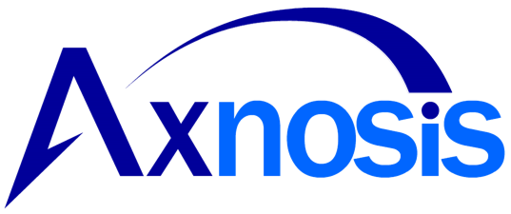

Human Resource Management

for

**Microsoft Dynamics 365 for Finance & Operations™**

*Dynamics SHR version* 10.34.2105.1

2025-09-22



|  |  |
| --- | --- |
| Dynamics 365 FO SHR module SHR is an add-on for Dynamics 365 suite of business application software.  This software provides compelling functionality to support Human Resource Management. |  |
|  | |
|  | |

Release version

**SHR Package version:** SHRDeployablePackage_10_34_2105_1

This package was created on Microsoft Dynamics 365 for Finance and Operations:

|  |  |  |
| --- | --- | --- |
| **Release** | **Version** | **Build number** |
| Application release | 10.0.43 | 10.34.2105 |
| Platform release | Platform update 66 | 7.0.7521.60 |

# Enhancements:

| **Module** | **Description** |
| --- | --- |
| Courses | * The **Course template** form was updated to include fields and fast tabs that appear in the Courses form, to allow more field to be auto populated from the template when creating a new course including:   + **Participants** field group was added to the General fast tab including fields for Maximum participants and Requirement status   + **Cost** field group including fields for Cost options; cost per participant and total cost   + **Sector education and training authority** field group including fields for pivotal course; credit bearing; number of credits; NQF level and learning programme matrix   + **Billing** field group including fields for Corporate customer; Free text invoice template; Splitting of bill to participants and participant percentage.   + **Course content** fast tab was added to allow definitions of content to be automatically added during course creation * The **Courses** form was updated to include fast tabs that appear in the Course template form, to allow more data to be displayed when creating a new course including:   + **Skills** fast tab   + **Education disciplines** fast tab   + **Certificates** fast tab   + **Course content** fast tab.   + **Participants** will automatically receive Course content included for the courses in which they are participants |
| Employment equity | * **Ethnic origin** label “Other” has been changed to “Foreign” in all forms and reports |

*Bug fixes:*

|  |  |
| --- | --- |
| **Module** | **Description** |
| Courses | * When selecting the **My courses** menu item, the courses list has been filtered to allow the worker to only see courses they are a participant in. * The **Announcements** in the **Learning workspace** has been filtered to only display announcements for courses in which the worker is a participant in * The **Study guides** listed in the **Learning workspace** has been updated to only show study guides for the courses the worker is a participant in |
| Performance appraisals | * The calculated mid-year; year-end and total ratings are now also updated when the weighting of KPAs or KPIs are changed after ratings have already been submitted. |

The information contained in this document represents the current view of Axnosis and Microsoft Corporation on the issues discussed as of the date of publication. Because Axnosis and Microsoft must respond to changing market conditions, this document should not be interpreted to be a commitment on the part of Axnosis and Microsoft, and Axnosis and Microsoft cannot guarantee the accuracy of any information presented after the date of publication.

This test script is for informational purposes only. AXNOSIS AND MICROSOFT MAKE NO WARRANTIES, EXPRESS, IMPLIED, OR STATUTORY, AS TO THE INFORMATION IN THIS DOCUMENT.

Complying with all applicable copyright laws is the responsibility of the user. Without limiting the rights under copyright, no part of this document may be reproduced, stored in or introduced into a retrieval system, or transmitted in any form or by any means (electronic, mechanical, photocopying, recording, or otherwise), or for any purpose, without the express written permission of Axnosis and Microsoft Corporation.

Axnosis and Microsoft may have patents, patent applications, trademarks, copyrights, or other intellectual property rights covering subject matter in this document. Except as expressly provided in any written license agreement from Axnosis and Microsoft, the furnishing of this document does not give you any license to these patents, trademarks, copyrights, or other intellectual property.

© 2021 Microsoft Corporation. All rights reserved. Any use or distribution of these materials without express authorization of Microsoft Corp. is strictly prohibited.

Microsoft and Windows are both registered trademarks of Microsoft Corporation in the United States and/or other countries.

The names of actual companies and products mentioned herein may be the trademarks of their respective owners.