
Dynamics GRC/HSE Release notes



Governance Risk & Compliance
Health, Safety & Environment

for

Microsoft Dynamics 365 for Finance & Operations™

Dynamics GRC/HSE version 10.39.1864.3

2026-10-30



Dynamics 365 FO GRC module  GRC is an add-on for Dynamics 365 suite of business application software.  This software provides compelling functionality to support Governance, Risk management and Compliance. | 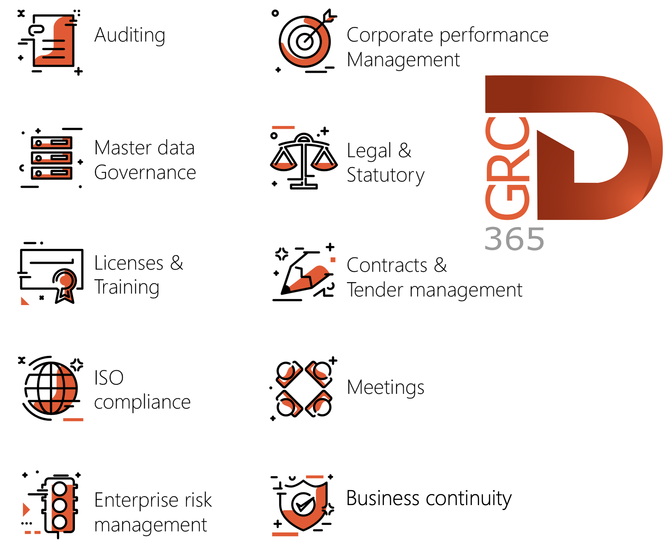

Dynamics 365 FO HSE/OHS

OHS/HSE is an add-on for Dynamics 365 suite of business application software.

This software adds to GRC in that compliance is now deeper with explicit functionality for Health, Safety and Environment as per the depicted sub-modules below.
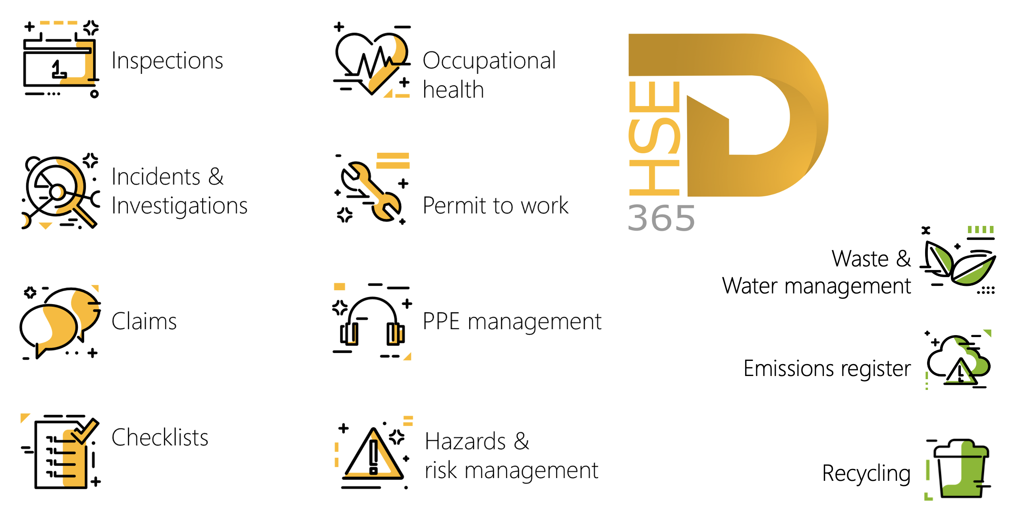

Release version

GRC/HSE Package version: OHSDeployablePackage_10_39_1864_3

This package was created on Microsoft Dynamics 365 for Finance and Operations:

Release | Version | Build number
Application release | 10.0.48 | 10.39.1864
Platform release | Platform update 72 | 7.0.7996.33

Enhancements:

Module | Description
Contracts management | - A new Allow contract currency change slider was added to the Governance, Risk and Compliance parameters > Governance > Contracts governance Fast tab, under a new field group, Contract Changes. This option allows the currency to be changed on contracts in the Created or Draft stage. The currency cannot be changed if a purchase agreement is linked, or any line distribution is effective.  - The following fields can now be inserted as columns to the Vendor invoice journal lines:  - Contract line distribution ID  - Contract item line number  - Contract item line distribution number  - A new Allow editing of value and currency option in Governance, Risk and Compliance parameters lets users change the Initial value and Currency fields in the New contract dialogue when creating a contract from a purchase requisition. The edited values are copied to the new contract. When the option is off, both fields stay locked to the purchase requisition values, as before.  - The Scope of change lines data entity on the Change request was enhanced with Excel add-in functionality.  - Add a toggle, Enable multi-year contract purchase requisitions slider was added to the Governance, Risk and Compliance parameters > Governance > Contracts governance Fast tab.  - When set to Yes: Multi-year purchase requestions can be created  - When set to No: Buttons, fields, and menus related to this feature are hidden
Tender management | - A new Delegate button was added to the All my tender checklists list page. This allows users to delegate their checklists to another user. When a checklist is delegated to a different user, a record is added under the Sign off Fast tab of the RFQ.  - A new read-only Overall % score column was added to the Compare request for quotation replies. (This is only on header type lines)  - A new Agreed by field was added on the Request for quotation bid form, under the Terms and conditions Fast tab. This is to indicate the vendor user that accepted the terms and conditions.
Module | Description
Business continuity management | The following two fields were lengthened to take 120 characters:  - The Description field on the Business impact assessment, General Fast tab.  - The Time frame field on the BC/DR plan, General Fast tab.

Bug fixes:

Module | Description
Contracts management | When a Baseline contract’s status was changed to Approved, an error displayed that states a primary customer or vendor should be specified.  The issue has been resolved.
Tender management | Only one vendor could be marked as Primary vendor on a PR, which was wrong, as it is possible that a PR can be assigned to multiple vendors.  Now, when an RFQ is awarded and the vendor is populated in the Purchase requisition line, the Primary vendor tick box is ticked.
Exposure groups | The scheduled HEGs samples were not displaying the Department information, and  the Description field was not allowing any input.  These issues have been resolved.
Incidents | “Ghost records” were created when the Cancel button was clicked on the Report an incident dialog.  The issue has been resolved.

Release Data impact

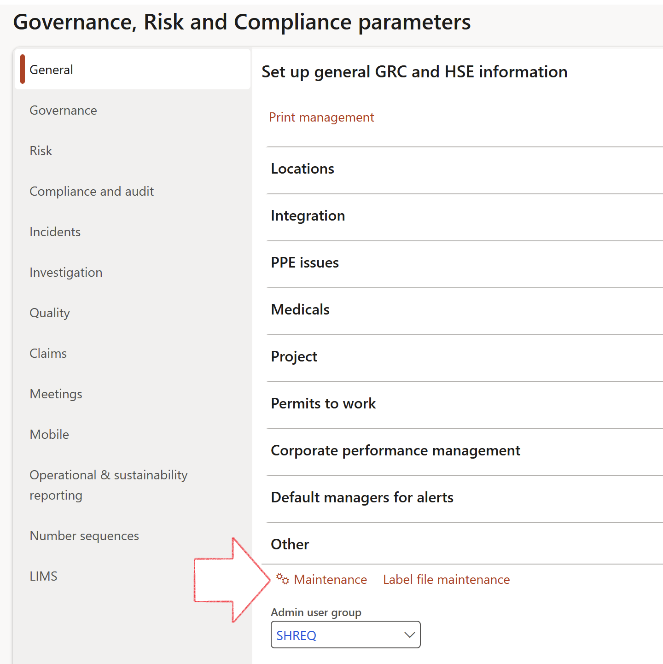

 | The Maintenance button is there for designated user. This button repairs any possible data issues. For a full history of all Data related repairs; see table below:

The information contained in this document represents the current view of Axnosis and Microsoft Corporation on the issues discussed as of the date of publication. Because Axnosis and Microsoft must respond to changing market conditions, this document should not be interpreted to be a commitment on the part of Axnosis and Microsoft, and Axnosis and Microsoft cannot guarantee the accuracy of any information presented after the date of publication.
This test script is for informational purposes only. AXNOSIS AND MICROSOFT MAKE NO WARRANTIES, EXPRESS, IMPLIED, OR STATUTORY, AS TO THE INFORMATION IN THIS DOCUMENT.
Complying with all applicable copyright laws is the responsibility of the user. Without limiting the rights under copyright, no part of this document may be reproduced, stored in or introduced into a retrieval system, or transmitted in any form or by any means (electronic, mechanical, photocopying, recording, or otherwise), or for any purpose, without the express written permission of Axnosis and Microsoft Corporation.
Axnosis and Microsoft may have patents, patent applications, trademarks, copyrights, or other intellectual property rights covering subject matter in this document. Except as expressly provided in any written license agreement from Axnosis and Microsoft, the furnishing of this document does not give you any license to these patents, trademarks, copyrights, or other intellectual property.
© 2021 Microsoft Corporation. All rights reserved. Any use or distribution of these materials without express authorization of Microsoft Corp. is strictly prohibited.
Microsoft and Windows are both registered trademarks of Microsoft Corporation in the United States and/or other countries.
The names of actual companies and products mentioned herein may be the trademarks of their respective owners.

Process | Description/notes | Release
Populate blank Accounting date fields | The Accounting date fields will be populated for all Line distributions on all Distribute all line amounts records, where the Accounting date = blank.  Date from → Accounting date. | 10.39.1864.3
Decimals on the RFQ scoring feedback forms | The Score fields on the checklist feedback form, will be populated with the historical score values. | 10.39.1864.1
Notifications and interface parameters config | The current parameters table was split, and the notifications & interface fields were moved to a new table. To ensure continued use of these notifications, administrators MUST execute this script.  This maintenance routine must be run in every legal entity. | 10.34.2105.25
Equivalent Functional location fields | The equivalent Functional location fields will be populated where an HSE Location exists on the permit to work pool header and linked Permit to worktable. | 10.30.2459.12
Fix Asset counter stock dimensions  Fix Line types on Data repository lines  Delete Orphan Data repositories | Replace empty stock dimension values with a blank dimension value  Populate missing line types from reporting templates on Data repository lines  Delete data repositories for which no template, year, site, period name or month was defined. | 10.26.1087.3  10.28.1080.6  10.30.2459.4
Display of non-calculation lines | Run this job to ensure data consistency and correct display of historical data.
Fix Inspection locations: Replace Work centre-based locations with HSE locations | Populate the new ObjectLocation field with the related HSE location associated with previously used work centre location (Location) field on the following tables:  - OHSInspectionJournalName  - OHSInspectionJournalTable  - OHSInspectionJournalTrans  - OHSInspectionHistory  - OHSSchedule | 10.24.1114.3
Re-number GRC Question and Answer Group lines | Re-number GRC Question and Answer Group line numbers. | 10.22.1561.3
Update existing risks with the new Control types | Update existing risks with the Control types that are setup on the new Control type setup form. | 10.17.1250.6

Process | Description/notes | Release
Update existing incidents with the new Incident types | Update existing incidents with the Incident types that are setup on the new Incident type setup form. (IncidentTypeRecId) | 10.17.1250.5
Fix budget transaction lines stock\item dimension | Set OHSInventDimId field value to "AllBlank" on table BudgetTransactionLine, where no value was recorded. This will solve the issue of records not displaying in the form.  Note: this step will only fix existing budget transaction records in the system. Should any new transactions be uploaded or changed via the data entity Budget Account Entries, special care needs to be taken to specify the Stock dimension = AllBlank and the Item on the excel sheet to import. | 10.1.1366.6
Populate SRS analysis enums | Still in concept phase. To provide a link between enum numerical value and value name for use with BYOD data entities. Enums available:  - OHSIncidentType,  - OHSIncidentSeverityType.  Table populated: SRSAnalysisEnums | 10.0.11785.3
Fix incident HRM injury link | Delete all orphaned records from the OHSIncidentHRMInjuryLnk table | 10.0.11785.3
Fix risk hazards | Assigning the value "Default Risk" to the new mandatory field RiskID (Key field) where empty | 10.0.80.10
Fix location vs. work centres | Populate the new LocationRecID field with the related location associated with previously used work centre location (Location) fields on the following tables:  - OHSHazardLocations,  - OHSRiskHazard,  - OHSRiskHazardWizard,  - OHSRiskRegister,  - OHSRisksWizard,  - OHSSafetyLocations,  - OHSSafetyPermit,  - OHSSafetyPermitLocations  - OHSSafetyPermitOverlap,  - OHSSafetyPlan,  - OHSInvestigation | 10.0.80.10

