
Dynamics GRC/HSE Release notes



Governance Risk & Compliance
Health, Safety & Environment

for

Microsoft Dynamics 365 for Finance & Operations™

Dynamics GRC/HSE version 10.39.1864.2

2026-10-07



Dynamics 365 FO GRC module  GRC is an add-on for Dynamics 365 suite of business application software.  This software provides compelling functionality to support Governance, Risk management and Compliance. | 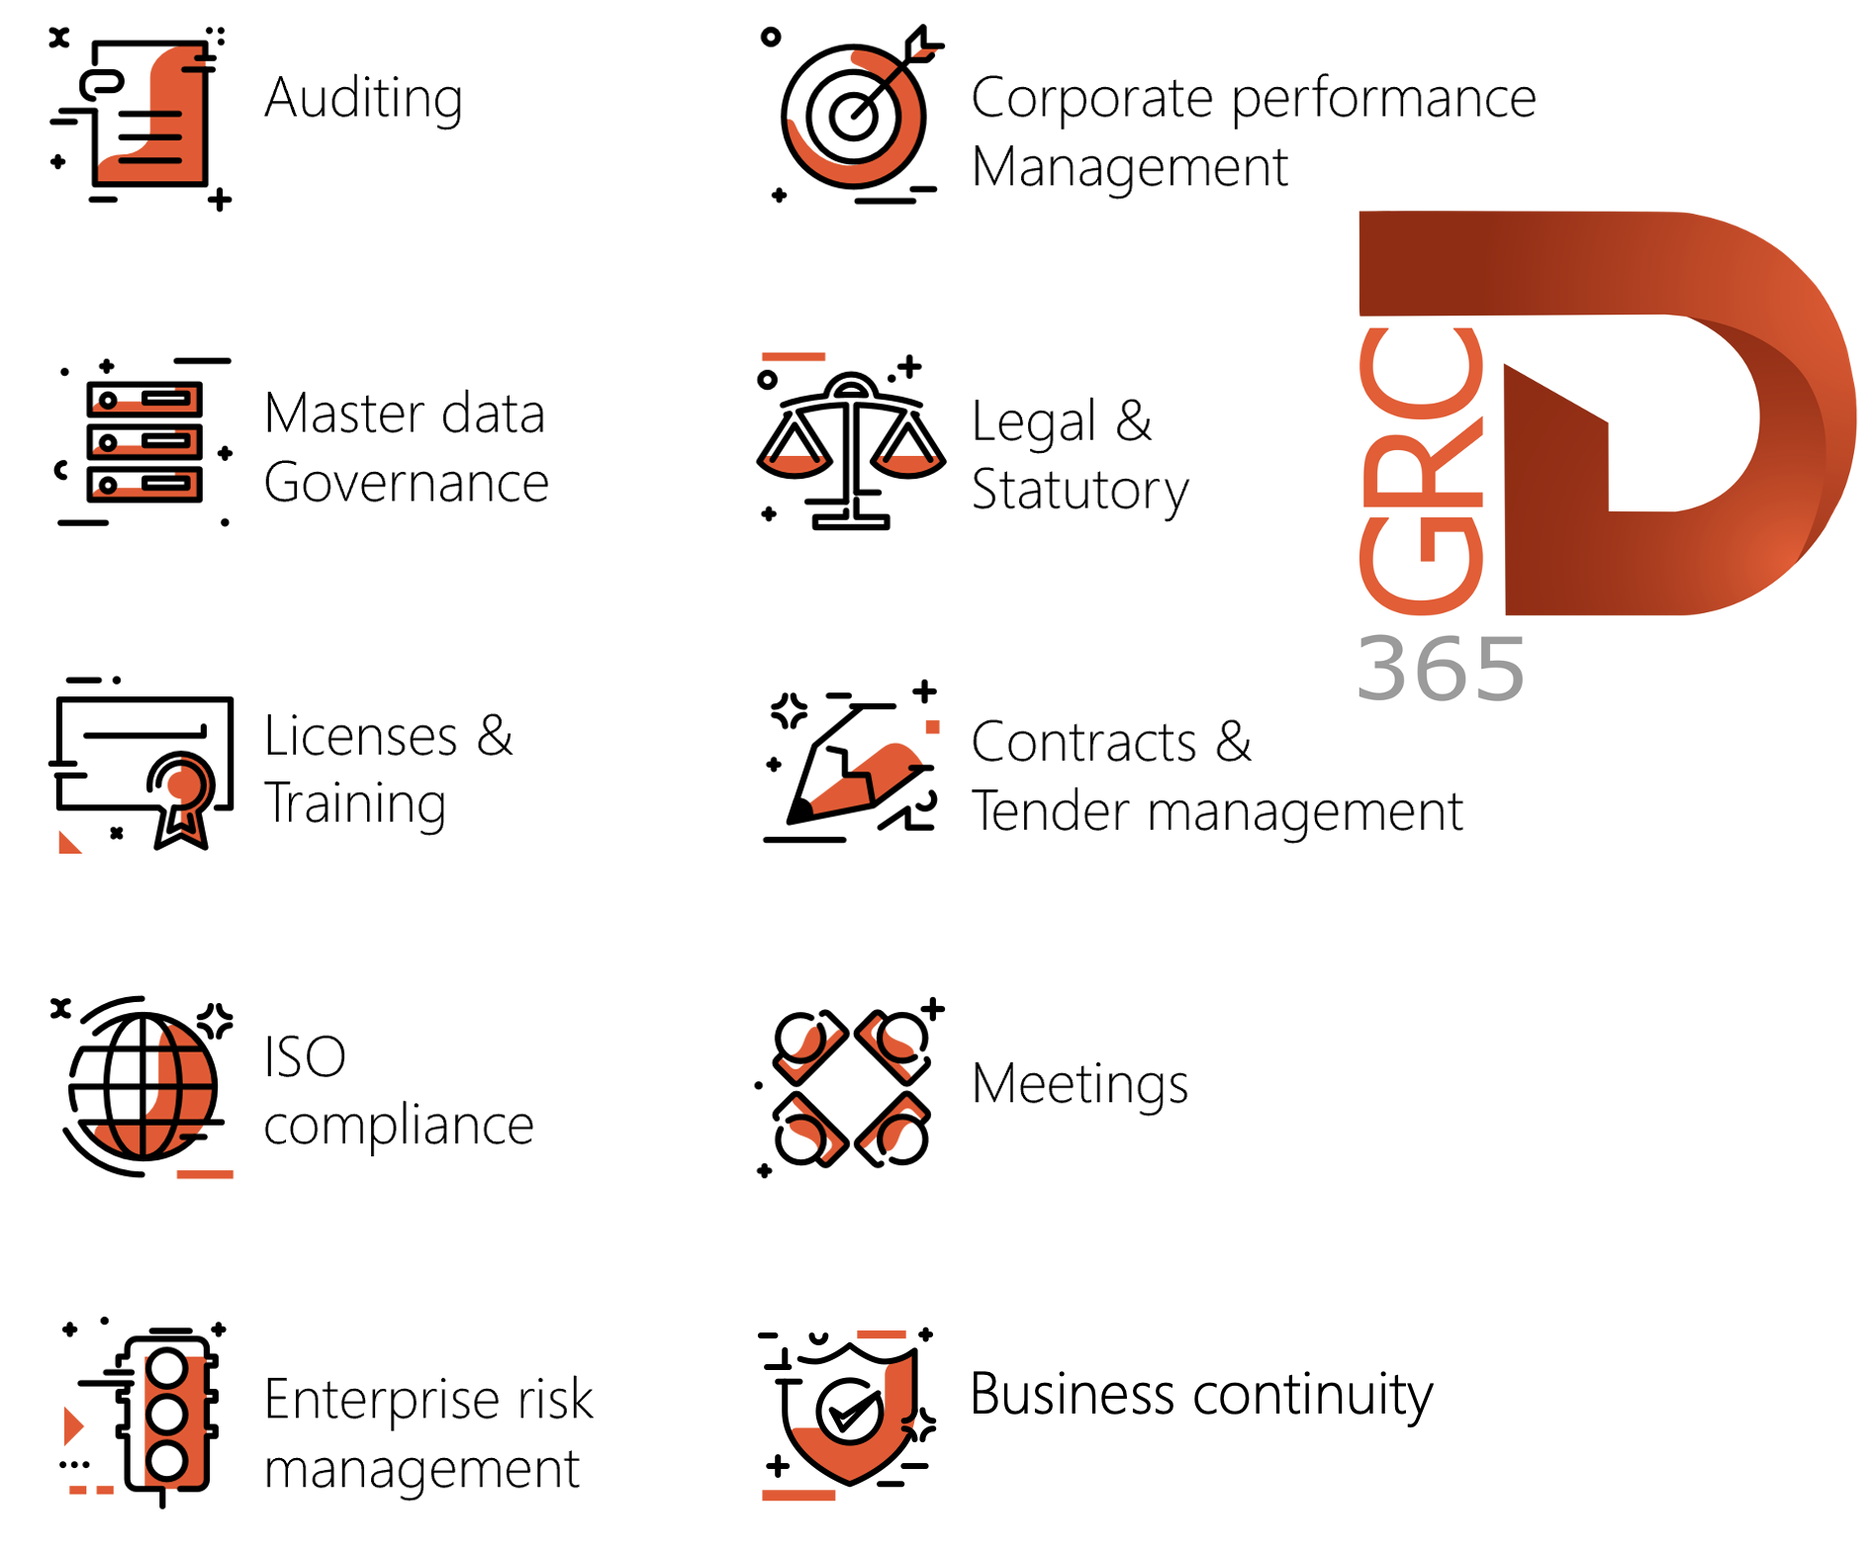

Dynamics 365 FO HSE/OHS

OHS/HSE is an add-on for Dynamics 365 suite of business application software.

This software adds to GRC in that compliance is now deeper with explicit functionality for Health, Safety and Environment as per the depicted sub-modules below.
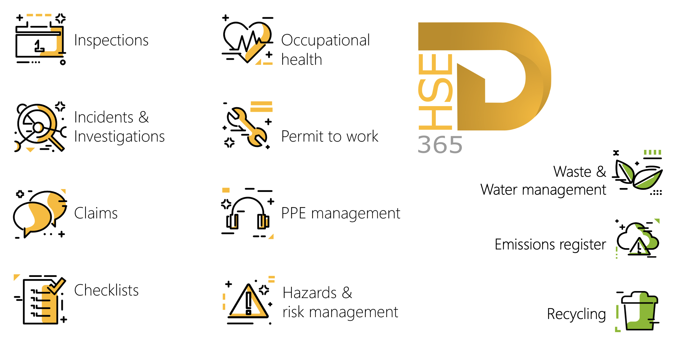

Release version

GRC/HSE Package version: OHSDeployablePackage_10_39_1864_2

This package was created on Microsoft Dynamics 365 for Finance and Operations:

Release | Version | Build number
Application release | 10.0.48 | 10.39.1864
Platform release | Platform update 72 | 7.0.7996.33

Enhancements:

Module | Description
Business continuity management | A new Save and close button was added to steps 2 – 7 of the BCM wizard. The last record changes on the form can now be saved when the form is closed.
Tender management | - The existing Request for quotation case lines data entity was added under the Open in excel menu on the RFQ detail form. Additional fields were added to the entity.  - A new Request for quotation reply lines entity was created.
Contracts management | - A new Multi-year contract option on purchase requisitions lets users split Draft PR lines based on the number of contract years. Each line becomes one line per contract year, with the unit price divided evenly and the last line absorbing any rounding difference. Each additional line’s accounting date is 1 January of the following years, and accounting distributions are copied in proportion. Standard D365FO budget control (if active for PRs) then checks and pre-encumbers each line in the fiscal period of its accounting date.  Example: a PR with 3 contract years and an accounting date of 15 March 2026 has a line with a unit price of 1,000. Splitting it gives:  - 333.33, accounting date 15 March 2026  - 333.33, accounting date 1 January 2027  - 333.34, accounting date 1 January 2028

Release Data impact

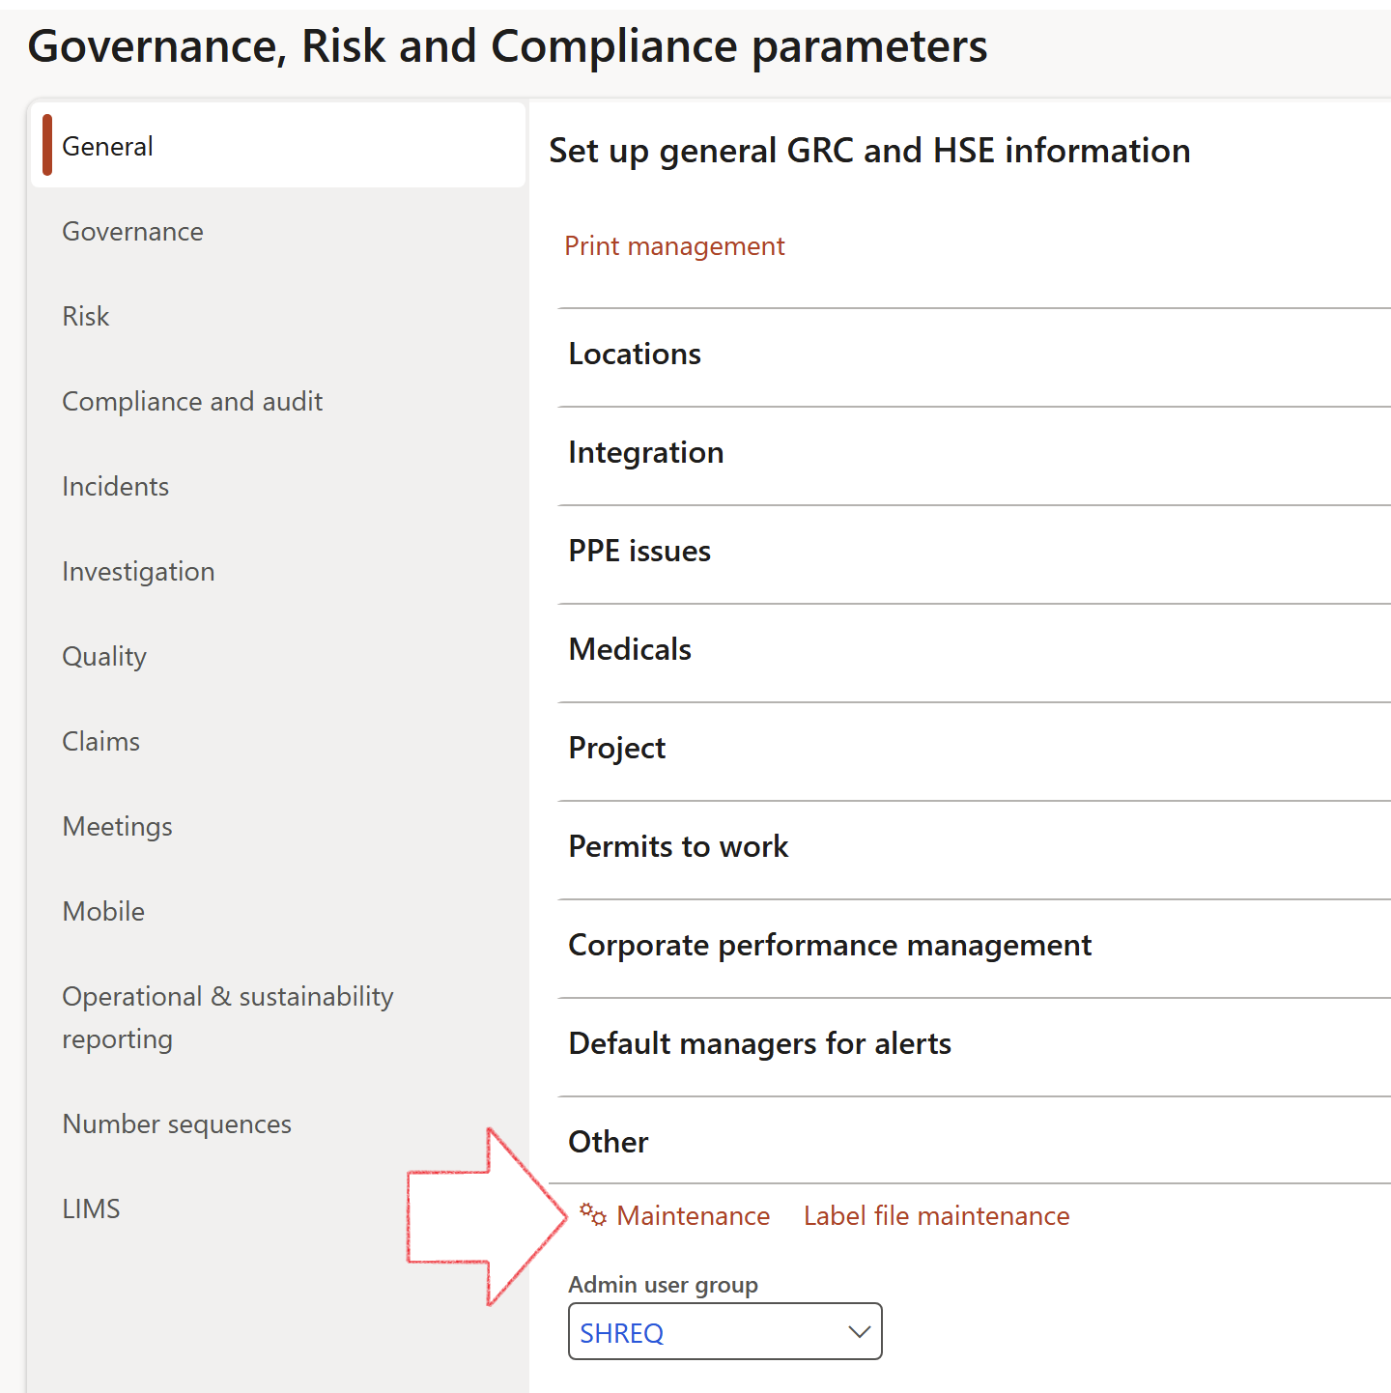

 | The Maintenance button is there for designated user. This button repairs any possible data issues. For a full history of all Data related repairs; see table below:

The information contained in this document represents the current view of Axnosis and Microsoft Corporation on the issues discussed as of the date of publication. Because Axnosis and Microsoft must respond to changing market conditions, this document should not be interpreted to be a commitment on the part of Axnosis and Microsoft, and Axnosis and Microsoft cannot guarantee the accuracy of any information presented after the date of publication.
This test script is for informational purposes only. AXNOSIS AND MICROSOFT MAKE NO WARRANTIES, EXPRESS, IMPLIED, OR STATUTORY, AS TO THE INFORMATION IN THIS DOCUMENT.
Complying with all applicable copyright laws is the responsibility of the user. Without limiting the rights under copyright, no part of this document may be reproduced, stored in or introduced into a retrieval system, or transmitted in any form or by any means (electronic, mechanical, photocopying, recording, or otherwise), or for any purpose, without the express written permission of Axnosis and Microsoft Corporation.
Axnosis and Microsoft may have patents, patent applications, trademarks, copyrights, or other intellectual property rights covering subject matter in this document. Except as expressly provided in any written license agreement from Axnosis and Microsoft, the furnishing of this document does not give you any license to these patents, trademarks, copyrights, or other intellectual property.
© 2021 Microsoft Corporation. All rights reserved. Any use or distribution of these materials without express authorization of Microsoft Corp. is strictly prohibited.
Microsoft and Windows are both registered trademarks of Microsoft Corporation in the United States and/or other countries.
The names of actual companies and products mentioned herein may be the trademarks of their respective owners.

Process | Description/notes | Release
Decimals on the RFQ scoring feedback forms | The Score fields on the checklist feedback form, will be populated with the historical score values. | 10.39.1864.1
Notifications and interface parameters config | The current parameters table was split, and the notifications & interface fields were moved to a new table. To ensure continued use of these notifications, administrators MUST execute this script.  This maintenance routine must be run in every legal entity. | 10.34.2105.25
Equivalent Functional location fields | The equivalent Functional location fields will be populated where an HSE Location exists on the permit to work pool header and linked Permit to worktable. | 10.30.2459.12
Fix Asset counter stock dimensions  Fix Line types on Data repository lines  Delete Orphan Data repositories | Replace empty stock dimension values with a blank dimension value  Populate missing line types from reporting templates on Data repository lines  Delete data repositories for which no template, year, site, period name or month was defined. | 10.26.1087.3  10.28.1080.6  10.30.2459.4
Display of non-calculation lines | Run this job to ensure data consistency and correct display of historical data.
Fix Inspection locations: Replace Work centre-based locations with HSE locations | Populate the new ObjectLocation field with the related HSE location associated with previously used work centre location (Location) field on the following tables:  - OHSInspectionJournalName  - OHSInspectionJournalTable  - OHSInspectionJournalTrans  - OHSInspectionHistory  - OHSSchedule | 10.24.1114.3
Re-number GRC Question and Answer Group lines | Re-number GRC Question and Answer Group line numbers. | 10.22.1561.3
Update existing risks with the new Control types | Update existing risks with the Control types that are setup on the new Control type setup form. | 10.17.1250.6
Update existing incidents with the new Incident types | Update existing incidents with the Incident types that are setup on the new Incident type setup form. (IncidentTypeRecId) | 10.17.1250.5

Process | Description/notes | Release
Fix budget transaction lines stock\item dimension | Set OHSInventDimId field value to "AllBlank" on table BudgetTransactionLine, where no value was recorded. This will solve the issue of records not displaying in the form.  Note: this step will only fix existing budget transaction records in the system. Should any new transactions be uploaded or changed via the data entity Budget Account Entries, special care needs to be taken to specify the Stock dimension = AllBlank and the Item on the excel sheet to import. | 10.1.1366.6
Populate SRS analysis enums | Still in concept phase. To provide a link between enum numerical value and value name for use with BYOD data entities. Enums available:  - OHSIncidentType,  - OHSIncidentSeverityType.  Table populated: SRSAnalysisEnums | 10.0.11785.3
Fix incident HRM injury link | Delete all orphaned records from the OHSIncidentHRMInjuryLnk table | 10.0.11785.3
Fix risk hazards | Assigning the value "Default Risk" to the new mandatory field RiskID (Key field) where empty | 10.0.80.10
Fix location vs. work centres | Populate the new LocationRecID field with the related location associated with previously used work centre location (Location) fields on the following tables:  - OHSHazardLocations,  - OHSRiskHazard,  - OHSRiskHazardWizard,  - OHSRiskRegister,  - OHSRisksWizard,  - OHSSafetyLocations,  - OHSSafetyPermit,  - OHSSafetyPermitLocations  - OHSSafetyPermitOverlap,  - OHSSafetyPlan,  - OHSInvestigation | 10.0.80.10

