
Dynamics GRC/HSE Release notes



Governance Risk & Compliance
Health, Safety & Environment

for

Microsoft Dynamics 365 for Finance & Operations™

Dynamics GRC/HSE version 10.37.1974.2

2026-06-08



Dynamics 365 FO GRC module  GRC is an add-on for Dynamics 365 suite of business application software.  This software provides compelling functionality to support Governance, Risk management and Compliance. | 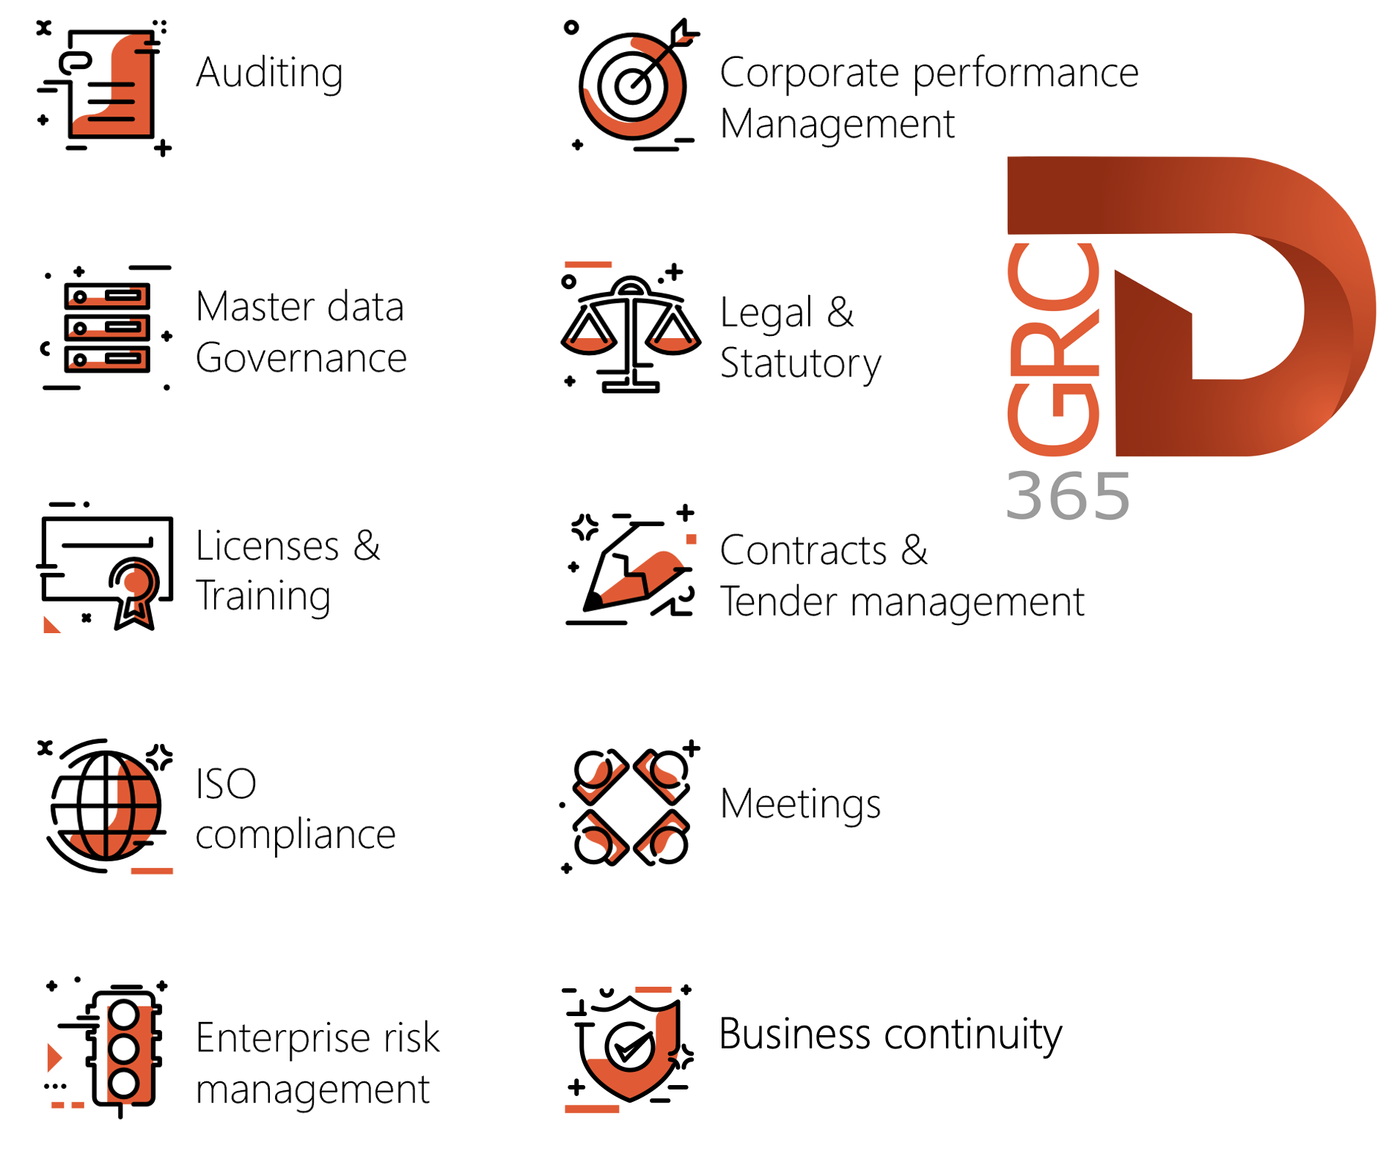

Dynamics 365 FO HSE/OHS

OHS/HSE is an add-on for Dynamics 365 suite of business application software.

This software adds to GRC in that compliance is now deeper with explicit functionality for Health, Safety and Environment as per the depicted sub-modules below.
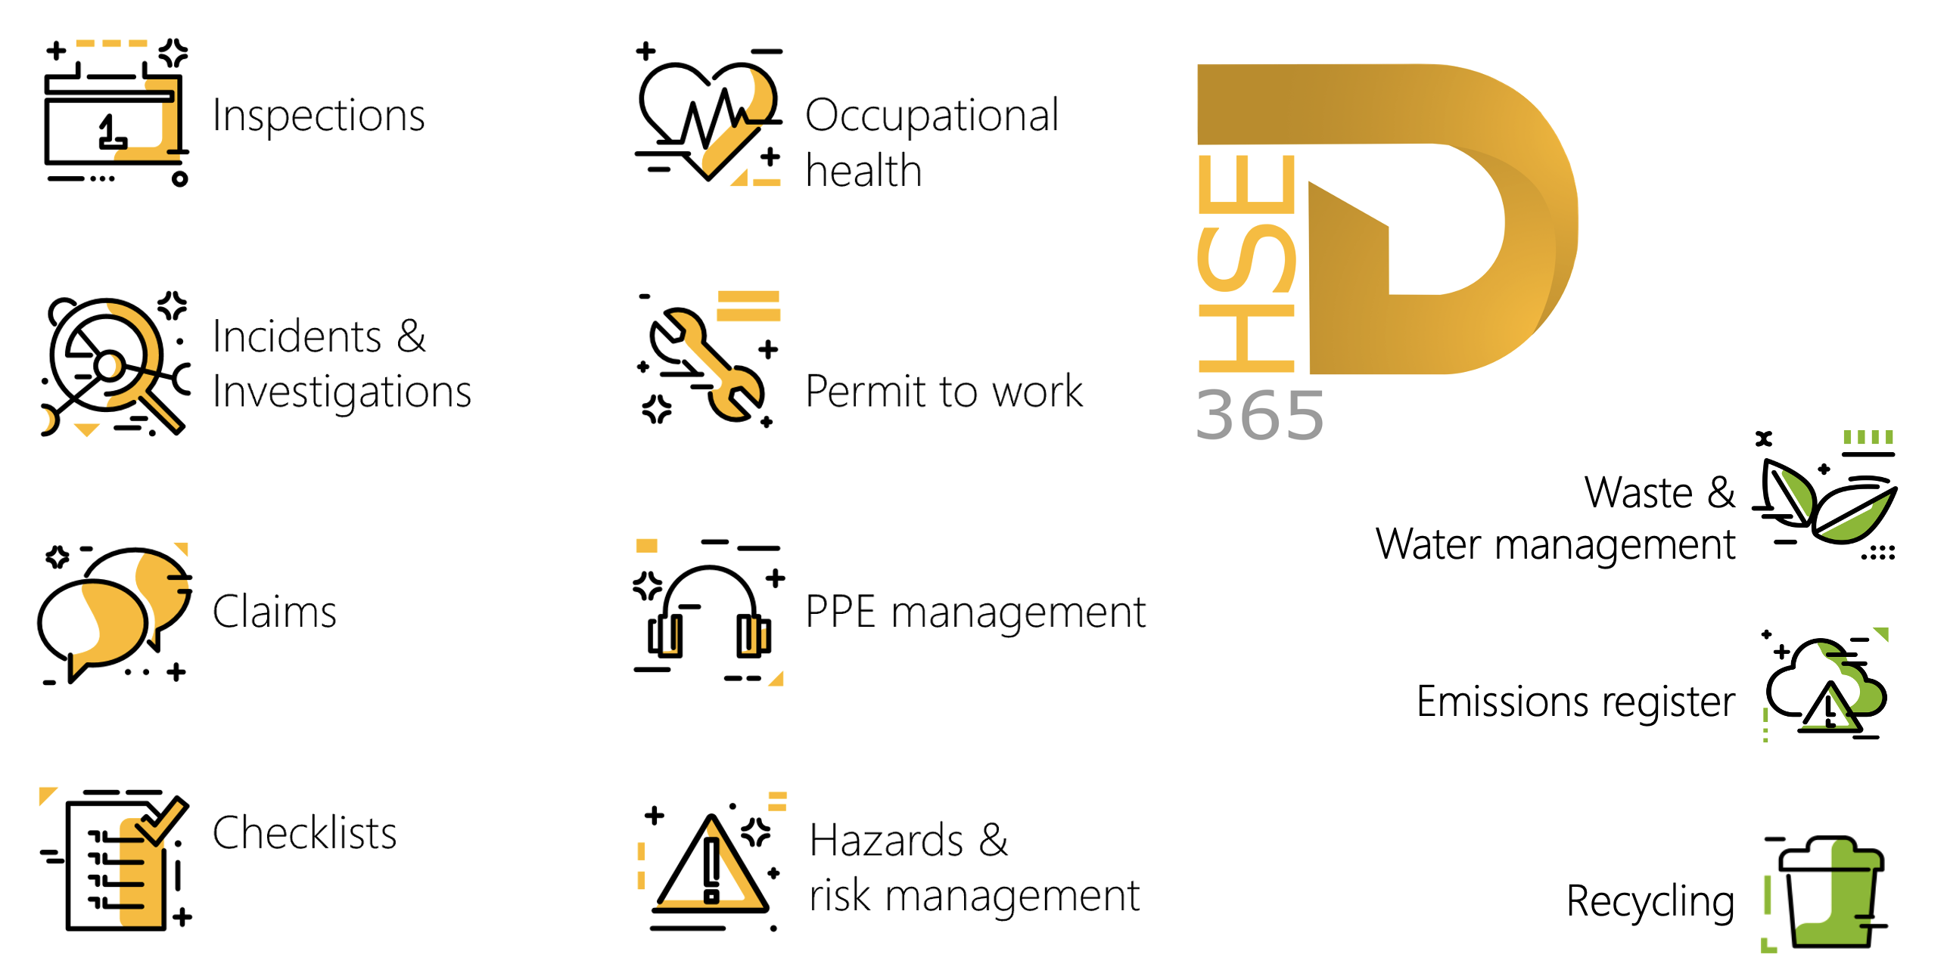

Release version

GRC/HSE Package version: OHSDeployablePackage_10_37_1974_2

This package was created on Microsoft Dynamics 365 for Finance and Operations:

Release | Version | Build number
Application release | 10.0.46 | 10.37.1974
Platform release | Platform update 70 | 7.0.7778.29

Enhancements:

Module | Description
Contracts | - On the Contract, Content Fast tab, Statement of final account Index tab: The Print the statement of final account button is now available when the contract stage = Terminate.  - The Distribute all line amounts form now includes a new Related vendor invoice journals Fast tab. When you select a contract line distribution line, this tab shows the vendor invoice journals posted against it, listing each journal's batch number, name, and description. You can navigate directly from here to the linked journal, and the list updates automatically as you select different lines.  - A new column, User group, was added to the RACI and other contacts grid on the Contract.  - On creation of a new Contract, the user group configured on the corresponding contract classification is automatically added to the RACI and other contacts grid  - The Procurement team now receives contract expiration, consumption threshold, and performance bond expiration notifications.  - Contracts can now be configured as budget-controlled documents at the legal entity level, aligning their behaviour with other standard budget-controlled document types in D365FO and supporting multi-year fiscal scenarios.  Key capabilities delivered:  - Contracts are available as a selectable document type under Documents and journals, following standard D365FO budget control rules and configuration.  - Purchase requisition line accounting distributions are copied to contract line distributions when a contract is created from a purchase requisition, and the sourcing (PR) process is closed out.  - Creating a contract from a PR relieves the associated pre-encumbrances (including across fiscal years). Distributions must total 100% of the contract line value, with a budget check triggered when marked Effective.  - Encumbrances are created in the appropriate fiscal periods (including multi-year) and adjusted when distributions are modified.  - Vendor invoice journals referencing contract line distributions relieve encumbrances (fully or partially) and post actual expenditures.  - Closing or terminating a contract automatically releases any remaining encumbrances.

Module | Description
Tender management | - On the Solicitation type, under the Governance Fast tab: A new Mask line prices slider was added. If this slider is moved to yes, the RFQ line Unit prices will default to 0 when the RFQ is sent to Vendors.  - A new security privilege was created for users with the Governance manager role to access the Tender evaluation report button on the FRQ Action pane.  - On the RFQ Header, under the Governance Fast tab, Negotiation Index tab:  The following buttons can now be accessed to users with the Tender manager security role: Send email to vendor and Send email to requester.
Management of change | - On the Change request, Site and Warehouse (under the Scope of change (lines) Fast tab), have been added to the OHSEngChgScopeOfLines data entity. Now, when Site and Warehouse are selected, on approval, they are carried over to Contract item line site and/or warehouse (only for CRs with a contract reference).
Business continuity | On the Operating unit, Process and functions Fast tab: the help text for the Add buttons on the Dependency dialog, was improved.
Permits to work | The functionality to request due date extension of a PTW was enhanced.  - A new Approve extension button was added on the Action pane in the Function group.  - A new New due date field was added under the Extension Fast tab.

Bug fixes:

Module | Description
Advanced case management | If the Name field on the data entity for attachment on cases was left blank, the record was ignored.  The issue has been resolved.
Contracts | Contracts could be created without a Primary vendor/customer selected under the Trading partners Fast tab.  The issue has been resolved.
Tender management | - Evaluation checklists were created for vendors that have declined to bid.  - On the Vendor collaboration portal, Vendor bidding workspace, Bids in progress grid: The Solicitation type was still visible for RFQ’s where the Mask solicitation type slider was on.  These issues have been resolved.
Workflow | An error came up when a user received an email from D365FO to approve a contract.  The issue has been resolved.

Release Data impact

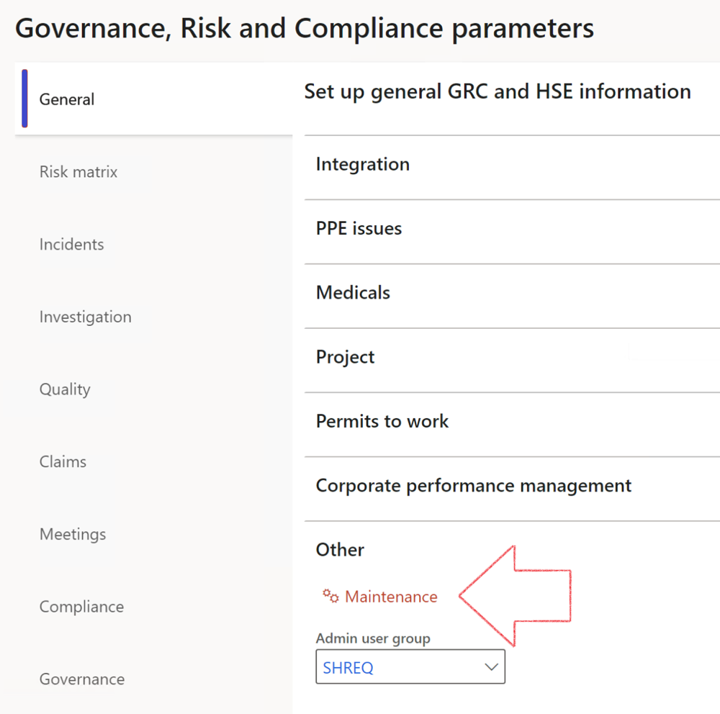

 | The Maintenance button is there for designated user. This button repairs any possible data issues. For a full history of all Data related repairs; see table below:

The information contained in this document represents the current view of Axnosis and Microsoft Corporation on the issues discussed as of the date of publication. Because Axnosis and Microsoft must respond to changing market conditions, this document should not be interpreted to be a commitment on the part of Axnosis and Microsoft, and Axnosis and Microsoft cannot guarantee the accuracy of any information presented after the date of publication.
This test script is for informational purposes only. AXNOSIS AND MICROSOFT MAKE NO WARRANTIES, EXPRESS, IMPLIED, OR STATUTORY, AS TO THE INFORMATION IN THIS DOCUMENT.
Complying with all applicable copyright laws is the responsibility of the user. Without limiting the rights under copyright, no part of this document may be reproduced, stored in or introduced into a retrieval system, or transmitted in any form or by any means (electronic, mechanical, photocopying, recording, or otherwise), or for any purpose, without the express written permission of Axnosis and Microsoft Corporation.
Axnosis and Microsoft may have patents, patent applications, trademarks, copyrights, or other intellectual property rights covering subject matter in this document. Except as expressly provided in any written license agreement from Axnosis and Microsoft, the furnishing of this document does not give you any license to these patents, trademarks, copyrights, or other intellectual property.
© 2021 Microsoft Corporation. All rights reserved. Any use or distribution of these materials without express authorization of Microsoft Corp. is strictly prohibited.
Microsoft and Windows are both registered trademarks of Microsoft Corporation in the United States and/or other countries.
The names of actual companies and products mentioned herein may be the trademarks of their respective owners.

Process | Description/notes | Release
Fix location vs. work centres | Populate the new LocationRecID field with the related location associated with previously used work centre location (Location) fields on the following tables:  - OHSHazardLocations,  - OHSRiskHazard,  - OHSRiskHazardWizard,  - OHSRiskRegister,  - OHSRisksWizard,  - OHSSafetyLocations,  - OHSSafetyPermit,  - OHSSafetyPermitLocations  - OHSSafetyPermitOverlap,  - OHSSafetyPlan,  - OHSInvestigation | 10.0.80.10
Fix risk hazards | Assigning the value "Default Risk" to the new mandatory field RiskID (Key field) where empty | 10.0.80.10
Fix incident HRM injury link | Delete all orphaned records from the OHSIncidentHRMInjuryLnk table | 10.0.11785.3
Populate SRS analysis enums | Still in concept phase. To provide a link between enum numerical value and value name for use with BYOD data entities. Enums available:  - OHSIncidentType,  - OHSIncidentSeverityType.  Table populated: SRSAnalysisEnums | 10.0.11785.3
Fix budget transaction lines stock\item dimension | Set OHSInventDimId field value to "AllBlank" on table BudgetTransactionLine, where no value was recorded. This will solve the issue of records not displaying in the form.  Note: this step will only fix existing budget transaction records in the system. Should any new transactions be uploaded or changed via the data entity Budget Account Entries, special care needs to be taken to specify the Stock dimension = AllBlank and the Item on the excel sheet to import. | 10.1.1366.6
Update existing incidents with the new Incident types | Update existing incidents with the Incident types that are setup on the new Incident type setup form. (IncidentTypeRecId) | 10.17.1250.5
Update existing risks with the new Control types | Update existing risks with the Control types that are setup on the new Control type setup form. | 10.17.1250.6
Re-number GRC Question and Answer Group lines | Re-number GRC Question and Answer Group line numbers. | 10.22.1561.3
Process | Description/notes | Release
Fix Inspection locations: Replace Work centre-based locations with HSE locations | Populate the new ObjectLocation field with the related HSE location associated with previously used work centre location (Location) field on the following tables:  - OHSInspectionJournalName  - OHSInspectionJournalTable  - OHSInspectionJournalTrans  - OHSInspectionHistory  - OHSSchedule | 10.24.1114.3
Display of non-calculation lines | Run this job to ensure data consistency and correct display of historical data.
Fix Asset counter stock dimensions  Fix Line types on Data repository lines  Delete Orphan Data repositories | Replace empty stock dimension values with a blank dimension value  Populate missing line types from reporting templates on Data repository lines  Delete data repositories for which no template, year, site, period name or month was defined. | 10.26.1087.3  10.28.1080.6  10.30.2459.4
Equivalent Functional location fields | The equivalent Functional location fields will be populated where an HSE Location exists on the permit to work pool header and linked Permit to worktable. | 10.30.2459.12
Notifications and interface parameters config | The current parameters table was split, and the notifications & interface fields were moved to a new table. To ensure continued use of these notifications, administrators MUST execute this script. In future releases the current fields will be deprecated.  This maintenance routine must be run in every legal entity. | 10.34.2105.25

