
Dynamics GRC/HSE Release notes



Governance Risk & Compliance
Health, Safety & Environment

for

Microsoft Dynamics 365 for Finance & Operations™

Dynamics GRC/HSE version 10.37.1974.12

2026-09-10



Dynamics 365 FO GRC module  GRC is an add-on for Dynamics 365 suite of business application software.  This software provides compelling functionality to support Governance, Risk management and Compliance. | 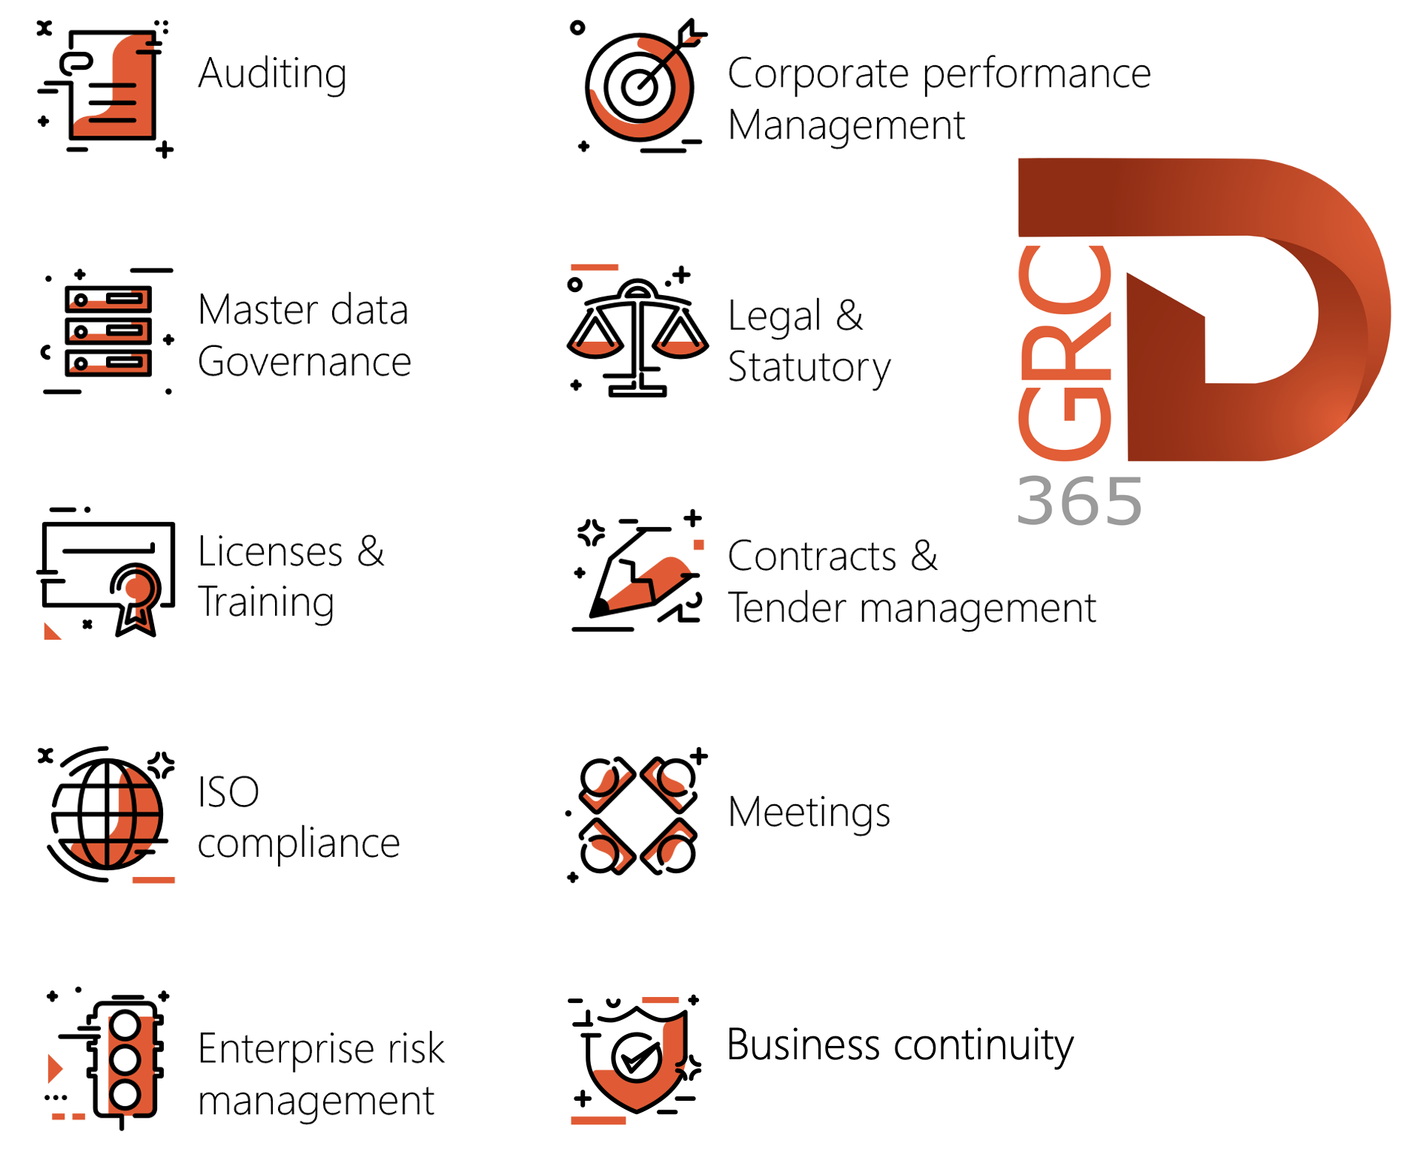

Dynamics 365 FO HSE/OHS

OHS/HSE is an add-on for Dynamics 365 suite of business application software.

This software adds to GRC in that compliance is now deeper with explicit functionality for Health, Safety and Environment as per the depicted sub-modules below.
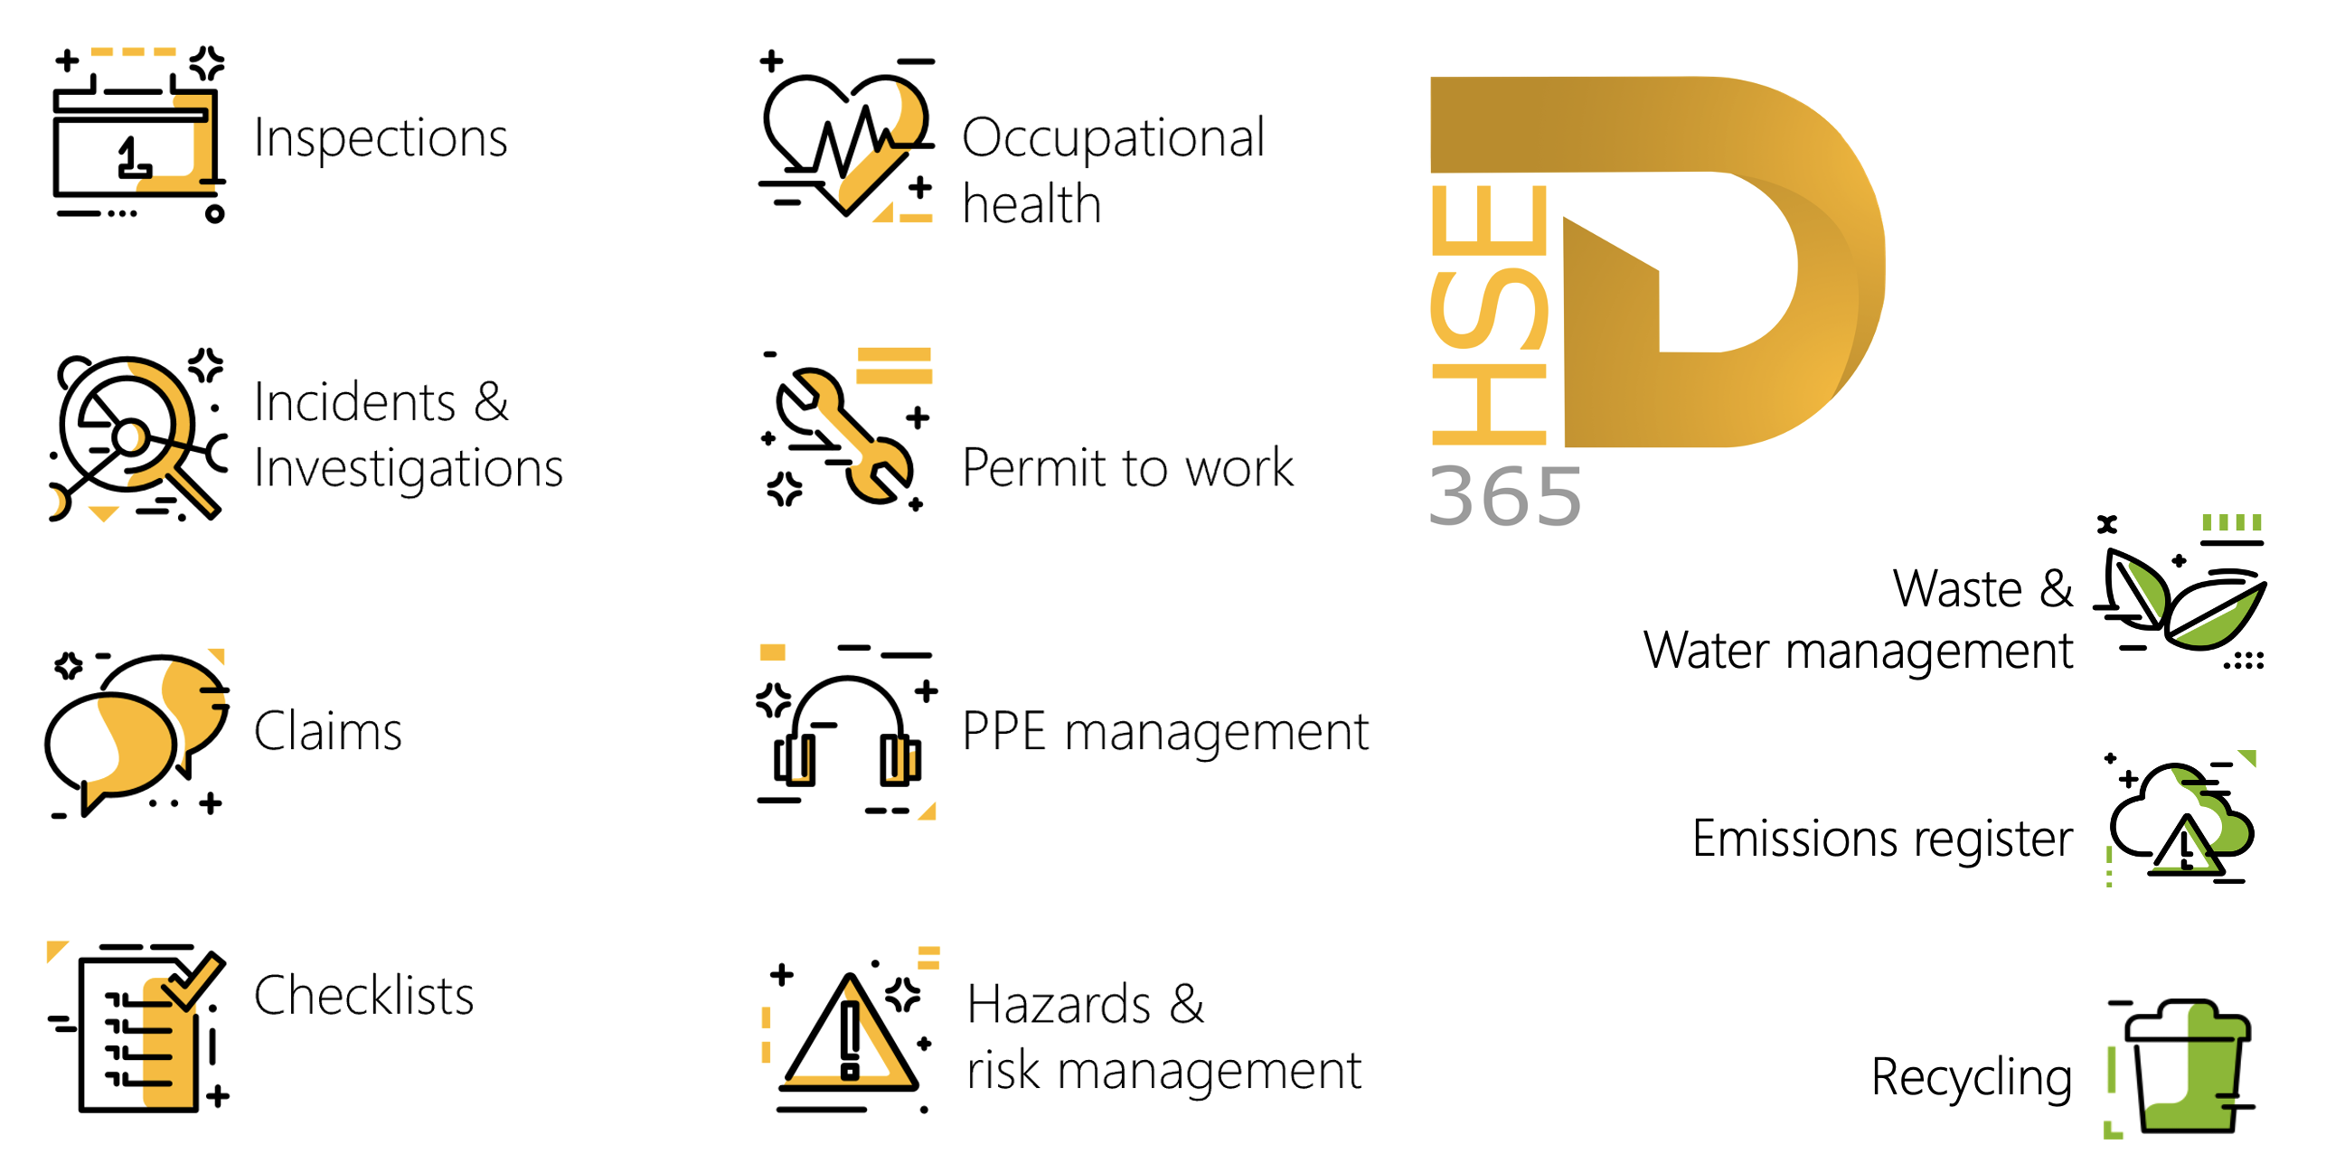

Release version

GRC/HSE Package version: OHSDeployablePackage_10_37_1974_12

This package was created on Microsoft Dynamics 365 for Finance and Operations:

Release | Version | Build number
Application release | 10.0.46 | 10.37.1974
Platform release | Platform update 70 | 7.0.7778.29

Enhancements:

Module | Description
Contracts management | The following privileges were added to the Governance contracts maintain duty:  - Submit contract item lines distribution workflow  - Approve contract item lines distribution workflow  - Process workflow tasks for contract item lines distribution
Tender management | - On the RFQ:  - When the Send button is clicked, the date fields under the Governance Fast tab, Event information Index tab, Dates field group, will be locked.  - When an amendment request is created on an RFQ, the abovementioned dates will be editable.  - The Extended due date label was changed to Extended expiration date.  - On the GRC parameters, Governance tab, Sourcing and tender governance Fast tab: a new Envelope opening dates cannot be before bid closing date slider was added. If this is set to Yes, the Technical and Commercial envelope opening dates cannot be set to be before the Bid closing date on an RFQ.  - Procurement and sourcing, Setup, Procurement and sourcing parameters, Vendor collaboration tab, under the General Fast tab:  - a new “Display envelope opening date and time” slider was added. When this slider is set to yes, vendors will see when the Commercial and Technical envelopes were opened for an RFQ.  - On the Vendor bidding workspace, Bids in progress tab:  - The following columns were added to display the date and time for when the abovementioned slider is set to yes:  - Technical envelope opened  - Commercial envelope opened
Legal | - A new Create Legal panel dialog was created.  - The grid is now sorted alphabetically on the Legal category column.

Module | Description
Business continuity management | - On the Continuity and disaster recovery Header, Target Fast tab, Key contracts Index tab:  - The Additional comments memo box was renamed to SPOF additional comments  - A new Name column was added to the grid.  - The Document number of the selected contract will be displayed in this new field.  - The value in the Description field of the selected Contract will be displayed in the Description field on the BCDR plan.  - A new Contract additional comments memo box was added.  - The value entered in the Memo box on the Contract, is displayed in thes new memo box.  - These changes were also done on the BCM Wizard.  - The following columns were added on the Operating unit, under the Continuity equipment Fast tab:  - Where held - Free text field  - Outsourced - Y/N enum  - Alternative location - Free text field  - Max value  - Currency  - Lead time - Free text field  - These changes were also done on the BCM Wizard.  - The following help text on the Business continuity workspace, Process dependencies Index tab, was changed:  - Upstream dependencies field: "Max count upstream dependencies"  - Downstream dependencies field: "Max count downstream dependencies"  - The following security roles were created for BCM:  - BCM Administrator  - BCM Champion  - BCM Department manager
Operational and sustainability reporting | A full-year rolling forecasting capability has been introduced. As actual values are recorded, the system automatically recalculates and updates the forecast for the remaining months of the fiscal year according to the calculation method configured for each line.
General | All the old notification fields were removed from the Parameter table:  - The Notifications tab is no longer on the GRC/HSE parameters  - The Interfaces button is no longer under the General tab, Integration Fast tab

Bug fixes:

Module | Description
Tender management | There was a rule that a user had to be in the Commercial team to access the Compare replies button on an RFQ.  This rule is now excluded if the "Enable tender management" parameter under the GRC parameters, Governance tab, Sourcing and tender governance Fast tab = No.
Business continuity management | There was an error on the BCDR plan when a Key contract (one also selected on a different BCDR plan) was selected under the Target Fast tab, Key contracts Index tab.  The issue has been resolved.
Legal | The Legal panel grid was un-editable.  The issue has been resolved.

Release Data impact

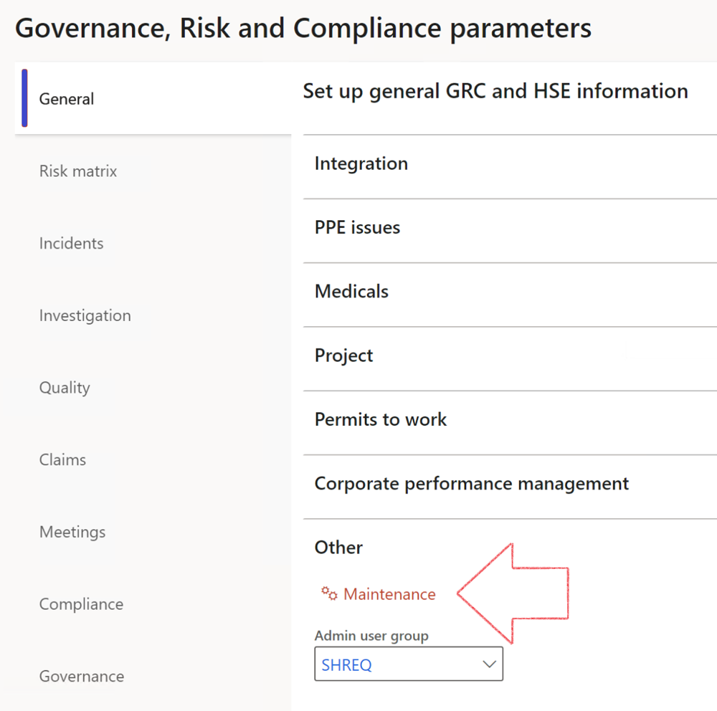

 | The Maintenance button is there for designated user. This button repairs any possible data issues. For a full history of all Data related repairs; see table below:

The information contained in this document represents the current view of Axnosis and Microsoft Corporation on the issues discussed as of the date of publication. Because Axnosis and Microsoft must respond to changing market conditions, this document should not be interpreted to be a commitment on the part of Axnosis and Microsoft, and Axnosis and Microsoft cannot guarantee the accuracy of any information presented after the date of publication.
This test script is for informational purposes only. AXNOSIS AND MICROSOFT MAKE NO WARRANTIES, EXPRESS, IMPLIED, OR STATUTORY, AS TO THE INFORMATION IN THIS DOCUMENT.
Complying with all applicable copyright laws is the responsibility of the user. Without limiting the rights under copyright, no part of this document may be reproduced, stored in or introduced into a retrieval system, or transmitted in any form or by any means (electronic, mechanical, photocopying, recording, or otherwise), or for any purpose, without the express written permission of Axnosis and Microsoft Corporation.
Axnosis and Microsoft may have patents, patent applications, trademarks, copyrights, or other intellectual property rights covering subject matter in this document. Except as expressly provided in any written license agreement from Axnosis and Microsoft, the furnishing of this document does not give you any license to these patents, trademarks, copyrights, or other intellectual property.
© 2021 Microsoft Corporation. All rights reserved. Any use or distribution of these materials without express authorization of Microsoft Corp. is strictly prohibited.
Microsoft and Windows are both registered trademarks of Microsoft Corporation in the United States and/or other countries.
The names of actual companies and products mentioned herein may be the trademarks of their respective owners.

Process | Description/notes | Release
Fix location vs. work centres | Populate the new LocationRecID field with the related location associated with previously used work centre location (Location) fields on the following tables:  - OHSHazardLocations,  - OHSRiskHazard,  - OHSRiskHazardWizard,  - OHSRiskRegister,  - OHSRisksWizard,  - OHSSafetyLocations,  - OHSSafetyPermit,  - OHSSafetyPermitLocations  - OHSSafetyPermitOverlap,  - OHSSafetyPlan,  - OHSInvestigation | 10.0.80.10
Fix risk hazards | Assigning the value "Default Risk" to the new mandatory field RiskID (Key field) where empty | 10.0.80.10
Fix incident HRM injury link | Delete all orphaned records from the OHSIncidentHRMInjuryLnk table | 10.0.11785.3
Populate SRS analysis enums | Still in concept phase. To provide a link between enum numerical value and value name for use with BYOD data entities. Enums available:  - OHSIncidentType,  - OHSIncidentSeverityType.  Table populated: SRSAnalysisEnums | 10.0.11785.3
Fix budget transaction lines stock\item dimension | Set OHSInventDimId field value to "AllBlank" on table BudgetTransactionLine, where no value was recorded. This will solve the issue of records not displaying in the form.  Note: this step will only fix existing budget transaction records in the system. Should any new transactions be uploaded or changed via the data entity Budget Account Entries, special care needs to be taken to specify the Stock dimension = AllBlank and the Item on the excel sheet to import. | 10.1.1366.6
Update existing incidents with the new Incident types | Update existing incidents with the Incident types that are setup on the new Incident type setup form. (IncidentTypeRecId) | 10.17.1250.5
Update existing risks with the new Control types | Update existing risks with the Control types that are setup on the new Control type setup form. | 10.17.1250.6
Re-number GRC Question and Answer Group lines | Re-number GRC Question and Answer Group line numbers. | 10.22.1561.3
Process | Description/notes | Release
Fix Inspection locations: Replace Work centre-based locations with HSE locations | Populate the new ObjectLocation field with the related HSE location associated with previously used work centre location (Location) field on the following tables:  - OHSInspectionJournalName  - OHSInspectionJournalTable  - OHSInspectionJournalTrans  - OHSInspectionHistory  - OHSSchedule | 10.24.1114.3
Display of non-calculation lines | Run this job to ensure data consistency and correct display of historical data.
Fix Asset counter stock dimensions  Fix Line types on Data repository lines  Delete Orphan Data repositories | Replace empty stock dimension values with a blank dimension value  Populate missing line types from reporting templates on Data repository lines  Delete data repositories for which no template, year, site, period name or month was defined. | 10.26.1087.3  10.28.1080.6  10.30.2459.4
Equivalent Functional location fields | The equivalent Functional location fields will be populated where an HSE Location exists on the permit to work pool header and linked Permit to worktable. | 10.30.2459.12
Notifications and interface parameters config | The current parameters table was split, and the notifications & interface fields were moved to a new table. To ensure continued use of these notifications, administrators MUST execute this script.  This maintenance routine must be run in every legal entity. | 10.34.2105.25

