
Dynamics GRC/HSE Release notes



Governance Risk & Compliance
Health, Safety & Environment

for

Microsoft Dynamics 365 for Finance & Operations™

Dynamics GRC/HSE version 10.34.2105.8

2025-10-17



Dynamics 365 FO GRC module  GRC is an add-on for Dynamics 365 suite of business application software.  This software provides compelling functionality to support Governance, Risk management and Compliance. | 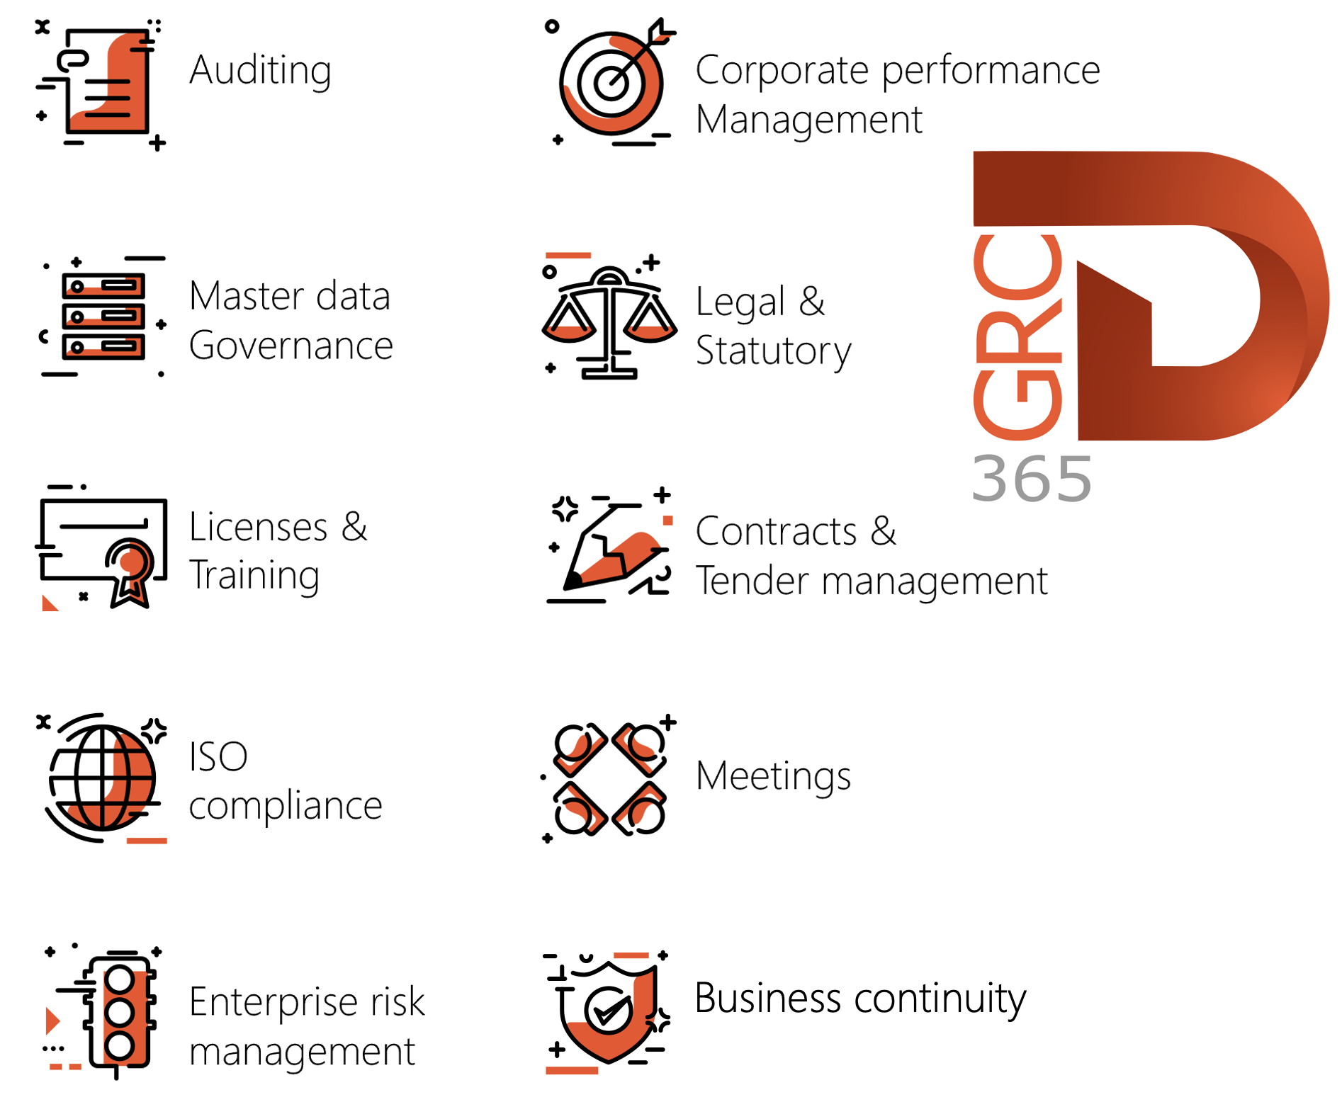

Dynamics 365 FO HSE/OHS

OHS/HSE is an add-on for Dynamics 365 suite of business application software.

This software adds to GRC in that compliance is now deeper with explicit functionality for Health, Safety and Environment as per the depicted sub-modules below.
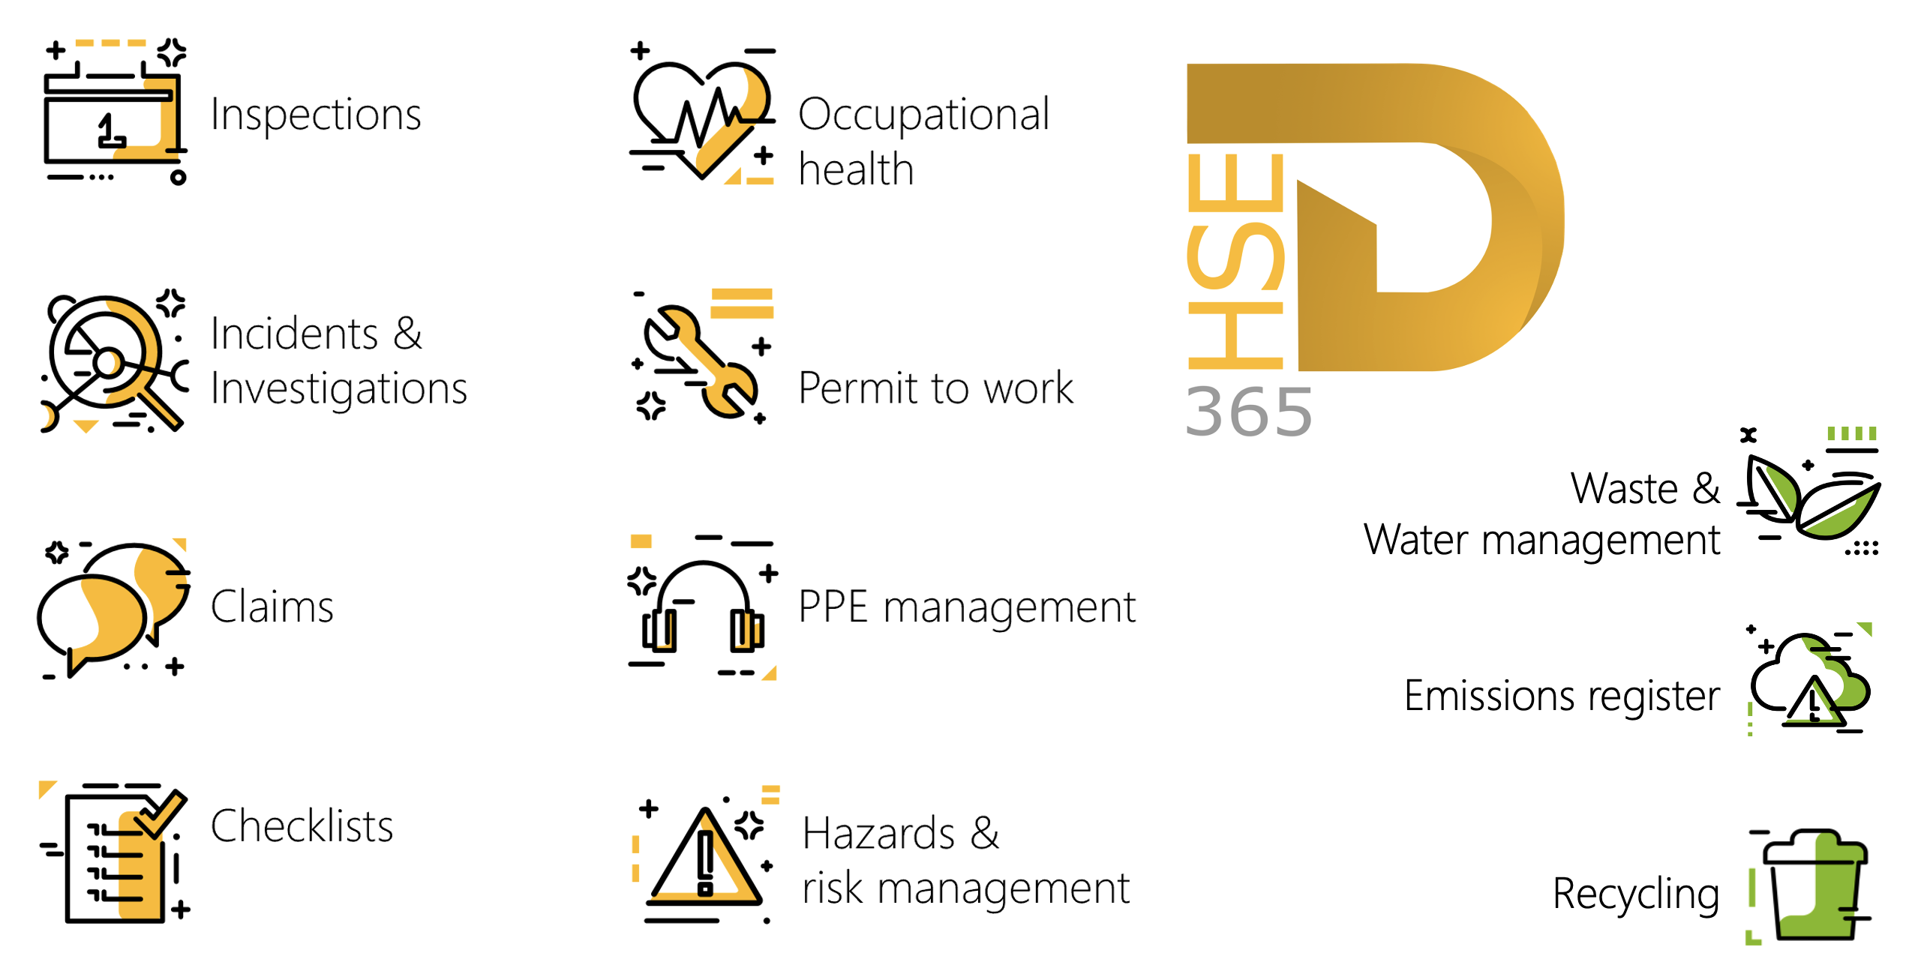

Release version

GRC/HSE Package version: OHSDeployablePackage_10_34_2105_8

This package was created on Microsoft Dynamics 365 for Finance and Operations:

Release | Version | Build number
Application release | 10.0.43 | 10.34.2105
Platform release | Platform update 67 | 7.0.7521.60

Enhancements:

Module | Description
Business continuity | - The 3rd party by department labels and report were changed to 3rd party per department  - On the Recovery strategy, in the Loss type dropdown list, the Threat column was hidden and the following columns displayed:  - Personnel, Workplace, IT applications, Equipment and Stakeholders.  - On the Operating unit under the General Fast tab, the Total personnel required, and the Minimum personnel required fields were moved into a new Business continuity field group.  - A new Business continuity Fast tab was added on the Business process template form. The Minimum workers field and the Total workers required field, were moved to this new Fast tab. The following fields were created & added under this Fast tab:  - Background/additional information (memo box)  - RTO and RPO (enums)  - Peak periods (free text field)  - A new Business as usual Index tab was added to the BCM workspace. The user can choose which department he/she wants to view details for.  - A new Software applications per department SSRS report was created. The new menu item is under GRC, Business continuity, Reports and inquiries. The report can also be printed from the BCM workspace.
Enterprise risk management | The Risk administrator security role was enhanced to allow access to additional menu items and buttons.
Management of change | The Scope of change entries for change requests now cater for multiple procurement categories for the same change type.

Module | Description
Contracts management | - On the Contract:  - Under the Content Fast tab:  - Cover page Index tab, a new Vessel lookup was added. This lookup is only available when on the Contract (type) classification, the Applied to value = Supply chain.  - References Index tab, Batch attributes was added as a value on the Elements relation type enum.  - Under the Item lines Fast tab, a new Sales category column was added.  - The Projects Fast tab was renamed to Projects and pricing, and new Currency column was added next to the Amount column.  - Under the Trading partners Fast tab, the following lookups were added: Ship from port and Ship to port  - Under the Payment schedule Fast tab, when a Payment schedule is selected, the lines are populated based on the Percentage or Amount from the Payment schedule base table.  - On Batch attributes:  - A new Basis free text field was added in the Header  - Under the Values Fast tab:  - The Target field was renamed to Target (typical)  - A new Rejection free text field was added.  - On the Contract classification setup form:  - The Performance bond batch template field was moved out of the grid to below the grid.  - A new LMP type field (enum) was added. Coal was added as a new value to this enum.  - The LMP type field (enum) was also added on the Sales order header under the Setup Fast tab.  - On the Sales order lines, under the Sales order lines Fast tab, Adjust price (NCV) was added as a new value under the Update line button. This option opens a new dialog where the user can re-calculate the net amount.  - On the Sales order Header, under the General Fast tab, the following was added under the References field group:  - A lookup to Contracts and a Document number display method.  - Purchase agreements created from contracts now assign the correct commitment type based on the line configuration: item lines use Product quantity commitment, procurement category lines use Product category value commitment, and category hierarchy lines use Value commitment. When contract enforcement is enabled, users cannot add or remove lines, and enforcement fields (Max value, Price, Discount) are locked. Purchase orders released from these agreements adhere to enforced contract values, while standard purchase agreements remain unchanged.
Enterprise legal | On the Legal, Contracts and Tender management workspace, Enterprise legal Index tab:  - A new Summary Fast tab with 5 new tiles was added.  - Three additional mini list pages were added under the Details Fast tab.

Bug fixes:
Module | Description
Enterprise risk management | There was a refresh issue when a risk line was being closed.  The issue has been resolved.
Medicals | There were inconsistent results when trying to import medical consultations data using data management and the HSE Medical consultations data entity.  The issue has been resolved.

Release Data impact

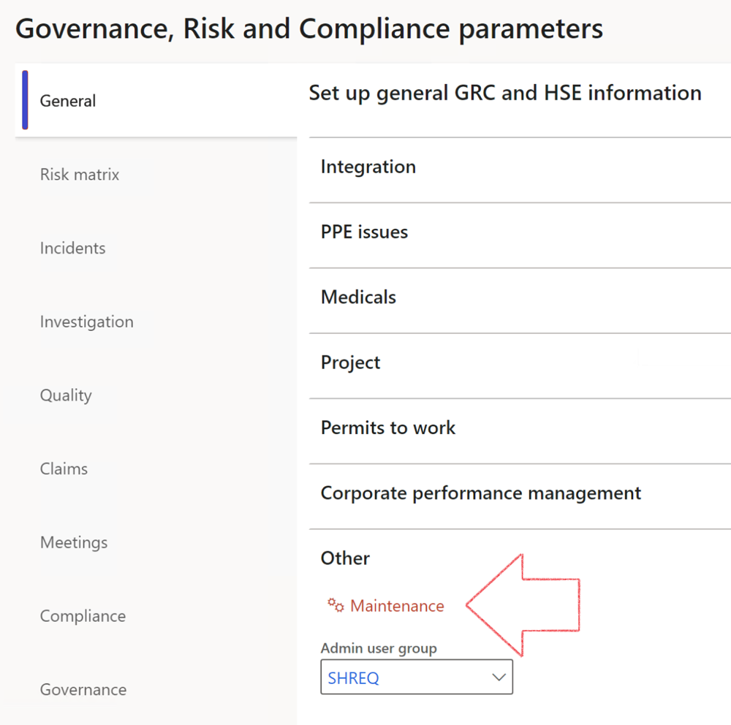

 | The Maintenance button is there for designated user. This button repairs any possible data issues. For a full history of all Data related repairs; see table below:

The information contained in this document represents the current view of Axnosis and Microsoft Corporation on the issues discussed as of the date of publication. Because Axnosis and Microsoft must respond to changing market conditions, this document should not be interpreted to be a commitment on the part of Axnosis and Microsoft, and Axnosis and Microsoft cannot guarantee the accuracy of any information presented after the date of publication.
This test script is for informational purposes only. AXNOSIS AND MICROSOFT MAKE NO WARRANTIES, EXPRESS, IMPLIED, OR STATUTORY, AS TO THE INFORMATION IN THIS DOCUMENT.
Complying with all applicable copyright laws is the responsibility of the user. Without limiting the rights under copyright, no part of this document may be reproduced, stored in or introduced into a retrieval system, or transmitted in any form or by any means (electronic, mechanical, photocopying, recording, or otherwise), or for any purpose, without the express written permission of Axnosis and Microsoft Corporation.
Axnosis and Microsoft may have patents, patent applications, trademarks, copyrights, or other intellectual property rights covering subject matter in this document. Except as expressly provided in any written license agreement from Axnosis and Microsoft, the furnishing of this document does not give you any license to these patents, trademarks, copyrights, or other intellectual property.
© 2021 Microsoft Corporation. All rights reserved. Any use or distribution of these materials without express authorization of Microsoft Corp. is strictly prohibited.
Microsoft and Windows are both registered trademarks of Microsoft Corporation in the United States and/or other countries.
The names of actual companies and products mentioned herein may be the trademarks of their respective owners.

Process | Description/notes | Release
Fix location vs. work centres | Populate the new LocationRecID field with the related location associated with previously used work centre location (Location) fields on the following tables:  - OHSHazardLocations,  - OHSRiskHazard,  - OHSRiskHazardWizard,  - OHSRiskRegister,  - OHSRisksWizard,  - OHSSafetyLocations,  - OHSSafetyPermit,  - OHSSafetyPermitLocations  - OHSSafetyPermitOverlap,  - OHSSafetyPlan,  - OHSInvestigation | 10.0.80.10
Fix risk hazards | Assigning the value "Default Risk" to the new mandatory field RiskID (Key field) where empty | 10.0.80.10
Fix incident HRM injury link | Delete all orphaned records from the OHSIncidentHRMInjuryLnk table | 10.0.11785.3
Populate SRS analysis enums | Still in concept phase. To provide a link between enum numerical value and value name for use with BYOD data entities. Enums available:  - OHSIncidentType,  - OHSIncidentSeverityType.  Table populated: SRSAnalysisEnums | 10.0.11785.3
Fix budget transaction lines stock\item dimension | Set OHSInventDimId field value to "AllBlank" on table BudgetTransactionLine, where no value was recorded. This will solve the issue of records not displaying in the form.  Note: this step will only fix existing budget transaction records in the system. Should any new transactions be uploaded or changed via the data entity Budget Account Entries, special care needs to be taken to specify the Stock dimension = AllBlank and the Item on the excel sheet to import. | 10.1.1366.6
Update existing incidents with the new Incident types | Update existing incidents with the Incident types that are setup on the new Incident type setup form. (IncidentTypeRecId) | 10.17.1250.5
Update existing risks with the new Control types | Update existing risks with the Control types that are setup on the new Control type setup form. | 10.17.1250.6
Re-number GRC Question and Answer Group lines | Re-number GRC Question and Answer Group line numbers | 10.22.1561.3
Fix Inspection locations: Replace Work centre-based locations with HSE locations | Populate the new ObjectLocation field with the related HSE location associated with previously used work centre location (Location) field on the following tables:  - OHSInspectionJournalName  - OHSInspectionJournalTable  - OHSInspectionJournalTrans  - OHSInspectionHistory  - OHSSchedule | 10.24.1114.3
Process | Description/notes | Release
Display of non-calculation lines | Run this job to ensure data consistency and correct display of historical data.
Fix Asset counter stock dimensions  Fix Line types on Data repository lines  Delete Orphan Data repositories | Replace empty stock dimension values with a blank dimension value  Populate missing line types from reporting templates on Data repository lines  Delete data repositories for which no template, year, site, period name or month was defined. | 10.26.1087.3  10.28.1080.6  10.30.2459.4
Equivalent Functional location fields | The equivalent Functional location fields will be populated where an HSE Location exists on the permit to work pool header and linked Permit to work table. | 10.30.2459.12

