

Dynamics GRC/HSE Release notes



Governance Risk & Compliance

Health, Safety & Environment

for

**Microsoft Dynamics 365 for Finance & Operations™**

*Dynamics GRC/HSE version* 10.34.2105.7

2025-10-09



|  |  |
| --- | --- |
| Dynamics 365 FO GRC module GRC is an add-on for Dynamics 365 suite of business application software.  This software provides compelling functionality to support Governance, Risk management and Compliance. |  |
| Dynamics 365 FO HSE/OHS OHS/HSE is an add-on for Dynamics 365 suite of business application software.  This software adds to GRC in that compliance is now deeper with explicit functionality for Health, Safety and Environment as per the depicted sub-modules below. | |
|  | |

Release version

**GRC/HSE Package version:** OHSDeployablePackage_10_34_2105_7

This package was created on Microsoft Dynamics 365 for Finance and Operations:

|  |  |  |
| --- | --- | --- |
| **Release** | **Version** | **Build number** |
| Application release | 10.0.43 | 10.34.2105 |
| Platform release | Platform update 67 | 7.0.7521.60 |

# Enhancements:

|  |  |
| --- | --- |
| Module | Description |
| Operational risk management | * On the Risk register **lines:**   + Under the **Associations** Fast tab, **Purpose** is now also displayed in the **ID** dropdown when **Activity** is selected in the **Entity type** column.   + Under the **General** Fast tab, **Business process** Index tab, the **Accounting area** was added to the **Name** lookup. |
| Contracts management | * On the **Legal, Contracts and tender management workspace**:   + The **Enterprise legal and contracts** Index tab was renamed to **Enterprise legal**   + A new **Contracts** Index tab was added with the following Fast tabs (moved from the **Enterprise legal and contracts** Index tab):     - **Summary** and **Contracts per classification**.     - Under the **Contracts per classification** Fast tab, the grid and chart were swapped**.** * A new **Final account contracts** menu item was added under **GRC, Governance, Contracts**. * On the **Contract**, Content Fast tab, **References** Index tab, **BC/DR** was added as a new value to the **Element relation type** enum. When this enum value is selected, the **Element relation** does a lookup to **BC/DR plans**. * On the **Contract**, under the **Projects** Fast tab, a new **Milestones** Index tab was added. * A section for clients to sign was added on the **SOFA** report. |
| Management of change | * On the **Change type** setup form, **Fee and time** was added as a value to the **Type** enum. * This change type allows users to specify both a **date extension value** as well as a **cost adjustment** on a single change request line. The specified details will also carry over to **contract references** after the change request has been approved. |

|  |  |
| --- | --- |
| Module | Description |
| Business continuity | * On the **Operating unit**, under the **Single point of failure** Fast tab, the label of the **Criticality** field group was changed to **3rd party criticality**. * On the **Recovery strategy**, **Threat** is now also displayed in the **Loss type** dropdown. * A new **3rd parties by department** report was created. A new menu item for this report was added under **GRC, Business continuity, Reports and inquiries**. * The following was done on the **Business continuity workspace**:   + The **Human resource requirements** Index tab was swapped with the **Business processes** Index tab.   + The **Single point of failure** Index tab was swapped with the **3rd party** Index tab.   + Under the **Business processes** index tab, the height of the grid and the graph were decreased, and a new grid added displaying **RTO by department**.   + Under the **Single point of failure** index tab: The grid was made wider so that the user does not have to scroll.   + Under the **My work** index tab:     - A new Fast tab **Status view** was added between the existing Fast tabs. The following two new pie charts are under this Fast tab:       * **BC/DR plans by status** and **BIA by status**     - The **RPO value** and **RTO value** columns were hidden as they were duplicates   + A new **Print** button was added in the Action strip. The following reports can be printed from here:     - **Impact assessment; downtime report**     - **Recovery strategy per department**     - **3rd party by department** * On the **Activated plans**:   + **Completed** was added as a value to the **Status** enum   + The **RTO** and **RPO** values were replaced with the **RTO** and **RPO** enums found on the BC/DR plan   + **Start date and time** and **End date and time** displays were added under the **General** Fast tab   + **Start** and **End** buttons were added in the Action strip * On the BC/DR Header, **Targets** Fast tab, **Key contracts** Index tab, the following display methods were added in front of the **SPOF** column:   + **Active SLA in place** and **Continuity plans tested**   + When a **Contract** is selected on the **BC/DR plan**, a record is added on the Contract, Content fast tab, under the **References** Index tab. * The following columns were added to the **Continuity and disaster recovery type** setup form:   + **Add business processes, Add application**   + **Add equipment, Add vital records**   These columns represent Fast tabs on the **Operating unit/Department**. When these boxes are ticked, the data entered under the Fast tabs on the Department defaults to the BC/DR plan when it is created using the combination of **Continuity and disaster recovery type** and **Department**. |

|  |  |
| --- | --- |
| Module | Description |
|  | * The following yes/no columns were added on the **Loss type** setup form:   + **Personnel, Workplace**   + **IT applications, Equipment**   + **Stakeholders** |
| Investigations | * The **Status** button in the Action pane of the **Investigation** is now **always available,** even when workflow is enabled. * When an Investigation is created from an Incident, or when the Incident is linked to the Investigation via the **Add** button under the **Incident** Fast tab on the **Investigation**: * The value selected in the **5 WHY needed**? field on the **Incident** form, under the **Interpretation** Fast tab, **Cause** Index tab, now pulls through to the **5 WHY needed**? field on the **Investigation** form under the **Cause** Fast tab. * The **RACI** Index tab on the Investigation, under the General Fast tab, was renamed to **RACI and other contacts**. A grid was added under the **RACI** fields where the user can add details of additional contacts. * On the **Permit to work types** setup form:   + The following values were added to the **Type** enum     - **Work authorisation, Safe mechanical lifting**     - **Line of fire, Driving**     - **Bypassing safety controls**   + The size of the memo box under the grid was decreased to display **safety icons**. |
| Inspections | * On the **Inspection journal**:   + Under the Line details Fast tab, the **Line number** is now displayed as a **whole number**.   + In the **Related information** pane, a new Fact box was added to display the **Prolog**. The memo box that used to display the **Prolog** under the Line details Fast tab, is now hidden.   + On the **Inspection sheet print dialog**, a new parameter was added, giving users the option to **Print already captured answers**. |
| Safety and security | The **Open** button was hidden on the **Safety view** workspace. |

# Bug fixes:

|  |  |
| --- | --- |
| Module | Description |
| Contracts management | The **Contracts sofa register report** displayed duplicate records.  The issue has been resolved. |
| Management of change | There was an issue when importing the **OHSEngChgScopeOfChange** data entity.  The issue has been resolved. |
| Operational risk management | An **error message** was popping up when a risk assessment was being done from an **Inspection journal**.  The issue has been resolved. |

Release Data impact

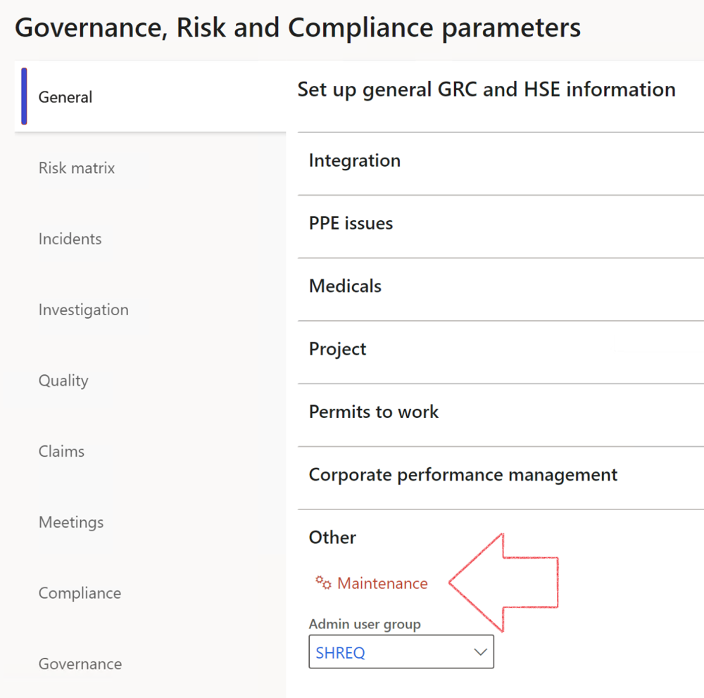

|  |  |
| --- | --- |
|  | The **Maintenance** button is there for designated user. This button repairs any possible data issues. For a full history of all Data related repairs; see table below: |

The information contained in this document represents the current view of Axnosis and Microsoft Corporation on the issues discussed as of the date of publication. Because Axnosis and Microsoft must respond to changing market conditions, this document should not be interpreted to be a commitment on the part of Axnosis and Microsoft, and Axnosis and Microsoft cannot guarantee the accuracy of any information presented after the date of publication.

This test script is for informational purposes only. AXNOSIS AND MICROSOFT MAKE NO WARRANTIES, EXPRESS, IMPLIED, OR STATUTORY, AS TO THE INFORMATION IN THIS DOCUMENT.

Complying with all applicable copyright laws is the responsibility of the user. Without limiting the rights under copyright, no part of this document may be reproduced, stored in or introduced into a retrieval system, or transmitted in any form or by any means (electronic, mechanical, photocopying, recording, or otherwise), or for any purpose, without the express written permission of Axnosis and Microsoft Corporation.

Axnosis and Microsoft may have patents, patent applications, trademarks, copyrights, or other intellectual property rights covering subject matter in this document. Except as expressly provided in any written license agreement from Axnosis and Microsoft, the furnishing of this document does not give you any license to these patents, trademarks, copyrights, or other intellectual property.

© 2021 Microsoft Corporation. All rights reserved. Any use or distribution of these materials without express authorization of Microsoft Corp. is strictly prohibited.

Microsoft and Windows are both registered trademarks of Microsoft Corporation in the United States and/or other countries.

The names of actual companies and products mentioned herein may be the trademarks of their respective owners.

|  |  |  |
| --- | --- | --- |
| **Process** | **Description/notes** | **Release** |
| Fix location vs. work centres | Populate the new **LocationRecID** field with the related location associated with previously used work centre location (Location) fields on the following tables:   * OHSHazardLocations, * OHSRiskHazard, * OHSRiskHazardWizard, * OHSRiskRegister, * OHSRisksWizard, * OHSSafetyLocations, * OHSSafetyPermit, * OHSSafetyPermitLocations * OHSSafetyPermitOverlap, * OHSSafetyPlan, * OHSInvestigation | 10.0.80.10 |
| Fix risk hazards | Assigning the value "Default Risk" to the new mandatory field **RiskID** (Key field) where empty | 10.0.80.10 |
| Fix incident HRM injury link | Delete all orphaned records from the **OHSIncidentHRMInjuryLnk** table | 10.0.11785.3 |
| Populate SRS analysis enums | Still in concept phase. To provide a link between enum numerical value and value name for use with BYOD data entities. Enums available:   * OHSIncidentType, * OHSIncidentSeverityType.   Table populated: **SRSAnalysisEnums** | 10.0.11785.3 |
| Fix budget transaction lines stock\item dimension | Set **OHSInventDimId** field value to "**AllBlank**" on table **BudgetTransactionLine**, where no value was recorded. This will solve the issue of records not displaying in the form.  **Note: this step will only fix existing budget transaction records in the system. Should any new transactions be uploaded or changed via the data entity Budget Account Entries, special care needs to be taken to specify the Stock dimension = AllBlank and the Item on the excel sheet to import.** | 10.1.1366.6 |
| Update existing incidents with the new **Incident types** | Update existing incidents with the **Incident types** that are setup on the new **Incident type** setup form. (IncidentTypeRecId) | 10.17.1250.5 |
| Update existing risks with the new **Control types** | Update existing risks with the **Control types** that are setup on the new **Control type** setup form. | 10.17.1250.6 |
| Re-number GRC Question and Answer **Group lines** | Re-number GRC Question and Answer **Group line numbers** | 10.22.1561.3 |
| Fix Inspection locations: Replace Work centre-based locations with HSE locations | Populate the new **ObjectLocation** field with the related HSE location associated with previously used work centre location (**Location**) field on the following tables:   * OHSInspectionJournalName * OHSInspectionJournalTable * OHSInspectionJournalTrans * OHSInspectionHistory * OHSSchedule | 10.24.1114.3 |
| **Process** | **Description/notes** | **Release** |
| Display of non-calculation lines | Run this job to ensure data consistency and correct display of historical data. |  |
| Fix Asset counter stock dimensions  Fix Line types on Data repository lines  Delete Orphan Data repositories | Replace empty stock dimension values with a blank dimension value  Populate missing line types from reporting templates on Data repository lines  Delete data repositories for which no template, year, site, period name or month was defined. | 10.26.1087.3  10.28.1080.6  10.30.2459.4 |
| Equivalent Functional location fields | The equivalent Functional location fields will be populated where an HSE Location exists on the permit to work pool header and linked Permit to work table. | 10.30.2459.12 |