

Dynamics GRC/HSE Release notes



Governance Risk & Compliance

Health, Safety & Environment

for

**Microsoft Dynamics 365 for Finance & Operations™**

*Dynamics GRC/HSE version* 10.34.2105.6

2025-10-03



|  |  |
| --- | --- |
| Dynamics 365 FO GRC module GRC is an add-on for Dynamics 365 suite of business application software.  This software provides compelling functionality to support Governance, Risk management and Compliance. |  |
| Dynamics 365 FO HSE/OHS OHS/HSE is an add-on for Dynamics 365 suite of business application software.  This software adds to GRC in that compliance is now deeper with explicit functionality for Health, Safety and Environment as per the depicted sub-modules below. | |
|  | |

Release version

**GRC/HSE Package version:** OHSDeployablePackage_10_34_2105_6

This package was created on Microsoft Dynamics 365 for Finance and Operations:

|  |  |  |
| --- | --- | --- |
| **Release** | **Version** | **Build number** |
| Application release | 10.0.43 | 10.34.2105 |
| Platform release | Platform update 67 | 7.0.7521.60 |

# Enhancements:

|  |  |
| --- | --- |
| Module | Description |
| Business continuity | * On the (BC/DR) **Continuity and disaster recovery** header, under the **Target** Fast tab the following Index tabs were added:   + **Equipment recovery**   + **Vital records** * The **Department** selected on the **BC/DR header** is now displayed on the **Lines** under the **Continuity and disaster recovery header** Fast tab. * On the **BC/DR lines**, under the **Line details** Fast tab, **Recovery strategy** Index tab, a **Loss type** column was added to the grid. * On the **Operating unit**:   + The label of the **Vital documents** Fast tab was changed to **Vital records**.   + The **Name** and **Description** fields under the **Vital documents** Fast tab were lengthened to accommodate more characters. * A **Business processes** lookup was added on the **Recovery strategy header**, * On the **Business continuity workspace**:   + The resolution of the graphs and grids on the workspace, was conformed so that information could be displayed clearly.   + The **RTO by department** label was changed to **Single point of failure**   + Another Index tab was added with label **3rd party** * A new **Recovery strategies** SSRS report was created and can be printed from the new menu item under **GRC, Business continuity, Reports and Inquiries, Recovery strategy by department**. * A new **Threat** column was added to the **Loss type** setup form. |
| Enterprise risk management | * Additional **privileges** were added to the **Risk administrator** and **Risk manager** **security rolls**. * On the **Approved group risks** list page, a new **Reinstate as group** button was added in the Action pane. When a **Group risk** was removed from the group and needs to be **reinstated**, this button can be used. * The **EntAssetMaintenanceWorkOrderLineV2Entity** (Data entity) was extended with the following fields that were added to the **Workorder lines**:   + **Safety Permit Id**   + **Safety Plan Id**   + **Risk register Id**   + **Safety permit Pool Id**   + **Vendor Account** |

|  |  |
| --- | --- |
| Module | Description |
| Management of change | * A new column has been added to the **Scope of change (lines)** Fast tab on the **Change request** form, labelled **Unit price**. Users now have the option to add a unit price for quantity-only change type lines. This will ensure that new purchase agreements created from the change request will have a valid line amount for quantity-only changes. * On the **Change request**, **Changes to** Fast tab, under the **Purchase orders** field group: The value that was being displayed in the **Initial purchase order** amount field, was changed to display the **Subtotal amount** instead of the **Total amount**. |
| Tender management | * On the **Attachments** form, under the **General** Fast tab, the **Attachment certification type** lookup is visible for all members in **Technical teams**, as well as **external vendor collaboration** users. * The following changes were made to the **RFQ statuses**: * **Approved** was renamed to **Recommend** * The code behind the current **Closed** status was moved to the **Rejected** status * **Closed** was renamed to **Completed** * On the RFQ, on the **Recommendation** dialog:   + The default of the **Recommend** slider was changed to **Yes**   + The following fields are now mandatory:     - Recommended by     - Seconded by     - Vendor   + When **OK** is clicked, the Status of the RFQ changed to **Recommended**. |
| Contract management | * On the **Contract classification** setup form:   + The following fields were moved to below the grid:     - **Email template, Email batch template**     - **Notification batch template, Notification %**     - **Vendor termination batch, User group batch**   + **Help text** was added to the above fields   + A **Goal group** lookup was added to the grid. |

# Bug fixes:

|  |  |
| --- | --- |
| Module | Description |
| Enterprise risk management | When a **Risk line** was submitted to workflow and the **Cancel** button clicked, a notification came up informing the user that the line was indeed submitted to workflow.  The issue has been resolved. |
| Business continuity | On the **BCM workspace**, under the **Business processes** Index tab, the values displayed in the **# of processes** and **# of assessments** columns were not being calculated correctly.  The issue has been resolved. |

Release Data impact

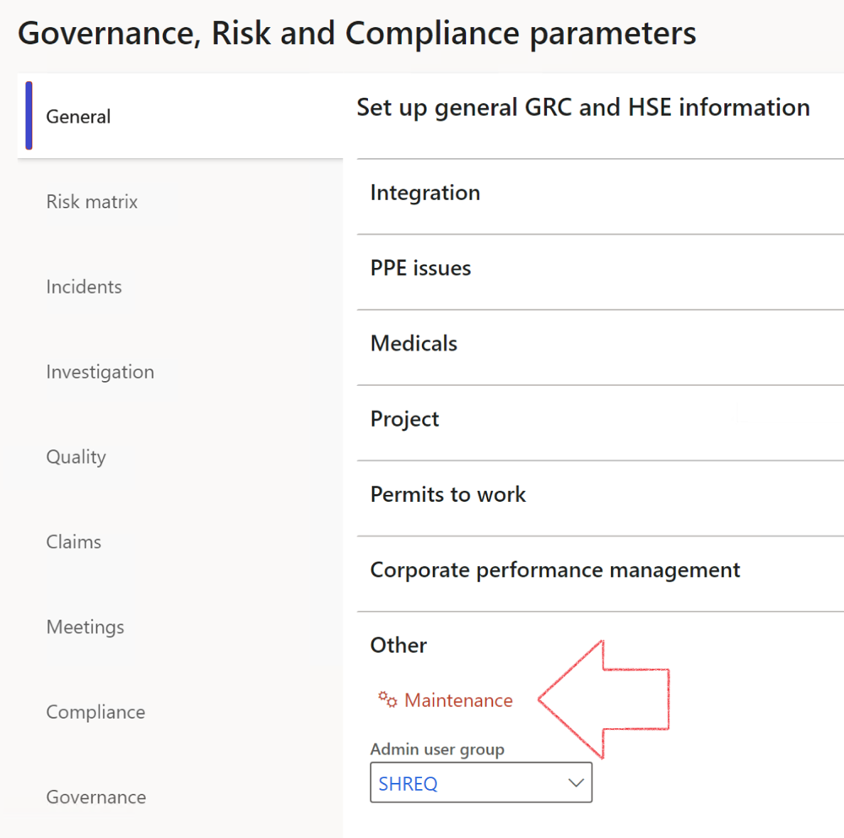

|  |  |
| --- | --- |
|  | The **Maintenance** button is there for designated user. This button repairs any possible data issues. For a full history of all Data related repairs; see table below: |

The information contained in this document represents the current view of Axnosis and Microsoft Corporation on the issues discussed as of the date of publication. Because Axnosis and Microsoft must respond to changing market conditions, this document should not be interpreted to be a commitment on the part of Axnosis and Microsoft, and Axnosis and Microsoft cannot guarantee the accuracy of any information presented after the date of publication.

This test script is for informational purposes only. AXNOSIS AND MICROSOFT MAKE NO WARRANTIES, EXPRESS, IMPLIED, OR STATUTORY, AS TO THE INFORMATION IN THIS DOCUMENT.

Complying with all applicable copyright laws is the responsibility of the user. Without limiting the rights under copyright, no part of this document may be reproduced, stored in or introduced into a retrieval system, or transmitted in any form or by any means (electronic, mechanical, photocopying, recording, or otherwise), or for any purpose, without the express written permission of Axnosis and Microsoft Corporation.

Axnosis and Microsoft may have patents, patent applications, trademarks, copyrights, or other intellectual property rights covering subject matter in this document. Except as expressly provided in any written license agreement from Axnosis and Microsoft, the furnishing of this document does not give you any license to these patents, trademarks, copyrights, or other intellectual property.

© 2021 Microsoft Corporation. All rights reserved. Any use or distribution of these materials without express authorization of Microsoft Corp. is strictly prohibited.

Microsoft and Windows are both registered trademarks of Microsoft Corporation in the United States and/or other countries.

The names of actual companies and products mentioned herein may be the trademarks of their respective owners.

|  |  |  |
| --- | --- | --- |
| **Process** | **Description/notes** | **Release** |
| Fix location vs. work centres | Populate the new **LocationRecID** field with the related location associated with previously used work centre location (Location) fields on the following tables:   * OHSHazardLocations, * OHSRiskHazard, * OHSRiskHazardWizard, * OHSRiskRegister, * OHSRisksWizard, * OHSSafetyLocations, * OHSSafetyPermit, * OHSSafetyPermitLocations * OHSSafetyPermitOverlap, * OHSSafetyPlan, * OHSInvestigation | 10.0.80.10 |
| Fix risk hazards | Assigning the value "Default Risk" to the new mandatory field **RiskID** (Key field) where empty | 10.0.80.10 |
| Fix incident HRM injury link | Delete all orphaned records from the **OHSIncidentHRMInjuryLnk** table | 10.0.11785.3 |
| Populate SRS analysis enums | Still in concept phase. To provide a link between enum numerical value and value name for use with BYOD data entities. Enums available:   * OHSIncidentType, * OHSIncidentSeverityType.   Table populated: **SRSAnalysisEnums** | 10.0.11785.3 |
| Fix budget transaction lines stock\item dimension | Set **OHSInventDimId** field value to "**AllBlank**" on table **BudgetTransactionLine**, where no value was recorded. This will solve the issue of records not displaying in the form.  **Note: this step will only fix existing budget transaction records in the system. Should any new transactions be uploaded or changed via the data entity Budget Account Entries, special care needs to be taken to specify the Stock dimension = AllBlank and the Item on the excel sheet to import.** | 10.1.1366.6 |
| Update existing incidents with the new **Incident types** | Update existing incidents with the **Incident types** that are setup on the new **Incident type** setup form. (IncidentTypeRecId) | 10.17.1250.5 |
| Update existing risks with the new **Control types** | Update existing risks with the **Control types** that are setup on the new **Control type** setup form. | 10.17.1250.6 |
| Re-number GRC Question and Answer **Group lines** | Re-number GRC Question and Answer **Group line numbers** | 10.22.1561.3 |
| Fix Inspection locations: Replace Work centre-based locations with HSE locations | Populate the new **ObjectLocation** field with the related HSE location associated with previously used work centre location (**Location**) field on the following tables:   * OHSInspectionJournalName * OHSInspectionJournalTable * OHSInspectionJournalTrans * OHSInspectionHistory * OHSSchedule | 10.24.1114.3 |
| **Process** | **Description/notes** | **Release** |
| Display of non-calculation lines | Run this job to ensure data consistency and correct display of historical data. |  |
| Fix Asset counter stock dimensions  Fix Line types on Data repository lines  Delete Orphan Data repositories | Replace empty stock dimension values with a blank dimension value  Populate missing line types from reporting templates on Data repository lines  Delete data repositories for which no template, year, site, period name or month was defined. | 10.26.1087.3  10.28.1080.6  10.30.2459.4 |
| Equivalent Functional location fields | The equivalent Functional location fields will be populated where an HSE Location exists on the permit to work pool header and linked Permit to work table. | 10.30.2459.12 |