

Dynamics GRC/HSE Release notes



Governance Risk & Compliance

Health, Safety & Environment

for

**Microsoft Dynamics 365 for Finance & Operations™**

*Dynamics GRC/HSE version* 10.34.2105.4

2025-09-23



|  |  |
| --- | --- |
| Dynamics 365 FO GRC module GRC is an add-on for Dynamics 365 suite of business application software.  This software provides compelling functionality to support Governance, Risk management and Compliance. |  |
| Dynamics 365 FO HSE/OHS OHS/HSE is an add-on for Dynamics 365 suite of business application software.  This software adds to GRC in that compliance is now deeper with explicit functionality for Health, Safety and Environment as per the depicted sub-modules below. | |
|  | |

Release version

**GRC/HSE Package version:** OHSDeployablePackage_10_34_2105_4

This package was created on Microsoft Dynamics 365 for Finance and Operations:

|  |  |  |
| --- | --- | --- |
| **Release** | **Version** | **Build number** |
| Application release | 10.0.43 | 10.34.2105 |
| Platform release | Platform update 67 | 7.0.7521.60 |

# Enhancements:

|  |  |
| --- | --- |
| Module | Description |
| Business continuity management | * On the **Continuity and disaster recovery** form   + The **RTO classification** field was renamed to **RTO**.   + The current **RTO** free text field is now hidden. * On the **Impact assessment; downtime report**, the **RTO** column now points to the new **RTO** enum field which was added to the **Business impact assessment form.** * The abovementioned **RTO** enum field was also added on the **Software applications** setup form. * On the **Vendor**: a new **Critical 3rd party** button was added under the **Vendor profile** Fast tab. This button opens a **3rd party BCM** dialog where the user can indicate the Vendor’s **3rd party dependency** details. * The Microsoft **Operating unit** menu item (under Organisation administration) was copied to **GRC, Business continuity, Setup for business continuity**. * The following Fast tabs were added to the **Operating unit**:   + **Continuity equipment**   + **Vital documents** |
| Enterprise risk management | * When the **Risk line status = Approved**, the following fields are editable under the **Review and follow up** Fast tab, **Risk actions** Index tab:   + **Enable for review slider, Review frequency**   + **Review instruction, To be reviewed by** * On the **Control status and effectiveness** setup form, **Control status** tab, a new **Default status when risk closes** column was added: Only **one default control status** can be selected. |
| Operational risk management  &  Environmental risk management | * On the risk register **lines**, under the **Mitigation** Fast tab:   + In the Button strip, a new button was added, Label = "**Show all**" or "**Hide**".     - When the **Show all** button is clicked, the**DIME**and**DIME score** columns are visible in the grid.     - When the **Hide** button is clicked, the **DIME**and**DIME score** columns are hidden in the grid.   + The following fields were moved to below the grid:     - **Action by, Action due date**     - **Closed date, Activity number** * Help text was added to all the DIME fields for all risk classes. |

|  |  |
| --- | --- |
| Module | Description |
| Management of change | * The **EngChgEngineeringChangeRequestHeaderEntity** Data entity was extended with the required fields. * A new Data entity was created for the Scope of change lines: **OHSEngChgScopeOfChangeEntity** (Public name:**OHSEngChgScopeOfChanges**) |
| Document management | The current *OHSPolicyTable* workflows were split into the various document types listed in the **Document type** enum:   * Agenda, Contract, Minutes * Policy, Report, Resolutions * Specifications, Other |
| Contracts management | Under GRC, Governance, **Periodic**, a new **Auto expiry of contract and other documents** was added. This opens a batch job that users can schedule to run in the background, to compare the **system date** with **Document date**. |
| Corporate performance management | On the **Supplier performance management** report:   * The **Evaluation date** column is now hidden, as this is already printed in the header of the report. * The **Goal templates** row/line was made wider to accommodate longer headings. |
| Investigations | * The functions of the buttons in the Action pane of the **Investigation** form are now enabled/disabled depending on the **status** of the Investigation:   + For statuses **Created**, **Reported**, **Re-investigate**, all buttons will be enabled.   + For **Closed**, only the following buttons will be enabled: Status (with only Re-investigate as an option), **Print**, **Send email notification** and **Documents**. * The “**right**” to create **new Investigations** was added to the **Investigation Admin** and **Controller** security rolls. |
| Incidents | The following **privileges** were added to the Incident Administration duty which belongs to the Incident Administrator role:   * The **Go to incident** button on the All reported incidents list page. * The **Create investigation** button on the Incident. |
| General | Two new menu items were added to the **Microsoft Help** dropdown list:   * **Suggestions**: Opens the Axnosis suggestions/ideas website (for future use) * **Wiki**: Opens the **Axnosis Wiki pages** |

# Bug fixes:

|  |  |
| --- | --- |
| Module | Description |
| Tender management | For **Line level negotiations**: The **Negotiation status** on the RFQ was only updating to **Response received** for one line that was negotiated on, not for all negotiated lines.  The issue has been resolved. |
| Investigations | The relationship between an **Incident** and the **Investigation** created from the Incident was broken due to the new **Create investigation** form that was added earlier.  The issue has been resolved. |
| General | There was an issue on the Vendor certifications entity (OHSVendCertificationEntity):  The **Value added vendor** field was missing, and the **Comments** field was not updating D365 after the import.  The issue has been resolved. |

Release Data impact

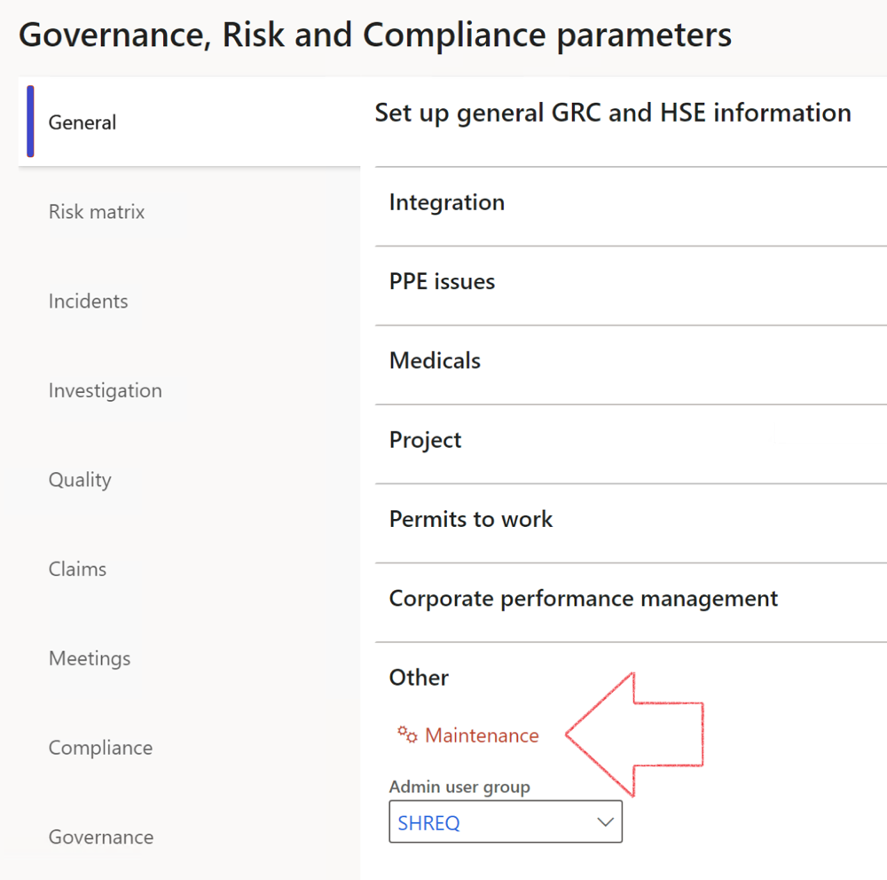

|  |  |
| --- | --- |
|  | The **Maintenance** button is there for designated user. This button repairs any possible data issues. For a full history of all Data related repairs; see table below: |

The information contained in this document represents the current view of Axnosis and Microsoft Corporation on the issues discussed as of the date of publication. Because Axnosis and Microsoft must respond to changing market conditions, this document should not be interpreted to be a commitment on the part of Axnosis and Microsoft, and Axnosis and Microsoft cannot guarantee the accuracy of any information presented after the date of publication.

This test script is for informational purposes only. AXNOSIS AND MICROSOFT MAKE NO WARRANTIES, EXPRESS, IMPLIED, OR STATUTORY, AS TO THE INFORMATION IN THIS DOCUMENT.

Complying with all applicable copyright laws is the responsibility of the user. Without limiting the rights under copyright, no part of this document may be reproduced, stored in or introduced into a retrieval system, or transmitted in any form or by any means (electronic, mechanical, photocopying, recording, or otherwise), or for any purpose, without the express written permission of Axnosis and Microsoft Corporation.

Axnosis and Microsoft may have patents, patent applications, trademarks, copyrights, or other intellectual property rights covering subject matter in this document. Except as expressly provided in any written license agreement from Axnosis and Microsoft, the furnishing of this document does not give you any license to these patents, trademarks, copyrights, or other intellectual property.

© 2021 Microsoft Corporation. All rights reserved. Any use or distribution of these materials without express authorization of Microsoft Corp. is strictly prohibited.

Microsoft and Windows are both registered trademarks of Microsoft Corporation in the United States and/or other countries.

The names of actual companies and products mentioned herein may be the trademarks of their respective owners.

|  |  |  |
| --- | --- | --- |
| **Process** | **Description/notes** | **Release** |
| Fix location vs. work centres | Populate the new **LocationRecID** field with the related location associated with previously used work centre location (Location) fields on the following tables:   * OHSHazardLocations, * OHSRiskHazard, * OHSRiskHazardWizard, * OHSRiskRegister, * OHSRisksWizard, * OHSSafetyLocations, * OHSSafetyPermit, * OHSSafetyPermitLocations * OHSSafetyPermitOverlap, * OHSSafetyPlan, * OHSInvestigation | 10.0.80.10 |
| Fix risk hazards | Assigning the value "Default Risk" to the new mandatory field **RiskID** (Key field) where empty | 10.0.80.10 |
| Fix incident HRM injury link | Delete all orphaned records from the **OHSIncidentHRMInjuryLnk** table | 10.0.11785.3 |
| Populate SRS analysis enums | Still in concept phase. To provide a link between enum numerical value and value name for use with BYOD data entities. Enums available:   * OHSIncidentType, * OHSIncidentSeverityType.   Table populated: **SRSAnalysisEnums** | 10.0.11785.3 |
| Fix budget transaction lines stock\item dimension | Set **OHSInventDimId** field value to "**AllBlank**" on table **BudgetTransactionLine**, where no value was recorded. This will solve the issue of records not displaying in the form.  **Note: this step will only fix existing budget transaction records in the system. Should any new transactions be uploaded or changed via the data entity Budget Account Entries, special care needs to be taken to specify the Stock dimension = AllBlank and the Item on the excel sheet to import.** | 10.1.1366.6 |
| Update existing incidents with the new **Incident types** | Update existing incidents with the **Incident types** that are setup on the new **Incident type** setup form. (IncidentTypeRecId) | 10.17.1250.5 |
| Update existing risks with the new **Control types** | Update existing risks with the **Control types** that are setup on the new **Control type** setup form. | 10.17.1250.6 |
| Re-number GRC Question and Answer **Group lines** | Re-number GRC Question and Answer **Group line numbers** | 10.22.1561.3 |
| Fix Inspection locations: Replace Work centre-based locations with HSE locations | Populate the new **ObjectLocation** field with the related HSE location associated with previously used work centre location (**Location**) field on the following tables:   * OHSInspectionJournalName * OHSInspectionJournalTable * OHSInspectionJournalTrans * OHSInspectionHistory * OHSSchedule | 10.24.1114.3 |
| **Process** | **Description/notes** | **Release** |
| Display of non-calculation lines | Run this job to ensure data consistency and correct display of historical data. |  |
| Fix Asset counter stock dimensions  Fix Line types on Data repository lines  Delete Orphan Data repositories | Replace empty stock dimension values with a blank dimension value  Populate missing line types from reporting templates on Data repository lines  Delete data repositories for which no template, year, site, period name or month was defined. | 10.26.1087.3  10.28.1080.6  10.30.2459.4 |
| Equivalent Functional location fields | The equivalent Functional location fields will be populated where an HSE Location exists on the permit to work pool header and linked Permit to work table. | 10.30.2459.12 |