

Dynamics GRC/HSE Release notes



Governance Risk & Compliance

Health, Safety & Environment

for

**Microsoft Dynamics 365 for Finance & Operations™**

*Dynamics GRC/HSE version* 10.34.2105.3

2025-09-16



|  |  |
| --- | --- |
| Dynamics 365 FO GRC module GRC is an add-on for Dynamics 365 suite of business application software.  This software provides compelling functionality to support Governance, Risk management and Compliance. |  |
| Dynamics 365 FO HSE/OHS OHS/HSE is an add-on for Dynamics 365 suite of business application software.  This software adds to GRC in that compliance is now deeper with explicit functionality for Health, Safety and Environment as per the depicted sub-modules below. | |
|  | |

Release version

**GRC/HSE Package version:** OHSDeployablePackage_10_34_2105_3

This package was created on Microsoft Dynamics 365 for Finance and Operations:

|  |  |  |
| --- | --- | --- |
| **Release** | **Version** | **Build number** |
| Application release | 10.0.43 | 10.34.2105 |
| Platform release | Platform update 67 | 7.0.7521.60 |

# Enhancements:

|  |  |
| --- | --- |
| Module | Description |
| Contract management | * On the **Contract**: The **Closed** stage was relabelled to **Expired.** * On the **Contract**, Content Fast tab, Statement of final account Index tab, the **Sofa status** dropdown list now becomes available when the contract **status = Approved**. * When the **Sofa** status is changed to **In progress**, a record is created under the Sign off Fast tab. |
| Management of change | * To keep the **Purchase agreement** and linked **Contract** in sync: the **Expiration date** on the **Purchase agreement** will be updated when the **Expiration date** on the **Contract** is updated. * **Assets** and **Projects** have been added to the filter criteria on the **GRC Change request** list page. |
| Vendor portal | * On the **Create invoice** dialog that opens from the Vendor collaboration, **Invoicing** workspace, all fields referring to the contract values, are now hidden. * The error that was stopping vendors from creating an **Invoice** above the remaining contract value, was removed. |
| Enterprise risk management | * On the **Risk line**, under the **General** Fast tab, Identification Index tab, the **Risk owner** field is now blank and editable after consolidation. * On the Risk register header, in the Action pane, Function button group: The **Reset lines** button was renamed to **Reset line statuses**. **Help text** was also added for this button. |
| Business continuity | * On the **BC/DR plan**:   + When the **Department** field is modified, the **Employee accountable** field is populated with the selected Department manager’s name. Previously the **Employee responsible** field was populated. This does not happen anymore.   + **Review actions** can now also be done when the **BC/DR plan status = Approved**. * **Approval** email notifications are now sent to the **employee accountable** when the status of the BC/DR plan is changed to **Submitted**. * The email template parameter was added on the GRC parameters, **Notifications** Tab, under the **Email templates for batch use (and where due dated apply)** Fast tab. |
| Safety | The “look” of the **Confined space** and **Asbestos registers** (reports) were changed to conform with our other reports. |

|  |  |
| --- | --- |
| Module | Description |
| General | The Legal entity column and Legal entity filter have been removed from the Approval authority form. |

# Bug fixes:

|  |  |
| --- | --- |
| Module | Description |
| Enterprise risk management | * After consolidation:   + The **Quantifiable** risk was not displaying the summation of the **MFL values**.   + The **Residual cost** was 0. * An **error** came up when risk lines were manually approved before consolidation.   These issues have been resolved. |
| Tender management | When a **RFQ** was created from a Purchase requisition/Procurement plan or stand alone, the **currency** defined on the **Solicitation type** was not pulled through to the RFQ.  The issue has been resolved. |
| Management of change | The **Approval authority** financial dimension configurations were ignored when derived dimensions were blanked out. |
| Business continuity | On the BC/DR plan, the “jump references” for the following fields were not working:   * Business process. * Business impact assessment. |
| Corporate performance management | On the **Budget register entry**:   * Under the **Budget account entries** Fast tab, the **Amount** field was renamed to **M1 amount.** * When, from the line view, a new line record is created for a new month, and the record is then rolled up to the bucket view, the various months did not roll up to a single line record, with the various month values in the applicable fields.   The issue has been resolved. |

Release Data impact

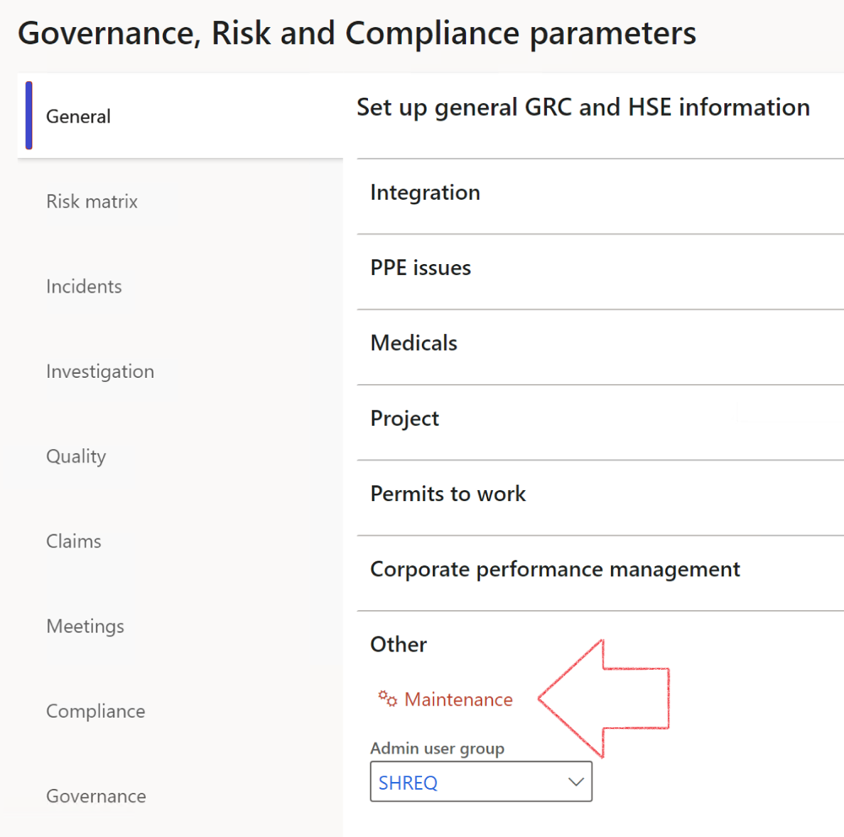

|  |  |
| --- | --- |
|  | The **Maintenance** button is there for designated user. This button repairs any possible data issues. For a full history of all Data related repairs; see table below: |

The information contained in this document represents the current view of Axnosis and Microsoft Corporation on the issues discussed as of the date of publication. Because Axnosis and Microsoft must respond to changing market conditions, this document should not be interpreted to be a commitment on the part of Axnosis and Microsoft, and Axnosis and Microsoft cannot guarantee the accuracy of any information presented after the date of publication.

This test script is for informational purposes only. AXNOSIS AND MICROSOFT MAKE NO WARRANTIES, EXPRESS, IMPLIED, OR STATUTORY, AS TO THE INFORMATION IN THIS DOCUMENT.

Complying with all applicable copyright laws is the responsibility of the user. Without limiting the rights under copyright, no part of this document may be reproduced, stored in or introduced into a retrieval system, or transmitted in any form or by any means (electronic, mechanical, photocopying, recording, or otherwise), or for any purpose, without the express written permission of Axnosis and Microsoft Corporation.

Axnosis and Microsoft may have patents, patent applications, trademarks, copyrights, or other intellectual property rights covering subject matter in this document. Except as expressly provided in any written license agreement from Axnosis and Microsoft, the furnishing of this document does not give you any license to these patents, trademarks, copyrights, or other intellectual property.

© 2021 Microsoft Corporation. All rights reserved. Any use or distribution of these materials without express authorization of Microsoft Corp. is strictly prohibited.

Microsoft and Windows are both registered trademarks of Microsoft Corporation in the United States and/or other countries.

The names of actual companies and products mentioned herein may be the trademarks of their respective owners.

|  |  |  |
| --- | --- | --- |
| **Process** | **Description/notes** | **Release** |
| Fix location vs. work centres | Populate the new **LocationRecID** field with the related location associated with previously used work centre location (Location) fields on the following tables:   * OHSHazardLocations, * OHSRiskHazard, * OHSRiskHazardWizard, * OHSRiskRegister, * OHSRisksWizard, * OHSSafetyLocations, * OHSSafetyPermit, * OHSSafetyPermitLocations * OHSSafetyPermitOverlap, * OHSSafetyPlan, * OHSInvestigation | 10.0.80.10 |
| Fix risk hazards | Assigning the value "Default Risk" to the new mandatory field **RiskID** (Key field) where empty | 10.0.80.10 |
| Fix incident HRM injury link | Delete all orphaned records from the **OHSIncidentHRMInjuryLnk** table | 10.0.11785.3 |
| Populate SRS analysis enums | Still in concept phase. To provide a link between enum numerical value and value name for use with BYOD data entities. Enums available:   * OHSIncidentType, * OHSIncidentSeverityType.   Table populated: **SRSAnalysisEnums** | 10.0.11785.3 |
| Fix budget transaction lines stock\item dimension | Set **OHSInventDimId** field value to "**AllBlank**" on table **BudgetTransactionLine**, where no value was recorded. This will solve the issue of records not displaying in the form.  **Note: this step will only fix existing budget transaction records in the system. Should any new transactions be uploaded or changed via the data entity Budget Account Entries, special care needs to be taken to specify the Stock dimension = AllBlank and the Item on the excel sheet to import.** | 10.1.1366.6 |
| Update existing incidents with the new **Incident types** | Update existing incidents with the **Incident types** that are setup on the new **Incident type** setup form. (IncidentTypeRecId) | 10.17.1250.5 |
| Update existing risks with the new **Control types** | Update existing risks with the **Control types** that are setup on the new **Control type** setup form. | 10.17.1250.6 |
| Re-number GRC Question and Answer **Group lines** | Re-number GRC Question and Answer **Group line numbers** | 10.22.1561.3 |
| Fix Inspection locations: Replace Work centre-based locations with HSE locations | Populate the new **ObjectLocation** field with the related HSE location associated with previously used work centre location (**Location**) field on the following tables:   * OHSInspectionJournalName * OHSInspectionJournalTable * OHSInspectionJournalTrans * OHSInspectionHistory * OHSSchedule | 10.24.1114.3 |
| **Process** | **Description/notes** | **Release** |
| Display of non-calculation lines | Run this job to ensure data consistency and correct display of historical data. |  |
| Fix Asset counter stock dimensions  Fix Line types on Data repository lines  Delete Orphan Data repositories | Replace empty stock dimension values with a blank dimension value  Populate missing line types from reporting templates on Data repository lines  Delete data repositories for which no template, year, site, period name or month was defined. | 10.26.1087.3  10.28.1080.6  10.30.2459.4 |
| Equivalent Functional location fields | The equivalent Functional location fields will be populated where an HSE Location exists on the permit to work pool header and linked Permit to work table. | 10.30.2459.12 |