
Dynamics GRC/HSE Release notes



Governance Risk & Compliance
Health, Safety & Environment

for

Microsoft Dynamics 365 for Finance & Operations™

Dynamics GRC/HSE version 10.34.2105.26

2026-04-16



Dynamics 365 FO GRC module  GRC is an add-on for Dynamics 365 suite of business application software.  This software provides compelling functionality to support Governance, Risk management and Compliance. | 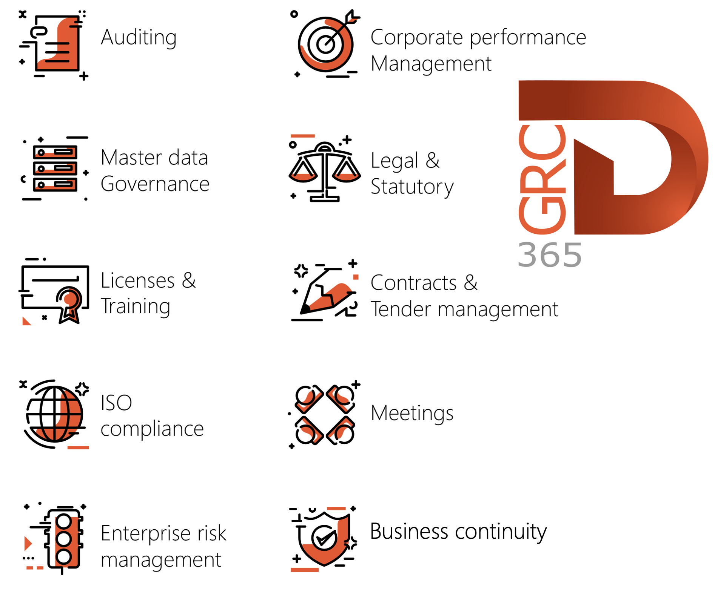

Dynamics 365 FO HSE/OHS

OHS/HSE is an add-on for Dynamics 365 suite of business application software.

This software adds to GRC in that compliance is now deeper with explicit functionality for Health, Safety and Environment as per the depicted sub-modules below.
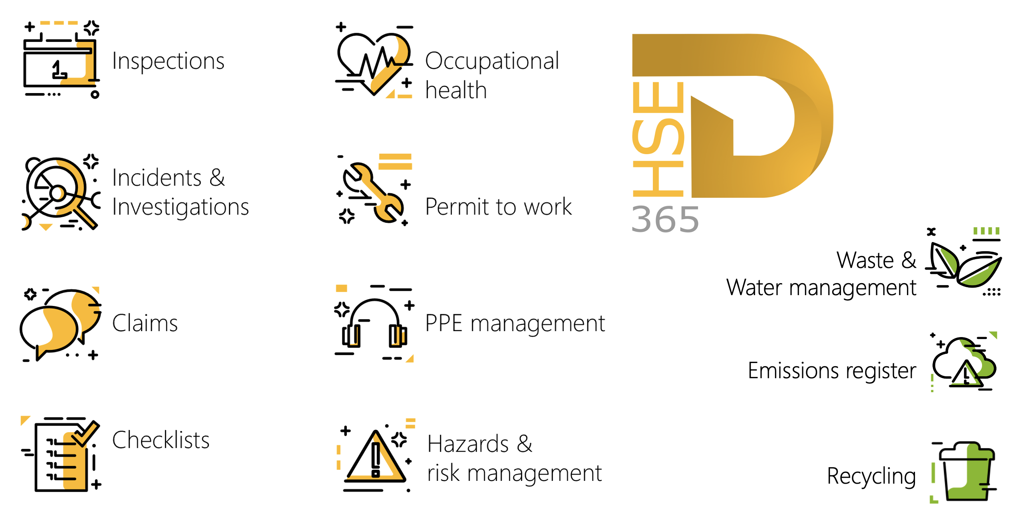

Release version

GRC/HSE Package version: OHSDeployablePackage_10_34_2105_26

This package was created on Microsoft Dynamics 365 for Finance and Operations:

Release | Version | Build number
Application release | 10.0.43 | 10.34.2105
Platform release | Platform update 67 | 7.0.7521.60

Enhancements:

Module | Description
Business continuity | - On the Operating unit, under the Process and functions Fast tab:  - Two new columns (display methods) were added to the back of the grid:  - Upstream dependency  - Downstream dependency  - A new Dependency button was added in the button strip.  - This new button opens a new Dependency form (dialog) where the user can add/remove upstream and downstream dependencies to the process on the Operating unit (Department).  - The system does a count of the upstream and downstream dependencies and displays the totals in the two new columns in the grid.  - On the BCDR plan header, Target Fast tab, Key contracts Index tab: a new free text column was added for Scope of work. (also added to the BCM wizard, Step 7)  - On the 3rd party per department report:  - The value entered in the new Scope of work field (added above) on the BCDR plan, is now displayed in the Scope of work column on the report.  - The value entered in the Description field on the BCDR plan header, Target Fast tab, Key contracts Index tab, is now displayed in the Description of services column on the report.  - On the BCDR plan, under the Target Fast tab, Business process Index tab: The help text for the SPOF column was changed to: Is the process dependent on a single employee?  - Four new columns were added on the BCDR plan, under the Target Fast tab, Equipment recovery Index tab:  - Alternative location  - Max value  - Currency  - Lead time

Module | Description
Management of change | - Financial dimensions can now be entered on each Change request line.  - A new Update financial dimensions button was added in the button strip of the Scope of change (lines) Fast tab.  - This new button opens a new Update scope of change financial dimensions form (dialog) where the user can select Financial dimensions for each line.  - Contract expiry date changes were previously applied to existing purchase agreement header expiry dates, linked to the primary vendor. The updated expiry date however, was not applied to the purchase agreement lines. This has now been fixed.
Contracts management | - When a Contract is marked as “to be reviewed”, a notification will be sent to the worker selected in the To be reviewed by field.  - There are enhancements on Projects creation form Contracts.  - On the Contract, under the Projects and pricing Fast tab, a new Create a group of projects button was added.  - When this new button is clicked, all SOW records in grid without a project link will be created into a project Hierarchy. The statement of work ID flagged as "main" will be the top project.
Tender management | - There is now only one slider on the Open envelope dialog for Downloading all Bid attachments.  - When this slider is set to Yes, the system will find all Header replies (technical responses), and all Line replies (commercial responses), and group them accordingly in zip files for downloading.  - GRC, Tender management, All RFQs, on the RFQ Header, under the Governance Fast tad, Committee Index tab: The Change team member button was added to the Tender manager security role.
Corporate performance management | On the Performance transactions inquiry:  - The Batch number column was moved to after the Item number column.  - A new Location column (lookup) was added after the Site column.
Permits to work | On the Permit to work, on the Request extension drop-dialog, the To be approved by field is now hidden.

Release Data impact

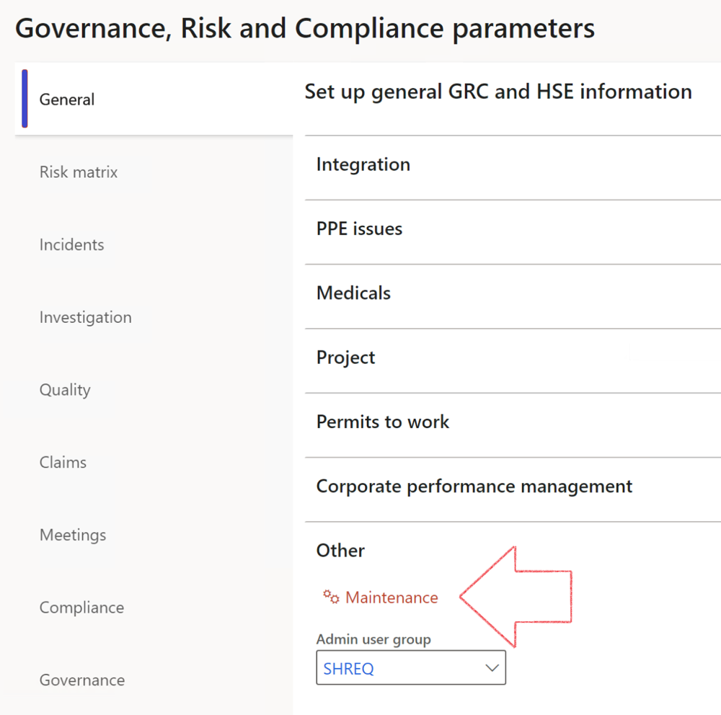

 | The Maintenance button is there for designated user. This button repairs any possible data issues. For a full history of all Data related repairs; see table below:

The information contained in this document represents the current view of Axnosis and Microsoft Corporation on the issues discussed as of the date of publication. Because Axnosis and Microsoft must respond to changing market conditions, this document should not be interpreted to be a commitment on the part of Axnosis and Microsoft, and Axnosis and Microsoft cannot guarantee the accuracy of any information presented after the date of publication.
This test script is for informational purposes only. AXNOSIS AND MICROSOFT MAKE NO WARRANTIES, EXPRESS, IMPLIED, OR STATUTORY, AS TO THE INFORMATION IN THIS DOCUMENT.
Complying with all applicable copyright laws is the responsibility of the user. Without limiting the rights under copyright, no part of this document may be reproduced, stored in or introduced into a retrieval system, or transmitted in any form or by any means (electronic, mechanical, photocopying, recording, or otherwise), or for any purpose, without the express written permission of Axnosis and Microsoft Corporation.
Axnosis and Microsoft may have patents, patent applications, trademarks, copyrights, or other intellectual property rights covering subject matter in this document. Except as expressly provided in any written license agreement from Axnosis and Microsoft, the furnishing of this document does not give you any license to these patents, trademarks, copyrights, or other intellectual property.
© 2021 Microsoft Corporation. All rights reserved. Any use or distribution of these materials without express authorization of Microsoft Corp. is strictly prohibited.
Microsoft and Windows are both registered trademarks of Microsoft Corporation in the United States and/or other countries.
The names of actual companies and products mentioned herein may be the trademarks of their respective owners.

Process | Description/notes | Release
Fix location vs. work centres | Populate the new LocationRecID field with the related location associated with previously used work centre location (Location) fields on the following tables:  - OHSHazardLocations,  - OHSRiskHazard,  - OHSRiskHazardWizard,  - OHSRiskRegister,  - OHSRisksWizard,  - OHSSafetyLocations,  - OHSSafetyPermit,  - OHSSafetyPermitLocations  - OHSSafetyPermitOverlap,  - OHSSafetyPlan,  - OHSInvestigation | 10.0.80.10
Fix risk hazards | Assigning the value "Default Risk" to the new mandatory field RiskID (Key field) where empty | 10.0.80.10
Fix incident HRM injury link | Delete all orphaned records from the OHSIncidentHRMInjuryLnk table | 10.0.11785.3
Populate SRS analysis enums | Still in concept phase. To provide a link between enum numerical value and value name for use with BYOD data entities. Enums available:  - OHSIncidentType,  - OHSIncidentSeverityType.  Table populated: SRSAnalysisEnums | 10.0.11785.3
Fix budget transaction lines stock\item dimension | Set OHSInventDimId field value to "AllBlank" on table BudgetTransactionLine, where no value was recorded. This will solve the issue of records not displaying in the form.  Note: this step will only fix existing budget transaction records in the system. Should any new transactions be uploaded or changed via the data entity Budget Account Entries, special care needs to be taken to specify the Stock dimension = AllBlank and the Item on the excel sheet to import. | 10.1.1366.6
Update existing incidents with the new Incident types | Update existing incidents with the Incident types that are setup on the new Incident type setup form. (IncidentTypeRecId) | 10.17.1250.5
Update existing risks with the new Control types | Update existing risks with the Control types that are setup on the new Control type setup form. | 10.17.1250.6
Re-number GRC Question and Answer Group lines | Re-number GRC Question and Answer Group line numbers. | 10.22.1561.3
Process | Description/notes | Release
Fix Inspection locations: Replace Work centre-based locations with HSE locations | Populate the new ObjectLocation field with the related HSE location associated with previously used work centre location (Location) field on the following tables:  - OHSInspectionJournalName  - OHSInspectionJournalTable  - OHSInspectionJournalTrans  - OHSInspectionHistory  - OHSSchedule | 10.24.1114.3
Display of non-calculation lines | Run this job to ensure data consistency and correct display of historical data.
Fix Asset counter stock dimensions  Fix Line types on Data repository lines  Delete Orphan Data repositories | Replace empty stock dimension values with a blank dimension value  Populate missing line types from reporting templates on Data repository lines  Delete data repositories for which no template, year, site, period name or month was defined. | 10.26.1087.3  10.28.1080.6  10.30.2459.4
Equivalent Functional location fields | The equivalent Functional location fields will be populated where an HSE Location exists on the permit to work pool header and linked Permit to worktable. | 10.30.2459.12
Notifications and interface parameters config | The current parameters table was split, and the notifications & interface fields were moved to a new table. To ensure continued use of these notifications, administrators MUST execute this script. In future releases the current fields will be deprecated.  This maintenance routine must be run in every legal entity. | 10.34.2105.25

