
Dynamics GRC/HSE Release notes



Governance Risk & Compliance
Health, Safety & Environment

for

Microsoft Dynamics 365 for Finance & Operations™

Dynamics GRC/HSE version 10.34.2105.22

2026-03-06



Dynamics 365 FO GRC module  GRC is an add-on for Dynamics 365 suite of business application software.  This software provides compelling functionality to support Governance, Risk management and Compliance. | 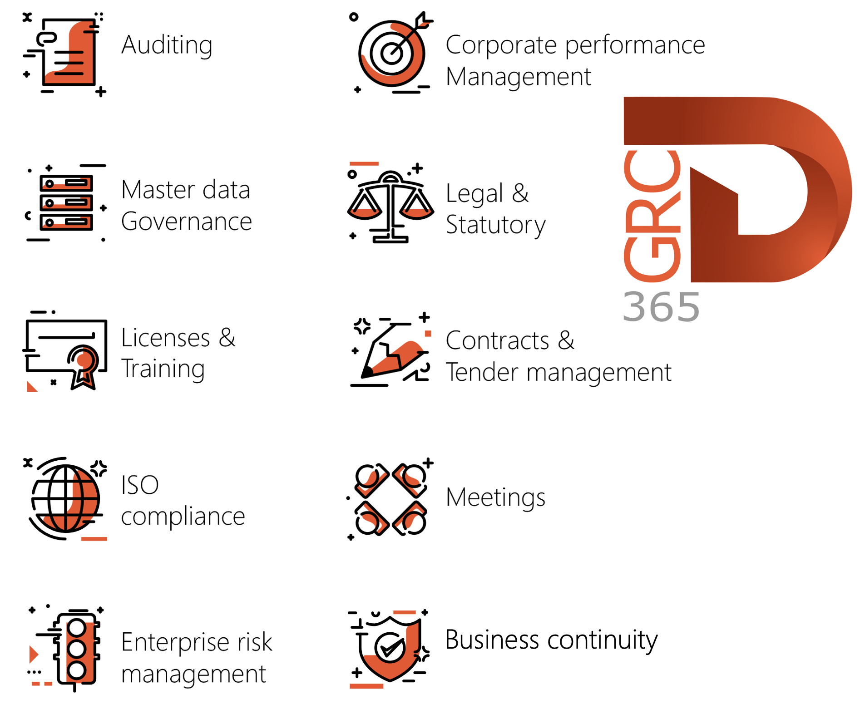

Dynamics 365 FO HSE/OHS

OHS/HSE is an add-on for Dynamics 365 suite of business application software.

This software adds to GRC in that compliance is now deeper with explicit functionality for Health, Safety and Environment as per the depicted sub-modules below.
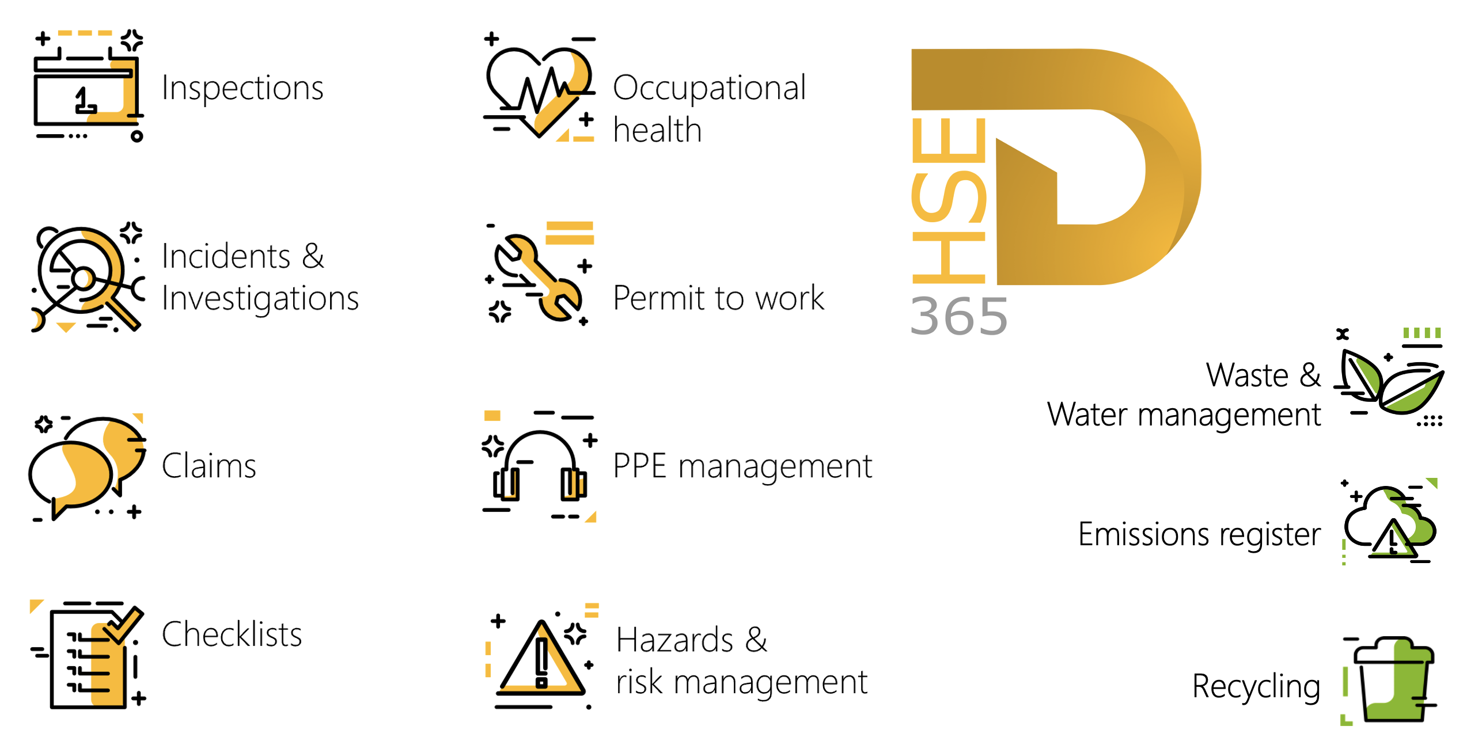

Release version

GRC/HSE Package version: OHSDeployablePackage_10_34_2105_22

This package was created on Microsoft Dynamics 365 for Finance and Operations:

Release | Version | Build number
Application release | 10.0.43 | 10.34.2105
Platform release | Platform update 67 | 7.0.7521.60

Enhancements:

Module | Description
Inspections | - Comments that were entered on the Inspection journal lines are now printed on the Inspection sheet report.  - The headings of the Inspection sheet report are now printed on every page.
Internal audit | The icon column on the Risk control matrix per audit file report was made narrower and the label removed so that the size of the icons display correctly.
Tender management | - When an RFQ with purchase type = Purchase agreement, is awarded, the last negotiated price now pulls through to the contract that is created.  - When an RFQ with purchase type = Purchase order is awarded, the last negotiated price from the header pulls through to the PO.  - On the Compare requests for quotation replies:  Instead of the Mark tick boxes, The Proposed winning bid tick boxes are now used to indicate what lines should be sent for a Negotiation request.
Contracts and Management of change | A new Total contract value (Including historical contract value) field was added on both the Contracts and the Change request forms. The value in this field is calculated by summing the Opening balance (Total contract value) and the Total historical amount utilised (Historical contract value), thereby providing a consolidated view of the full contract value including previously utilised historical amounts.
Contracts management | - A new Create contract button was added to the Action pane of the Release approved purchase requisitions form. This new button allows users to create a contract from selected purchase requisition (PR) lines.  - Users can multi-select eligible PR lines across one or more purchase requisitions and create a single contract for the selected lines. The system creates the contract header and contract lines and links each contract line back to its source PR line for traceability.  - On the GRC parameters, under the Governance tab, Contract governance Fast tab, a new Contract creation source field was added. The options in this new enum are: Purchase requisition, Release approved purchase requisitions or Both.

Bug fixes:

Module | Description
Inspections | When the Post button was clicked on an Inspect journal, and the user chose to cancel the posting, the journal was still posted.  The issue has been resolved.
Operational and sustainability reporting | There was an error when running OSR reports. The below was done to resolve the problem:  The Year field on the report dialogs was replaced with a Fiscal year field. Users can now select the actual Fiscal year. The below reports were updated with this change:  - Year to date report (Forecast)  - Year to date report  - Monthly report  - Quarterly report

Release Data impact

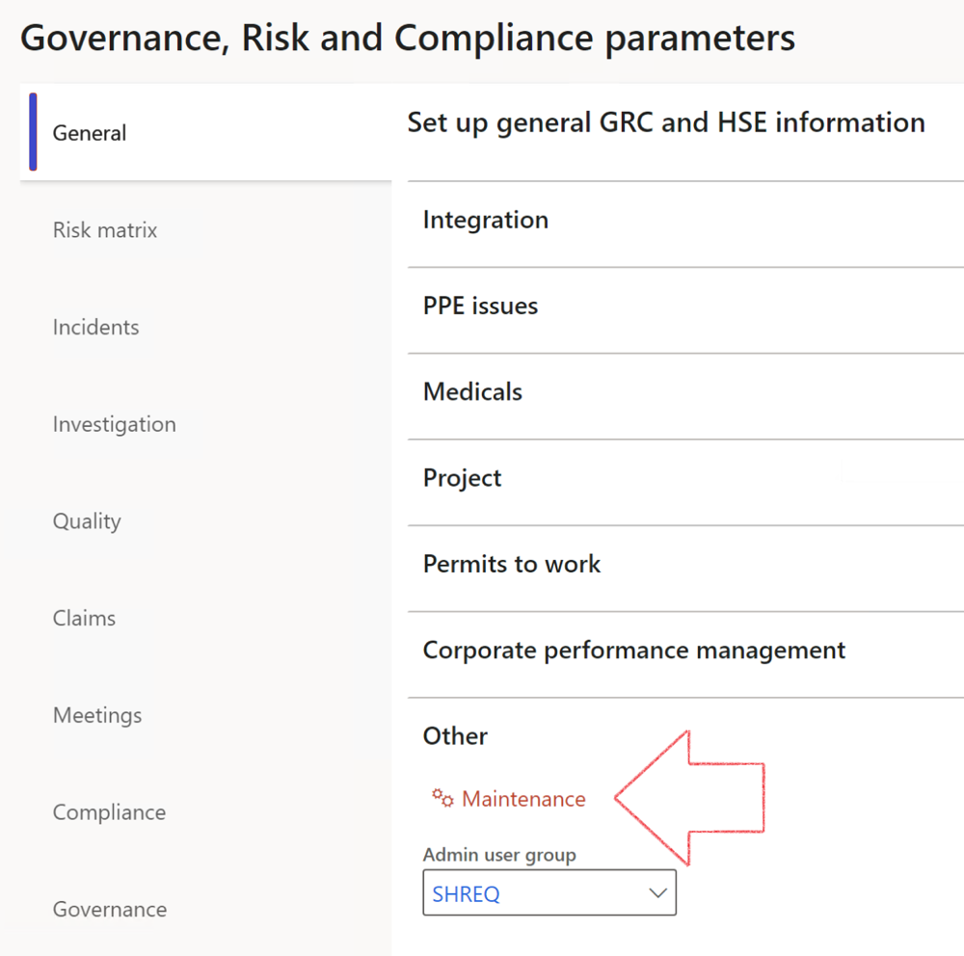

 | The Maintenance button is there for designated user. This button repairs any possible data issues. For a full history of all Data related repairs; see table below:

The information contained in this document represents the current view of Axnosis and Microsoft Corporation on the issues discussed as of the date of publication. Because Axnosis and Microsoft must respond to changing market conditions, this document should not be interpreted to be a commitment on the part of Axnosis and Microsoft, and Axnosis and Microsoft cannot guarantee the accuracy of any information presented after the date of publication.
This test script is for informational purposes only. AXNOSIS AND MICROSOFT MAKE NO WARRANTIES, EXPRESS, IMPLIED, OR STATUTORY, AS TO THE INFORMATION IN THIS DOCUMENT.
Complying with all applicable copyright laws is the responsibility of the user. Without limiting the rights under copyright, no part of this document may be reproduced, stored in or introduced into a retrieval system, or transmitted in any form or by any means (electronic, mechanical, photocopying, recording, or otherwise), or for any purpose, without the express written permission of Axnosis and Microsoft Corporation.
Axnosis and Microsoft may have patents, patent applications, trademarks, copyrights, or other intellectual property rights covering subject matter in this document. Except as expressly provided in any written license agreement from Axnosis and Microsoft, the furnishing of this document does not give you any license to these patents, trademarks, copyrights, or other intellectual property.
© 2021 Microsoft Corporation. All rights reserved. Any use or distribution of these materials without express authorization of Microsoft Corp. is strictly prohibited.
Microsoft and Windows are both registered trademarks of Microsoft Corporation in the United States and/or other countries.
The names of actual companies and products mentioned herein may be the trademarks of their respective owners.

Process | Description/notes | Release
Fix location vs. work centres | Populate the new LocationRecID field with the related location associated with previously used work centre location (Location) fields on the following tables:  - OHSHazardLocations,  - OHSRiskHazard,  - OHSRiskHazardWizard,  - OHSRiskRegister,  - OHSRisksWizard,  - OHSSafetyLocations,  - OHSSafetyPermit,  - OHSSafetyPermitLocations  - OHSSafetyPermitOverlap,  - OHSSafetyPlan,  - OHSInvestigation | 10.0.80.10
Fix risk hazards | Assigning the value "Default Risk" to the new mandatory field RiskID (Key field) where empty | 10.0.80.10
Fix incident HRM injury link | Delete all orphaned records from the OHSIncidentHRMInjuryLnk table | 10.0.11785.3
Populate SRS analysis enums | Still in concept phase. To provide a link between enum numerical value and value name for use with BYOD data entities. Enums available:  - OHSIncidentType,  - OHSIncidentSeverityType.  Table populated: SRSAnalysisEnums | 10.0.11785.3
Fix budget transaction lines stock\item dimension | Set OHSInventDimId field value to "AllBlank" on table BudgetTransactionLine, where no value was recorded. This will solve the issue of records not displaying in the form.  Note: this step will only fix existing budget transaction records in the system. Should any new transactions be uploaded or changed via the data entity Budget Account Entries, special care needs to be taken to specify the Stock dimension = AllBlank and the Item on the excel sheet to import. | 10.1.1366.6
Update existing incidents with the new Incident types | Update existing incidents with the Incident types that are setup on the new Incident type setup form. (IncidentTypeRecId) | 10.17.1250.5
Update existing risks with the new Control types | Update existing risks with the Control types that are setup on the new Control type setup form. | 10.17.1250.6
Re-number GRC Question and Answer Group lines | Re-number GRC Question and Answer Group line numbers. | 10.22.1561.3
Process | Description/notes | Release
Fix Inspection locations: Replace Work centre-based locations with HSE locations | Populate the new ObjectLocation field with the related HSE location associated with previously used work centre location (Location) field on the following tables:  - OHSInspectionJournalName  - OHSInspectionJournalTable  - OHSInspectionJournalTrans  - OHSInspectionHistory  - OHSSchedule | 10.24.1114.3
Display of non-calculation lines | Run this job to ensure data consistency and correct display of historical data.
Fix Asset counter stock dimensions  Fix Line types on Data repository lines  Delete Orphan Data repositories | Replace empty stock dimension values with a blank dimension value  Populate missing line types from reporting templates on Data repository lines  Delete data repositories for which no template, year, site, period name or month was defined. | 10.26.1087.3  10.28.1080.6  10.30.2459.4
Equivalent Functional location fields | The equivalent Functional location fields will be populated where an HSE Location exists on the permit to work pool header and linked Permit to work table. | 10.30.2459.12

