
Dynamics GRC/HSE Release notes



Governance Risk & Compliance
Health, Safety & Environment

for

Microsoft Dynamics 365 for Finance & Operations™

Dynamics GRC/HSE version 10.34.2105.20

2026-02-13



Dynamics 365 FO GRC module  GRC is an add-on for Dynamics 365 suite of business application software.  This software provides compelling functionality to support Governance, Risk management and Compliance. | 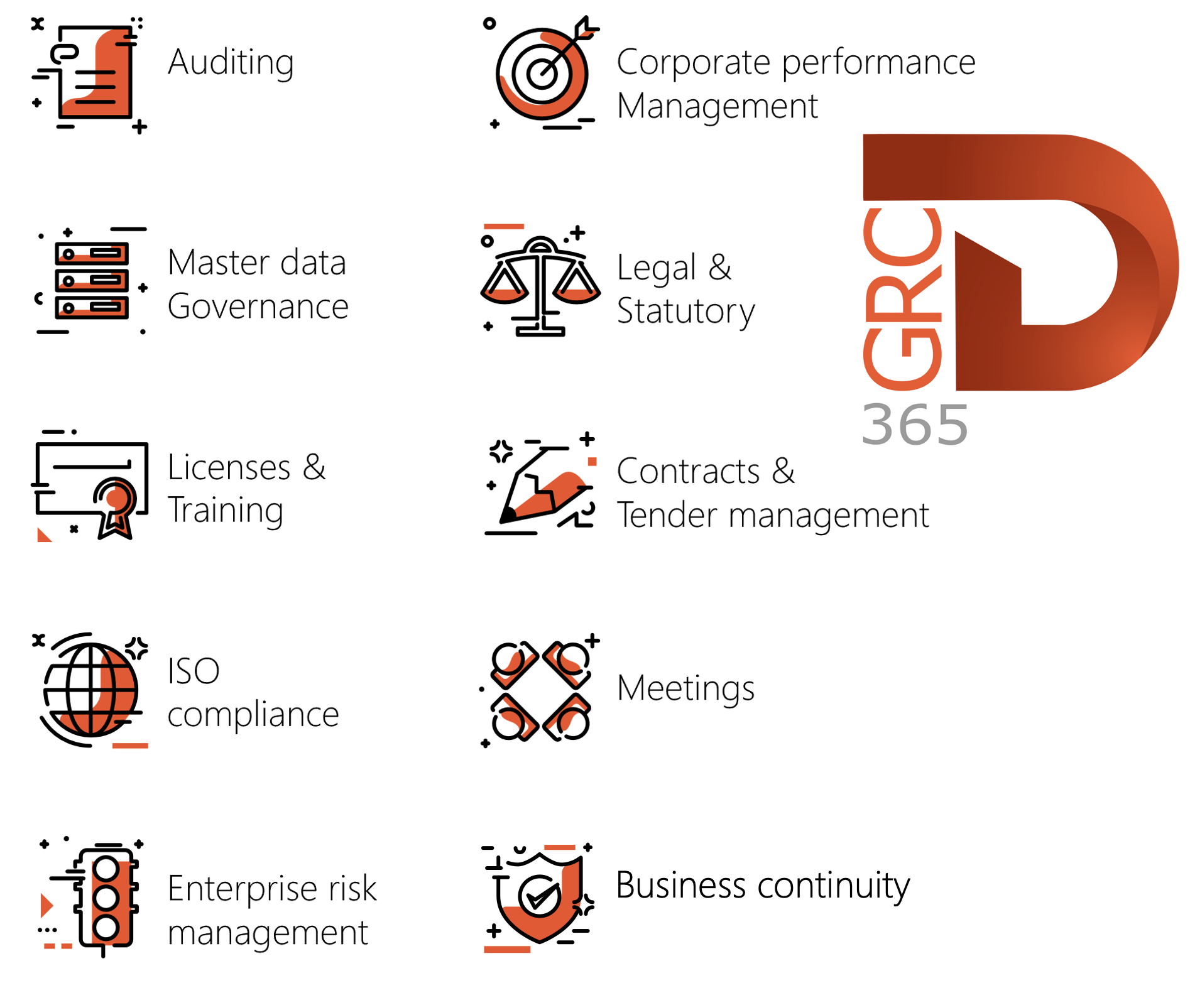

Dynamics 365 FO HSE/OHS

OHS/HSE is an add-on for Dynamics 365 suite of business application software.

This software adds to GRC in that compliance is now deeper with explicit functionality for Health, Safety and Environment as per the depicted sub-modules below.
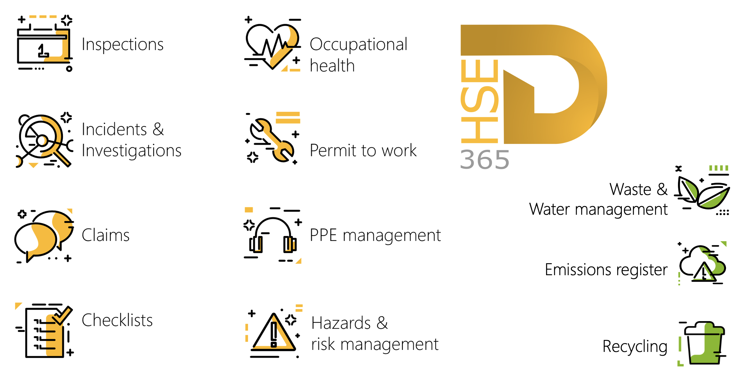

Release version

GRC/HSE Package version: OHSDeployablePackage_10_34_2105_20

This package was created on Microsoft Dynamics 365 for Finance and Operations:

Release | Version | Build number
Application release | 10.0.43 | 10.34.2105
Platform release | Platform update 67 | 7.0.7521.60

Enhancements:

Module | Description
General | On the Financial dimensions form: Shipping port was added as a value on the Use values from enum.
Inspections | Images attached to inspection journal lines are now printed on the Inspection journal report.
Enterprise risk management | The label of the New approved group risk dialog was changed to New approved master risk.
Operational and sustainability reporting | The system now returns only the fuel usage for the selected functional location.
Management of change | On the Change request under the Scope of change (lines) Fast tab:  When the value in the Change type column is changed:  - the Qty value is reset to 0, and  - the Total additional cost impact value is set to 0.

Module | Description
Tender management | - The Compare replies button on the RFQ and All RFQs list page, is no longer available to users who are not members of the Commercial evaluation team.  - On the RFQ, Governance Fast tab, Negotiation grid: The Open envelope button is disabled for that round if status = Envelope opened.  - A new Create all evaluation checklists slider was added on the Open envelope confirmation dialog. When this slider is set to Yes:  - The system does a check for Technical and Commercial checklists and also the relevant Scoring criteria.  - If checklists do not exist, the user is given the option to create the relevant checklists.  - For envelope opening not required:  - On the Compare replies form, the Negotiation price response value column is no longer hidden.  - For single envelope opening:  - The Attach commercial bid response button on the Manage replies is now always disabled.  - The Edit RFQ reply button on the Mange replies form will be disabled until the Commercial envelope is opened for the selected vendor.  - On the RFQ Action pane: the Evaluation button (Process button group) and the Evaluation report button (View button group) are only available:  - For members in the Evaluation team  - If the Commercial envelope was opened for all qualifying vendors.  - The View envelope button on the Negotiation checklist feedback form now only shows attachments where Used for = Negotiation.  - On the Vendor bidding form:  - the Attach technical response button in the button strip is now always greyed out.  - under the Line details Fast tab:  - The Negotiation price field was changed to a display.  - The value in the Negotiation response field under the Lines Fast tab is now displayed in the Negotiation price field under the Line details Fast tab.  - For parallel and sequential envelope opening:  - The Edit RFQ reply button on the Manage replies form is enabled whenever a technical or commercial envelope is opened.

Bug fixes:

Module | Description
Management of change | - There was an issue when updating Procurement categories on purchase agreements via the Update existing purchase agreement form.  - When updating an existing purchase agreement, the unit price of the first item was updating incorrectly.  These issues have been resolved.

Release Data impact

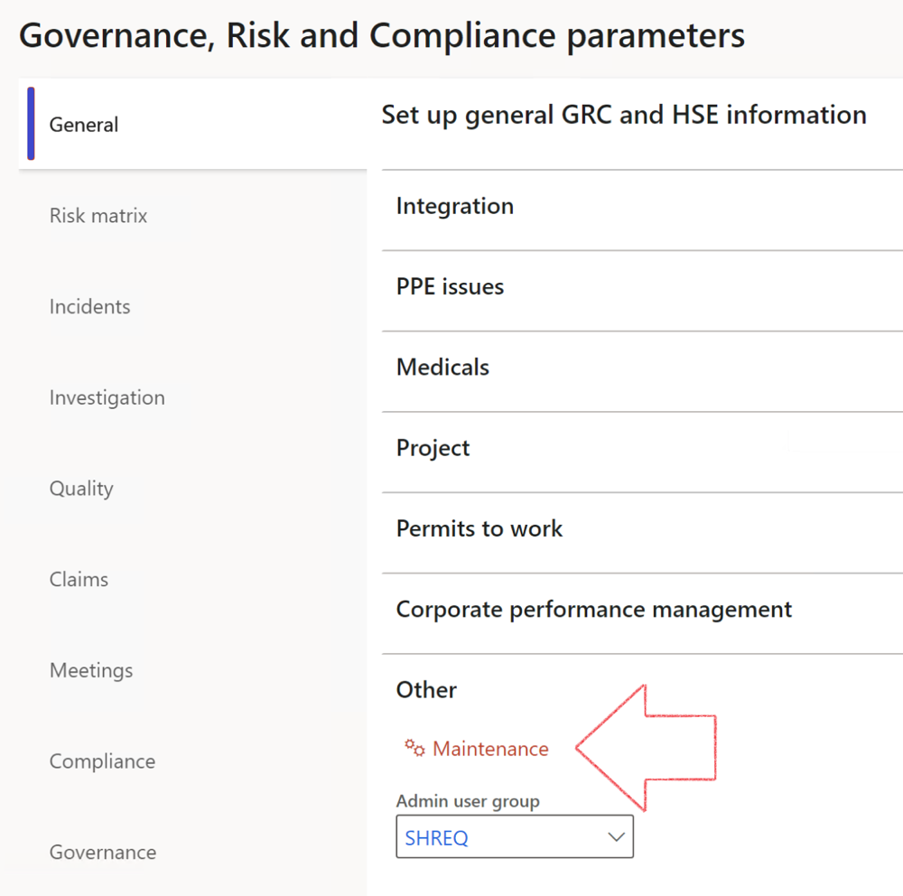

 | The Maintenance button is there for designated user. This button repairs any possible data issues. For a full history of all Data related repairs; see table below:

The information contained in this document represents the current view of Axnosis and Microsoft Corporation on the issues discussed as of the date of publication. Because Axnosis and Microsoft must respond to changing market conditions, this document should not be interpreted to be a commitment on the part of Axnosis and Microsoft, and Axnosis and Microsoft cannot guarantee the accuracy of any information presented after the date of publication.
This test script is for informational purposes only. AXNOSIS AND MICROSOFT MAKE NO WARRANTIES, EXPRESS, IMPLIED, OR STATUTORY, AS TO THE INFORMATION IN THIS DOCUMENT.
Complying with all applicable copyright laws is the responsibility of the user. Without limiting the rights under copyright, no part of this document may be reproduced, stored in or introduced into a retrieval system, or transmitted in any form or by any means (electronic, mechanical, photocopying, recording, or otherwise), or for any purpose, without the express written permission of Axnosis and Microsoft Corporation.
Axnosis and Microsoft may have patents, patent applications, trademarks, copyrights, or other intellectual property rights covering subject matter in this document. Except as expressly provided in any written license agreement from Axnosis and Microsoft, the furnishing of this document does not give you any license to these patents, trademarks, copyrights, or other intellectual property.
© 2021 Microsoft Corporation. All rights reserved. Any use or distribution of these materials without express authorization of Microsoft Corp. is strictly prohibited.
Microsoft and Windows are both registered trademarks of Microsoft Corporation in the United States and/or other countries.
The names of actual companies and products mentioned herein may be the trademarks of their respective owners.

Process | Description/notes | Release
Fix location vs. work centres | Populate the new LocationRecID field with the related location associated with previously used work centre location (Location) fields on the following tables:  - OHSHazardLocations,  - OHSRiskHazard,  - OHSRiskHazardWizard,  - OHSRiskRegister,  - OHSRisksWizard,  - OHSSafetyLocations,  - OHSSafetyPermit,  - OHSSafetyPermitLocations  - OHSSafetyPermitOverlap,  - OHSSafetyPlan,  - OHSInvestigation | 10.0.80.10
Fix risk hazards | Assigning the value "Default Risk" to the new mandatory field RiskID (Key field) where empty | 10.0.80.10
Fix incident HRM injury link | Delete all orphaned records from the OHSIncidentHRMInjuryLnk table | 10.0.11785.3
Populate SRS analysis enums | Still in concept phase. To provide a link between enum numerical value and value name for use with BYOD data entities. Enums available:  - OHSIncidentType,  - OHSIncidentSeverityType.  Table populated: SRSAnalysisEnums | 10.0.11785.3
Fix budget transaction lines stock\item dimension | Set OHSInventDimId field value to "AllBlank" on table BudgetTransactionLine, where no value was recorded. This will solve the issue of records not displaying in the form.  Note: this step will only fix existing budget transaction records in the system. Should any new transactions be uploaded or changed via the data entity Budget Account Entries, special care needs to be taken to specify the Stock dimension = AllBlank and the Item on the excel sheet to import. | 10.1.1366.6
Update existing incidents with the new Incident types | Update existing incidents with the Incident types that are setup on the new Incident type setup form. (IncidentTypeRecId) | 10.17.1250.5
Update existing risks with the new Control types | Update existing risks with the Control types that are setup on the new Control type setup form. | 10.17.1250.6
Re-number GRC Question and Answer Group lines | Re-number GRC Question and Answer Group line numbers | 10.22.1561.3
Fix Inspection locations: Replace Work centre-based locations with HSE locations | Populate the new ObjectLocation field with the related HSE location associated with previously used work centre location (Location) field on the following tables:  - OHSInspectionJournalName  - OHSInspectionJournalTable  - OHSInspectionJournalTrans  - OHSInspectionHistory  - OHSSchedule | 10.24.1114.3
Process | Description/notes | Release
Display of non-calculation lines | Run this job to ensure data consistency and correct display of historical data.
Fix Asset counter stock dimensions  Fix Line types on Data repository lines  Delete Orphan Data repositories | Replace empty stock dimension values with a blank dimension value  Populate missing line types from reporting templates on Data repository lines  Delete data repositories for which no template, year, site, period name or month was defined. | 10.26.1087.3  10.28.1080.6  10.30.2459.4
Equivalent Functional location fields | The equivalent Functional location fields will be populated where an HSE Location exists on the permit to work pool header and linked Permit to work table. | 10.30.2459.12

