

Dynamics GRC/HSE Release notes



Governance Risk & Compliance

Health, Safety & Environment

for

**Microsoft Dynamics 365 for Finance & Operations™**

*Dynamics GRC/HSE version* 10.34.2105.2

2025-09-08



|  |  |
| --- | --- |
| Dynamics 365 FO GRC module GRC is an add-on for Dynamics 365 suite of business application software.  This software provides compelling functionality to support Governance, Risk management and Compliance. |  |
| Dynamics 365 FO HSE/OHS OHS/HSE is an add-on for Dynamics 365 suite of business application software.  This software adds to GRC in that compliance is now deeper with explicit functionality for Health, Safety and Environment as per the depicted sub-modules below. | |
|  | |

Release version

**GRC/HSE Package version:** OHSDeployablePackage_10_34_2105_2

This package was created on Microsoft Dynamics 365 for Finance and Operations:

|  |  |  |
| --- | --- | --- |
| **Release** | **Version** | **Build number** |
| Application release | 10.0.43 | 10.34.2105 |
| Platform release | Platform update 67 | 7.0.7521.60 |

# Enhancements:

|  |  |
| --- | --- |
| Module | Description |
| Enterprise risk management | * A risk line which is both **Approved and Closed** is now excluded for **consolidation**. * The **Risk manager** alert is now included in the **Activities batch alerts** on the GRC parameters. A new **placeholder** for **Risk manager** was added to the **Activities** message. * If on a **risk line** where **status = Approved**, the user clicks on the **Add** button under the **Assessment calculations and controls** Fast tab, **Summary** Index tab, a pop-up comes up advising the user that a new risk assessment is not allowed and that the status can be changed back to draft and a new risk assessment added, if Yes is clicked. The same happens when the **Do risk assessment** button under the **General** Fast tab is clicked. * For **reporting** and **PowerBI**, a new **Consolidation history** table was created.   + A new menu item was added underGRC, Risk, Reports and inquiries, **Consolidations transactions.**   + Every time users clicks on the **Consolidation** button, an insert of the risk lines and meta data is done. * The **Risk owner** field in the Consolidation Legal entity, will be editable during consolidation. * On the **Risk lines**, General Fast tab, Risk actions Index tab:   + The **Approved by** field is now always non-editable.   + The wording on the pop-up when the Approved slider is set to **Yes**, now reads as follows: **Approve header status as well?** * On the **Risk lines**, General Fast tab, when the **Approved** slider is moved to **No**, the Line status is changed to **Draft**, and the **Approval date** and **Approved by** fields are cleared. * The **Add mitigation control** button was added as a **privilege** to the **standard risk security roles**. |
| Business continuity | On the **Business impact: Downtime report**:   * A **Description** column was added. * The **24 – 72 Hrs** label was fixed. |

|  |  |
| --- | --- |
| Module | Description |
| Management of change | * Users can now update **Purchase order lines** from a **Purchase agreement**. * Derived values are now ignored on **Approval authority Financial dimensions**. |
| Contracts management | The **Budget control statistics inquiry** was enhanced to improve visibility of **available amounts** forcontract line distributions matching the inquiry criteria. |
| Tender management | * **Line level negotiations** on **Procurement categories** can now be done. * On the RFQ, Governance Fast tab, **Bid documents** Index tab:   + The pop-up no longer appears when a **Document pack** is selected.   + The **Bid documents** button was renamed to **Copy bid documents**. |
| Corporate performance management | * On the view **Goal measurements** dialog that opens from the **Vendor**, the following columns have been moved to the front of the grid:   + **Goal** and **Description**   + **From date** and **To date** * The existing **Goal** column is now displayed when the following menu items are opened: * GRC > Performance > **KRI & goals** * GRC > Performance > **My planned KRI & goals** |
| Hazards | On the **Hazards Data entity**: the **Addictive** column was renamed to **Additive**. |
| General | **Onboarding tasks** can now be created for **Customers**. |

# Bug fixes:

|  |  |
| --- | --- |
| Module | Description |
| Management of change | When the CR is created in a Legal entity different to the workflow batch job company account, changes on the **Change request** were not carried over to the **Contract**.  The issue has been resolved. |
| Contracts management | The label for the **Primary vendor contract expiration batch alert** job was updated to **Primary vendor contract termination batch alert**. |
| Tender management | * When **creating checklists** on the RFQ with a **unique team** to the RFQ (where the team leaders have changed) the **checklist reviewers** are incorrect. * The **Baseline contract** was not being populated on **RFQ** when created from **Procurement plan**.   These issues have been resolved. |
| Risk management | **Site and department combinations** on the new Risk were not being filtered correctly according to the Hazard/aspect selected.  The issue has been resolved. |
| Hazards | When a **Site** was specified on a **Location**, and then used on the **Hazard**, the Location was offered for selection although the Hazard and Location sites did not align.  The issue has been resolved. |

Release Data impact

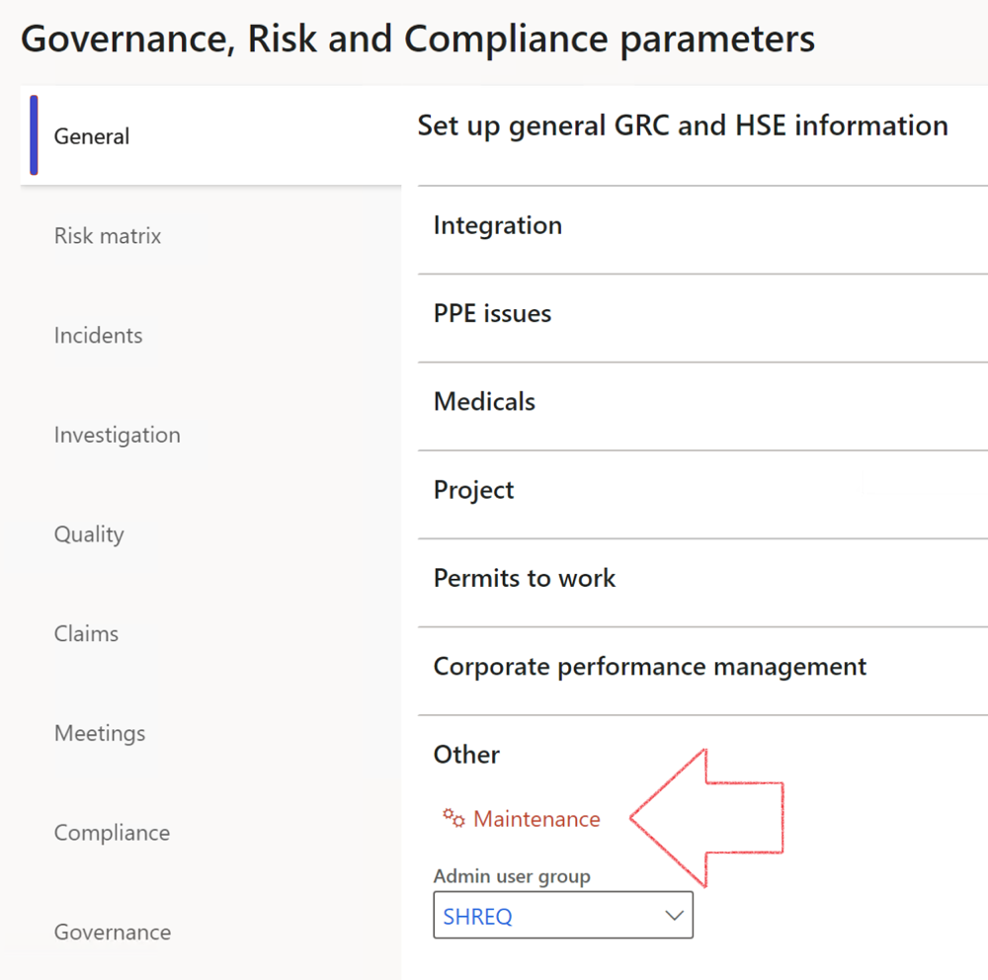

|  |  |
| --- | --- |
|  | The **Maintenance** button is there for designated user. This button repairs any possible data issues. For a full history of all Data related repairs; see table below: |

The information contained in this document represents the current view of Axnosis and Microsoft Corporation on the issues discussed as of the date of publication. Because Axnosis and Microsoft must respond to changing market conditions, this document should not be interpreted to be a commitment on the part of Axnosis and Microsoft, and Axnosis and Microsoft cannot guarantee the accuracy of any information presented after the date of publication.

This test script is for informational purposes only. AXNOSIS AND MICROSOFT MAKE NO WARRANTIES, EXPRESS, IMPLIED, OR STATUTORY, AS TO THE INFORMATION IN THIS DOCUMENT.

Complying with all applicable copyright laws is the responsibility of the user. Without limiting the rights under copyright, no part of this document may be reproduced, stored in or introduced into a retrieval system, or transmitted in any form or by any means (electronic, mechanical, photocopying, recording, or otherwise), or for any purpose, without the express written permission of Axnosis and Microsoft Corporation.

Axnosis and Microsoft may have patents, patent applications, trademarks, copyrights, or other intellectual property rights covering subject matter in this document. Except as expressly provided in any written license agreement from Axnosis and Microsoft, the furnishing of this document does not give you any license to these patents, trademarks, copyrights, or other intellectual property.

© 2021 Microsoft Corporation. All rights reserved. Any use or distribution of these materials without express authorization of Microsoft Corp. is strictly prohibited.

Microsoft and Windows are both registered trademarks of Microsoft Corporation in the United States and/or other countries.

The names of actual companies and products mentioned herein may be the trademarks of their respective owners.

|  |  |  |
| --- | --- | --- |
| **Process** | **Description/notes** | **Release** |
| Fix location vs. work centres | Populate the new **LocationRecID** field with the related location associated with previously used work centre location (Location) fields on the following tables:   * OHSHazardLocations, * OHSRiskHazard, * OHSRiskHazardWizard, * OHSRiskRegister, * OHSRisksWizard, * OHSSafetyLocations, * OHSSafetyPermit, * OHSSafetyPermitLocations * OHSSafetyPermitOverlap, * OHSSafetyPlan, * OHSInvestigation | 10.0.80.10 |
| Fix risk hazards | Assigning the value "Default Risk" to the new mandatory field **RiskID** (Key field) where empty | 10.0.80.10 |
| Fix incident HRM injury link | Delete all orphaned records from the **OHSIncidentHRMInjuryLnk** table | 10.0.11785.3 |
| Populate SRS analysis enums | Still in concept phase. To provide a link between enum numerical value and value name for use with BYOD data entities. Enums available:   * OHSIncidentType, * OHSIncidentSeverityType.   Table populated: **SRSAnalysisEnums** | 10.0.11785.3 |
| Fix budget transaction lines stock\item dimension | Set **OHSInventDimId** field value to "**AllBlank**" on table **BudgetTransactionLine**, where no value was recorded. This will solve the issue of records not displaying in the form.  **Note: this step will only fix existing budget transaction records in the system. Should any new transactions be uploaded or changed via the data entity Budget Account Entries, special care needs to be taken to specify the Stock dimension = AllBlank and the Item on the excel sheet to import.** | 10.1.1366.6 |
| Update existing incidents with the new **Incident types** | Update existing incidents with the **Incident types** that are setup on the new **Incident type** setup form. (IncidentTypeRecId) | 10.17.1250.5 |
| Update existing risks with the new **Control types** | Update existing risks with the **Control types** that are setup on the new **Control type** setup form. | 10.17.1250.6 |
| Re-number GRC Question and Answer **Group lines** | Re-number GRC Question and Answer **Group line numbers** | 10.22.1561.3 |
| Fix Inspection locations: Replace Work centre-based locations with HSE locations | Populate the new **ObjectLocation** field with the related HSE location associated with previously used work centre location (**Location**) field on the following tables:   * OHSInspectionJournalName * OHSInspectionJournalTable * OHSInspectionJournalTrans * OHSInspectionHistory * OHSSchedule | 10.24.1114.3 |
| **Process** | **Description/notes** | **Release** |
| Display of non-calculation lines | Run this job to ensure data consistency and correct display of historical data. |  |
| Fix Asset counter stock dimensions  Fix Line types on Data repository lines  Delete Orphan Data repositories | Replace empty stock dimension values with a blank dimension value  Populate missing line types from reporting templates on Data repository lines  Delete data repositories for which no template, year, site, period name or month was defined. | 10.26.1087.3  10.28.1080.6  10.30.2459.4 |
| Equivalent Functional location fields | The equivalent Functional location fields will be populated where an HSE Location exists on the permit to work pool header and linked Permit to work table. | 10.30.2459.12 |