
Dynamics GRC/HSE Release notes



Governance Risk & Compliance
Health, Safety & Environment

for

Microsoft Dynamics 365 for Finance & Operations™

Dynamics GRC/HSE version 10.34.2105.17

2026-01-16



Dynamics 365 FO GRC module  GRC is an add-on for Dynamics 365 suite of business application software.  This software provides compelling functionality to support Governance, Risk management and Compliance. | 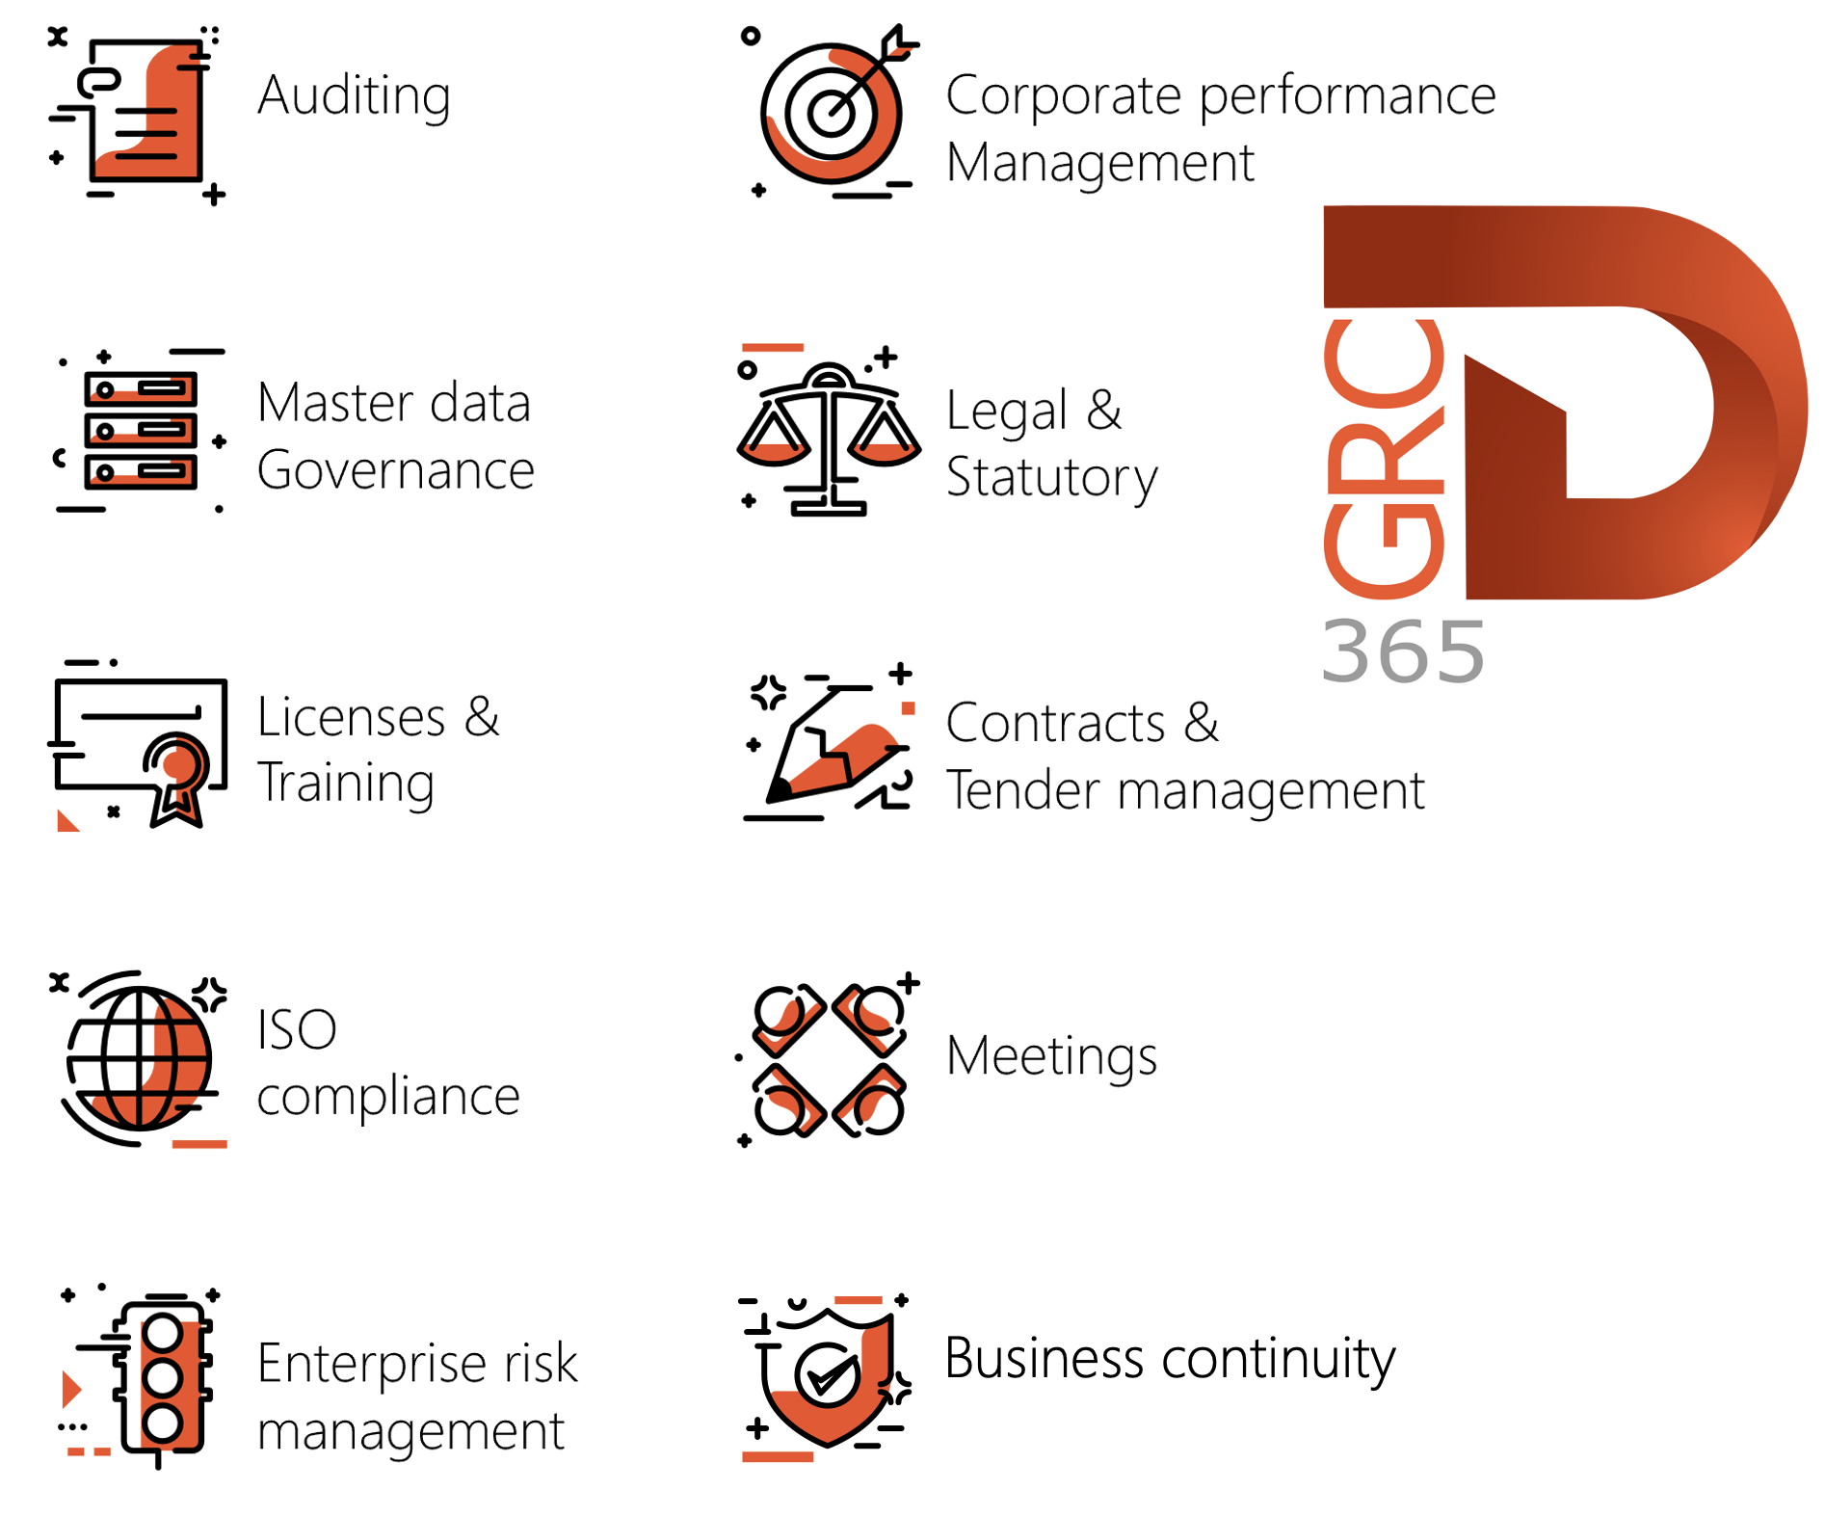

Dynamics 365 FO HSE/OHS

OHS/HSE is an add-on for Dynamics 365 suite of business application software.

This software adds to GRC in that compliance is now deeper with explicit functionality for Health, Safety and Environment as per the depicted sub-modules below.
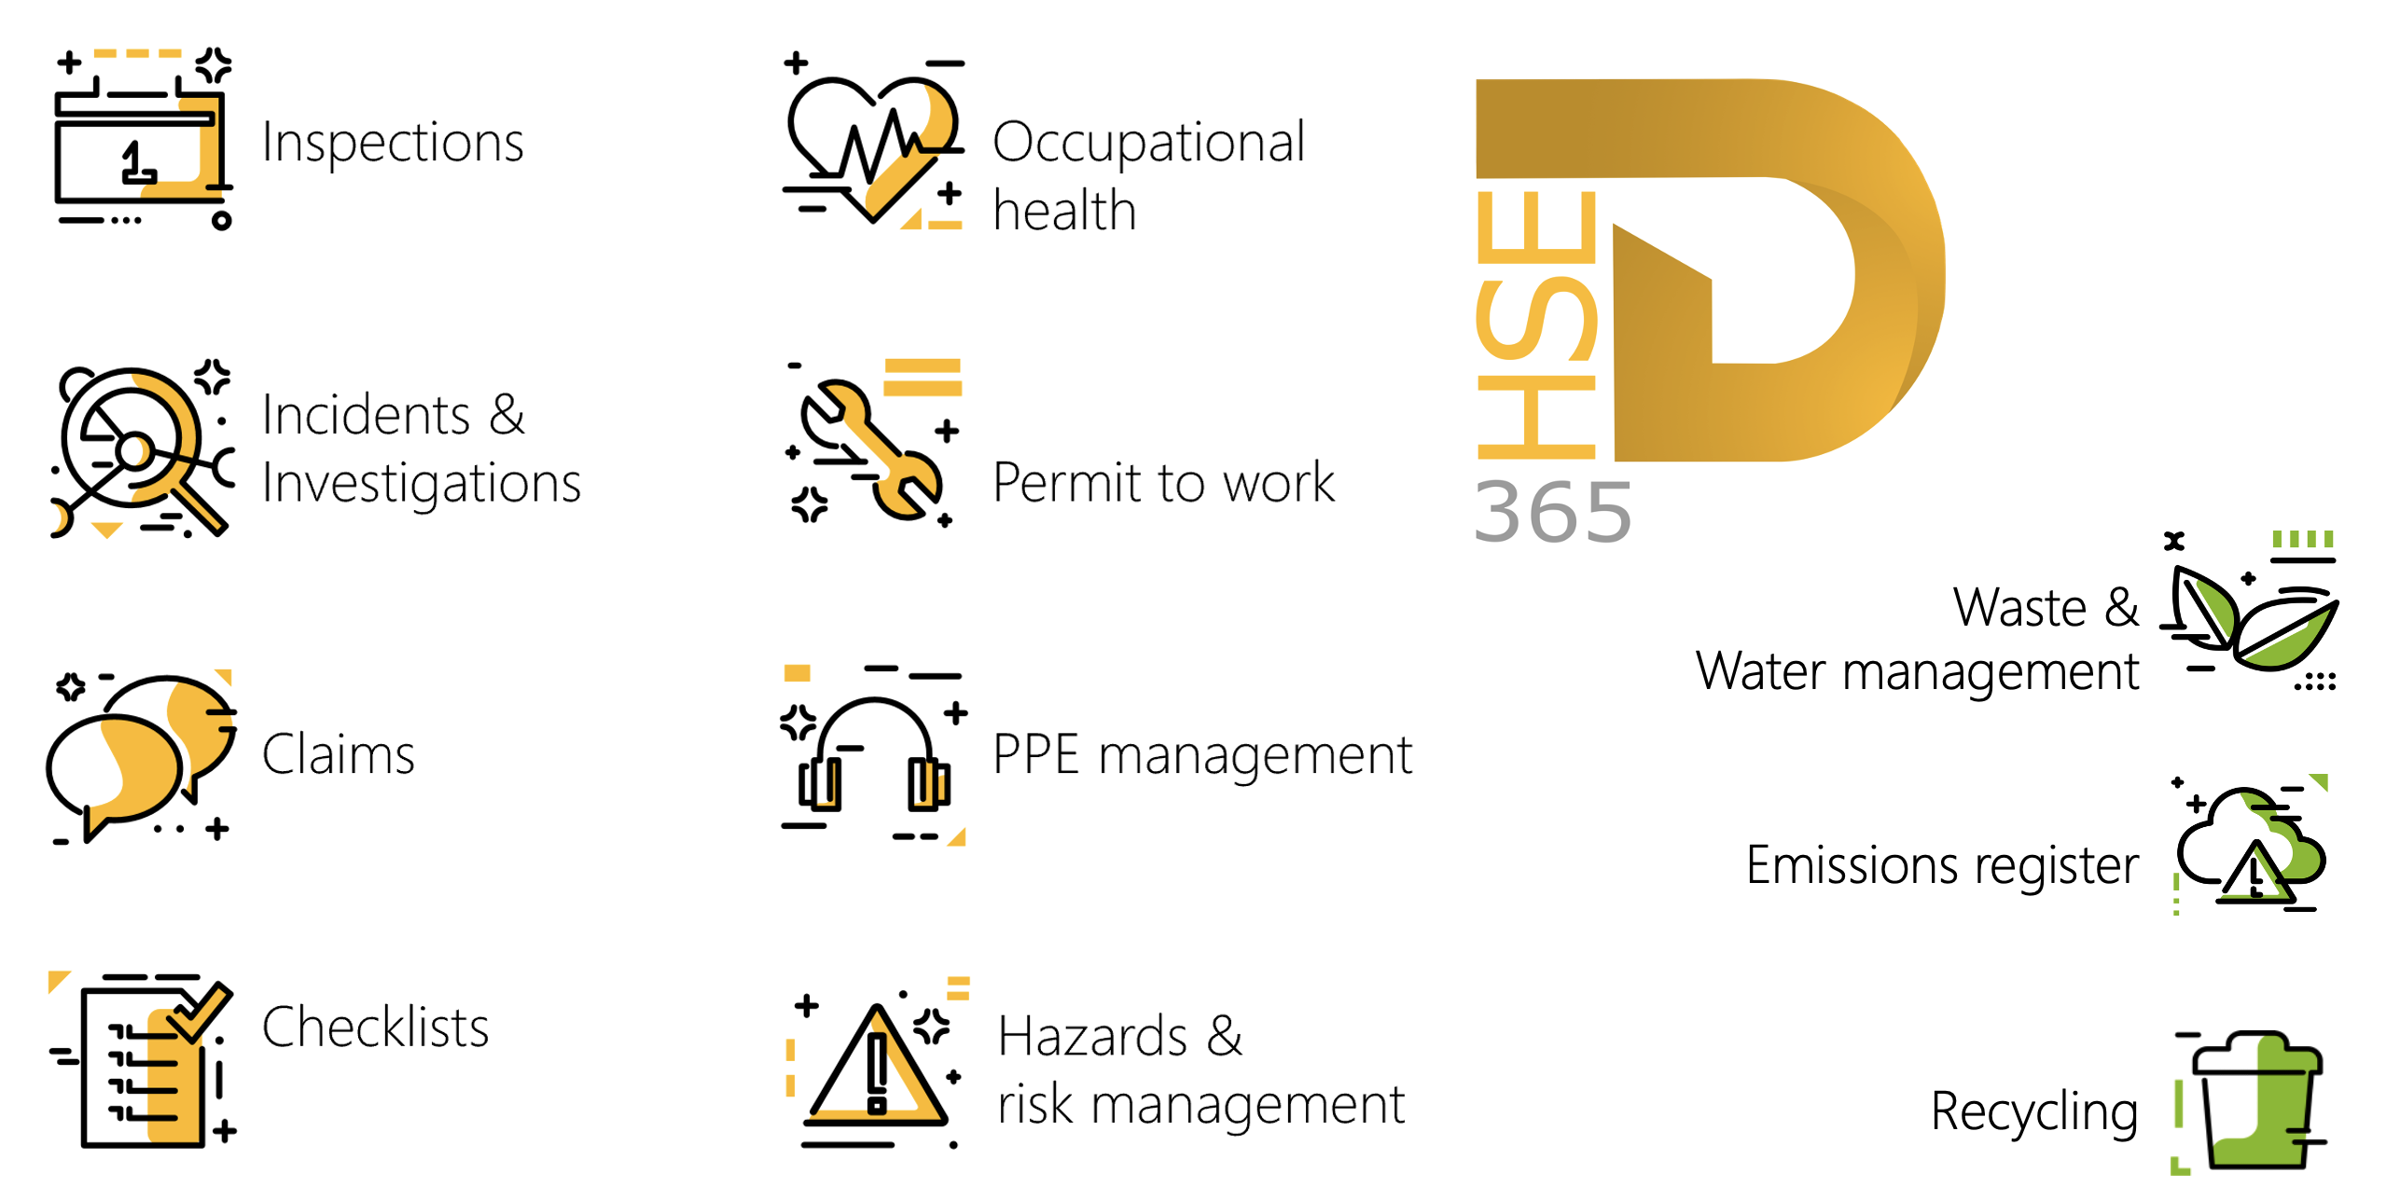

Release version

GRC/HSE Package version: OHSDeployablePackage_10_34_2105_17

This package was created on Microsoft Dynamics 365 for Finance and Operations:

Release | Version | Build number
Application release | 10.0.43 | 10.34.2105
Platform release | Platform update 67 | 7.0.7521.60

Enhancements:

Module | Description
General | The ObjectActive field was added to the OBject Table data entity.
Incidents | - On the Incident, under the Which objects Index tab: The filter on the Object lookup was enhanced to only show OHS Objects that have the Active slider set to Yes.  - The Report an incident dialog: The filter on the Location lookup was enhanced to only show OHS locations that have the Active slider set to Yes.
Enterprise risk management | - When the status of the Risk register header is changed to Submitted, the Employee accountable under the RACI Fast tab will receive a notification.  - The ability to do a risk assessment by category and using the sum or average scores as the risk assessment value.  - The following labels were renamed on the Risk register detail report:  - Original risk register is now Risk register  - Hazard description is now Label / Description
Business continuity management | - When Business process information is added to the Wizard under Step 2: My business processes, the updates are added to the Business process administration form.  - On the Recovery strategy per department report: The Process label was changed to Business process.  - On the 3rd party per department report: The Process label was changed to Business process.  - On the Impact assessment: downtime report:  - The Description label was changed to Business process  - The Minimum workers label was changed to Minimum workers required  - On the Impact assessment: HR requirements report:  - The Process label was changed to Business process  - The Total personnel required label was changed to Total workers required  - The Minimum personnel required label was changed to Minimum workers required

Module | Description
Tender management | - A new Changed Y/N slider was added on the Team form. When a team is changed on the RFQ, this slider will be set to Yes. All Team lookups on the Solicitation type now only show records where this new slider = No.  - On the Solicitation type:  - The Lock amendments slider was moved to under the Enable voting slider.  - A new Non-team member to open envelope slider was added under the Envelope opening lookup. When this slider is set to Yes, Team members will not be allowed to open envelopes (Applicable to all envelope types)  - Additional rules were added for when Single is selected in the Envelope opening field.  - A new Package ID mandatory Y/N slider was added under the Lock amendments slider.  - On the RFQ:  - Under the Governance Fast tab, Committee Index tab: A new Envelope opener column (Worker lookup) was added in the grid just after the Role column.  - A new rule was added to the Open envelopes button (Action pane, Process button group):  - If the Non-team member to open envelope slider on the Solicitation type = Yes: Then ONLY workers selected in the Worker column the Committee grid can click on the Open envelopes button.  - When an envelope was opened, a blue notification is displayed at the top of the screen.  - Under the Sign off Fast tab: Add a new Witnesses button was added in the button strip. On click of this new button, a new Witnesses dialog opens allowing users to add/remove the witnesses of envelope opening.  - On the Change team member dialog: On the Type of change enum, the Replace label was changed to Assign team leader, allowing users to assign team leaders from Change team member dialog.  - A View envelope button was added in the button strip of the Negotiation checklist feedback form.  - On the GRC parameters, Governance tab, under the Sourcing and tender governance Fast tab, a new Force solicitation type Y/N slider was added. When set to Yes, the Solicitation type lookup on Procurement plan and Purchase requisition creation will be mandatory.  - The help text for the Document pack lookup was improved on the following forms:  - Solicitation type, RFQ (Governance Fast tab, Bid documents Index tab) and Contract.  - The Certification type menu item under Procurement and sourcing, Setup, Vendors, was copied to GRC, Governance, Setup for governance.  - On the Request for quotation bid: A new Mandatory attachments Fast tab was added. This allows bidders to view the list of attachments that are mandatory when submitting a response to the bid. An Attachments button makes it easy to attach documents to the selected line.

Module | Description
Corporate performance management | - On the GRC parameters, General tab, under the Corporate performance management Fast tab, a new Show mining perspective Y/N slider was added. When this slider is set to No, the Mining perspective Index tab on the Performance scorecard workspace will be hidden.  - On the Key performance indicators list:  - Sales order and Purchase order were added as values to the KPI element 1 and KPI element 2 enums, as well as to the KPI element enum under the KPI list elements section.  - A new Filter button was added in the Action button strip. This opens a drop dialog where users can specify the following filters:  - Date interval  - Vendor  - Customer  - Asset  - The following filter were added on the Performance scorecard workspace, under the Key performance indicators list index tab:  - Vendor  - Customer  - Asset

Bug fixes:

Module | Description
Contracts management | - A “Lot ID must be filled in” error was displayed when changes were made to the free text line on the Sales order.  - When a new stock line was added under the Item lines Fast tab on a Contract, the user was unable to capture Site and Warehouse for the item.  - When a Sales order was created from a Contract, the Unit field on the Sales order was not being populated.  These issues have been resolved.

Release Data impact

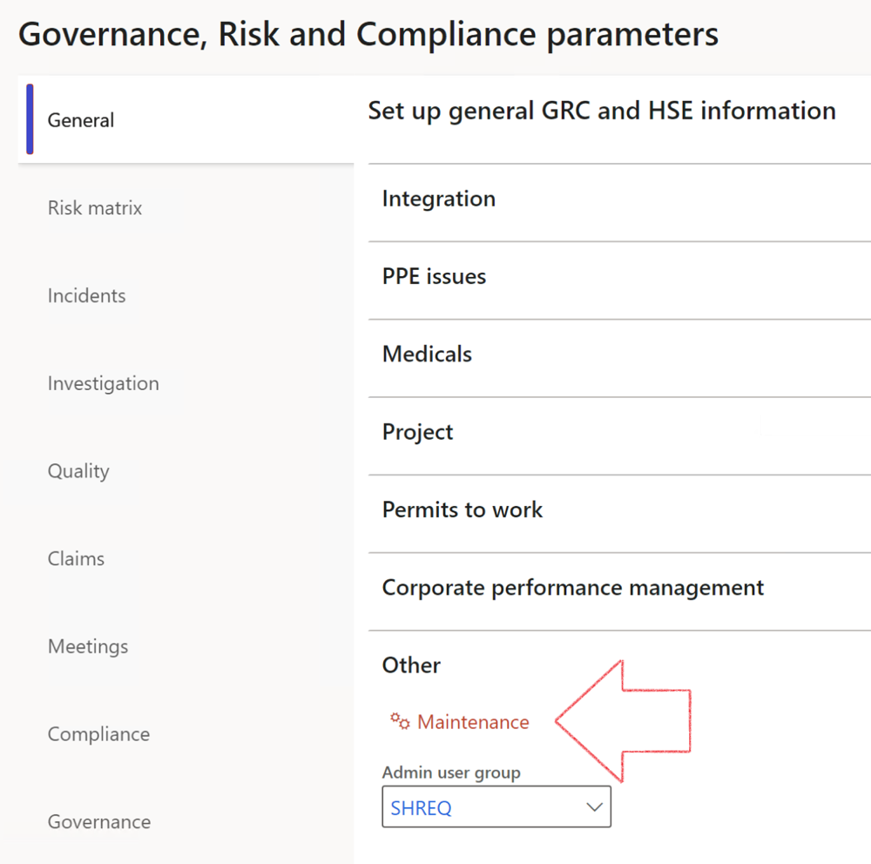

 | The Maintenance button is there for designated user. This button repairs any possible data issues. For a full history of all Data related repairs; see table below:

The information contained in this document represents the current view of Axnosis and Microsoft Corporation on the issues discussed as of the date of publication. Because Axnosis and Microsoft must respond to changing market conditions, this document should not be interpreted to be a commitment on the part of Axnosis and Microsoft, and Axnosis and Microsoft cannot guarantee the accuracy of any information presented after the date of publication.
This test script is for informational purposes only. AXNOSIS AND MICROSOFT MAKE NO WARRANTIES, EXPRESS, IMPLIED, OR STATUTORY, AS TO THE INFORMATION IN THIS DOCUMENT.
Complying with all applicable copyright laws is the responsibility of the user. Without limiting the rights under copyright, no part of this document may be reproduced, stored in or introduced into a retrieval system, or transmitted in any form or by any means (electronic, mechanical, photocopying, recording, or otherwise), or for any purpose, without the express written permission of Axnosis and Microsoft Corporation.
Axnosis and Microsoft may have patents, patent applications, trademarks, copyrights, or other intellectual property rights covering subject matter in this document. Except as expressly provided in any written license agreement from Axnosis and Microsoft, the furnishing of this document does not give you any license to these patents, trademarks, copyrights, or other intellectual property.
© 2021 Microsoft Corporation. All rights reserved. Any use or distribution of these materials without express authorization of Microsoft Corp. is strictly prohibited.
Microsoft and Windows are both registered trademarks of Microsoft Corporation in the United States and/or other countries.
The names of actual companies and products mentioned herein may be the trademarks of their respective owners.

Process | Description/notes | Release
Fix location vs. work centres | Populate the new LocationRecID field with the related location associated with previously used work centre location (Location) fields on the following tables:  - OHSHazardLocations,  - OHSRiskHazard,  - OHSRiskHazardWizard,  - OHSRiskRegister,  - OHSRisksWizard,  - OHSSafetyLocations,  - OHSSafetyPermit,  - OHSSafetyPermitLocations  - OHSSafetyPermitOverlap,  - OHSSafetyPlan,  - OHSInvestigation | 10.0.80.10
Fix risk hazards | Assigning the value "Default Risk" to the new mandatory field RiskID (Key field) where empty | 10.0.80.10
Fix incident HRM injury link | Delete all orphaned records from the OHSIncidentHRMInjuryLnk table | 10.0.11785.3
Populate SRS analysis enums | Still in concept phase. To provide a link between enum numerical value and value name for use with BYOD data entities. Enums available:  - OHSIncidentType,  - OHSIncidentSeverityType.  Table populated: SRSAnalysisEnums | 10.0.11785.3
Fix budget transaction lines stock\item dimension | Set OHSInventDimId field value to "AllBlank" on table BudgetTransactionLine, where no value was recorded. This will solve the issue of records not displaying in the form.  Note: this step will only fix existing budget transaction records in the system. Should any new transactions be uploaded or changed via the data entity Budget Account Entries, special care needs to be taken to specify the Stock dimension = AllBlank and the Item on the excel sheet to import. | 10.1.1366.6
Update existing incidents with the new Incident types | Update existing incidents with the Incident types that are setup on the new Incident type setup form. (IncidentTypeRecId) | 10.17.1250.5
Update existing risks with the new Control types | Update existing risks with the Control types that are setup on the new Control type setup form. | 10.17.1250.6
Re-number GRC Question and Answer Group lines | Re-number GRC Question and Answer Group line numbers | 10.22.1561.3
Fix Inspection locations: Replace Work centre-based locations with HSE locations | Populate the new ObjectLocation field with the related HSE location associated with previously used work centre location (Location) field on the following tables:  - OHSInspectionJournalName  - OHSInspectionJournalTable  - OHSInspectionJournalTrans  - OHSInspectionHistory  - OHSSchedule | 10.24.1114.3
Process | Description/notes | Release
Display of non-calculation lines | Run this job to ensure data consistency and correct display of historical data.
Fix Asset counter stock dimensions  Fix Line types on Data repository lines  Delete Orphan Data repositories | Replace empty stock dimension values with a blank dimension value  Populate missing line types from reporting templates on Data repository lines  Delete data repositories for which no template, year, site, period name or month was defined. | 10.26.1087.3  10.28.1080.6  10.30.2459.4
Equivalent Functional location fields | The equivalent Functional location fields will be populated where an HSE Location exists on the permit to work pool header and linked Permit to work table. | 10.30.2459.12

