
Dynamics GRC/HSE Release notes



Governance Risk & Compliance
Health, Safety & Environment

for

Microsoft Dynamics 365 for Finance & Operations™

Dynamics GRC/HSE version 10.34.2105.15

2025-12-23



Dynamics 365 FO GRC module  GRC is an add-on for Dynamics 365 suite of business application software.  This software provides compelling functionality to support Governance, Risk management and Compliance. | 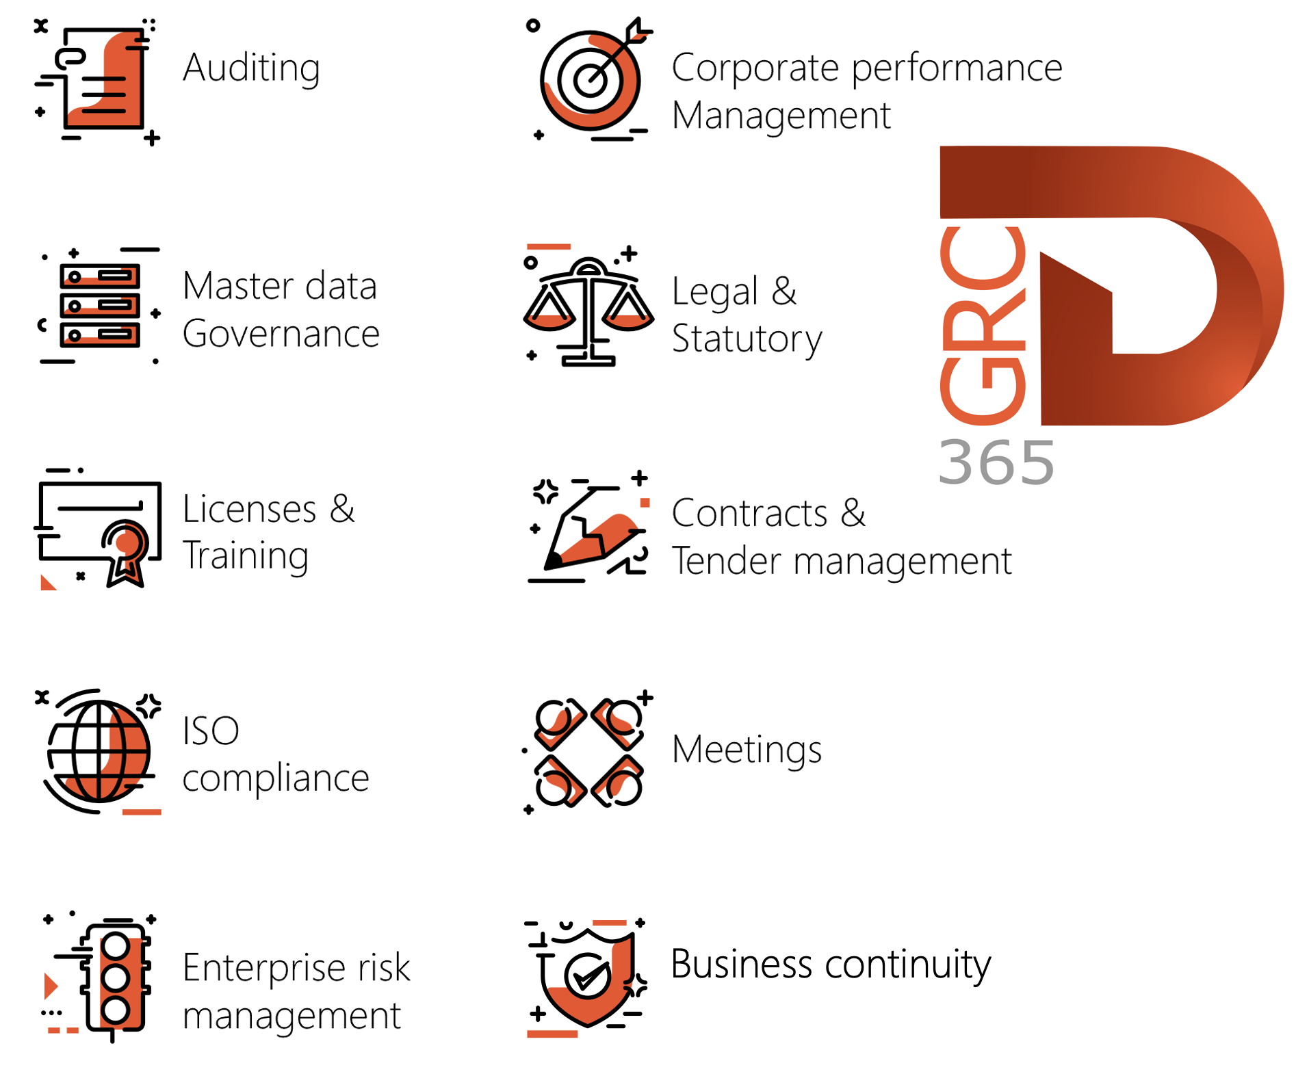

Dynamics 365 FO HSE/OHS

OHS/HSE is an add-on for Dynamics 365 suite of business application software.

This software adds to GRC in that compliance is now deeper with explicit functionality for Health, Safety and Environment as per the depicted sub-modules below.
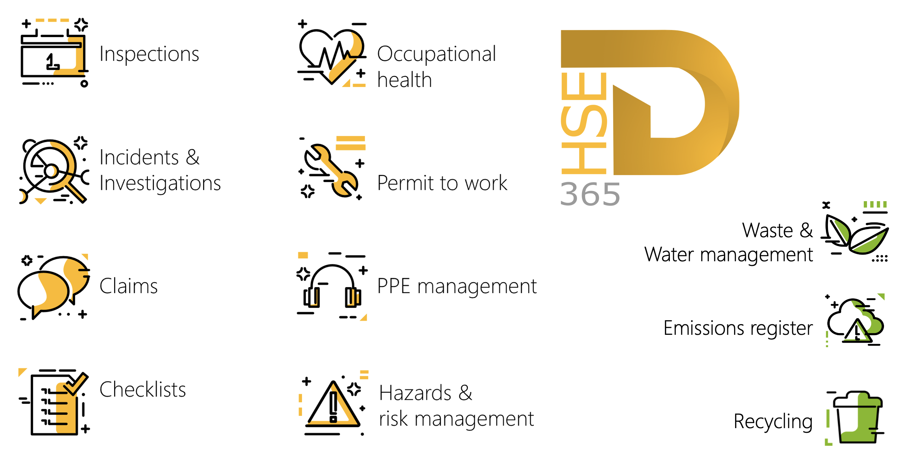

Release version

GRC/HSE Package version: OHSDeployablePackage_10_34_2105_15

This package was created on Microsoft Dynamics 365 for Finance and Operations:

Release | Version | Build number
Application release | 10.0.43 | 10.34.2105
Platform release | Platform update 67 | 7.0.7521.60

Enhancements:

Module | Description
Inspections | - On the Inspection sheet report:  - The "Already captured answer" column was renamed to: "Yes/No/NA".  - The Comments column is wider.  - Incidents can now be created form Inspection lines.
Enterprise risk management | - In the Action pane of the Risk register header, a new Approve all lines button was added in the Functions button group. This button enables users to simultaneously approve all risk lines that are in draft status.  - The Create activity button in the Action pane of the Lines view, is now always available.  - The To be reviewed by field on the Risk line is now only editable when the Risk line is Approved and the Enable for review slider = Yes.  - The following labels were changed:  - The Approved group risks menu item is now Approved master risks.  - The All group risks menu item is now All master risks.  - The All risk registers menu item is now All group risk registers.
Business continuity management | - A new Business continuity wizard was created to guide users (BCM Champions) through the BCM process.  - The Impact assessment: HR requirements report menu item was moved to under the Impact assessment: downtime report menu item.
Advanced case management | On the Case, under the Associations Fast tab, when the user clicks on the Medical consultation ID, the Medical consultation opens with the cards to the left minimized.
Corporate performance management | - On the Performance scorecard workspace: the Key performance indicators index tab’s label was renamed to Key performance indicators list.  - On the Contract, under the Trading partners Fast tab, the KPI list button was renamed to KPI and is now a button group. The user can choose to create the KPI list or view the KPI performance.  - On the Contract, under the Trading partners Fast tab, when the KPI list button is clicked: the Key performance area column in the KPI name lookup was moved to the back.

Module | Description
Contracts management | - Claims can now be created from a Contract:  - A new Create claim button was added under the Penalties Fast tab on the Contract.  - A new Contract penalties Fast tab was added on the Claim form to reference claims created form contracts.  - On the Claim type setup form, a new value was added to the Type enum = Contract.  - The Claim types menu item under HSE was copied to the GRC menu under Setup for governance.  - A new Notice of contract conclusion report was created and can be printed by clicking on the new Print contract conclusion button on the Contract, Content Fast tab, Statement of final account Index tab.  - A new Accounting date field was added to the Contract line distributions grid.  - Users can perform additional adjustments for coal sales if the sale order line does not have an item defined.
Tender management | On the Solicitation type: the Name column is now also displayed in all the team’s dropdown lists.

Release Data impact

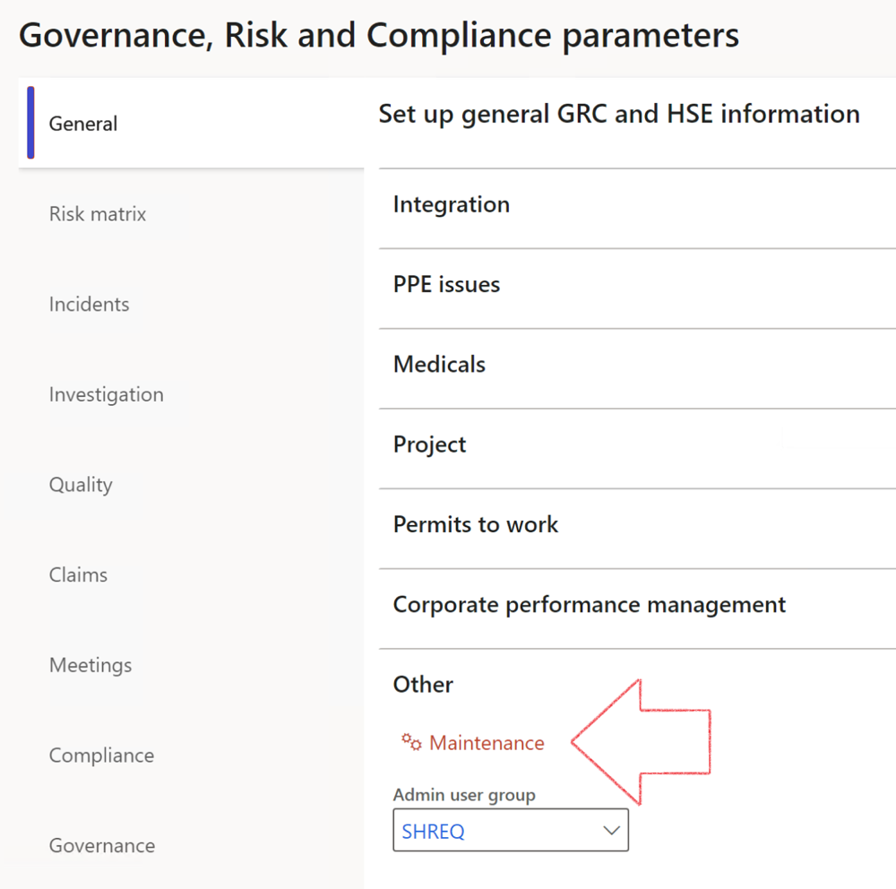

 | The Maintenance button is there for designated user. This button repairs any possible data issues. For a full history of all Data related repairs; see table below:

The information contained in this document represents the current view of Axnosis and Microsoft Corporation on the issues discussed as of the date of publication. Because Axnosis and Microsoft must respond to changing market conditions, this document should not be interpreted to be a commitment on the part of Axnosis and Microsoft, and Axnosis and Microsoft cannot guarantee the accuracy of any information presented after the date of publication.
This test script is for informational purposes only. AXNOSIS AND MICROSOFT MAKE NO WARRANTIES, EXPRESS, IMPLIED, OR STATUTORY, AS TO THE INFORMATION IN THIS DOCUMENT.
Complying with all applicable copyright laws is the responsibility of the user. Without limiting the rights under copyright, no part of this document may be reproduced, stored in or introduced into a retrieval system, or transmitted in any form or by any means (electronic, mechanical, photocopying, recording, or otherwise), or for any purpose, without the express written permission of Axnosis and Microsoft Corporation.
Axnosis and Microsoft may have patents, patent applications, trademarks, copyrights, or other intellectual property rights covering subject matter in this document. Except as expressly provided in any written license agreement from Axnosis and Microsoft, the furnishing of this document does not give you any license to these patents, trademarks, copyrights, or other intellectual property.
© 2021 Microsoft Corporation. All rights reserved. Any use or distribution of these materials without express authorization of Microsoft Corp. is strictly prohibited.
Microsoft and Windows are both registered trademarks of Microsoft Corporation in the United States and/or other countries.
The names of actual companies and products mentioned herein may be the trademarks of their respective owners.

Process | Description/notes | Release
Fix location vs. work centres | Populate the new LocationRecID field with the related location associated with previously used work centre location (Location) fields on the following tables:  - OHSHazardLocations,  - OHSRiskHazard,  - OHSRiskHazardWizard,  - OHSRiskRegister,  - OHSRisksWizard,  - OHSSafetyLocations,  - OHSSafetyPermit,  - OHSSafetyPermitLocations  - OHSSafetyPermitOverlap,  - OHSSafetyPlan,  - OHSInvestigation | 10.0.80.10
Fix risk hazards | Assigning the value "Default Risk" to the new mandatory field RiskID (Key field) where empty | 10.0.80.10
Fix incident HRM injury link | Delete all orphaned records from the OHSIncidentHRMInjuryLnk table | 10.0.11785.3
Populate SRS analysis enums | Still in concept phase. To provide a link between enum numerical value and value name for use with BYOD data entities. Enums available:  - OHSIncidentType,  - OHSIncidentSeverityType.  Table populated: SRSAnalysisEnums | 10.0.11785.3
Fix budget transaction lines stock\item dimension | Set OHSInventDimId field value to "AllBlank" on table BudgetTransactionLine, where no value was recorded. This will solve the issue of records not displaying in the form.  Note: this step will only fix existing budget transaction records in the system. Should any new transactions be uploaded or changed via the data entity Budget Account Entries, special care needs to be taken to specify the Stock dimension = AllBlank and the Item on the excel sheet to import. | 10.1.1366.6
Update existing incidents with the new Incident types | Update existing incidents with the Incident types that are setup on the new Incident type setup form. (IncidentTypeRecId) | 10.17.1250.5
Update existing risks with the new Control types | Update existing risks with the Control types that are setup on the new Control type setup form. | 10.17.1250.6
Re-number GRC Question and Answer Group lines | Re-number GRC Question and Answer Group line numbers | 10.22.1561.3
Fix Inspection locations: Replace Work centre-based locations with HSE locations | Populate the new ObjectLocation field with the related HSE location associated with previously used work centre location (Location) field on the following tables:  - OHSInspectionJournalName  - OHSInspectionJournalTable  - OHSInspectionJournalTrans  - OHSInspectionHistory  - OHSSchedule | 10.24.1114.3
Process | Description/notes | Release
Display of non-calculation lines | Run this job to ensure data consistency and correct display of historical data.
Fix Asset counter stock dimensions  Fix Line types on Data repository lines  Delete Orphan Data repositories | Replace empty stock dimension values with a blank dimension value  Populate missing line types from reporting templates on Data repository lines  Delete data repositories for which no template, year, site, period name or month was defined. | 10.26.1087.3  10.28.1080.6  10.30.2459.4
Equivalent Functional location fields | The equivalent Functional location fields will be populated where an HSE Location exists on the permit to work pool header and linked Permit to work table. | 10.30.2459.12

