
Dynamics GRC/HSE Release notes



Governance Risk & Compliance
Health, Safety & Environment

for

Microsoft Dynamics 365 for Finance & Operations™

Dynamics GRC/HSE version 10.34.2105.11

2025-11-18



Dynamics 365 FO GRC module  GRC is an add-on for Dynamics 365 suite of business application software.  This software provides compelling functionality to support Governance, Risk management and Compliance. | 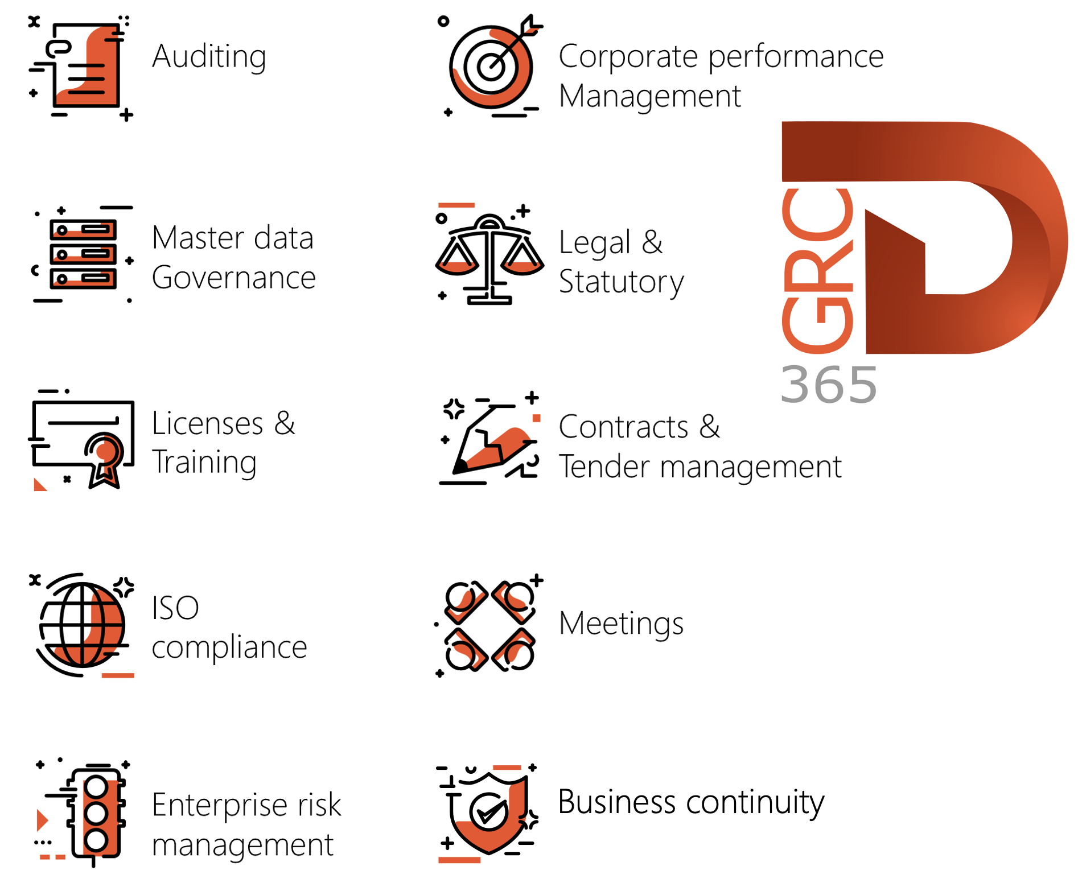

Dynamics 365 FO HSE/OHS

OHS/HSE is an add-on for Dynamics 365 suite of business application software.

This software adds to GRC in that compliance is now deeper with explicit functionality for Health, Safety and Environment as per the depicted sub-modules below.
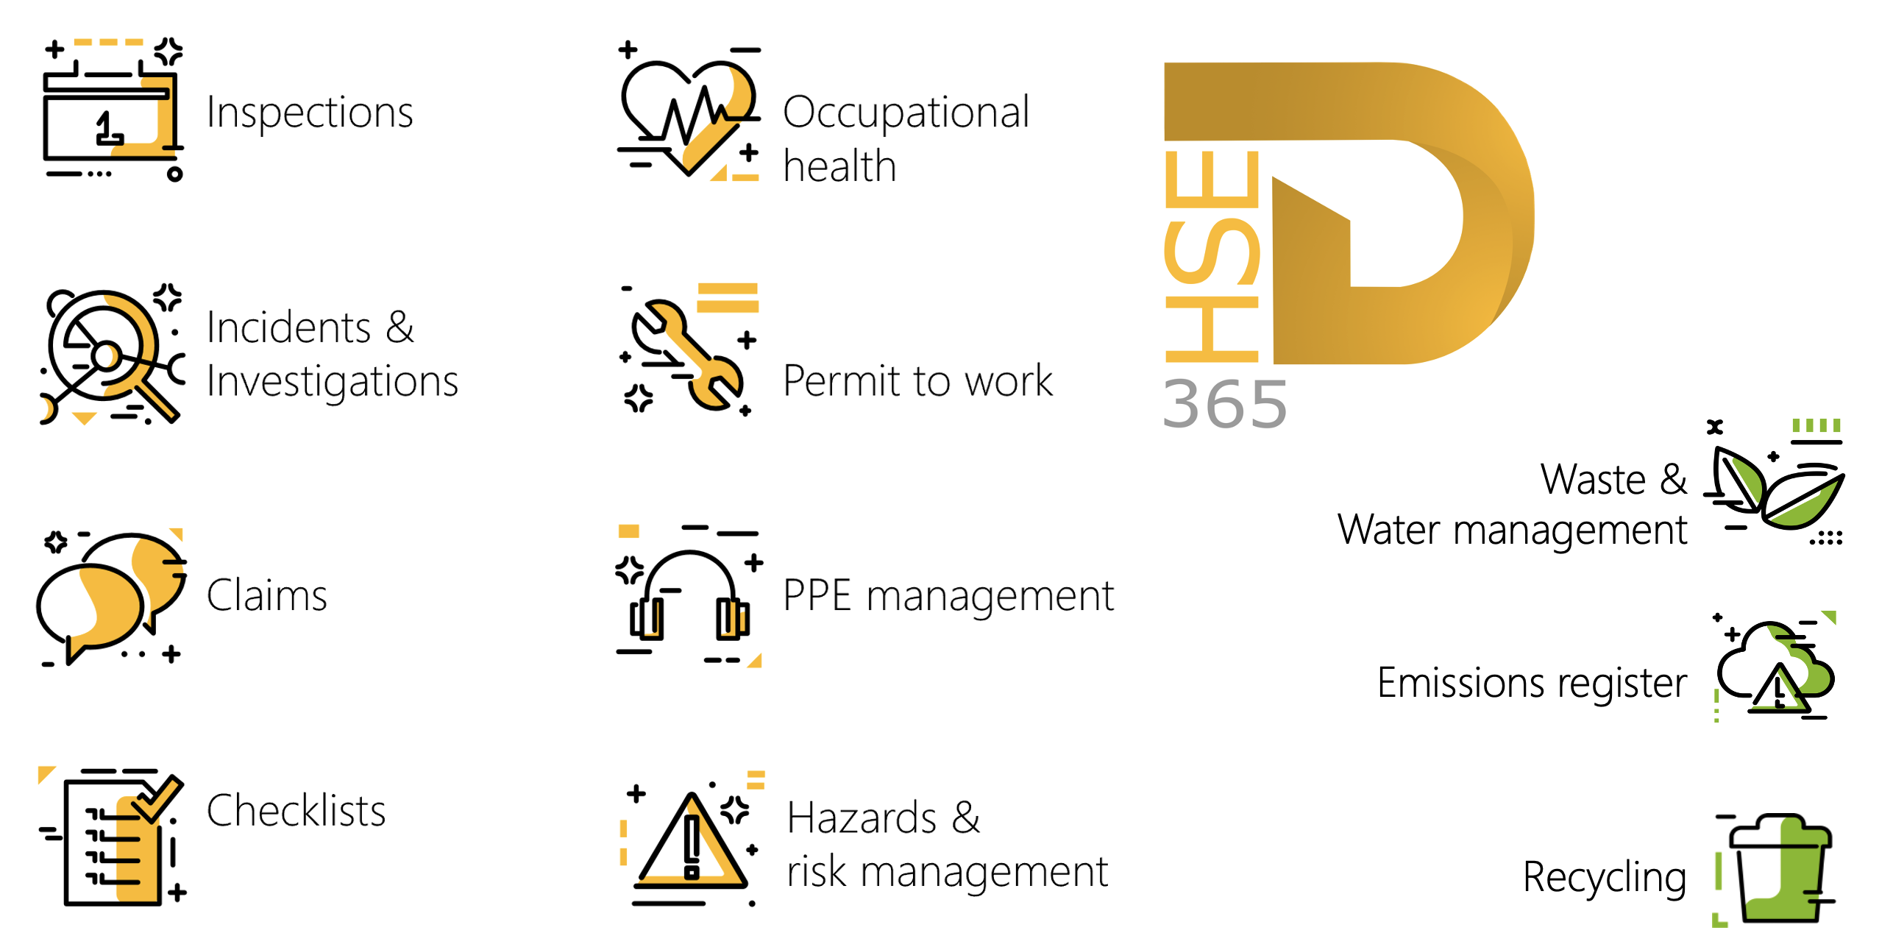

Release version

GRC/HSE Package version: OHSDeployablePackage_10_34_2105_11

This package was created on Microsoft Dynamics 365 for Finance and Operations:

Release | Version | Build number
Application release | 10.0.43 | 10.34.2105
Platform release | Platform update 67 | 7.0.7521.60

Enhancements:

Module | Description
Contracts management | - On the Legal, Contracts and Tender management workspace, Contracts Index tab:  - Two new Fast tabs were added: Accounts payable and Accounts receivable. The user can filter on Currency and Year to display the relevant information in a graph.  - The Sales order processing and enquiry workspace:  - New Contracts can now be created form the workspace  - A new All contracts tile was added. This tile opens a list of all account receivable contracts in legal entity.  - On the New contract dialog, in the Contract (type) classification dropdown, a display for AR was added.
Mine sales | - On the Sales order, users can capture the blending of stockpiles to increase average NCV. On click of Calculate the Average NCV is calculated and the price is adjusted accordingly.
Business continuity | - On the Activated plan:  - The End date and time field is now populated when the status is changed to Completed. The record will be locked.  - The Add and Remove buttons under the Disruptive events Fast tab are disabled when the status is changed to Closed.  - When the Re-open button is clicked, the status is changed to Created, and the Start button is enabled.  - The End date field id cleared when the Start button is clicked.
Tender management | - On the Procurement initiation form (PIF):  - The Technical and Commercial weight applied on the Solicitation type is now accurately displayed on the PIF report.  - Some columns were made wider to make reading easier.

Module | Description
Enterprise risk management | - A new Assessment roll forward enum/column was added to the end of the grid on the Risk type setup form.  - The currency on existing assessments (RALs) now only changes when the MFL field is modified.  - The following security privileges were created for existing duties:  - Maintain risk line assessment calculation inherent cost - added to the Maintain risk duty  - View risk line assessment calculation inherent cost – added to the View risk duty  These privileges can be assigned to custom roles or duties
Asset management | Functionality to enable users to procure spare parts from Maintenance requests in the Asset management module for emergency procurement purposes, was added. It allows users to create Purchase requisitions and Purchase orders directly from the Maintenance request when converting to a Work order.
Inspections | When a risk assessment is done on an Inspection, a record is added under the Signatures Fast tab with the Risk assessed box ticked.
O2M | - When an Incident ID is selected on the Create work order dialog, a record is added on the Incident under the Associations Fast tab.  - On the Work order:  - A new Incident display was added under the General Fast tab, displaying the associated Incident.  - A new Incidents button was added in the Action pane. This button opens a list page of all Incidents linked to the Work order.  - On the Maintenance request:  - On the Create new maintenance request dialog, a new Incident lookup was added.  - Under the Asset Fast tab, a new Incident display was added, displaying the associated Incident.  - When a Work order is created from an Incident, the Incident ID and selected Asset are populated on the create dialog.  - When a maintenance request is done from an Incident, the Incident ID is now populated in a new Incident field. A record is also added under the Associations Fast tab on the Incident.
Safety and security | A few changes were made to the Contractor safety and security portal to make it easier to navigate:  - Three Index tabs were added to group similar information together:  - My details, My work, Policies, contracts and links  - Additional menu items were added under the New button in the button strip:  - New risk assessment  - Request new permit to work  - The New and Delete buttons behind all the tiles are now disabled.  - Under Policies, documents and links:  - A hyperlink was added to the Document pack name, under the Policies, documents and links Index tab.  - Some details of the documents in the selected Document pack are now displayed in a new grid.

Bug fixes:

Module | Description
Tender management | - Some fields were not visible on the RFQ manage replies, and buttons on the RFQ were disabled when Envelope opening was set to Not required on the Solicitation type.  - When a Vendor is disqualified for Technical- or Commercial reasons on a Request for Quotation, the Vendor was not appearing in the Evaluation table as either Technically or Commercially disqualified.  These issues have been resolved.

Release Data impact

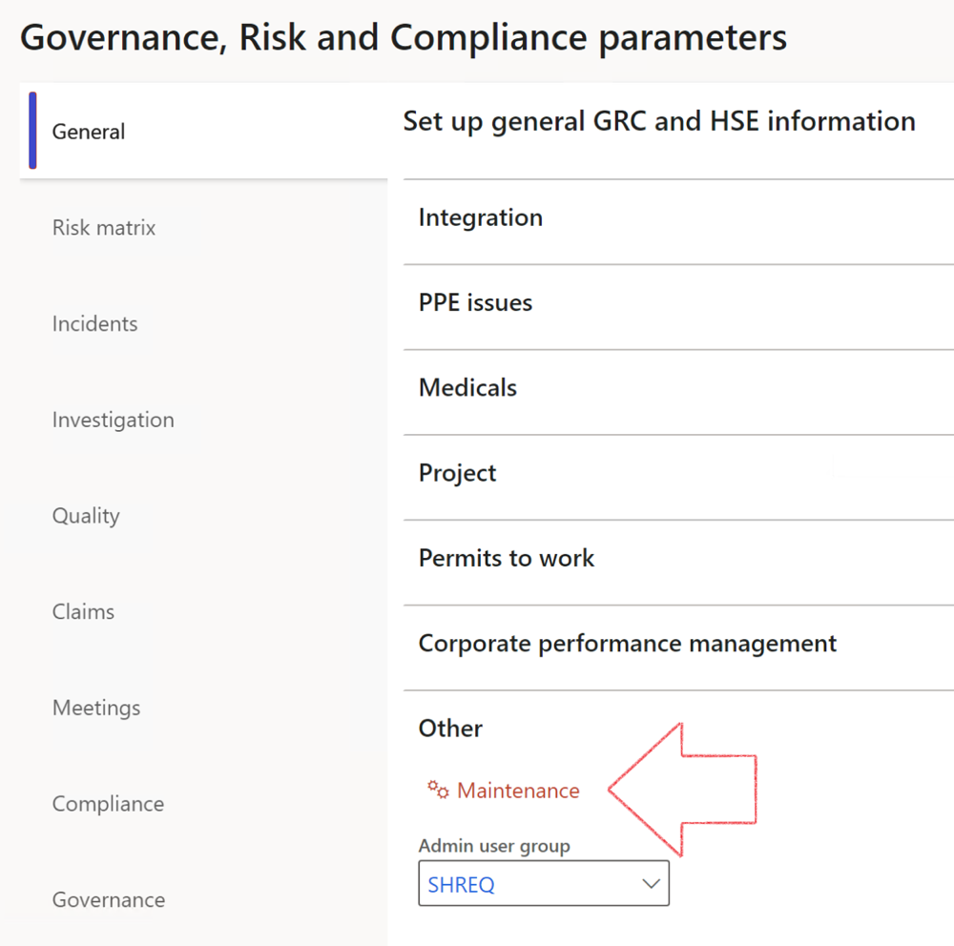

 | The Maintenance button is there for designated user. This button repairs any possible data issues. For a full history of all Data related repairs; see table below:

The information contained in this document represents the current view of Axnosis and Microsoft Corporation on the issues discussed as of the date of publication. Because Axnosis and Microsoft must respond to changing market conditions, this document should not be interpreted to be a commitment on the part of Axnosis and Microsoft, and Axnosis and Microsoft cannot guarantee the accuracy of any information presented after the date of publication.
This test script is for informational purposes only. AXNOSIS AND MICROSOFT MAKE NO WARRANTIES, EXPRESS, IMPLIED, OR STATUTORY, AS TO THE INFORMATION IN THIS DOCUMENT.
Complying with all applicable copyright laws is the responsibility of the user. Without limiting the rights under copyright, no part of this document may be reproduced, stored in or introduced into a retrieval system, or transmitted in any form or by any means (electronic, mechanical, photocopying, recording, or otherwise), or for any purpose, without the express written permission of Axnosis and Microsoft Corporation.
Axnosis and Microsoft may have patents, patent applications, trademarks, copyrights, or other intellectual property rights covering subject matter in this document. Except as expressly provided in any written license agreement from Axnosis and Microsoft, the furnishing of this document does not give you any license to these patents, trademarks, copyrights, or other intellectual property.
© 2021 Microsoft Corporation. All rights reserved. Any use or distribution of these materials without express authorization of Microsoft Corp. is strictly prohibited.
Microsoft and Windows are both registered trademarks of Microsoft Corporation in the United States and/or other countries.
The names of actual companies and products mentioned herein may be the trademarks of their respective owners.

Process | Description/notes | Release
Fix location vs. work centres | Populate the new LocationRecID field with the related location associated with previously used work centre location (Location) fields on the following tables:  - OHSHazardLocations,  - OHSRiskHazard,  - OHSRiskHazardWizard,  - OHSRiskRegister,  - OHSRisksWizard,  - OHSSafetyLocations,  - OHSSafetyPermit,  - OHSSafetyPermitLocations  - OHSSafetyPermitOverlap,  - OHSSafetyPlan,  - OHSInvestigation | 10.0.80.10
Fix risk hazards | Assigning the value "Default Risk" to the new mandatory field RiskID (Key field) where empty | 10.0.80.10
Fix incident HRM injury link | Delete all orphaned records from the OHSIncidentHRMInjuryLnk table | 10.0.11785.3
Populate SRS analysis enums | Still in concept phase. To provide a link between enum numerical value and value name for use with BYOD data entities. Enums available:  - OHSIncidentType,  - OHSIncidentSeverityType.  Table populated: SRSAnalysisEnums | 10.0.11785.3
Fix budget transaction lines stock\item dimension | Set OHSInventDimId field value to "AllBlank" on table BudgetTransactionLine, where no value was recorded. This will solve the issue of records not displaying in the form.  Note: this step will only fix existing budget transaction records in the system. Should any new transactions be uploaded or changed via the data entity Budget Account Entries, special care needs to be taken to specify the Stock dimension = AllBlank and the Item on the excel sheet to import. | 10.1.1366.6
Update existing incidents with the new Incident types | Update existing incidents with the Incident types that are setup on the new Incident type setup form. (IncidentTypeRecId) | 10.17.1250.5
Update existing risks with the new Control types | Update existing risks with the Control types that are setup on the new Control type setup form. | 10.17.1250.6
Re-number GRC Question and Answer Group lines | Re-number GRC Question and Answer Group line numbers | 10.22.1561.3
Fix Inspection locations: Replace Work centre-based locations with HSE locations | Populate the new ObjectLocation field with the related HSE location associated with previously used work centre location (Location) field on the following tables:  - OHSInspectionJournalName  - OHSInspectionJournalTable  - OHSInspectionJournalTrans  - OHSInspectionHistory  - OHSSchedule | 10.24.1114.3
Process | Description/notes | Release
Display of non-calculation lines | Run this job to ensure data consistency and correct display of historical data.
Fix Asset counter stock dimensions  Fix Line types on Data repository lines  Delete Orphan Data repositories | Replace empty stock dimension values with a blank dimension value  Populate missing line types from reporting templates on Data repository lines  Delete data repositories for which no template, year, site, period name or month was defined. | 10.26.1087.3  10.28.1080.6  10.30.2459.4
Equivalent Functional location fields | The equivalent Functional location fields will be populated where an HSE Location exists on the permit to work pool header and linked Permit to work table. | 10.30.2459.12

