
Dynamics GRC/HSE Release notes



Governance Risk & Compliance
Health, Safety & Environment

for

Microsoft Dynamics 365 for Finance & Operations™

Dynamics GRC/HSE version 10.34.2105.10

2025-11-10



Dynamics 365 FO GRC module  GRC is an add-on for Dynamics 365 suite of business application software.  This software provides compelling functionality to support Governance, Risk management and Compliance. | 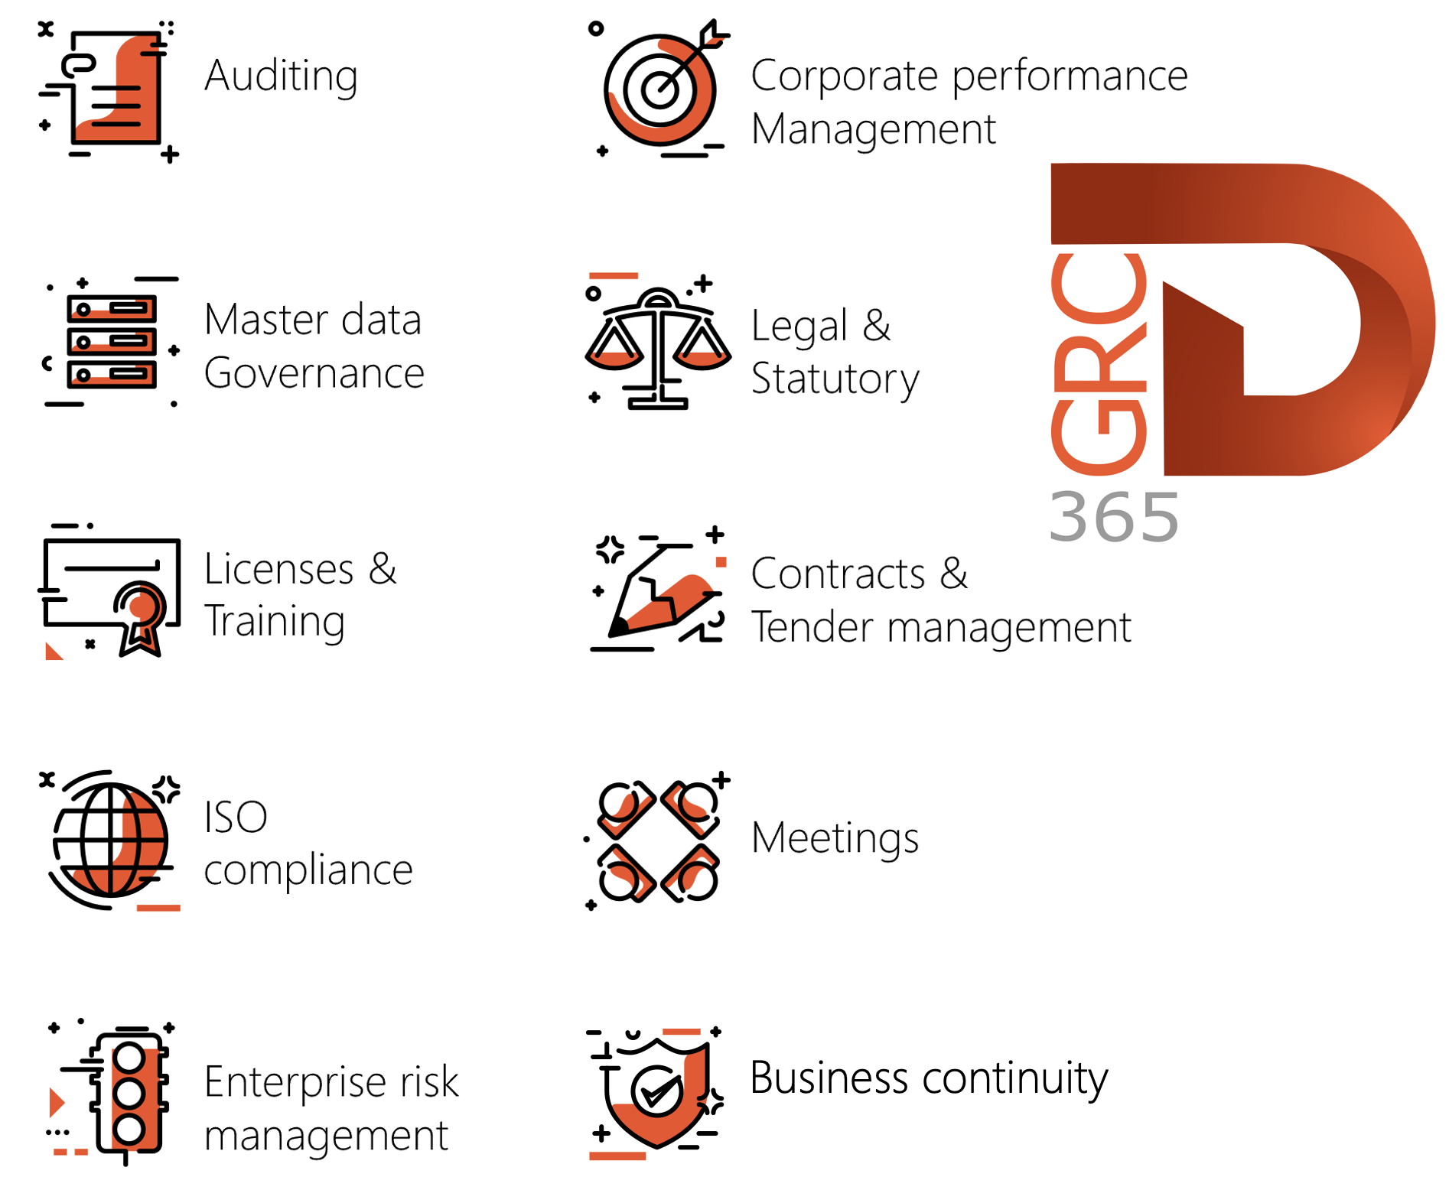

Dynamics 365 FO HSE/OHS

OHS/HSE is an add-on for Dynamics 365 suite of business application software.

This software adds to GRC in that compliance is now deeper with explicit functionality for Health, Safety and Environment as per the depicted sub-modules below.
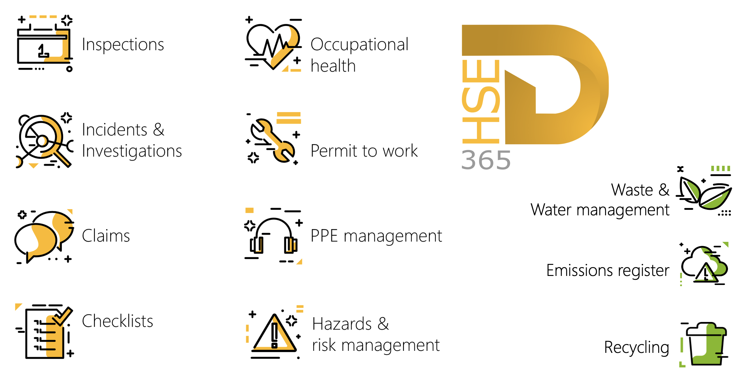

Release version

GRC/HSE Package version: OHSDeployablePackage_10_34_2105_10

This package was created on Microsoft Dynamics 365 for Finance and Operations:

Release | Version | Build number
Application release | 10.0.43 | 10.34.2105
Platform release | Platform update 67 | 7.0.7521.60

Enhancements:

Module | Description
Contracts management | - Sales orders can now be created form Contracts.  - On the Contract, under the Trading partners Fast tab, a new Forex column was added.  - On the Contract classification setup form, the Enforce AR label was changed to AR.
Vendor collaboration | - On the Vendor bidding workspace:  - The Negotiation response (header level) button was moved to after the Notifications button.  - The Negotiation response (header level) button is now greyed out for the vendor when:  - The Negotiations grid under the Governance Fast tab on the RFQ is blank  - The Status of the negotiation on the RFQ is changed to Requested  - The Negotiation response (header level) button is hidden when the Solicitation type on the RFQ, Negotiation level field = Line  - The Negotiation (header level) Fast tab is hidden when the Solicitation type on the RFQ, Negotiation level field = Line
Management of change | - Users will now be blocked from creating a new CR for a contract or PO when the reference number is entered manually on the CR form. The block will occur IF a CR has already been submitted for review on the provided reference (AND for contracts, the contract must have an Approved status). An appropriate warning message is displayed as well.  - The downstream functionality has been updated to reflect the correct commitment type for NEW lines on purchase agreements.  - Procurement categories will reflect a commitment type of Product category value commitment.  - Items will reflect a commitment type of Product quantity commitment.
Business continuity | - A department filter was added on the Impact assessment, Down time report. If the user does not select a department on the print dialog, the records are grouped by department on the report.  - On the Business continuity workspace, Print button’s dropdown list, the Impact assessment; Downtime report menu item was moved to the bottom of the list.

Module | Description
Tender management | - On the Procurement plan under the Planning and approvals Fast tab:  - Help text was added to the Technical envelope and Commercial envelope fields.  - Some labels were changed to align with the RFQ and Gantt chart.  - On the Procurement plan Gantt chart:  - Some labels were changed  - The following fields/labels were added under the Procurement plans column:  - Planned issuance of documents date  - RFQs to be sent date  - Envisaged technical envelope opening date  - Envisaged commercial envelope opening date  - Envisaged evaluation start date  - Envisaged evaluation end date  - The following columns were added on the Procurement plan lines, under the Procurement plan lines Fast tab: Line type and Procurement category.  - When a RFQ is created from the Procurement plan, the values selected on lines where the Type = Category now also pull through to the RFQ.  - A new Hide all button was added in the Button strip to hide additional columns added via the [Show] button.  - The Evaluation criteria field on the create New Procurement plan dialog is now hidden.  - On the RFQ header, Governance Fast tab, under the Bid specification Index tab, The Bid specification field is now a lookup to all Approved specifications, not Baseline specifications.  - On the Solicitation type, Governance Fast tab, the following functionality was added to the Enable voting slider:  - When the slider = Yes, the Create votes button on the RFQ, Governance Fast tab, Recommendation Index tab, is enabled.  - When the slider = No, the Create votes button on the RFQ, Governance Fast tab, Recommendation Index tab, is disabled.  - The Projects and pricing Fast tab is now visible on the Specification form (where Document type = Specification).  - On the RFQ Manage replies, the following fields are hidden if the Negotiation envelope has not been opened for the selected vendor:  - On the Manage replies Header under the Quotation Fast tab, Negotiation price field  - On the Manage replies Lines under the Purchase quotation lines Fast tab, Negotiation unit price column  - On the Compare replies, Negotiation price column  When the Negotiation envelope for the selected vendor is opened, all above mentioned fields are visible again.

Module | Description
Enterprise legal | - All the mini list pages on the Enterprise legal workspace, are now non-editable.  - A new mini list page was added on the Legal, Contracts and Tender management workspace, About to expire Index tab, for Open tender events.
Operational risk management | - Under Asset management, Work orders, Lines, under the Line details Fast tab: the help text for the Risk register field was improved to better guide the user.
Incidents | - On the Incident, under the Associations Fast tab, the following two values were added to the Entity type enum: Job card and Maintenance request.

Bug fixes:

Module | Description
Contracts management | On the Contract, under the Item lines Fast tab, the Discount % value was not pulling through to the Discount percent field on the Sales order.  The issue has been resolved.

Release Data impact

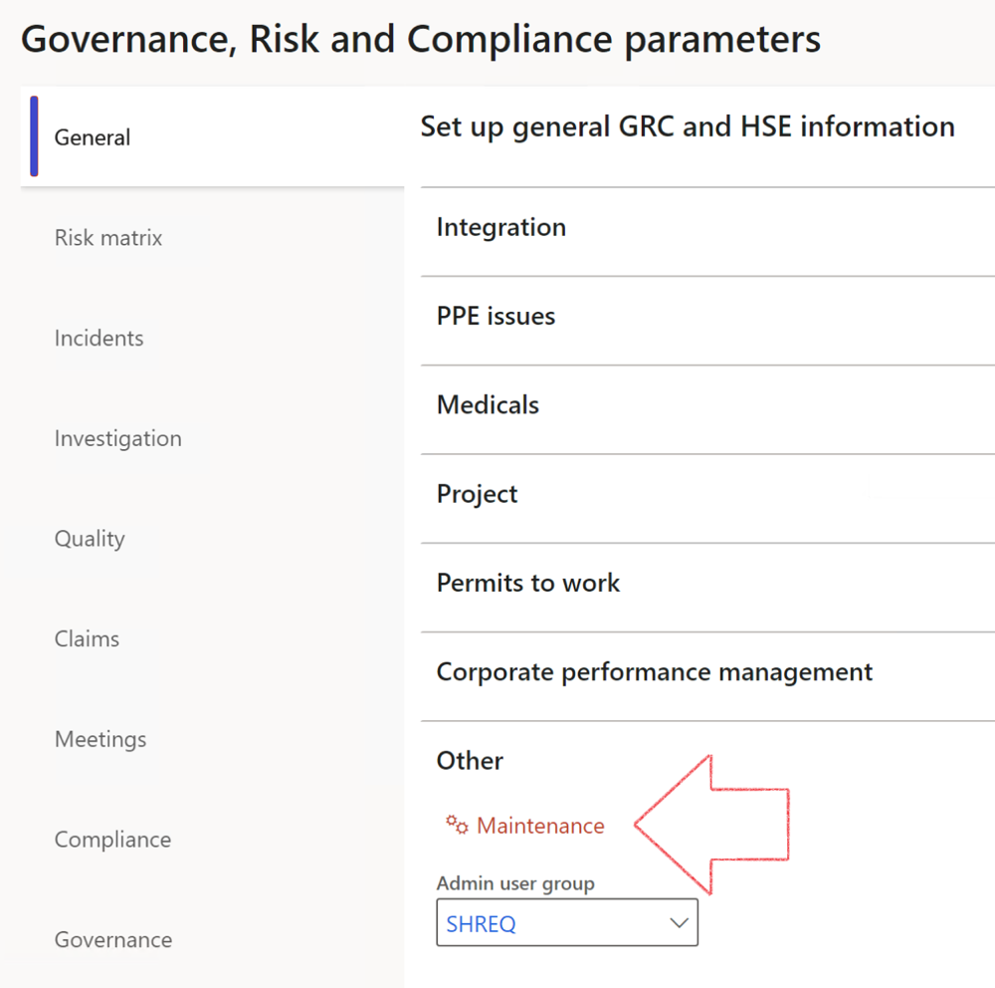

 | The Maintenance button is there for designated user. This button repairs any possible data issues. For a full history of all Data related repairs; see table below:

The information contained in this document represents the current view of Axnosis and Microsoft Corporation on the issues discussed as of the date of publication. Because Axnosis and Microsoft must respond to changing market conditions, this document should not be interpreted to be a commitment on the part of Axnosis and Microsoft, and Axnosis and Microsoft cannot guarantee the accuracy of any information presented after the date of publication.
This test script is for informational purposes only. AXNOSIS AND MICROSOFT MAKE NO WARRANTIES, EXPRESS, IMPLIED, OR STATUTORY, AS TO THE INFORMATION IN THIS DOCUMENT.
Complying with all applicable copyright laws is the responsibility of the user. Without limiting the rights under copyright, no part of this document may be reproduced, stored in or introduced into a retrieval system, or transmitted in any form or by any means (electronic, mechanical, photocopying, recording, or otherwise), or for any purpose, without the express written permission of Axnosis and Microsoft Corporation.
Axnosis and Microsoft may have patents, patent applications, trademarks, copyrights, or other intellectual property rights covering subject matter in this document. Except as expressly provided in any written license agreement from Axnosis and Microsoft, the furnishing of this document does not give you any license to these patents, trademarks, copyrights, or other intellectual property.
© 2021 Microsoft Corporation. All rights reserved. Any use or distribution of these materials without express authorization of Microsoft Corp. is strictly prohibited.
Microsoft and Windows are both registered trademarks of Microsoft Corporation in the United States and/or other countries.
The names of actual companies and products mentioned herein may be the trademarks of their respective owners.

Process | Description/notes | Release
Fix location vs. work centres | Populate the new LocationRecID field with the related location associated with previously used work centre location (Location) fields on the following tables:  - OHSHazardLocations,  - OHSRiskHazard,  - OHSRiskHazardWizard,  - OHSRiskRegister,  - OHSRisksWizard,  - OHSSafetyLocations,  - OHSSafetyPermit,  - OHSSafetyPermitLocations  - OHSSafetyPermitOverlap,  - OHSSafetyPlan,  - OHSInvestigation | 10.0.80.10
Fix risk hazards | Assigning the value "Default Risk" to the new mandatory field RiskID (Key field) where empty | 10.0.80.10
Fix incident HRM injury link | Delete all orphaned records from the OHSIncidentHRMInjuryLnk table | 10.0.11785.3
Populate SRS analysis enums | Still in concept phase. To provide a link between enum numerical value and value name for use with BYOD data entities. Enums available:  - OHSIncidentType,  - OHSIncidentSeverityType.  Table populated: SRSAnalysisEnums | 10.0.11785.3
Fix budget transaction lines stock\item dimension | Set OHSInventDimId field value to "AllBlank" on table BudgetTransactionLine, where no value was recorded. This will solve the issue of records not displaying in the form.  Note: this step will only fix existing budget transaction records in the system. Should any new transactions be uploaded or changed via the data entity Budget Account Entries, special care needs to be taken to specify the Stock dimension = AllBlank and the Item on the excel sheet to import. | 10.1.1366.6
Update existing incidents with the new Incident types | Update existing incidents with the Incident types that are setup on the new Incident type setup form. (IncidentTypeRecId) | 10.17.1250.5
Update existing risks with the new Control types | Update existing risks with the Control types that are setup on the new Control type setup form. | 10.17.1250.6
Re-number GRC Question and Answer Group lines | Re-number GRC Question and Answer Group line numbers | 10.22.1561.3
Fix Inspection locations: Replace Work centre-based locations with HSE locations | Populate the new ObjectLocation field with the related HSE location associated with previously used work centre location (Location) field on the following tables:  - OHSInspectionJournalName  - OHSInspectionJournalTable  - OHSInspectionJournalTrans  - OHSInspectionHistory  - OHSSchedule | 10.24.1114.3
Process | Description/notes | Release
Display of non-calculation lines | Run this job to ensure data consistency and correct display of historical data.
Fix Asset counter stock dimensions  Fix Line types on Data repository lines  Delete Orphan Data repositories | Replace empty stock dimension values with a blank dimension value  Populate missing line types from reporting templates on Data repository lines  Delete data repositories for which no template, year, site, period name or month was defined. | 10.26.1087.3  10.28.1080.6  10.30.2459.4
Equivalent Functional location fields | The equivalent Functional location fields will be populated where an HSE Location exists on the permit to work pool header and linked Permit to work table. | 10.30.2459.12

