

Dynamics GRC/HSE Release notes



Governance Risk & Compliance

Health, Safety & Environment

for

**Microsoft Dynamics 365 for Finance & Operations™**

*Dynamics GRC/HSE version* 10.33.1620.8

2025-03-13



|  |  |
| --- | --- |
| Dynamics 365 FO GRC module GRC is an add-on for Dynamics 365 suite of business application software.  This software provides compelling functionality to support Governance, Risk management and Compliance. |  |
| Dynamics 365 FO HSE/OHS OHS/HSE is an add-on for Dynamics 365 suite of business application software.  This software adds to GRC in that compliance is now deeper with explicit functionality for Health, Safety and Environment as per the depicted sub-modules below. | |
|  | |

Release version

**GRC/HSE Package version:** OHSDeployablePackage_10_33_1620_8

This package was created on Microsoft Dynamics 365 for Finance and Operations:

|  |  |  |
| --- | --- | --- |
| **Release** | **Version** | **Build number** |
| Application release | 10.0.42 | 10.33.1620 |
| Platform release | Platform update 66 | 7.0.7452.66 |

# Enhancements:

|  |  |
| --- | --- |
| Module | Description |
| Management of Change | * On the **Create new change request** dialog: the filter on the **Contract** lookup was improved to only list **Approved** contracts, and contracts with no active change requests linked. * A few changes were made on the **Change request** detail form:   + Under the **General** Fast tab: The **Final cost impact** display is now hidden.   + Additional displays were added under the **Changes to** Fast tab:     - Under the **Contracts** field group:       * **Approved CRs value, Current CR value, Total contract value**     - Under the **Purchase orders** field group:       * **Initial purchase order value, Approved CRs value, Current CR value, Total purchase order value** * On the **Contract**: the following fields were added on the **Renewal** drop-dialog:   + **Summary of change** – The values entered in this note box are pulled through to the Change request header.   + **Auto create note** – Yes/no slider. If **Yes** is selected, a note will automatically created on the Change request. |
| Tender management | * On the **Solicitation type**, under the **Governance** Fast tab: A new Recommendation team lookup was added. The value selected here gets passed to the RFQ under the Committees Index tab. * A **Recommendation** button was added in the Action pane of the **Compare replies** form so that Recommendations can be done from the Compare replies. * On the **RFQ**, under the Governance Fast tab, the **Approved bidders from procurement plan** label was changed to **Approved bidders from purchase requisition/procurement plan**. * A new **Bid negotiations** menu item was added under the Governance, Reports and inquiries menu item. This opens a new **Bid negotiations enquiry**. * A new **Delete submission** slider was added on the GRC parameters, Governance tab, **Sourcing and tender governance** Fast tab. The standard Microsoft wording on the RFQ, **Finalize amendment** wizard indicated that the bid was to be invalidated, and it was. If this new slider is set to **No**, the wording in the wizard does not indicate that the bid will be invalidated, and the bid is not invalidated. |

|  |  |
| --- | --- |
| **Module** | **Description** |
| Contracts management | * On the **Contract**, under the **Performance** Fast tab, a new **Number** column was added to the grid. * The following changes were made on the Action pane, under the **Compliance** tab of the **Vendor** form:   + The **Access cards** button was moved from the Audits button group to the Safety button group   + The **Create goals** button in the Performance button group was changed to **Create contract goals**. |
| Compliance audits | * The following display methods were added on the **Document pack** under the **Related documents** Fast tab:   + Type   + Date created   + Expiry date * On the **Area of compliance** lines, under the **Compliance functions** Fast tab, an **Audit procedure** lookup was added. Only job plans where the Audit tick is on, can be selected form this list. * A new **Show** button group was added on the **All compliance audits** Action pane. This gives the user the option to view the following:   + Al documents linked to the selected record   + All **audit procedures** linked to the selected record |
| Business continuity | * The following new menu items were added under the **Business continuity** folder so that the logged in user can view records for his/her own department:   + **All continuity and disaster recoveries for my department**   + **All business impact assessments for my department**   + **My business process administrations** * Once a BC/DR plan is **approved**, a record is added under the **Sign off** Fast tab. |
| Performance management | A new **Date** field was added on the **KRI & goals** form under the **Measurements** Fast tab. This Date field can also be edited by clicking on the **Edit measurements** button. |
| General | A new Documents Fast tab with Document pack lookup, was added to the **Courses** Form. |

*Bug fixes:*

|  |  |
| --- | --- |
| **Module** | **Description** |
| Contracts management | Contract-linked Invoices could exceed the contract value when **AP enforce** was set to **Yes**.  The issue has been resolved. |

Release Data impact

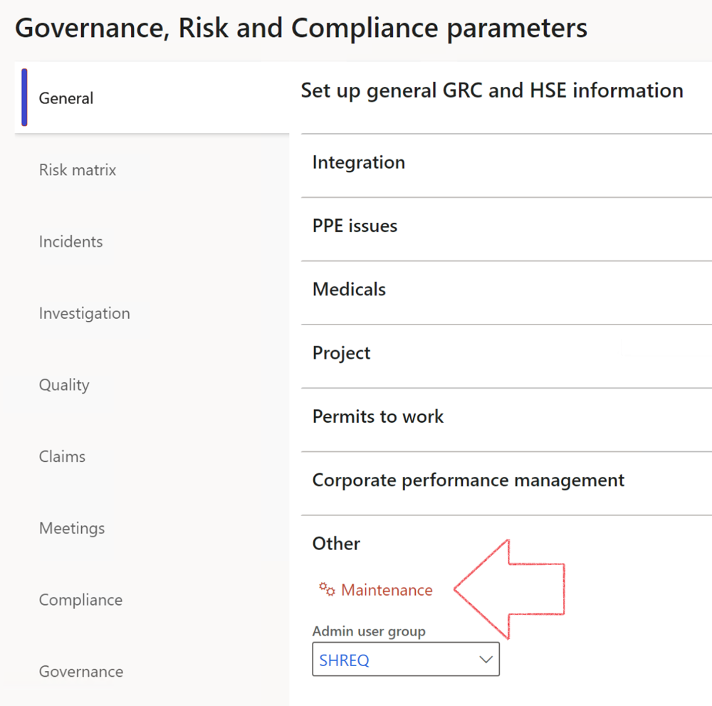

|  |  |
| --- | --- |
|  | The **Maintenance** button is there for designated user. This button repairs any possible data issues. For a full history of all Data related repairs; see table below: |

The information contained in this document represents the current view of Axnosis and Microsoft Corporation on the issues discussed as of the date of publication. Because Axnosis and Microsoft must respond to changing market conditions, this document should not be interpreted to be a commitment on the part of Axnosis and Microsoft, and Axnosis and Microsoft cannot guarantee the accuracy of any information presented after the date of publication.

This test script is for informational purposes only. AXNOSIS AND MICROSOFT MAKE NO WARRANTIES, EXPRESS, IMPLIED, OR STATUTORY, AS TO THE INFORMATION IN THIS DOCUMENT.

Complying with all applicable copyright laws is the responsibility of the user. Without limiting the rights under copyright, no part of this document may be reproduced, stored in or introduced into a retrieval system, or transmitted in any form or by any means (electronic, mechanical, photocopying, recording, or otherwise), or for any purpose, without the express written permission of Axnosis and Microsoft Corporation.

Axnosis and Microsoft may have patents, patent applications, trademarks, copyrights, or other intellectual property rights covering subject matter in this document. Except as expressly provided in any written license agreement from Axnosis and Microsoft, the furnishing of this document does not give you any license to these patents, trademarks, copyrights, or other intellectual property.

© 2021 Microsoft Corporation. All rights reserved. Any use or distribution of these materials without express authorization of Microsoft Corp. is strictly prohibited.

Microsoft and Windows are both registered trademarks of Microsoft Corporation in the United States and/or other countries.

The names of actual companies and products mentioned herein may be the trademarks of their respective owners.

|  |  |  |
| --- | --- | --- |
| **Process** | **Description/notes** | **Release** |
| Fix location vs. work centres | Populate the new **LocationRecID** field with the related location associated with previously used work centre location (Location) fields on the following tables:   * OHSHazardLocations, * OHSRiskHazard, * OHSRiskHazardWizard, * OHSRiskRegister, * OHSRisksWizard, * OHSSafetyLocations, * OHSSafetyPermit, * OHSSafetyPermitLocations * OHSSafetyPermitOverlap, * OHSSafetyPlan, * OHSInvestigation | 10.0.80.10 |
| Fix risk hazards | Assigning the value "Default Risk" to the new mandatory field **RiskID** (Key field) where empty | 10.0.80.10 |
| Fix incident HRM injury link | Delete all orphaned records from the **OHSIncidentHRMInjuryLnk** table | 10.0.11785.3 |
| Populate SRS analysis enums | Still in concept phase. To provide a link between enum numerical value and value name for use with BYOD data entities. Enums available:   * OHSIncidentType, * OHSIncidentSeverityType.   Table populated: **SRSAnalysisEnums** | 10.0.11785.3 |
| Fix budget transaction lines stock\item dimension | Set **OHSInventDimId** field value to "**AllBlank**" on table **BudgetTransactionLine**, where no value was recorded. This will solve the issue of records not displaying in the form.  **Note: this step will only fix existing budget transaction records in the system. Should any new transactions be uploaded or changed via the data entity Budget Account Entries, special care needs to be taken to specify the Stock dimension = AllBlank and the Item on the excel sheet to import.** | 10.1.1366.6 |
| Update existing incidents with the new **Incident types** | Update existing incidents with the **Incident types** that are setup on the new **Incident type** setup form. (IncidentTypeRecId) | 10.17.1250.5 |
| Update existing risks with the new **Control types** | Update existing risks with the **Control types** that are setup on the new **Control type** setup form. | 10.17.1250.6 |
| Re-number GRC Question and Answer **Group lines** | Re-number GRC Question and Answer **Group line numbers** | 10.22.1561.3 |
| Fix Inspection locations: Replace Work centre-based locations with HSE locations | Populate the new **ObjectLocation** field with the related HSE location associated with previously used work centre location (**Location**) field on the following tables:   * OHSInspectionJournalName * OHSInspectionJournalTable * OHSInspectionJournalTrans * OHSInspectionHistory * OHSSchedule | 10.24.1114.3 |
| **Process** | **Description/notes** | **Release** |
| Display of non-calculation lines | Run this job to ensure data consistency and correct display of historical data. |  |
| Fix Asset counter stock dimensions  Fix Line types on Data repository lines  Delete Orphan Data repositories | Replace empty stock dimension values with a blank dimension value  Populate missing line types from reporting templates on Data repository lines  Delete data repositories for which no template, year, site, period name or month was defined. | 10.26.1087.3  10.28.1080.6  10.30.2459.4 |
| Equivalent Functional location fields | The equivalent Functional location fields will be populated where an HSE Location exists on the permit to work pool header and linked Permit to work table. | 10.30.2459.12 |