

Dynamics GRC/HSE Release notes



Governance Risk & Compliance

Health, Safety & Environment

for

**Microsoft Dynamics 365 for Finance & Operations™**

*Dynamics GRC/HSE version* 10.33.1620.5

2025-02-24



|  |  |
| --- | --- |
| Dynamics 365 FO GRC module GRC is an add-on for Dynamics 365 suite of business application software.  This software provides compelling functionality to support Governance, Risk management and Compliance. |  |
| Dynamics 365 FO HSE/OHS OHS/HSE is an add-on for Dynamics 365 suite of business application software.  This software adds to GRC in that compliance is now deeper with explicit functionality for Health, Safety and Environment as per the depicted sub-modules below. | |
|  | |

Release version

**GRC/HSE Package version:** OHSDeployablePackage_10_33_1620_5

This package was created on Microsoft Dynamics 365 for Finance and Operations:

|  |  |  |
| --- | --- | --- |
| **Release** | **Version** | **Build number** |
| Application release | 10.0.42 | 10.33.1620 |
| Platform release | Platform update 66 | 7.0.7452.66 |

# Enhancements:

|  |  |
| --- | --- |
| Module | Description |
| Safety and security | The layout of the **Contractor safety and security** was changed, and the following was added:   * Mini **Compliance audits** list page – List of all audits where the vendor is part of the audit * Mini **Non-conformance raised** list page – List of non-conformances for the logged in vendor |
| Investigations | When a **non-conformance** (NC) is created from an **Investigation**, a NC record is added under the **Associations** Fast tab on the Investigation. |
| Inspections | When a **non-conformance** is created form an **Inspection journal**, the Department and Department manager from the Inspection journal will pull through to the non-conformance. |
| General | * On the **Vendor**, in the Action pane, **Compliance** tab: * In the **Audit** button group, a new **Access cards** button was added – Opens a list of access cards for the vendor * A new **Safety** button group was added with the following buttons:   + - **Safety inductions** - Opens a list of safety inductions for the vendor     - **Permits to work** - Opens a list of permits to work for the vendor * A new **Other** button group was added with a **Claims** button – Opens the **Claims** form for the vendor * On the GRC parameters, Notifications tab, Email templates for batch use Fast tab:   + The **Activities alert** lookup, and **Only SHREQ activities** slider were moved to the end of all the lookups.   + The **Sales agreement expiry alert** label was changed to **Notification alert**   + The **Purchase agreement expiry alert** label was changed to **Contract termination alert** * The following menu items are now hidden on the **GRC menu**:   + **All open Governance, risk and compliance actions**   + **Create schedules** * The following menu items are now hidden on the **HSE menu**:   + **Create schedules**   + **Scheduled capacity load**   + **All open health and safety actions** |

|  |  |
| --- | --- |
| Module | Description |
| Contracts management | * On the **Approval authority**:   + A new **Finance manager** column was added   + The existing **Finance manager** column was renamed to **Contract request approver** * For measuring performance on contracts: a new **Performance** Fast tab was added on the **Contract** detail form. (This **Performance** Fast tab is also visible on the **Reports** and **Policies** detail forms) * A **Historical contract value** field was added to the Contracts table and Data entity. * On the **Purchase agreement**, the **Performance** Fast tab was moved, and is now an Index tab under the **Contracts administration** Fast tab. * Help text was added to the **Total value** field on the Contract detail form for clarity. |
| Tender management | * A **Solicitation type** lookup was added on the **Create purchase requisition** dialog. The value selected here is populated on the created PR. * **Voting** on the **RFQ:**   + Under the **Governance** Fast tab, new **Create votes** buttons were added under the **Business information** Index tab and under the **Recommendation** Index tab. On click of these buttons, records are created on a new **Voting** table.   + On the Action pane, in the **View** group, a new **Votes** button was added which opens the **Votes** form, displaying votes for the RFQ.   + Two new menu items were added under the **Periodic** folder:     - **All tender votes**     - **All my votes**   + A new **My votes** tile was added onthe **Legal, contracts and tender management** workspace. * On the **RFQ** header, under the **General** Fast tab, a new **Workflow status** field group was added. * The **From date** on the **Procurement plan Gantt chart** is now by default the current system date. * The **Request for quotation workflow** field group on the **GRC parameters** is now hidden. * When a RFQ is created from a **Purchase requisition**, the attachments on the PR are copied to the **RFQ**. * When a **Contract** is created from a **Purchase requisition**, the Baseline contract from the linked **Solicitation type** is copied into the create form. * On the **Purchase requisition**, in the Action pane, a new **Send email** button was added under the maintain button group. * A new **Governance** Fast tab was added under the **Purchase requisition** header. The following fields are displayed under this new Fast tab:   + **Approved list of bidders** and **Email template**   + **Approval team** and **Solicitation type**   + **Contract request** and **Contract**   + **Package ID** |

*Bug fixes:*

|  |  |
| --- | --- |
| **Module** | **Description** |
| Contracts management | * The **child contract** reference hyper link under the **Sub documents** in the Related information pane, opened a policy details form and not the required contract details form. * When a contract was created from a **baseline contract** where the baseline contract had items listed, the first **purchase agreement** created on the contract did not include the items copied from the baseline contract. * Incorrect **unit prices** and **net amounts** were copied to PA created from contract lines.   These issues have been resolved. |

Release Data impact

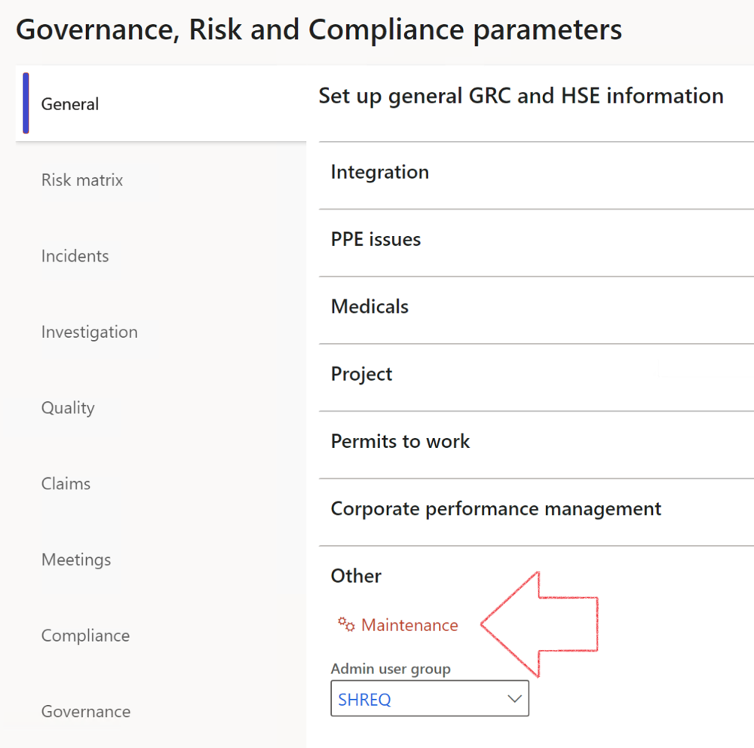

|  |  |
| --- | --- |
|  | The **Maintenance** button is there for designated user. This button repairs any possible data issues. For a full history of all Data related repairs; see table below: |

The information contained in this document represents the current view of Axnosis and Microsoft Corporation on the issues discussed as of the date of publication. Because Axnosis and Microsoft must respond to changing market conditions, this document should not be interpreted to be a commitment on the part of Axnosis and Microsoft, and Axnosis and Microsoft cannot guarantee the accuracy of any information presented after the date of publication.

This test script is for informational purposes only. AXNOSIS AND MICROSOFT MAKE NO WARRANTIES, EXPRESS, IMPLIED, OR STATUTORY, AS TO THE INFORMATION IN THIS DOCUMENT.

Complying with all applicable copyright laws is the responsibility of the user. Without limiting the rights under copyright, no part of this document may be reproduced, stored in or introduced into a retrieval system, or transmitted in any form or by any means (electronic, mechanical, photocopying, recording, or otherwise), or for any purpose, without the express written permission of Axnosis and Microsoft Corporation.

Axnosis and Microsoft may have patents, patent applications, trademarks, copyrights, or other intellectual property rights covering subject matter in this document. Except as expressly provided in any written license agreement from Axnosis and Microsoft, the furnishing of this document does not give you any license to these patents, trademarks, copyrights, or other intellectual property.

© 2021 Microsoft Corporation. All rights reserved. Any use or distribution of these materials without express authorization of Microsoft Corp. is strictly prohibited.

Microsoft and Windows are both registered trademarks of Microsoft Corporation in the United States and/or other countries.

The names of actual companies and products mentioned herein may be the trademarks of their respective owners.

|  |  |  |
| --- | --- | --- |
| **Process** | **Description/notes** | **Release** |
| Fix location vs. work centres | Populate the new **LocationRecID** field with the related location associated with previously used work centre location (Location) fields on the following tables:   * OHSHazardLocations, * OHSRiskHazard, * OHSRiskHazardWizard, * OHSRiskRegister, * OHSRisksWizard, * OHSSafetyLocations, * OHSSafetyPermit, * OHSSafetyPermitLocations * OHSSafetyPermitOverlap, * OHSSafetyPlan, * OHSInvestigation | 10.0.80.10 |
| Fix risk hazards | Assigning the value "Default Risk" to the new mandatory field **RiskID** (Key field) where empty | 10.0.80.10 |
| Fix incident HRM injury link | Delete all orphaned records from the **OHSIncidentHRMInjuryLnk** table | 10.0.11785.3 |
| Populate SRS analysis enums | Still in concept phase. To provide a link between enum numerical value and value name for use with BYOD data entities. Enums available:   * OHSIncidentType, * OHSIncidentSeverityType.   Table populated: **SRSAnalysisEnums** | 10.0.11785.3 |
| Fix budget transaction lines stock\item dimension | Set **OHSInventDimId** field value to "**AllBlank**" on table **BudgetTransactionLine**, where no value was recorded. This will solve the issue of records not displaying in the form.  **Note: this step will only fix existing budget transaction records in the system. Should any new transactions be uploaded or changed via the data entity Budget Account Entries, special care needs to be taken to specify the Stock dimension = AllBlank and the Item on the excel sheet to import.** | 10.1.1366.6 |
| Update existing incidents with the new **Incident types** | Update existing incidents with the **Incident types** that are setup on the new **Incident type** setup form. (IncidentTypeRecId) | 10.17.1250.5 |
| Update existing risks with the new **Control types** | Update existing risks with the **Control types** that are setup on the new **Control type** setup form. | 10.17.1250.6 |
| Re-number GRC Question and Answer **Group lines** | Re-number GRC Question and Answer **Group line numbers** | 10.22.1561.3 |
| Fix Inspection locations: Replace Work centre-based locations with HSE locations | Populate the new **ObjectLocation** field with the related HSE location associated with previously used work centre location (**Location**) field on the following tables:   * OHSInspectionJournalName * OHSInspectionJournalTable * OHSInspectionJournalTrans * OHSInspectionHistory * OHSSchedule | 10.24.1114.3 |
| **Process** | **Description/notes** | **Release** |
| Display of non-calculation lines | Run this job to ensure data consistency and correct display of historical data. |  |
| Fix Asset counter stock dimensions  Fix Line types on Data repository lines  Delete Orphan Data repositories | Replace empty stock dimension values with a blank dimension value  Populate missing line types from reporting templates on Data repository lines  Delete data repositories for which no template, year, site, period name or month was defined. | 10.26.1087.3  10.28.1080.6  10.30.2459.4 |
| Equivalent Functional location fields | The equivalent Functional location fields will be populated where an HSE Location exists on the permit to work pool header and linked Permit to work table. | 10.30.2459.12 |