

Dynamics GRC/HSE Release notes



Governance Risk & Compliance

Health, Safety & Environment

for

**Microsoft Dynamics 365 for Finance & Operations™**

*Dynamics GRC/HSE version* 10.33.1620.3

2025-02-14



|  |  |
| --- | --- |
| Dynamics 365 FO GRC module GRC is an add-on for Dynamics 365 suite of business application software.  This software provides compelling functionality to support Governance, Risk management and Compliance. |  |
| Dynamics 365 FO HSE/OHS OHS/HSE is an add-on for Dynamics 365 suite of business application software.  This software adds to GRC in that compliance is now deeper with explicit functionality for Health, Safety and Environment as per the depicted sub-modules below. | |
|  | |

Release version

**GRC/HSE Package version:** OHSDeployablePackage_10_33_1620_3

This package was created on Microsoft Dynamics 365 for Finance and Operations:

|  |  |  |
| --- | --- | --- |
| **Release** | **Version** | **Build number** |
| Application release | 10.0.42 | 10.33.1620 |
| Platform release | Platform update 66 | 7.0.7452.66 |

# Enhancements:

|  |  |
| --- | --- |
| Module | Description |
| Compliance audits | **To enhance contractor/vendor compliance:**   * On the **Vendor:**   + Under the **Vendor profile** Fast tab, these lookups were added:     - **Audit procedure**     - **Area of compliance**   + In the **Action pane**:     - A new **Compliance** tab was added with the following buttons:     - **Show audits** (Opens a list of compliance audits linked to the Vendor)     - **View non-conformance** (Opens a list of all Non-conformances linked to the Vendor) * On the **Compliance audit**:   + A new **Trading partners** button was added in the Action pane. When this button is clicked, a **Vendors** dialog opens where users can view as well as add/remove Vendors to the audit. * On the **Contractor safety and security portal** workspace:   + A new **Activity** option was added to the **New** button group, which, when selected, will open the **Create new activity** dialog.   + This newly created Activity will have a record under the **Associations** Fast tab, associating the selected vendor.   **To ensure Worker training compliance:**   * On the **Worker**, in the Action pane, under the Development button group, a new **Knowledge articles** button was added. * A new **Knowledge article** Fast tab was added |

|  |  |
| --- | --- |
| Module | Description |
| Management of change | On the **Request change request** drop-dialog (When users create a CR):   * The user now has the option to enter the **Summary of change**. This value is then passed to the **Summary of change** memo box on the **Change request** form, under the **General** Fast tab. * A new **Auto create note** Yes/no slider was added. When set to **yes**, a note will be added under the **Information** Fast tab, saving users time from doing this on the detail form. * On the **Approval authority**:   + The **Commercial owner** column was renamed to **Financial manager**   + The **Commercial user group** column is now hidden   + A **procurement manager** column was added   + A **procurement director** column was added |
| Business continuity | * On the **Continuity and disaster recovery**:   + A new **Create new BC/DR** dialog was created.   + A new **Create action plan with activities** dialog was introduced which opens when the user clicks on the **Activate** button in the Action pane. **Responsible workers** and **Due dates** for activities can be entered on each line now.   + A Status column was added to the **Continuity and disaster recovery** list page. * **Site** and **Department** columns were added to the **Business impact assessment** list page. |
| Corporate performance management | A new **Performance transactions reasons** setup form and table were created. Now, when a record is modified on the **Performance transactions** form, users must select a reason code from a **Reason code** lookup. This means that reasons are selected rather than free text. |
| General | For consistency, a few **Periodic** and **Reports and inquiries** menu item folders were moved around on the GRC and HSE menus. |

*Bug fixes:*

|  |  |
| --- | --- |
| **Module** | **Description** |
| Corporate performance management | The fields added to the change management control were editable by changing the values directly on the performance transactions form.  The issue has been resolved. |
| Contracts management | When a purchase agreement was created for a primary trading partner on a contract, the trading partner was duplicated.  The issue has been resolved. |

Release Data impact

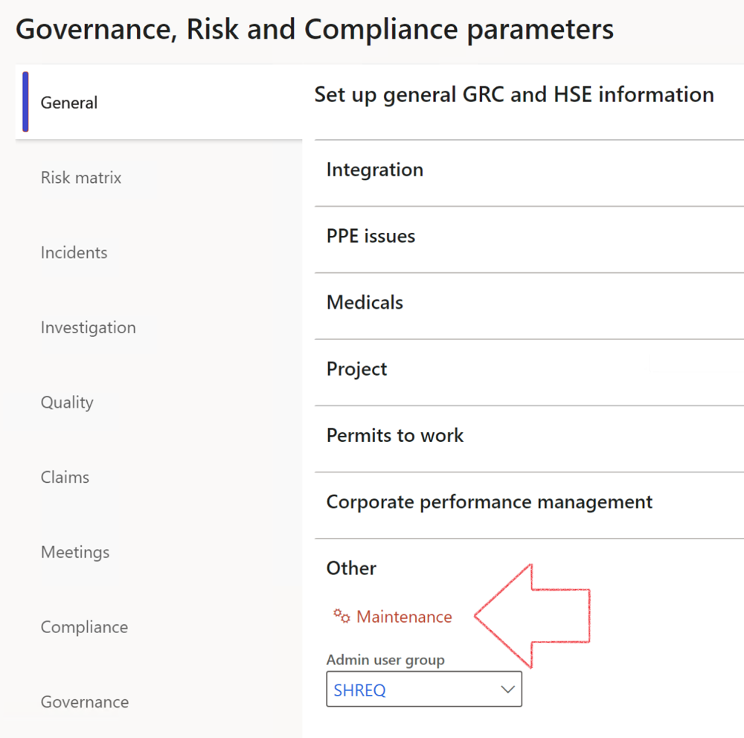

|  |  |
| --- | --- |
|  | The **Maintenance** button is there for designated user. This button repairs any possible data issues. For a full history of all Data related repairs; see table below: |

The information contained in this document represents the current view of Axnosis and Microsoft Corporation on the issues discussed as of the date of publication. Because Axnosis and Microsoft must respond to changing market conditions, this document should not be interpreted to be a commitment on the part of Axnosis and Microsoft, and Axnosis and Microsoft cannot guarantee the accuracy of any information presented after the date of publication.

This test script is for informational purposes only. AXNOSIS AND MICROSOFT MAKE NO WARRANTIES, EXPRESS, IMPLIED, OR STATUTORY, AS TO THE INFORMATION IN THIS DOCUMENT.

Complying with all applicable copyright laws is the responsibility of the user. Without limiting the rights under copyright, no part of this document may be reproduced, stored in or introduced into a retrieval system, or transmitted in any form or by any means (electronic, mechanical, photocopying, recording, or otherwise), or for any purpose, without the express written permission of Axnosis and Microsoft Corporation.

Axnosis and Microsoft may have patents, patent applications, trademarks, copyrights, or other intellectual property rights covering subject matter in this document. Except as expressly provided in any written license agreement from Axnosis and Microsoft, the furnishing of this document does not give you any license to these patents, trademarks, copyrights, or other intellectual property.

© 2021 Microsoft Corporation. All rights reserved. Any use or distribution of these materials without express authorization of Microsoft Corp. is strictly prohibited.

Microsoft and Windows are both registered trademarks of Microsoft Corporation in the United States and/or other countries.

The names of actual companies and products mentioned herein may be the trademarks of their respective owners.

|  |  |  |
| --- | --- | --- |
| **Process** | **Description/notes** | **Release** |
| Fix location vs. work centres | Populate the new **LocationRecID** field with the related location associated with previously used work centre location (Location) fields on the following tables:   * OHSHazardLocations, * OHSRiskHazard, * OHSRiskHazardWizard, * OHSRiskRegister, * OHSRisksWizard, * OHSSafetyLocations, * OHSSafetyPermit, * OHSSafetyPermitLocations * OHSSafetyPermitOverlap, * OHSSafetyPlan, * OHSInvestigation | 10.0.80.10 |
| Fix risk hazards | Assigning the value "Default Risk" to the new mandatory field **RiskID** (Key field) where empty | 10.0.80.10 |
| Fix incident HRM injury link | Delete all orphaned records from the **OHSIncidentHRMInjuryLnk** table | 10.0.11785.3 |
| Populate SRS analysis enums | Still in concept phase. To provide a link between enum numerical value and value name for use with BYOD data entities. Enums available:   * OHSIncidentType, * OHSIncidentSeverityType.   Table populated: **SRSAnalysisEnums** | 10.0.11785.3 |
| Fix budget transaction lines stock\item dimension | Set **OHSInventDimId** field value to "**AllBlank**" on table **BudgetTransactionLine**, where no value was recorded. This will solve the issue of records not displaying in the form.  **Note: this step will only fix existing budget transaction records in the system. Should any new transactions be uploaded or changed via the data entity Budget Account Entries, special care needs to be taken to specify the Stock dimension = AllBlank and the Item on the excel sheet to import.** | 10.1.1366.6 |
| Update existing incidents with the new **Incident types** | Update existing incidents with the **Incident types** that are setup on the new **Incident type** setup form. (IncidentTypeRecId) | 10.17.1250.5 |
| Update existing risks with the new **Control types** | Update existing risks with the **Control types** that are setup on the new **Control type** setup form. | 10.17.1250.6 |
| Re-number GRC Question and Answer **Group lines** | Re-number GRC Question and Answer **Group line numbers** | 10.22.1561.3 |
| Fix Inspection locations: Replace Work centre-based locations with HSE locations | Populate the new **ObjectLocation** field with the related HSE location associated with previously used work centre location (**Location**) field on the following tables:   * OHSInspectionJournalName * OHSInspectionJournalTable * OHSInspectionJournalTrans * OHSInspectionHistory * OHSSchedule | 10.24.1114.3 |
| **Process** | **Description/notes** | **Release** |
| Display of non-calculation lines | Run this job to ensure data consistency and correct display of historical data. |  |
| Fix Asset counter stock dimensions  Fix Line types on Data repository lines  Delete Orphan Data repositories | Replace empty stock dimension values with a blank dimension value  Populate missing line types from reporting templates on Data repository lines  Delete data repositories for which no template, year, site, period name or month was defined. | 10.26.1087.3  10.28.1080.6  10.30.2459.4 |
| Equivalent Functional location fields | The equivalent Functional location fields will be populated where an HSE Location exists on the permit to work pool header and linked Permit to work table. | 10.30.2459.12 |