

Dynamics GRC/HSE Release notes



Governance Risk & Compliance

Health, Safety & Environment

for

**Microsoft Dynamics 365 for Finance & Operations™**

*Dynamics GRC/HSE version* 10.33.1620.24

2025-07-11



|  |  |
| --- | --- |
| Dynamics 365 FO GRC module GRC is an add-on for Dynamics 365 suite of business application software.  This software provides compelling functionality to support Governance, Risk management and Compliance. |  |
| Dynamics 365 FO HSE/OHS OHS/HSE is an add-on for Dynamics 365 suite of business application software.  This software adds to GRC in that compliance is now deeper with explicit functionality for Health, Safety and Environment as per the depicted sub-modules below. | |
|  | |

Release version

**GRC/HSE Package version:** OHSDeployablePackage_10_33_1620_24

This package was created on Microsoft Dynamics 365 for Finance and Operations:

|  |  |  |
| --- | --- | --- |
| **Release** | **Version** | **Build number** |
| Application release | 10.0.42 | 10.33.1620 |
| Platform release | Platform update 66 | 7.0.7452.66 |

# Enhancements:

|  |  |
| --- | --- |
| Module | Description |
| Management of change | * Validation was added to the MOC workflow and on manual approval of the CR to warn/block the user when there is a record under the **Scope of change lines** Fast tab, with status = **Requested**. * On the **Change request**: the **Long description** under the **Scope of change lines** Fast tab is now added to the **Product name** column on **Contract, Item lines** Fast tab. * **Purchase orders** now integrate with **GRC Approval authority**. |
| Internal audit | In order for the **Internal audit report** to be printed form the audit (project):   * The report is generated using the **template** (baseline) selected on the Internal audit, under the **Internal audit** Fast tab, **Audit report** Index tab. * On the template (baseline) mentioned above:   + Under the **Clause** Index tab, **mapping values** can be selected that will super impose audit values onto the created report..   + **Internal audits** and a list of **Audit files** (that relates to the audit) are referenced under the **References** Index tab of the Internal Audit report. |
| Enterprise risk management | * The following was added on the **Approved group risks** form:   + Lookup to **Strategic pillar**   + Lookup to **Risk category** * On the **Enterprise risk register**: the **Strategic pillar** lookup under the **Strategy and response** Fast tab, was copied to the **General** Fast tab. * When an **Approved group risk** is selected on the Risk register, the **Strategic pillar** and **Risk category** values on the Approved group risk, are entered as defaults. * The following calculations were changed as below:   + **Residual cost**: Residual Cost = Inherent Cost (MFL) × (1 − Correction Percentage)   + **Residual score**: Residual Score = Residual likelihood score × Residual consequence score. |
| Tender management | * The Bid negotiations inquiry now displays the newest RFQ case at the top of the grid. * All the Tender management menu items that exist under GRC were copied to Procurement and sourcing. |

|  |  |
| --- | --- |
| Module | Description |
| Vendor collaboration | A new **Bid closing date** column was added on the **Vendor collaboration** workspace under the **New bid invitations** tab. A filter was added to this grid to only display **open bids**. |
| Document management | A **print icon** (button) was added on the following forms:  (Reports that are printed when this button is clicked, use the GRC documents engine)   * **Risk register header**, General Fast tab, next to the **Actual report** display. This will print the Risk management report. * **Investigation**, General Fast tab, Identification Index tab, next to the **Actual report** display. This will print the Investigation management report. * **Internal audit** (project), Internal audit fast tab, Audit report index tab, next to the **Report** display. This will print the Internal audit report. |
| Corporate performance management | * A **Planned assessor** (worker lookup) was added on the KRI & Goal form under the General Fast tab. * A **Planned assessor** column was column was added to the end of the grid on the KRI & Goals list page. * A **Planned assessor** can now also be selected when goals are created from the **Vendor**. * A new **My planned KRI & goals** menu item was added under **GRC, Performance**. This opens a list of goals assigned to the logged in user. * When the **View measurements** button on the Action pane of the Vendor is clicked, a new **Goal measurements** dialog opens, displaying all **Goals** and **Measurements** linked to the Vendor. |
| Investigations | * The following was done to enable the **5WHYs** method of Investigation:   + On the **HSE parameters**, the new **Life saving rule** field can now be added on the list of fields that can be added to be displayed on the **Create an incident** dialog.   + On the **Incident** detail form, under the **Interpretation** Fast tab, **Cause** Index tab, a new **5WHYs needed?** enum was added to the end of the grid.   + On the **Investigation** detail form, under the **Incident** Fast tab, a **5WHYs needed?** enum was added to the end of the grid (which displays the value selected on the Incident). * The **Areas covered by this investigation** Fast tab is now hidden on the Investigation. (Users can use the **Associations** Fast tab) |

*Bug fixes:*

|  |  |
| --- | --- |
| **Module** | **Description** |
| Contracts management | * **Contract item lines** defaulted in the incorrect **Unit price**. * The **Performance bond batch** alert's **Expiration date offset** (days) parameter value was inverted.   The issue has been resolved. |
| Enterprise risk management | The **Do risk assessment** button on the Risk register lines, under the **General** Fast tab, was editable when the risk was **closed**.  The issue has been resolved. |

Release Data impact

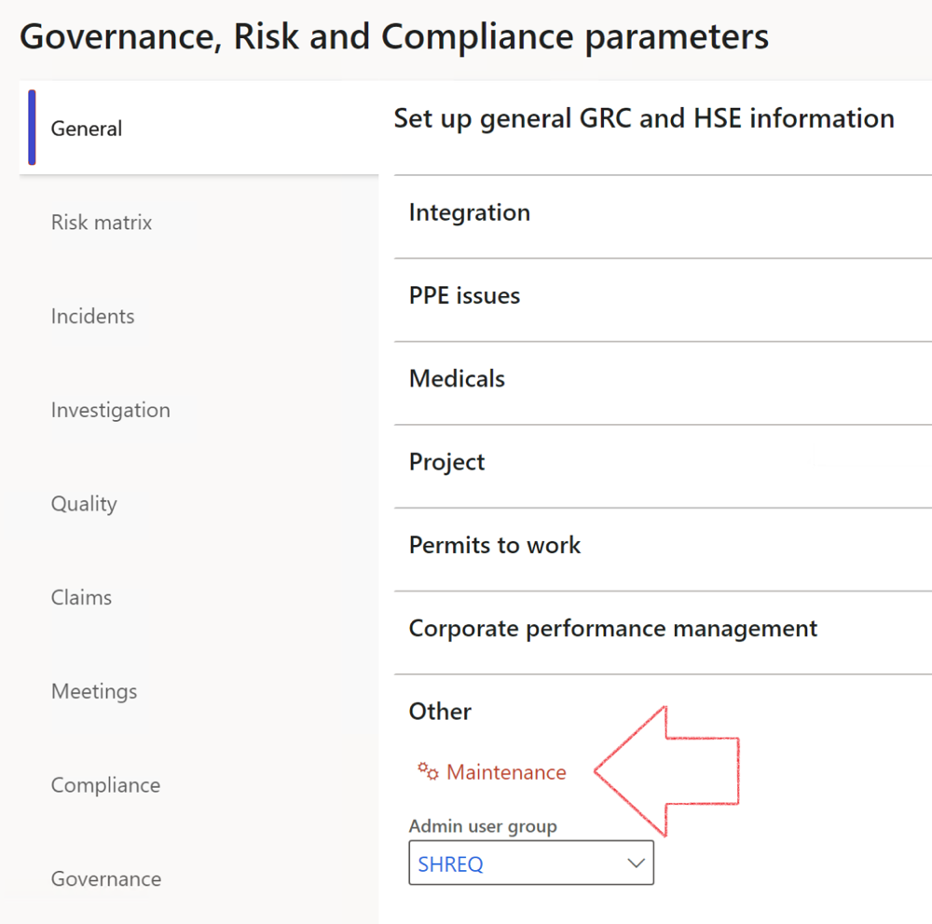

|  |  |
| --- | --- |
|  | The **Maintenance** button is there for designated user. This button repairs any possible data issues. For a full history of all Data related repairs; see table below: |

The information contained in this document represents the current view of Axnosis and Microsoft Corporation on the issues discussed as of the date of publication. Because Axnosis and Microsoft must respond to changing market conditions, this document should not be interpreted to be a commitment on the part of Axnosis and Microsoft, and Axnosis and Microsoft cannot guarantee the accuracy of any information presented after the date of publication.

This test script is for informational purposes only. AXNOSIS AND MICROSOFT MAKE NO WARRANTIES, EXPRESS, IMPLIED, OR STATUTORY, AS TO THE INFORMATION IN THIS DOCUMENT.

Complying with all applicable copyright laws is the responsibility of the user. Without limiting the rights under copyright, no part of this document may be reproduced, stored in or introduced into a retrieval system, or transmitted in any form or by any means (electronic, mechanical, photocopying, recording, or otherwise), or for any purpose, without the express written permission of Axnosis and Microsoft Corporation.

Axnosis and Microsoft may have patents, patent applications, trademarks, copyrights, or other intellectual property rights covering subject matter in this document. Except as expressly provided in any written license agreement from Axnosis and Microsoft, the furnishing of this document does not give you any license to these patents, trademarks, copyrights, or other intellectual property.

© 2021 Microsoft Corporation. All rights reserved. Any use or distribution of these materials without express authorization of Microsoft Corp. is strictly prohibited.

Microsoft and Windows are both registered trademarks of Microsoft Corporation in the United States and/or other countries.

The names of actual companies and products mentioned herein may be the trademarks of their respective owners.

|  |  |  |
| --- | --- | --- |
| **Process** | **Description/notes** | **Release** |
| Fix location vs. work centres | Populate the new **LocationRecID** field with the related location associated with previously used work centre location (Location) fields on the following tables:   * OHSHazardLocations, * OHSRiskHazard, * OHSRiskHazardWizard, * OHSRiskRegister, * OHSRisksWizard, * OHSSafetyLocations, * OHSSafetyPermit, * OHSSafetyPermitLocations * OHSSafetyPermitOverlap, * OHSSafetyPlan, * OHSInvestigation | 10.0.80.10 |
| Fix risk hazards | Assigning the value "Default Risk" to the new mandatory field **RiskID** (Key field) where empty | 10.0.80.10 |
| Fix incident HRM injury link | Delete all orphaned records from the **OHSIncidentHRMInjuryLnk** table | 10.0.11785.3 |
| Populate SRS analysis enums | Still in concept phase. To provide a link between enum numerical value and value name for use with BYOD data entities. Enums available:   * OHSIncidentType, * OHSIncidentSeverityType.   Table populated: **SRSAnalysisEnums** | 10.0.11785.3 |
| Fix budget transaction lines stock\item dimension | Set **OHSInventDimId** field value to "**AllBlank**" on table **BudgetTransactionLine**, where no value was recorded. This will solve the issue of records not displaying in the form.  **Note: this step will only fix existing budget transaction records in the system. Should any new transactions be uploaded or changed via the data entity Budget Account Entries, special care needs to be taken to specify the Stock dimension = AllBlank and the Item on the excel sheet to import.** | 10.1.1366.6 |
| Update existing incidents with the new **Incident types** | Update existing incidents with the **Incident types** that are setup on the new **Incident type** setup form. (IncidentTypeRecId) | 10.17.1250.5 |
| Update existing risks with the new **Control types** | Update existing risks with the **Control types** that are setup on the new **Control type** setup form. | 10.17.1250.6 |
| Re-number GRC Question and Answer **Group lines** | Re-number GRC Question and Answer **Group line numbers** | 10.22.1561.3 |
| Fix Inspection locations: Replace Work centre-based locations with HSE locations | Populate the new **ObjectLocation** field with the related HSE location associated with previously used work centre location (**Location**) field on the following tables:   * OHSInspectionJournalName * OHSInspectionJournalTable * OHSInspectionJournalTrans * OHSInspectionHistory * OHSSchedule | 10.24.1114.3 |
| **Process** | **Description/notes** | **Release** |
| Display of non-calculation lines | Run this job to ensure data consistency and correct display of historical data. |  |
| Fix Asset counter stock dimensions  Fix Line types on Data repository lines  Delete Orphan Data repositories | Replace empty stock dimension values with a blank dimension value  Populate missing line types from reporting templates on Data repository lines  Delete data repositories for which no template, year, site, period name or month was defined. | 10.26.1087.3  10.28.1080.6  10.30.2459.4 |
| Equivalent Functional location fields | The equivalent Functional location fields will be populated where an HSE Location exists on the permit to work pool header and linked Permit to work table. | 10.30.2459.12 |