

Dynamics GRC/HSE Release notes



Governance Risk & Compliance

Health, Safety & Environment

for

**Microsoft Dynamics 365 for Finance & Operations™**

*Dynamics GRC/HSE version* 10.33.1620.22

2025-06-27



|  |  |
| --- | --- |
| Dynamics 365 FO GRC module GRC is an add-on for Dynamics 365 suite of business application software.  This software provides compelling functionality to support Governance, Risk management and Compliance. |  |
| Dynamics 365 FO HSE/OHS OHS/HSE is an add-on for Dynamics 365 suite of business application software.  This software adds to GRC in that compliance is now deeper with explicit functionality for Health, Safety and Environment as per the depicted sub-modules below. | |
|  | |

Release version

**GRC/HSE Package version:** OHSDeployablePackage_10_33_1620_22

This package was created on Microsoft Dynamics 365 for Finance and Operations:

|  |  |  |
| --- | --- | --- |
| **Release** | **Version** | **Build number** |
| Application release | 10.0.42 | 10.33.1620 |
| Platform release | Platform update 66 | 7.0.7452.66 |

# Enhancements:

|  |  |
| --- | --- |
| Module | Description |
| Contracts management | * Contract records now support **document attachments**, allowing users to upload, view, and manage supporting files directly within each contract. This enhances **traceability**, ensures all relevant documentation is **stored in one place**, and improves **audit** readiness. * A new free-text **Product name** field has been introduced on contract item lines. It is editable when a procurement category is selected without an item, and automatically populated from the originating PR or RFQ when creating a contract. If an item is selected, the field defaults to the item name, aligning with standard D365FO behaviour. * A new data entity, **Contract Item Lines Distribution V2**, has been created to manage accounting distributions for contract item lines. It enables import and update of distribution values, ledger accounts, and date ranges through data management, supporting accurate and efficient contract financial planning. * A **version list** has been added to the **Distribute all line amounts** form, allowing users to navigate archived versions of contract line distributions. The list displays all versions sorted from latest to oldest, showing the status, effective date, and version number for each entry. Users can no longer manually set a distribution's status to "**Archived**"; this status is now automatically assigned when a new version becomes "**Effective**." The "Archived" status has also been removed from the status selection dropdown to prevent manual assignment. |
| Risk management | * The following Yes/no sliders on the **Risk type** setup form have been changed to columns instead: **Hide guide, Hide strategy, Hide performance** and **Hide outcomes** * On the Risk register **Header**, under the **Default line values** Fast tab, a new **Use header risk type** slider was added.   + When this new slider is set to **Yes**, the **Risk type** selected on the header under the General Fast, will by default be used on the risk lines.   + When the **Risk type** is selected under the header field group on the **Create risk register** dialog, the **Risk type** defaults to the **Risk type** under the **Lines** field group. * On the **Risk register lines**, General Fast tab under the **Risk actions** Index tab, the **Review** slider’s label was changed to **Enable for review**. (Help text was also added)   When this slider is set to **No**, the **To be reviewed by** field is greyed out. |

|  |  |
| --- | --- |
| Module | Description |
| Tender management | * On the **RFQ**, **Governance** Fast tab, **Bid specification** Index tab:   + The **Statement of work** and **Items** field groups were swapped.   + A new **print** button was added next to the **Bill of material** field. This new button opens the **print** **dialog** for printing the document (Specification) * To give users the ability to create and score additional checklists:   + On the **Solicitation type**, a new **Other weight %** field was added.   + On the **Scoring criteria**, on the **Include in checklist** enum, a new value was added: **Other evaluation**   + On the RFQ, Governance Fast tab, a new **Additional checklists** Index tab was added.     - There are three button groups under this new Index tab: **Create checklist**, **Analysis** and **View scores**. * On the **RFQ**: When Envelopes of type **Negotiation** are opened for all Qualifying vendors, a record is added under the **Sign off** Fast tab (only for qualified vendors) * On the **Tender evaluation matrix**:   + A new **Type** column was added. This column indicates what type of checklist is displayed.   + The **Worker** column was renamed to **Evaluator** |
| Management of change | The standard **Microsoft PR workflow** was extended to integrate with the **GRC Approval authority**. |
| Business continuity management | * On the **Continuity and disaster recovery Header**, under the General Fast tab and under the **Follow up and review** Fast tab, the **Review** slider’s label was changed to **Enable for review**. (Help text was also added). When this slider is set to **No**, the **To be reviewed by** field is greyed out. |
| Incidents | * On **Permit to work types** setup form, a new **LSR** (Life saving rule) tick box column was added to the end of the grid. * On the **Incident**, under the **Interpretation** Fast tab, **Cause** Index tab, a new **Life saving rule** lookup was added. This is a lookup to the abovementioned setup form for records where the **LSR** tick is on. |
| General | The **Risk** label on the **Entity type** enum was changed to **Risk assessment**. |

*Bug fixes:*

|  |  |
| --- | --- |
| **Module** | **Description** |
| Vendor portal | On the Vendor portal, **Vendor bidding** workspace (Negotiation lines grid), the **Round number** was not display correctly in grid.  The issue has been resolved. |
| Investigations | All buttons and fields on the **Investigation** were not disabled when the Status = **Closed**.  The issue has been resolved. The **Status** button and **Re-investigate** option are still available. |

Release Data impact

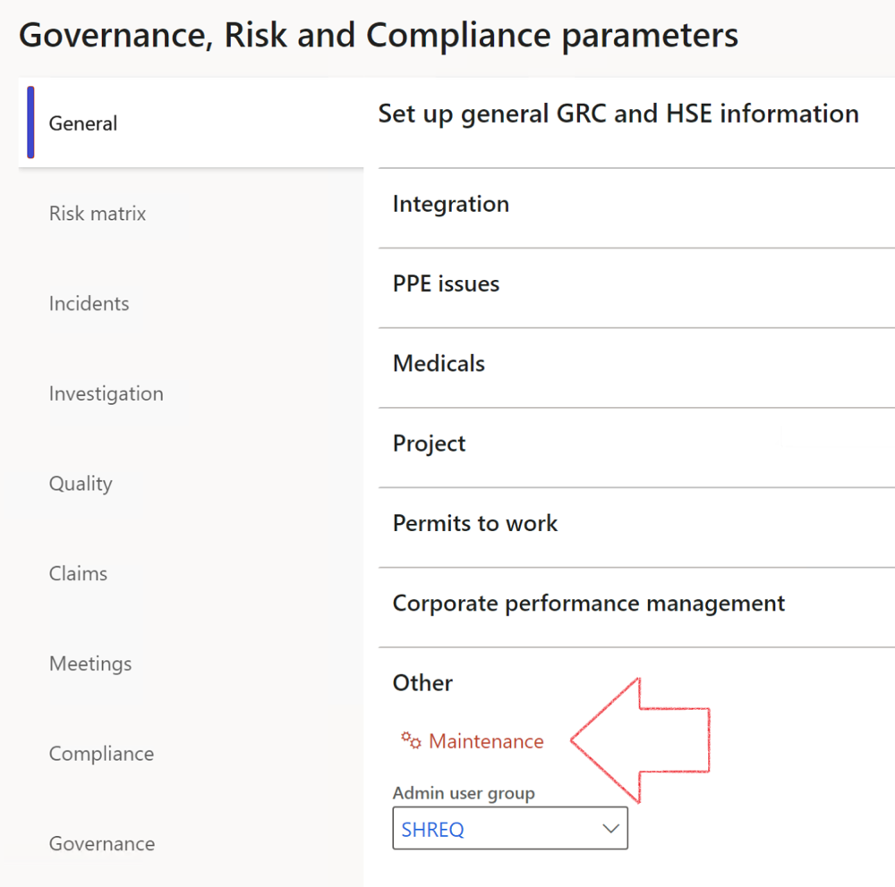

|  |  |
| --- | --- |
|  | The **Maintenance** button is there for designated user. This button repairs any possible data issues. For a full history of all Data related repairs; see table below: |

The information contained in this document represents the current view of Axnosis and Microsoft Corporation on the issues discussed as of the date of publication. Because Axnosis and Microsoft must respond to changing market conditions, this document should not be interpreted to be a commitment on the part of Axnosis and Microsoft, and Axnosis and Microsoft cannot guarantee the accuracy of any information presented after the date of publication.

This test script is for informational purposes only. AXNOSIS AND MICROSOFT MAKE NO WARRANTIES, EXPRESS, IMPLIED, OR STATUTORY, AS TO THE INFORMATION IN THIS DOCUMENT.

Complying with all applicable copyright laws is the responsibility of the user. Without limiting the rights under copyright, no part of this document may be reproduced, stored in or introduced into a retrieval system, or transmitted in any form or by any means (electronic, mechanical, photocopying, recording, or otherwise), or for any purpose, without the express written permission of Axnosis and Microsoft Corporation.

Axnosis and Microsoft may have patents, patent applications, trademarks, copyrights, or other intellectual property rights covering subject matter in this document. Except as expressly provided in any written license agreement from Axnosis and Microsoft, the furnishing of this document does not give you any license to these patents, trademarks, copyrights, or other intellectual property.

© 2021 Microsoft Corporation. All rights reserved. Any use or distribution of these materials without express authorization of Microsoft Corp. is strictly prohibited.

Microsoft and Windows are both registered trademarks of Microsoft Corporation in the United States and/or other countries.

The names of actual companies and products mentioned herein may be the trademarks of their respective owners.

|  |  |  |
| --- | --- | --- |
| **Process** | **Description/notes** | **Release** |
| Fix location vs. work centres | Populate the new **LocationRecID** field with the related location associated with previously used work centre location (Location) fields on the following tables:   * OHSHazardLocations, * OHSRiskHazard, * OHSRiskHazardWizard, * OHSRiskRegister, * OHSRisksWizard, * OHSSafetyLocations, * OHSSafetyPermit, * OHSSafetyPermitLocations * OHSSafetyPermitOverlap, * OHSSafetyPlan, * OHSInvestigation | 10.0.80.10 |
| Fix risk hazards | Assigning the value "Default Risk" to the new mandatory field **RiskID** (Key field) where empty | 10.0.80.10 |
| Fix incident HRM injury link | Delete all orphaned records from the **OHSIncidentHRMInjuryLnk** table | 10.0.11785.3 |
| Populate SRS analysis enums | Still in concept phase. To provide a link between enum numerical value and value name for use with BYOD data entities. Enums available:   * OHSIncidentType, * OHSIncidentSeverityType.   Table populated: **SRSAnalysisEnums** | 10.0.11785.3 |
| Fix budget transaction lines stock\item dimension | Set **OHSInventDimId** field value to "**AllBlank**" on table **BudgetTransactionLine**, where no value was recorded. This will solve the issue of records not displaying in the form.  **Note: this step will only fix existing budget transaction records in the system. Should any new transactions be uploaded or changed via the data entity Budget Account Entries, special care needs to be taken to specify the Stock dimension = AllBlank and the Item on the excel sheet to import.** | 10.1.1366.6 |
| Update existing incidents with the new **Incident types** | Update existing incidents with the **Incident types** that are setup on the new **Incident type** setup form. (IncidentTypeRecId) | 10.17.1250.5 |
| Update existing risks with the new **Control types** | Update existing risks with the **Control types** that are setup on the new **Control type** setup form. | 10.17.1250.6 |
| Re-number GRC Question and Answer **Group lines** | Re-number GRC Question and Answer **Group line numbers** | 10.22.1561.3 |
| Fix Inspection locations: Replace Work centre-based locations with HSE locations | Populate the new **ObjectLocation** field with the related HSE location associated with previously used work centre location (**Location**) field on the following tables:   * OHSInspectionJournalName * OHSInspectionJournalTable * OHSInspectionJournalTrans * OHSInspectionHistory * OHSSchedule | 10.24.1114.3 |
| **Process** | **Description/notes** | **Release** |
| Display of non-calculation lines | Run this job to ensure data consistency and correct display of historical data. |  |
| Fix Asset counter stock dimensions  Fix Line types on Data repository lines  Delete Orphan Data repositories | Replace empty stock dimension values with a blank dimension value  Populate missing line types from reporting templates on Data repository lines  Delete data repositories for which no template, year, site, period name or month was defined. | 10.26.1087.3  10.28.1080.6  10.30.2459.4 |
| Equivalent Functional location fields | The equivalent Functional location fields will be populated where an HSE Location exists on the permit to work pool header and linked Permit to work table. | 10.30.2459.12 |