

Dynamics GRC/HSE Release notes



Governance Risk & Compliance

Health, Safety & Environment

for

**Microsoft Dynamics 365 for Finance & Operations™**

*Dynamics GRC/HSE version* 10.33.1620.21

2025-06-24



|  |  |
| --- | --- |
| Dynamics 365 FO GRC module GRC is an add-on for Dynamics 365 suite of business application software.  This software provides compelling functionality to support Governance, Risk management and Compliance. |  |
| Dynamics 365 FO HSE/OHS OHS/HSE is an add-on for Dynamics 365 suite of business application software.  This software adds to GRC in that compliance is now deeper with explicit functionality for Health, Safety and Environment as per the depicted sub-modules below. | |
|  | |

Release version

**GRC/HSE Package version:** OHSDeployablePackage_10_33_1620_21

This package was created on Microsoft Dynamics 365 for Finance and Operations:

|  |  |  |
| --- | --- | --- |
| **Release** | **Version** | **Build number** |
| Application release | 10.0.42 | 10.33.1620 |
| Platform release | Platform update 66 | 7.0.7452.66 |

# Enhancements:

|  |  |
| --- | --- |
| Module | Description |
| Corporate performance management | * On the **KRI & goals**, under the **Measurements** Fast tab: the **Worker** field is now populated with the logged in user’s name (User doing the measurements) * The **Worker** field on the **Vendor** under the **Performance** Fast tab now displays the above details. * The worker is now also printed on **Supplier performance report** under the **Measured by** column. |
| Tender management | * On the RFQ, Governance Fast tab, Negotiations Index tab:   + The View **button** is now hidden.   + The help text of the **View scores button** to: "View scores of the negotiation analysis"   + The **Vendor account** and **Vendor name** columns were moved to before the **Round** column.   + The **By whom** column was moved to the end of the grid.   + The label of the**Request dialog** was changed to Header request * On the **Open envelope confirmation** dialog: the Technical or commercial **label was changed** to “Envelope type”. * The word **Round** as well as the **relevant round** **number** is now displayed in front of the two checklist descriptions below:   + **RFQ scores** and **All checklists** * On the Bid negotiations inquiry:   + The **label** of the Amount field **was changed** to Negotiation amount   + Two **columns were added** in front of the Original amount column, labels = Negotiation average and Negotiation % * On the **Tender score summary**:   + A new **Scoring criteria** button group was added in the Action button strip (this replaced the existing Scoring criteria button). The following are buttons under this new button group:     - **Technical evaluation, Commercial evaluation**     - **Risk evaluation, Safety evaluation** |

|  |  |
| --- | --- |
| Module | Description |
| Risk management | * A **Risk management report** can now be created from the **Risk register header**:   + A new **Create risk report** button was added in the Action pane under the **Print** button group (On the Action pane of the Header and Lines views)   + On the **Risk register header**, **General** Fast tab:     - A new **Detail report** field group was added with the following:       * A lookup to **Baseline management reports**       * Display with label **Actual report** (the name of the newly created report is displayed in this field)   + A few fields were moved around and a new **Closed by** display was added. The name of the user who closes the Risk register will be displayed here.   + On the PCR (Risk management report), Cover page Fast tab:     - Under the **References** Index tab, the **Risk register** is referenced     - Under the **Clause** Index tab: the mapped fields from the Risk register (according to the **Risk register mapping** field), populate the memo bog under the grid.     - The Risk register is referenced in the **Where used** field **Cover page** Fast tab. * On the Risk register lines, **General** Fast tab: A **Do risk assessment** button was exposed for the following Index tabs: **RACI, Business process** and **Risk actions** * On the **Risk register**, in the Action pane: the fields on the **Change RACI** drop dialog were rearranged.   ·      On the Risk register, under the **Assessment calculations and controls** Fast tab, **Controls** Index tab:  o   The **Effectiveness factor** column is now hidden and replaced with new **Mitigation effectiveness** column which is a user defined lookup.   * For **Review and follow up actions**:   + For Header and Lines: A new **Reviews** button was added in the Action pane under the Functions group.   + A new **In review** badge indicates that there is an active review action.   + For **Lines**, under the General Fast tab, **Risk actions** Index tab, some labels were changed and help text added.   + For **Header**: Some labels were changed and fields moved around. * On the **Risk configuration** setup form, under the **Mitigation effectiveness** tab, a new **Effectiveness** column was added to the end of the grid. * On the **Risk appetite** setup form, **Create investigation** was added as a value on the **Action** enum. * On **Approved group risks**:   + The following was added under the grid: **Long description** memo box and **Quantifiable** Yes/no slider   + On the create **New approved group risk** dialog:     - The **Group** slider’s default = **Yes**     - The **Long description** and **Quantifiable** fields were added * The following Yes/no sliders were added on the **Risk type** setup form:   + **Hide guide, Hide strategy, Hide performance** and **Hide outcomes**   When these sliders are set to **Yes**, the corresponding Fast tabs on the Risk register lines will be hidden. |

*Bug fixes:*

|  |  |
| --- | --- |
| **Module** | **Description** |
| Tender management | * On the RFQ, Governance Fast tab, **Negotiation** Index tab:   + The **Status** column was not updated after a negotiation response was received from a vendor   + For Line level negotiations: the **Negotiation response** display under the grid was not updated with the vendor’s latest negotiation price. * The **round number** in the description of the negotiation checklists did not change when checklists were created for new rounds.   These issues have been resolved. |
| Risk management | There was no association between **Activities** created from the Risk register lines, under the **Assessment calculations and controls** Fast tab.  The issue has been resolved. |

Release Data impact

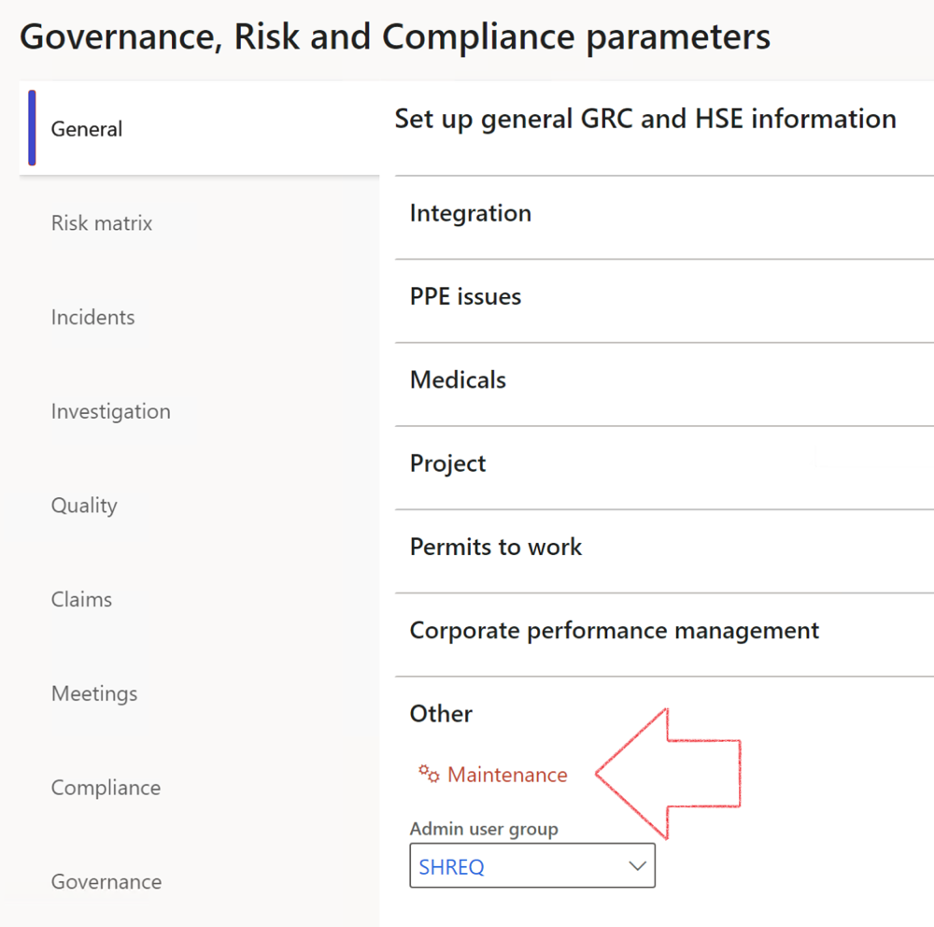

|  |  |
| --- | --- |
|  | The **Maintenance** button is there for designated user. This button repairs any possible data issues. For a full history of all Data related repairs; see table below: |

The information contained in this document represents the current view of Axnosis and Microsoft Corporation on the issues discussed as of the date of publication. Because Axnosis and Microsoft must respond to changing market conditions, this document should not be interpreted to be a commitment on the part of Axnosis and Microsoft, and Axnosis and Microsoft cannot guarantee the accuracy of any information presented after the date of publication.

This test script is for informational purposes only. AXNOSIS AND MICROSOFT MAKE NO WARRANTIES, EXPRESS, IMPLIED, OR STATUTORY, AS TO THE INFORMATION IN THIS DOCUMENT.

Complying with all applicable copyright laws is the responsibility of the user. Without limiting the rights under copyright, no part of this document may be reproduced, stored in or introduced into a retrieval system, or transmitted in any form or by any means (electronic, mechanical, photocopying, recording, or otherwise), or for any purpose, without the express written permission of Axnosis and Microsoft Corporation.

Axnosis and Microsoft may have patents, patent applications, trademarks, copyrights, or other intellectual property rights covering subject matter in this document. Except as expressly provided in any written license agreement from Axnosis and Microsoft, the furnishing of this document does not give you any license to these patents, trademarks, copyrights, or other intellectual property.

© 2021 Microsoft Corporation. All rights reserved. Any use or distribution of these materials without express authorization of Microsoft Corp. is strictly prohibited.

Microsoft and Windows are both registered trademarks of Microsoft Corporation in the United States and/or other countries.

The names of actual companies and products mentioned herein may be the trademarks of their respective owners.

|  |  |  |
| --- | --- | --- |
| **Process** | **Description/notes** | **Release** |
| Fix location vs. work centres | Populate the new **LocationRecID** field with the related location associated with previously used work centre location (Location) fields on the following tables:   * OHSHazardLocations, * OHSRiskHazard, * OHSRiskHazardWizard, * OHSRiskRegister, * OHSRisksWizard, * OHSSafetyLocations, * OHSSafetyPermit, * OHSSafetyPermitLocations * OHSSafetyPermitOverlap, * OHSSafetyPlan, * OHSInvestigation | 10.0.80.10 |
| Fix risk hazards | Assigning the value "Default Risk" to the new mandatory field **RiskID** (Key field) where empty | 10.0.80.10 |
| Fix incident HRM injury link | Delete all orphaned records from the **OHSIncidentHRMInjuryLnk** table | 10.0.11785.3 |
| Populate SRS analysis enums | Still in concept phase. To provide a link between enum numerical value and value name for use with BYOD data entities. Enums available:   * OHSIncidentType, * OHSIncidentSeverityType.   Table populated: **SRSAnalysisEnums** | 10.0.11785.3 |
| Fix budget transaction lines stock\item dimension | Set **OHSInventDimId** field value to "**AllBlank**" on table **BudgetTransactionLine**, where no value was recorded. This will solve the issue of records not displaying in the form.  **Note: this step will only fix existing budget transaction records in the system. Should any new transactions be uploaded or changed via the data entity Budget Account Entries, special care needs to be taken to specify the Stock dimension = AllBlank and the Item on the excel sheet to import.** | 10.1.1366.6 |
| Update existing incidents with the new **Incident types** | Update existing incidents with the **Incident types** that are setup on the new **Incident type** setup form. (IncidentTypeRecId) | 10.17.1250.5 |
| Update existing risks with the new **Control types** | Update existing risks with the **Control types** that are setup on the new **Control type** setup form. | 10.17.1250.6 |
| Re-number GRC Question and Answer **Group lines** | Re-number GRC Question and Answer **Group line numbers** | 10.22.1561.3 |
| Fix Inspection locations: Replace Work centre-based locations with HSE locations | Populate the new **ObjectLocation** field with the related HSE location associated with previously used work centre location (**Location**) field on the following tables:   * OHSInspectionJournalName * OHSInspectionJournalTable * OHSInspectionJournalTrans * OHSInspectionHistory * OHSSchedule | 10.24.1114.3 |
| **Process** | **Description/notes** | **Release** |
| Display of non-calculation lines | Run this job to ensure data consistency and correct display of historical data. |  |
| Fix Asset counter stock dimensions  Fix Line types on Data repository lines  Delete Orphan Data repositories | Replace empty stock dimension values with a blank dimension value  Populate missing line types from reporting templates on Data repository lines  Delete data repositories for which no template, year, site, period name or month was defined. | 10.26.1087.3  10.28.1080.6  10.30.2459.4 |
| Equivalent Functional location fields | The equivalent Functional location fields will be populated where an HSE Location exists on the permit to work pool header and linked Permit to work table. | 10.30.2459.12 |