

Dynamics GRC/HSE Release notes



Governance Risk & Compliance

Health, Safety & Environment

for

**Microsoft Dynamics 365 for Finance & Operations™**

*Dynamics GRC/HSE version* 10.33.1620.19

2025-06-13



|  |  |
| --- | --- |
| Dynamics 365 FO GRC module GRC is an add-on for Dynamics 365 suite of business application software.  This software provides compelling functionality to support Governance, Risk management and Compliance. |  |
| Dynamics 365 FO HSE/OHS OHS/HSE is an add-on for Dynamics 365 suite of business application software.  This software adds to GRC in that compliance is now deeper with explicit functionality for Health, Safety and Environment as per the depicted sub-modules below. | |
|  | |

Release version

**GRC/HSE Package version:** OHSDeployablePackage_10_33_1620_19

This package was created on Microsoft Dynamics 365 for Finance and Operations:

|  |  |  |
| --- | --- | --- |
| **Release** | **Version** | **Build number** |
| Application release | 10.0.42 | 10.33.1620 |
| Platform release | Platform update 66 | 7.0.7452.66 |

# Enhancements:

|  |  |
| --- | --- |
| Module | Description |
| General | The following changes were made to the **All planned GRC actions** workspace to enhance **Review and follow up** activities:   * Two new read only memo boxes were added below the grid:   + **Review instructions**   + **Review notes** * The **Close** button now opens a **Close planned action** drop-dialog where the user can enter **Review notes** which will then populate the new **Review notes** field mentioned above. * A new **Reset** button was added to the Action button strip. This will take the users back to the original list after the users navigated using the tiles. * The original **Filter** above the grid is now hidden as it was not serving any purpose * A new **Show closed** filter was added above the grid. * The **Due this week** tile was hidden. * The **Employee relations** tile was renamed to **Risk registers** and moved to in front of the **Risk assessments** tile. This will be re purposed in a future release. * Filters are now applied when the **Contract, BC/DR plans** & **Risk assessments** tiles are clicked to only show records from the relevant source. * In the grid:   + The **Date create** label was changed to **Action date**   + On the **Type** enum: the **Follow up** value was changed to **Review** |
| Business continuity | The following changes were made to the **Continuity and disaster recovery** form to enhance **Review and follow up** activities:   * Two new **Review** sliders were added, one under the **General** Fast tab and one under the **Review and follow up** Fast tab * Under the **Review and follow up** Fast tab: Label changes were applied and fields moved. * Two new buttons were added in the Action button strip:   + **Reviews**: Opens a list of all reviews created for the BC/DR plan   + **Close review** * When a **Review** planned action is closed, a record is added under the **Sign off** Fast tab with the **Review** box ticked for auditing purposes. |

|  |  |
| --- | --- |
| **Module** | **Description** |
| Contracts management | A new field was added to the **Contracts data entity** (DEFAULTDIMENSIONDISPLAYVALUE) through which the **Financial dimensions** can be uploaded. |
| Management of change | A new **currency conversion method** has been included in the Management of change module to allow users to create change requests with different currency values. The cost impact is then converted to the currency applicable to the reference on which the change request has been created. |
| Tender management | * When a **Header negotiation request** on RFQ case is deleted, **all fields** under the **Negotiations (header level)**Fast tab, on the Edit RFQ replies, are cleared. * If there is **no line level negotiation** request, the **Confirm response** button on the Edit RFQ replies is greyed out. * Help text was added to the **Negotiation response** column on the Edit RFQ reply, under the **Lines** Fast tab. |
| Baseline documents | * Three Enums were added for mapping rules when users create a **Risk management report**, **Investigation management report** or an **Audit report** using a **Baseline.** * The **Contract (type) Classification**, **Initial value** and **Currency** fields are now hidden on the following create dialogs:   + Baseline risk management report   + Baseline investigation management report   + Baseline audit report   + Baseline agendas, minutes and resolutions report |
| Investigations | * On the **Management investigation report**, under the **Content** Fast tab:   + The **Consumption** Index tab was hidden   + Under the **References** Index tab, **Investigation** was added as a value on the **Element relation type** enum * On the **Investigation**, under the **General** Fast tab:   + The following two memo boxes were added:     - **In scope** and **Out of scope**   + The **Closed date** field was moved and a **Closed by** field was added. These are system populated when users close a record.   + A new **RACI** Index tab was added between the existing Index tabs   + Under the **Cause** Fast tab:     - The **tree view** was hidden     - The **notes** entered on the **Cause** setup form are now displayed on the Investigation   + Users now can create an **Investigation report** using a baseline (template). Certain fields on the investigation will be copied into the relevant clause lines, and references on the Investigation report will include **Investigation IDs** and **Incident IDs** |
| Incidents | On the Incidents, under the **Interpretation** Fast tab, **Cause** Index tab:   * + The **tree view** was hidden   + The **notes** entered on the **Cause** setup form are now displayed on the Incident |

|  |  |
| --- | --- |
| **Module** | **Description** |
| Enterprise risk management | * On the **Risk lines** (grid), a **Company** column was added in the **Label** lookup * On the **Risk lines**, under the **General** Fast tab:   + The **Risk** and **Label** fields were hidden as these are displayed to the left and above the Fast tab.   + The **Risk type** field was moved.   + The **Key** slider was renamed to **Top.**   + A new **Do risk assessment** button was added.   + **Help text** was added to a few fields. * On the **Risk lines**, under the **Assessment guidance** Fast tab:   + A new **Instruction** Index tab with a free text memo box (also on the Header view), was added between the existing Index tabs. These are used on the new [Do risk assessment] button. * On the **Risk register Header**, under the **General** Fast tab, the following two memo boxes were added: **Overview** and **Regulation** * The **Association** list on the **Risk lines** was expanded to include references to **Questionnaires** where the **Used for** value **= Risk assessment** |

*Bug fixes:*

|  |  |
| --- | --- |
| **Module** | **Description** |
| Enterprise risk management | Some fields on **Closed risk lines** were editable.  The issue has been resolved. |
| Vendor portal | RFQ lines with **status = Submitted** are no longer shown on the **Vendor bidding** workspace under the **Negotiation (lines) bids** tab |

Release Data impact

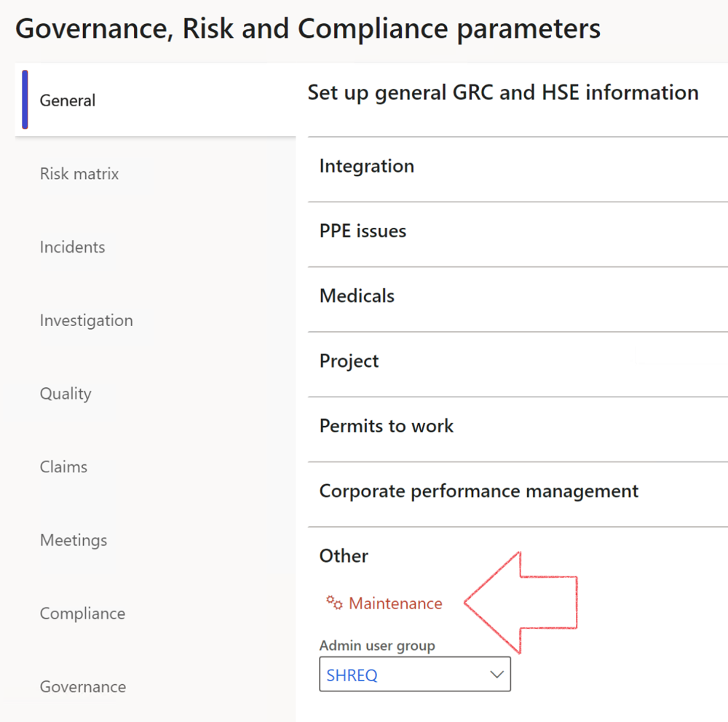

|  |  |
| --- | --- |
|  | The **Maintenance** button is there for designated user. This button repairs any possible data issues. For a full history of all Data related repairs; see table below: |

The information contained in this document represents the current view of Axnosis and Microsoft Corporation on the issues discussed as of the date of publication. Because Axnosis and Microsoft must respond to changing market conditions, this document should not be interpreted to be a commitment on the part of Axnosis and Microsoft, and Axnosis and Microsoft cannot guarantee the accuracy of any information presented after the date of publication.

This test script is for informational purposes only. AXNOSIS AND MICROSOFT MAKE NO WARRANTIES, EXPRESS, IMPLIED, OR STATUTORY, AS TO THE INFORMATION IN THIS DOCUMENT.

Complying with all applicable copyright laws is the responsibility of the user. Without limiting the rights under copyright, no part of this document may be reproduced, stored in or introduced into a retrieval system, or transmitted in any form or by any means (electronic, mechanical, photocopying, recording, or otherwise), or for any purpose, without the express written permission of Axnosis and Microsoft Corporation.

Axnosis and Microsoft may have patents, patent applications, trademarks, copyrights, or other intellectual property rights covering subject matter in this document. Except as expressly provided in any written license agreement from Axnosis and Microsoft, the furnishing of this document does not give you any license to these patents, trademarks, copyrights, or other intellectual property.

© 2021 Microsoft Corporation. All rights reserved. Any use or distribution of these materials without express authorization of Microsoft Corp. is strictly prohibited.

Microsoft and Windows are both registered trademarks of Microsoft Corporation in the United States and/or other countries.

The names of actual companies and products mentioned herein may be the trademarks of their respective owners.

|  |  |  |
| --- | --- | --- |
| **Process** | **Description/notes** | **Release** |
| Fix location vs. work centres | Populate the new **LocationRecID** field with the related location associated with previously used work centre location (Location) fields on the following tables:   * OHSHazardLocations, * OHSRiskHazard, * OHSRiskHazardWizard, * OHSRiskRegister, * OHSRisksWizard, * OHSSafetyLocations, * OHSSafetyPermit, * OHSSafetyPermitLocations * OHSSafetyPermitOverlap, * OHSSafetyPlan, * OHSInvestigation | 10.0.80.10 |
| Fix risk hazards | Assigning the value "Default Risk" to the new mandatory field **RiskID** (Key field) where empty | 10.0.80.10 |
| Fix incident HRM injury link | Delete all orphaned records from the **OHSIncidentHRMInjuryLnk** table | 10.0.11785.3 |
| Populate SRS analysis enums | Still in concept phase. To provide a link between enum numerical value and value name for use with BYOD data entities. Enums available:   * OHSIncidentType, * OHSIncidentSeverityType.   Table populated: **SRSAnalysisEnums** | 10.0.11785.3 |
| Fix budget transaction lines stock\item dimension | Set **OHSInventDimId** field value to "**AllBlank**" on table **BudgetTransactionLine**, where no value was recorded. This will solve the issue of records not displaying in the form.  **Note: this step will only fix existing budget transaction records in the system. Should any new transactions be uploaded or changed via the data entity Budget Account Entries, special care needs to be taken to specify the Stock dimension = AllBlank and the Item on the excel sheet to import.** | 10.1.1366.6 |
| Update existing incidents with the new **Incident types** | Update existing incidents with the **Incident types** that are setup on the new **Incident type** setup form. (IncidentTypeRecId) | 10.17.1250.5 |
| Update existing risks with the new **Control types** | Update existing risks with the **Control types** that are setup on the new **Control type** setup form. | 10.17.1250.6 |
| Re-number GRC Question and Answer **Group lines** | Re-number GRC Question and Answer **Group line numbers** | 10.22.1561.3 |
| Fix Inspection locations: Replace Work centre-based locations with HSE locations | Populate the new **ObjectLocation** field with the related HSE location associated with previously used work centre location (**Location**) field on the following tables:   * OHSInspectionJournalName * OHSInspectionJournalTable * OHSInspectionJournalTrans * OHSInspectionHistory * OHSSchedule | 10.24.1114.3 |
| **Process** | **Description/notes** | **Release** |
| Display of non-calculation lines | Run this job to ensure data consistency and correct display of historical data. |  |
| Fix Asset counter stock dimensions  Fix Line types on Data repository lines  Delete Orphan Data repositories | Replace empty stock dimension values with a blank dimension value  Populate missing line types from reporting templates on Data repository lines  Delete data repositories for which no template, year, site, period name or month was defined. | 10.26.1087.3  10.28.1080.6  10.30.2459.4 |
| Equivalent Functional location fields | The equivalent Functional location fields will be populated where an HSE Location exists on the permit to work pool header and linked Permit to work table. | 10.30.2459.12 |