

Dynamics GRC/HSE Release notes



Governance Risk & Compliance

Health, Safety & Environment

for

**Microsoft Dynamics 365 for Finance & Operations™**

*Dynamics GRC/HSE version* 10.33.1620.18

2025-06-03



|  |  |
| --- | --- |
| Dynamics 365 FO GRC module GRC is an add-on for Dynamics 365 suite of business application software.  This software provides compelling functionality to support Governance, Risk management and Compliance. |  |
| Dynamics 365 FO HSE/OHS OHS/HSE is an add-on for Dynamics 365 suite of business application software.  This software adds to GRC in that compliance is now deeper with explicit functionality for Health, Safety and Environment as per the depicted sub-modules below. | |
|  | |

Release version

**GRC/HSE Package version:** OHSDeployablePackage_10_33_1620_18

This package was created on Microsoft Dynamics 365 for Finance and Operations:

|  |  |  |
| --- | --- | --- |
| **Release** | **Version** | **Build number** |
| Application release | 10.0.42 | 10.33.1620 |
| Platform release | Platform update 66 | 7.0.7452.66 |

# Enhancements:

|  |  |
| --- | --- |
| Module | Description |
| Tender management | * On the RFQ, Governance Fast tab, under the **Negotiations** Index tab:   + When a Vendor responds to a negotiation request (via Vendor portal/Edit RFQ reply), the **Status** column is updated with **Response received**.   + On the **Request** dialog (Add request button), the **Round** field is updated according to the vendor selected in the **For which supplier/vendor** field.   + The **Response attachments** slider was moved from the **Header level** field group to the **Line level** field group. All the fields under both these field groups are now read only. * On **Edit RFQ reply**, under the **Negotiations (header level)** Fast tab:   + When the negotiation request is sent via the RFQ (**Add request** button under the **Negotiations** index tab) the **Requested date** field is populated with the date on which the request was sent.   + A **Response date** field was added   + The fields are now displayed in three field groups. This makes it easier to see the info in context. * On the **Solicitation type**, a new **Negotiation level** field was added where users choose to either do **Header level** or **Line level** negotiations. Certain buttons on the **RFQ**, **Compare replies** and **Manage replies** are enabled/disabled according to the choice made. * The following labels were changed:   + On the **RFQ**, Governance Fast tab, **Negotiations** Index tab, Header level field group: **No** **changes to technical response** is now **Technical unchanged**   + On Edit RFQ reply:     - **No changes to technical response** is now **Technical unchanged** (Also on the Negotiation response dialog)     - The **Negotiation response** button is now **Negotiation response (header level)**   + On Manage replies Lines, **Purchase quotation lines** Fast tab, the **Negotiation** button is now **Negotiation request** |
| Vendor portal | On the **Request for quotation bid**, under the **Lines** Fast tab, help text was added to the **Negotiation response** column. |

|  |  |
| --- | --- |
| Module | Description |
| Risk management | * The following menu items were removed from the **GRC, Risk** menu:   + **Enterprise risk (self) assessment**   + **Enterprise risk assessment**   + **Operational risk assessment**   + **Environmental risk assessment** * On the **Risk and compliance workspace:**   + A **New** button was added that opens a dropdown list where the user can select one of the four options mentioned above.   + The **New risk assessment** tile was replaced with a **New non conformance** tile which opens the **Create non conformance** dialog. * The following columns were added to the **Risk type** setup form:   + **Quantifiable, ISO standard**   + **Risk category, Review frequency**   When a Risk type is selected on the Risk line, the above values are auto populated on the Risk line.   * On the **Enterprise risk register** lines:   + Under the **General** Fast tab:     - **Identification** Index tab:       * A new **Quantifiable** slider was added       * the **Risk owner** field is now both free text and a lookup to the HR Worker table. (Also on the create **Enterprise risk** dialog)     - **Risk actions** Index tab:       * A new **Closing** field group was added to the end of the Index tab       * A **Closed** **by** worker lookup was added       * The label of the **Approval and closing** field group was changed to **Approval**       * Under the **Review and follow** up field group:         + A new non editable **First follow up** date field was added         + A new editable **Review** slider was added         + The **Reason** note box was renamed to **Last review notes**         + A new **Follow up** note box was added         + The **Last review date** and **Closed by** fields are now read only   + Under the **Assessment calculations and controls** Fast tab:     - A new **RAL** (Risk assessment line number) column was added in the front of the grid. This is to make reporting easier.     - A new **Improvement potential** column was added, with an enum with the following values: Complex, Moderate, Simple, Blank (default = blank) * The **Approved group risks** form/query is now cross company:   + A new **Legal entity** filter was added next to the existing filter above the grid.   + A new **Company** column was added to the end of the grid   + A new **Risk type** column was added as fourth column in the grid |
| Corporate performance management | Minor improvements were done on the **Supplier performance** **report**. |

|  |  |
| --- | --- |
| **Module** | **Description** |
| Contracts management | * On the **Contract**, under the **Review and follow up** Fast tab:   + The two memo boxes were moved to the end of the Fast tab   + A new **Review slider** was added (The same one as under the **Content** Fast tab) * To be able to change the values in the **RACI** fields of an Approved contract, a new **Change RACI** button with **Change RACI** drop-dialog, was added to the button strip in the Action pane. * The **Contract email template** now includes the **Total value** and **Approved CRs** placeholders. * A data entity was created to import/export **Contract line distributions** (linked to item lines and contract) * To **automate contract renewal tracking**, the system can now generate a monthly report listing contracts due for renewal and distribute it to relevant **users** for review. |
| Management of change | On the **Change request** under the **Changes to** Fast tab:   * The **References** field group was moved to the end under the Fast tab * The **Investment** field was moved to be next to the **Contract reference** display |
| Business continuity | * The following was added on Continuity and disaster recovery:   + A Reviews button was added in the Action pane button strip (for future use)   + Under the Review and follow up Fast tab: * Yes/no slider with label Review (This was also added under the General Fast tab) * **First follow up date** field and **Last review notes** memo box |
| General | When a Counting journal of **Type** *Mining & Plant* is posted, the value in the **Counted** field is now posted to the **Quantity** field on the Performance transactions form. |

*Bug fixes:*

|  |  |
| --- | --- |
| **Module** | **Description** |
| Tender management | * The **negotiation (line level) response** from the vendor was not displayed on the RFQ under the Negotiation grid. * The **Round** field in the **Negotiation** grid on the RFQ was not updated with the value entered on the **Request** dialog on the **Compare replies** (Negotiation request button) * On the RFQ, Governance Fast tab, **Negotiation** Index tab: Negotiation requests were not created for all qualified vendors when the **Add request** button was clicked.   These issues have been resolved. |
| Contracts management | * Importing the contract item lines data entity was failing on upload. * When a contract is approved, the **Renewal** button is unavailable in the Action pane. * After a contract has been renewed, the contract cannot be **submitted for Workflow** approval. * Importing the contract item lines data entity was failing on upload   These issues have been resolved. |

Release Data impact

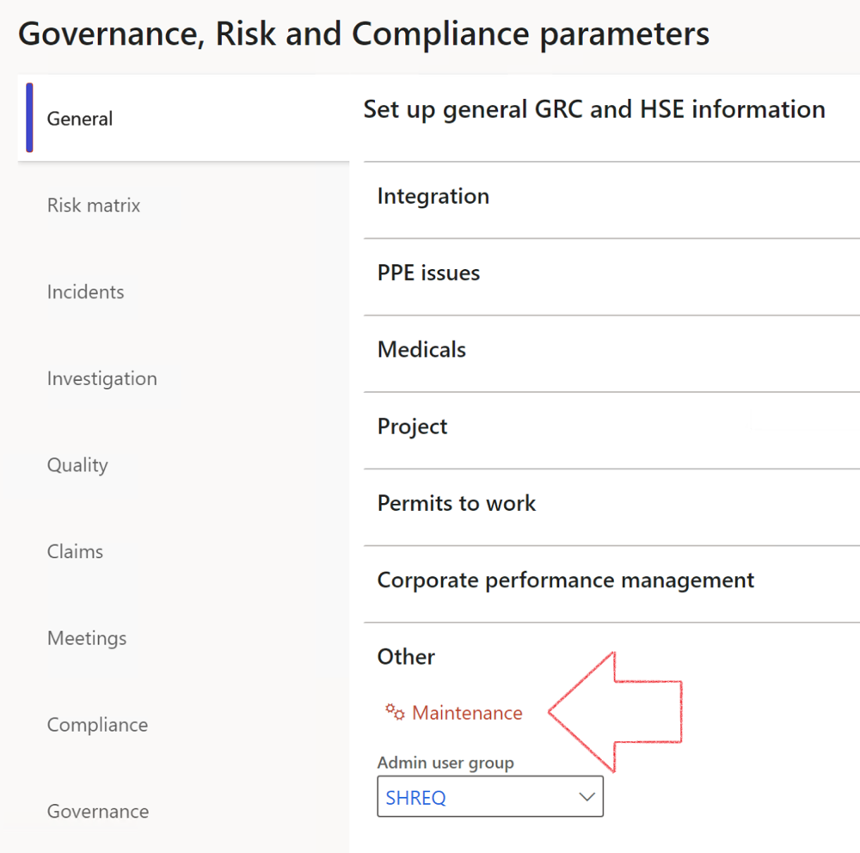

|  |  |
| --- | --- |
|  | The **Maintenance** button is there for designated user. This button repairs any possible data issues. For a full history of all Data related repairs; see table below: |

The information contained in this document represents the current view of Axnosis and Microsoft Corporation on the issues discussed as of the date of publication. Because Axnosis and Microsoft must respond to changing market conditions, this document should not be interpreted to be a commitment on the part of Axnosis and Microsoft, and Axnosis and Microsoft cannot guarantee the accuracy of any information presented after the date of publication.

This test script is for informational purposes only. AXNOSIS AND MICROSOFT MAKE NO WARRANTIES, EXPRESS, IMPLIED, OR STATUTORY, AS TO THE INFORMATION IN THIS DOCUMENT.

Complying with all applicable copyright laws is the responsibility of the user. Without limiting the rights under copyright, no part of this document may be reproduced, stored in or introduced into a retrieval system, or transmitted in any form or by any means (electronic, mechanical, photocopying, recording, or otherwise), or for any purpose, without the express written permission of Axnosis and Microsoft Corporation.

Axnosis and Microsoft may have patents, patent applications, trademarks, copyrights, or other intellectual property rights covering subject matter in this document. Except as expressly provided in any written license agreement from Axnosis and Microsoft, the furnishing of this document does not give you any license to these patents, trademarks, copyrights, or other intellectual property.

© 2021 Microsoft Corporation. All rights reserved. Any use or distribution of these materials without express authorization of Microsoft Corp. is strictly prohibited.

Microsoft and Windows are both registered trademarks of Microsoft Corporation in the United States and/or other countries.

The names of actual companies and products mentioned herein may be the trademarks of their respective owners.

|  |  |  |
| --- | --- | --- |
| **Process** | **Description/notes** | **Release** |
| Fix location vs. work centres | Populate the new **LocationRecID** field with the related location associated with previously used work centre location (Location) fields on the following tables:   * OHSHazardLocations, * OHSRiskHazard, * OHSRiskHazardWizard, * OHSRiskRegister, * OHSRisksWizard, * OHSSafetyLocations, * OHSSafetyPermit, * OHSSafetyPermitLocations * OHSSafetyPermitOverlap, * OHSSafetyPlan, * OHSInvestigation | 10.0.80.10 |
| Fix risk hazards | Assigning the value "Default Risk" to the new mandatory field **RiskID** (Key field) where empty | 10.0.80.10 |
| Fix incident HRM injury link | Delete all orphaned records from the **OHSIncidentHRMInjuryLnk** table | 10.0.11785.3 |
| Populate SRS analysis enums | Still in concept phase. To provide a link between enum numerical value and value name for use with BYOD data entities. Enums available:   * OHSIncidentType, * OHSIncidentSeverityType.   Table populated: **SRSAnalysisEnums** | 10.0.11785.3 |
| Fix budget transaction lines stock\item dimension | Set **OHSInventDimId** field value to "**AllBlank**" on table **BudgetTransactionLine**, where no value was recorded. This will solve the issue of records not displaying in the form.  **Note: this step will only fix existing budget transaction records in the system. Should any new transactions be uploaded or changed via the data entity Budget Account Entries, special care needs to be taken to specify the Stock dimension = AllBlank and the Item on the excel sheet to import.** | 10.1.1366.6 |
| Update existing incidents with the new **Incident types** | Update existing incidents with the **Incident types** that are setup on the new **Incident type** setup form. (IncidentTypeRecId) | 10.17.1250.5 |
| Update existing risks with the new **Control types** | Update existing risks with the **Control types** that are setup on the new **Control type** setup form. | 10.17.1250.6 |
| Re-number GRC Question and Answer **Group lines** | Re-number GRC Question and Answer **Group line numbers** | 10.22.1561.3 |
| Fix Inspection locations: Replace Work centre-based locations with HSE locations | Populate the new **ObjectLocation** field with the related HSE location associated with previously used work centre location (**Location**) field on the following tables:   * OHSInspectionJournalName * OHSInspectionJournalTable * OHSInspectionJournalTrans * OHSInspectionHistory * OHSSchedule | 10.24.1114.3 |
| **Process** | **Description/notes** | **Release** |
| Display of non-calculation lines | Run this job to ensure data consistency and correct display of historical data. |  |
| Fix Asset counter stock dimensions  Fix Line types on Data repository lines  Delete Orphan Data repositories | Replace empty stock dimension values with a blank dimension value  Populate missing line types from reporting templates on Data repository lines  Delete data repositories for which no template, year, site, period name or month was defined. | 10.26.1087.3  10.28.1080.6  10.30.2459.4 |
| Equivalent Functional location fields | The equivalent Functional location fields will be populated where an HSE Location exists on the permit to work pool header and linked Permit to work table. | 10.30.2459.12 |