

Dynamics GRC/HSE Release notes



Governance Risk & Compliance

Health, Safety & Environment

for

**Microsoft Dynamics 365 for Finance & Operations™**

*Dynamics GRC/HSE version* 10.33.1620.17

2025-05-21



|  |  |
| --- | --- |
| Dynamics 365 FO GRC module GRC is an add-on for Dynamics 365 suite of business application software.  This software provides compelling functionality to support Governance, Risk management and Compliance. |  |
| Dynamics 365 FO HSE/OHS OHS/HSE is an add-on for Dynamics 365 suite of business application software.  This software adds to GRC in that compliance is now deeper with explicit functionality for Health, Safety and Environment as per the depicted sub-modules below. | |
|  | |

Release version

**GRC/HSE Package version:** OHSDeployablePackage_10_33_1620_17

This package was created on Microsoft Dynamics 365 for Finance and Operations:

|  |  |  |
| --- | --- | --- |
| **Release** | **Version** | **Build number** |
| Application release | 10.0.42 | 10.33.1620 |
| Platform release | Platform update 66 | 7.0.7452.66 |

# Enhancements:

|  |  |
| --- | --- |
| Module | Description |
| Tender management | * On the RFQ, Governance Fast tab:   + **Negotiation** Index tab:     - Request for negotiation dialog, a validation was added to the **For which supplier/vendor** dropdown to include only vendors with a status of **Received**.     - The **Bid line attachments** button is now hidden.     - Rules were added to the **Remove** button for removing records from the grid. The value in the **Negotiation request** field on the Vendor RFQ reply, under the **Lines** Fast tab, will toggle back to **No** when a negotiation request (line level) is removed from the grid.   + **Event information** Index tab: The **Bid closing date** field now also displays the time. * On the RFQ, when the Commercial analysis button is clicked, filters were added to the Checklists **Closed** slider to only show **Commercial checklists**. The same filters were added to the **View scores** button when **Commercial** is selected. * The **Description** field on the **Scoring method** was lengthened to accommodate 354 characters. * **For future use**: On the GRC parameters, two new Yes/No sliders were added.   + **Disable on RFQ** is under the **Sourcing and tender governance** Fast ab   + **Use numbering sequence** is under the **Document governance** Fast tab |
| Vendor portal | On the vendor RFQ reply, under the Lines Fast tab, the label of the **Submit** button was changed to **Confirm response**. |
| Management of change | The **Print** button now includes an option to create and attach a PDF version of the contract to a record on the **PDF Repository**. |

|  |  |
| --- | --- |
| Module | Description |
| Contracts management | * A new **Numbering sequence** alternative is now available for **Contracts**. If the new **Use numbering sequence** slider (mentioned in the previous release notes) is set to Yes, the **Name** field on the Contract will be populated with the pre-defined numbering sequence. * The following rules now apply when creating vendor credit notes (via Vendor invoice journal):   + **Crediting contract line distributions** decrease the contract line distribution's line amount utilised.   + The credited amount is **prevented from exceeding** the contract line distribution's line amount utilised.   + The same validations apply on posting, except the invoice lines linked to contract line distributions' **Credit value is checked** to not exceed the Amount utilised instead of the Amount available of the linked contract line distribution. * On the **Distribute all line amounts** form, under the Line distributions Fast tab: help text was added to the columns to assist users. |
| Enterprise risk management | The following labels were changed on the **Risk register lines**:   * Under the **General** Fast tab: **Date** is now **Creation date** * Under the **Assessment calculations and controls** Fast tab: **Date** is now **Assessment date** |
| Corporate performance management | * On the **Vendor group**, a **Goal group** was added to the end of the grid. * When a user selects a **Vendor group** while creating a new Vendor, the linked **Goal group** will be added to the **Goal group** field under the **Vendor profile** Fast tab. |

*Bug fixes:*

|  |  |
| --- | --- |
| **Module** | **Description** |
| Tender management | * After negotiation envelope opening, the original bid amount was displaying incorrect values for all vendors. This caused the **Savings amount** to be incorrectly calculated. * The Original bid value on the Bid negotiation inquiry was not pulling through from the **Total net price** on Manage replies header, Quotation Fast tab. * The **Negotiation price** on the Manage replies under the **Quotation** Fast tab, was not pulling through to the Compare replies, **Negotiation price** column.   These issues have been resolved. |
| Contracts management | The creation of **new contract line distribution**, when there are an unposted vendor invoice journals which have contract line distributions linked to the contract, is now blocked. |
| Management of change | It was not possible to create a **new Change request** from the Change request list page if no record existed.  The issue has been resolved. |

Release Data impact

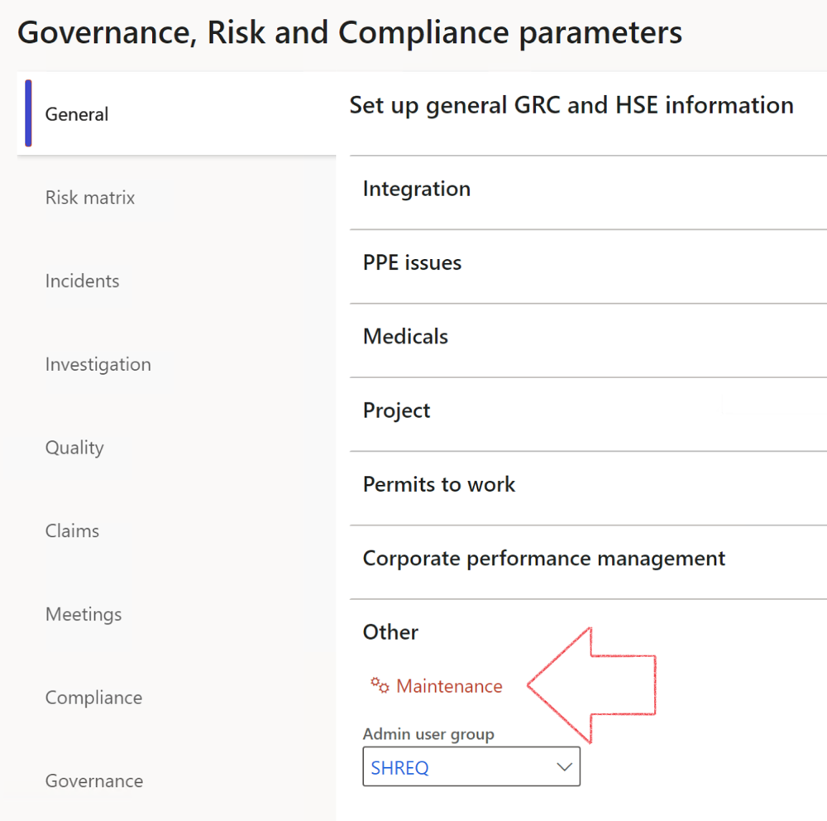

|  |  |
| --- | --- |
|  | The **Maintenance** button is there for designated user. This button repairs any possible data issues. For a full history of all Data related repairs; see table below: |

The information contained in this document represents the current view of Axnosis and Microsoft Corporation on the issues discussed as of the date of publication. Because Axnosis and Microsoft must respond to changing market conditions, this document should not be interpreted to be a commitment on the part of Axnosis and Microsoft, and Axnosis and Microsoft cannot guarantee the accuracy of any information presented after the date of publication.

This test script is for informational purposes only. AXNOSIS AND MICROSOFT MAKE NO WARRANTIES, EXPRESS, IMPLIED, OR STATUTORY, AS TO THE INFORMATION IN THIS DOCUMENT.

Complying with all applicable copyright laws is the responsibility of the user. Without limiting the rights under copyright, no part of this document may be reproduced, stored in or introduced into a retrieval system, or transmitted in any form or by any means (electronic, mechanical, photocopying, recording, or otherwise), or for any purpose, without the express written permission of Axnosis and Microsoft Corporation.

Axnosis and Microsoft may have patents, patent applications, trademarks, copyrights, or other intellectual property rights covering subject matter in this document. Except as expressly provided in any written license agreement from Axnosis and Microsoft, the furnishing of this document does not give you any license to these patents, trademarks, copyrights, or other intellectual property.

© 2021 Microsoft Corporation. All rights reserved. Any use or distribution of these materials without express authorization of Microsoft Corp. is strictly prohibited.

Microsoft and Windows are both registered trademarks of Microsoft Corporation in the United States and/or other countries.

The names of actual companies and products mentioned herein may be the trademarks of their respective owners.

|  |  |  |
| --- | --- | --- |
| **Process** | **Description/notes** | **Release** |
| Fix location vs. work centres | Populate the new **LocationRecID** field with the related location associated with previously used work centre location (Location) fields on the following tables:   * OHSHazardLocations, * OHSRiskHazard, * OHSRiskHazardWizard, * OHSRiskRegister, * OHSRisksWizard, * OHSSafetyLocations, * OHSSafetyPermit, * OHSSafetyPermitLocations * OHSSafetyPermitOverlap, * OHSSafetyPlan, * OHSInvestigation | 10.0.80.10 |
| Fix risk hazards | Assigning the value "Default Risk" to the new mandatory field **RiskID** (Key field) where empty | 10.0.80.10 |
| Fix incident HRM injury link | Delete all orphaned records from the **OHSIncidentHRMInjuryLnk** table | 10.0.11785.3 |
| Populate SRS analysis enums | Still in concept phase. To provide a link between enum numerical value and value name for use with BYOD data entities. Enums available:   * OHSIncidentType, * OHSIncidentSeverityType.   Table populated: **SRSAnalysisEnums** | 10.0.11785.3 |
| Fix budget transaction lines stock\item dimension | Set **OHSInventDimId** field value to "**AllBlank**" on table **BudgetTransactionLine**, where no value was recorded. This will solve the issue of records not displaying in the form.  **Note: this step will only fix existing budget transaction records in the system. Should any new transactions be uploaded or changed via the data entity Budget Account Entries, special care needs to be taken to specify the Stock dimension = AllBlank and the Item on the excel sheet to import.** | 10.1.1366.6 |
| Update existing incidents with the new **Incident types** | Update existing incidents with the **Incident types** that are setup on the new **Incident type** setup form. (IncidentTypeRecId) | 10.17.1250.5 |
| Update existing risks with the new **Control types** | Update existing risks with the **Control types** that are setup on the new **Control type** setup form. | 10.17.1250.6 |
| Re-number GRC Question and Answer **Group lines** | Re-number GRC Question and Answer **Group line numbers** | 10.22.1561.3 |
| Fix Inspection locations: Replace Work centre-based locations with HSE locations | Populate the new **ObjectLocation** field with the related HSE location associated with previously used work centre location (**Location**) field on the following tables:   * OHSInspectionJournalName * OHSInspectionJournalTable * OHSInspectionJournalTrans * OHSInspectionHistory * OHSSchedule | 10.24.1114.3 |
| **Process** | **Description/notes** | **Release** |
| Display of non-calculation lines | Run this job to ensure data consistency and correct display of historical data. |  |
| Fix Asset counter stock dimensions  Fix Line types on Data repository lines  Delete Orphan Data repositories | Replace empty stock dimension values with a blank dimension value  Populate missing line types from reporting templates on Data repository lines  Delete data repositories for which no template, year, site, period name or month was defined. | 10.26.1087.3  10.28.1080.6  10.30.2459.4 |
| Equivalent Functional location fields | The equivalent Functional location fields will be populated where an HSE Location exists on the permit to work pool header and linked Permit to work table. | 10.30.2459.12 |