

Dynamics GRC/HSE Release notes



Governance Risk & Compliance

Health, Safety & Environment

for

**Microsoft Dynamics 365 for Finance & Operations™**

*Dynamics GRC/HSE version* 10.33.1620.16

2025-05-14



|  |  |
| --- | --- |
| Dynamics 365 FO GRC module GRC is an add-on for Dynamics 365 suite of business application software.  This software provides compelling functionality to support Governance, Risk management and Compliance. |  |
| Dynamics 365 FO HSE/OHS OHS/HSE is an add-on for Dynamics 365 suite of business application software.  This software adds to GRC in that compliance is now deeper with explicit functionality for Health, Safety and Environment as per the depicted sub-modules below. | |
|  | |

Release version

**GRC/HSE Package version:** OHSDeployablePackage_10_33_1620_16

This package was created on Microsoft Dynamics 365 for Finance and Operations:

|  |  |  |
| --- | --- | --- |
| **Release** | **Version** | **Build number** |
| Application release | 10.0.42 | 10.33.1620 |
| Platform release | Platform update 66 | 7.0.7452.66 |

# Enhancements:

|  |  |
| --- | --- |
| Module | Description |
| Tender management | * On the **Edit manage replies** and on the **Vendor portal** under the **Negotiations (header level)** Fast tab:   + The **Item number** field is hidden   + The **Original bid value total** display was copied from the Lines. * On the **Edit manage replies** and on the **Vendor portal** under the **Lines** Fast tab:   (also on the Manage replies lines under the Purchase quotation lines grid)   * + The **Negotiation request** and **Negotiation response** columns were moved to the end of the grid.   + A new non-editable column, **Negotiation status,** was added to the end of the grid, as well as a new **Round** column.   + The following fields were added below the grid:     - **Original bid value total**. (Sum of the **Net amount** column)     - **Negotiated bid value total**. (Sum of **Negotiation response** column + sum of the **Net amount** column excluding the **Net amount** value where the **Negotiation response** enum **= Yes**)   + A new **Submit** button was added for confirming the negotiation response. A message to warn the user that response submission is final.   + The following labels were changed:     - **Bafo response** in the button strip is now **Negotiation response**     - The **Negotiations** Fast tab is now **Negotiations (header level)**     - The **Attach BAFO response** button’s label is now **Attach negotiation response.** * On the **Manage replies** Header**, Quotation** Fast tab:   + Help text was added to the **Total net price** field.   + A new **Gear icon** was added next to the **Negotiated price** field. When clicked, the negotiated item line prices will be updated to the quotation header based on Negotiated bid value total. * **Icons** were added on the cards on the **Manage replies**. This makes it easier for users to identify vendors that comply or that are disqualified based on the Process status. |

|  |  |
| --- | --- |
| Module | Description |
| Tender management | * Vendors that have been **disqualified** on the RFQ:   + are now **excluded** on the **Compare replies**.   + Are **excluded** when **Negotiation checklists** are created. * The following fields and buttons are disabled for **disqualified vendors** on the **Manage replies**:   + All fields under the Quotation and Price/discount Fast tabs   + The following buttons under the Purchase quotation lines Fast tab:     - Add line, Attach commercial bid response     - Negotiation, Send email to supplier * On the **RFQ** Header**, Governance Fast tab, Negotiations** Index tab:   + Two new field groups were created. One for **Header** level negotiation details and one for **Line** level negotiation details. These two field groups are shown/hidden depending on the line that is selected in the grid above. * On the **Bid negotiation** inquiry:   + A new **Show line level negotiation** Yes/no slider was added. The new columns added to the **Manage replies lines** under the **Purchase quotation lines** grid (mentioned above) were also added to the inquiry and can now either be displayed/hidden. |
| Management of change | * The default value for the **Auto create note** slider on the CR create dialog is now **Yes**. * An adjustment was made to the **select** conditions for **MOC Workflow** for approval authority line matching. |
| Contracts management | * Help text to assist users, was added to the fields listed under the Consumption index tab on the Contract details form. * On the Contract: The **RACI** Fast tab was renamed to **RACI and other contacts** and a new table was created which is exposed as a grid under the current RACI fields. Additional Workers can be selected here and their contact detail entered. |
| Document management | In preparation for giving users the option to use a numbering sequence for Contracts/Other documents:   * On the **GRC parameters, Governance tab, Contracts governance** Fast tab, a new **Use numbering sequence** Yes/No slider was added. |
| Vendor portal | On the **Vendor bidding** workspace:   * The **Vendor name** is now displayed under the vendor lookup * Under the **Bids** section, a new **Negotiation (lines) bids** tab was added. A list of open bid lines that negotiation requests were done for, are listed here. |

*Bug fixes:*

|  |  |
| --- | --- |
| **Module** | **Description** |
| Contracts management | When Contract line items were imported using the Data entity, the Contract item lines were not imported and not displayed on contract record.  The issue has been resolved. |

Release Data impact

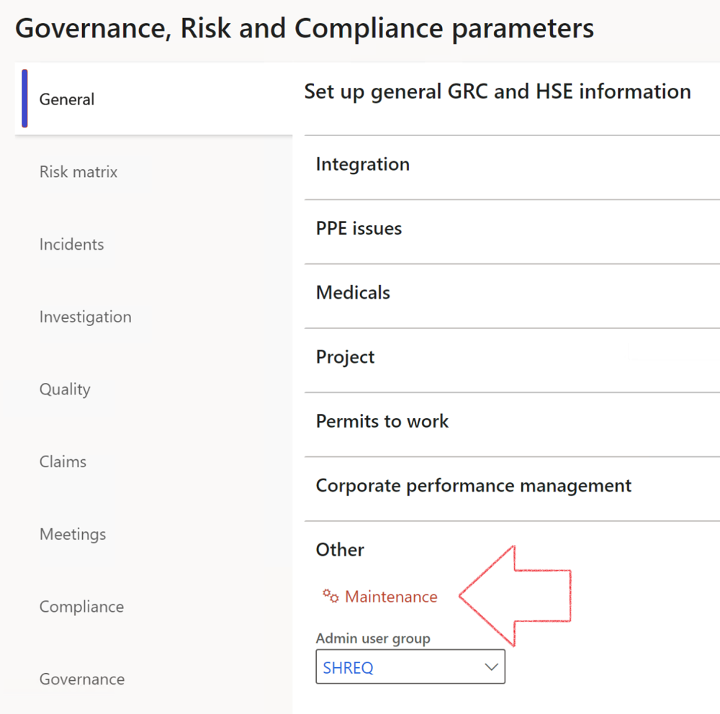

|  |  |
| --- | --- |
|  | The **Maintenance** button is there for designated user. This button repairs any possible data issues. For a full history of all Data related repairs; see table below: |

The information contained in this document represents the current view of Axnosis and Microsoft Corporation on the issues discussed as of the date of publication. Because Axnosis and Microsoft must respond to changing market conditions, this document should not be interpreted to be a commitment on the part of Axnosis and Microsoft, and Axnosis and Microsoft cannot guarantee the accuracy of any information presented after the date of publication.

This test script is for informational purposes only. AXNOSIS AND MICROSOFT MAKE NO WARRANTIES, EXPRESS, IMPLIED, OR STATUTORY, AS TO THE INFORMATION IN THIS DOCUMENT.

Complying with all applicable copyright laws is the responsibility of the user. Without limiting the rights under copyright, no part of this document may be reproduced, stored in or introduced into a retrieval system, or transmitted in any form or by any means (electronic, mechanical, photocopying, recording, or otherwise), or for any purpose, without the express written permission of Axnosis and Microsoft Corporation.

Axnosis and Microsoft may have patents, patent applications, trademarks, copyrights, or other intellectual property rights covering subject matter in this document. Except as expressly provided in any written license agreement from Axnosis and Microsoft, the furnishing of this document does not give you any license to these patents, trademarks, copyrights, or other intellectual property.

© 2021 Microsoft Corporation. All rights reserved. Any use or distribution of these materials without express authorization of Microsoft Corp. is strictly prohibited.

Microsoft and Windows are both registered trademarks of Microsoft Corporation in the United States and/or other countries.

The names of actual companies and products mentioned herein may be the trademarks of their respective owners.

|  |  |  |
| --- | --- | --- |
| **Process** | **Description/notes** | **Release** |
| Fix location vs. work centres | Populate the new **LocationRecID** field with the related location associated with previously used work centre location (Location) fields on the following tables:   * OHSHazardLocations, * OHSRiskHazard, * OHSRiskHazardWizard, * OHSRiskRegister, * OHSRisksWizard, * OHSSafetyLocations, * OHSSafetyPermit, * OHSSafetyPermitLocations * OHSSafetyPermitOverlap, * OHSSafetyPlan, * OHSInvestigation | 10.0.80.10 |
| Fix risk hazards | Assigning the value "Default Risk" to the new mandatory field **RiskID** (Key field) where empty | 10.0.80.10 |
| Fix incident HRM injury link | Delete all orphaned records from the **OHSIncidentHRMInjuryLnk** table | 10.0.11785.3 |
| Populate SRS analysis enums | Still in concept phase. To provide a link between enum numerical value and value name for use with BYOD data entities. Enums available:   * OHSIncidentType, * OHSIncidentSeverityType.   Table populated: **SRSAnalysisEnums** | 10.0.11785.3 |
| Fix budget transaction lines stock\item dimension | Set **OHSInventDimId** field value to "**AllBlank**" on table **BudgetTransactionLine**, where no value was recorded. This will solve the issue of records not displaying in the form.  **Note: this step will only fix existing budget transaction records in the system. Should any new transactions be uploaded or changed via the data entity Budget Account Entries, special care needs to be taken to specify the Stock dimension = AllBlank and the Item on the excel sheet to import.** | 10.1.1366.6 |
| Update existing incidents with the new **Incident types** | Update existing incidents with the **Incident types** that are setup on the new **Incident type** setup form. (IncidentTypeRecId) | 10.17.1250.5 |
| Update existing risks with the new **Control types** | Update existing risks with the **Control types** that are setup on the new **Control type** setup form. | 10.17.1250.6 |
| Re-number GRC Question and Answer **Group lines** | Re-number GRC Question and Answer **Group line numbers** | 10.22.1561.3 |
| Fix Inspection locations: Replace Work centre-based locations with HSE locations | Populate the new **ObjectLocation** field with the related HSE location associated with previously used work centre location (**Location**) field on the following tables:   * OHSInspectionJournalName * OHSInspectionJournalTable * OHSInspectionJournalTrans * OHSInspectionHistory * OHSSchedule | 10.24.1114.3 |
| **Process** | **Description/notes** | **Release** |
| Display of non-calculation lines | Run this job to ensure data consistency and correct display of historical data. |  |
| Fix Asset counter stock dimensions  Fix Line types on Data repository lines  Delete Orphan Data repositories | Replace empty stock dimension values with a blank dimension value  Populate missing line types from reporting templates on Data repository lines  Delete data repositories for which no template, year, site, period name or month was defined. | 10.26.1087.3  10.28.1080.6  10.30.2459.4 |
| Equivalent Functional location fields | The equivalent Functional location fields will be populated where an HSE Location exists on the permit to work pool header and linked Permit to work table. | 10.30.2459.12 |