

Dynamics GRC/HSE Release notes



Governance Risk & Compliance

Health, Safety & Environment

for

**Microsoft Dynamics 365 for Finance & Operations™**

*Dynamics GRC/HSE version* 10.33.1620.15

2025-05-07



|  |  |
| --- | --- |
| Dynamics 365 FO GRC module GRC is an add-on for Dynamics 365 suite of business application software.  This software provides compelling functionality to support Governance, Risk management and Compliance. |  |
| Dynamics 365 FO HSE/OHS OHS/HSE is an add-on for Dynamics 365 suite of business application software.  This software adds to GRC in that compliance is now deeper with explicit functionality for Health, Safety and Environment as per the depicted sub-modules below. | |
|  | |

Release version

**GRC/HSE Package version:** OHSDeployablePackage_10_33_1620_15

This package was created on Microsoft Dynamics 365 for Finance and Operations:

|  |  |  |
| --- | --- | --- |
| **Release** | **Version** | **Build number** |
| Application release | 10.0.42 | 10.33.1620 |
| Platform release | Platform update 66 | 7.0.7452.66 |

# Enhancements:

|  |  |
| --- | --- |
| Module | Description |
| Tender management | * On the RFQ, on the **Overall pricing** dialog:   + A **vendor account** **name** column was added   + Disqualified vendors are excluded from the grid   + Calculations for the **Original score** and **Negotiation score** columns were fixed. * On the **RFQ header**, under the **Governance** Fast tab:   + Under the **Event information** Index tab, a new **Estimated value of bid** field was added.   + Under the **Negotiation** Index tab:     - The help text for the **Add request** button was improved.     - A new **View** button group was added (for future use)     - A new value, **Envelope opened**, was added to the **Status** enum.     - A new **Response attachments** slider was added below the grid. This will serve as an indicator to the user of whether the bidder has uploaded response attachments via the portal. * On the **Solicitation type**:   + The **Evaluation criteria** enum display is now hidden   + The following numeric fields were added, and a validation exists to see if they add up to 100%:     - **Technical weight %**, **Commercial weight %**     - **Risk weight %**, **Safety weight %** * On the **Tender score summary**:   + The following columns were added:     - **Technical average %**, **Commercial average %**, **Negotiation average %**   + The **Evaluation criteria** display is now hidden     - The **Technical weight %** from the Solicitation type is now displayed     - The **Commercial weight %** from the Solicitation type is now displayed   + The **Show negotiation** and **Show prices** yes/no sliders were swapped * On the Procurement plan Header: the **Evaluation criteria** display is now hidden * On the **GRC parameters, Governance** tab, **Contracts governance** Fast tab, help text was added on the **Numbering** field to assist users. * On the **Vendor RFQ bid** form, under the **Lines** Fast tab, as well as on the **RFQ manage replies Lines:**   + A new **Negotiation request** column was added   + A **Negotiation response** column was added   + The **Bafo response** button was hidden   + A new **Round history** button was added (for future use) |
| **Module** | **Description** |
| Contracts management | * On the **Contract**, under the **Item lines** Fast tab, a **privilege** was added on the **Distribute all line amounts** button. * Validations are now performed to ensure that invoiced amounts do not exceed the allocated contract line distribution for the relevant period and ledger account. |
| Management of change | * A new Fast tab, labelled **Change request approvers**, was added to the change request details form. The Fast tab content contains nine approver indicators to indicate which approvers will be included in the change request workflow process once the change request is submitted for workflow approval. The approvers are linked to the GRC Approval Authority. * The GRC **Approval Authority** was expanded to include six additional worker columns, labelled **End user 1** to **End user 6**. The visibility of the additional columns can be controlled via a parameter discussed below. * A new parameter was added to the **Governance** tab, under the **Sourcing and tender governance** Fast tab, to allow users to show or hide the **Change request approvers** Fast tab on change requests. Additionally, the parameter also controls the visibility of the additional columns discussed above. * **Management of change workflow designer** enhancements have been made to expand the workflow capabilities of the Management of change module. |
| Corporate performance management | * A **Number** column was added to the following grids:   On **Goal groups**, under the **Goal templated associated with the group** Fast tab  On **Goal templates**, under the **Measurements** Fast tab |

*Bug fixes:*

|  |  |
| --- | --- |
| **Module** | **Description** |
| Contracts management | On **created** contracts: vendors could not be added under the **Trading partners** grid, an item could not be added to the **Item lines** grid.  The issue has been resolved. |
| Tender management | On the **RFQ Compare replies**: Negotiation requests were created for the RFQ Header instead of the RFQ lines.  The issue has been resolved. |

Release Data impact

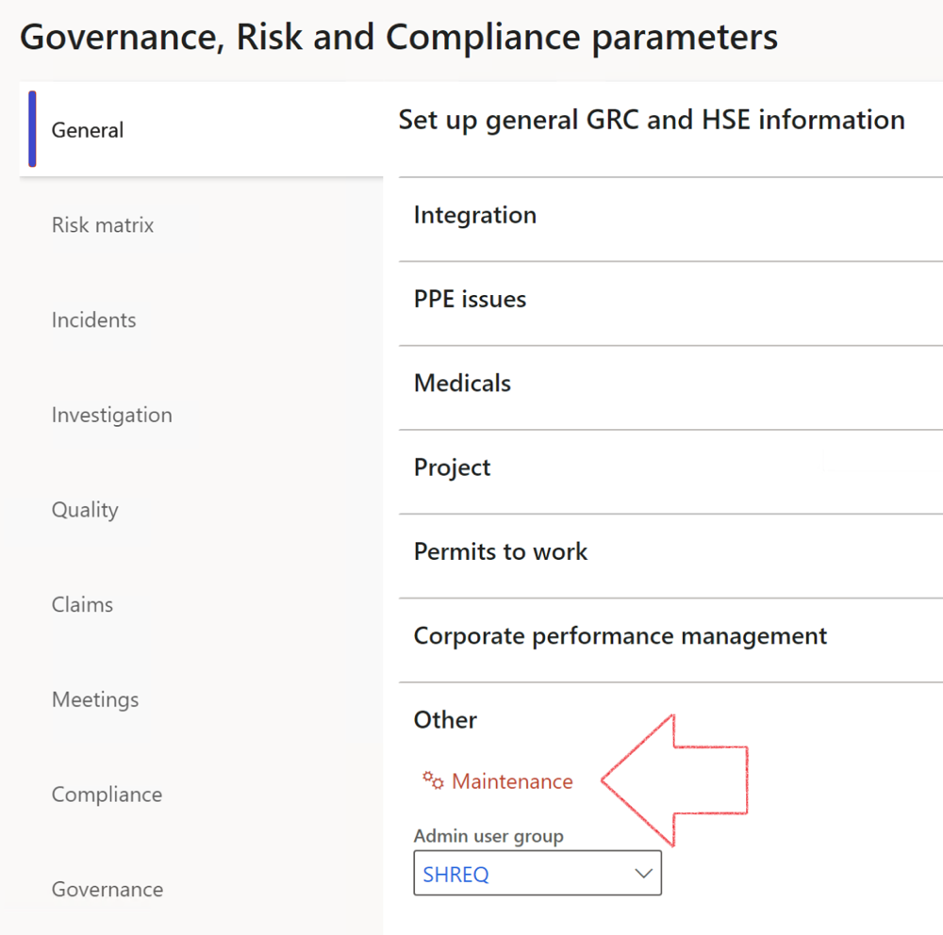

|  |  |
| --- | --- |
|  | The **Maintenance** button is there for designated user. This button repairs any possible data issues. For a full history of all Data related repairs; see table below: |

The information contained in this document represents the current view of Axnosis and Microsoft Corporation on the issues discussed as of the date of publication. Because Axnosis and Microsoft must respond to changing market conditions, this document should not be interpreted to be a commitment on the part of Axnosis and Microsoft, and Axnosis and Microsoft cannot guarantee the accuracy of any information presented after the date of publication.

This test script is for informational purposes only. AXNOSIS AND MICROSOFT MAKE NO WARRANTIES, EXPRESS, IMPLIED, OR STATUTORY, AS TO THE INFORMATION IN THIS DOCUMENT.

Complying with all applicable copyright laws is the responsibility of the user. Without limiting the rights under copyright, no part of this document may be reproduced, stored in or introduced into a retrieval system, or transmitted in any form or by any means (electronic, mechanical, photocopying, recording, or otherwise), or for any purpose, without the express written permission of Axnosis and Microsoft Corporation.

Axnosis and Microsoft may have patents, patent applications, trademarks, copyrights, or other intellectual property rights covering subject matter in this document. Except as expressly provided in any written license agreement from Axnosis and Microsoft, the furnishing of this document does not give you any license to these patents, trademarks, copyrights, or other intellectual property.

© 2021 Microsoft Corporation. All rights reserved. Any use or distribution of these materials without express authorization of Microsoft Corp. is strictly prohibited.

Microsoft and Windows are both registered trademarks of Microsoft Corporation in the United States and/or other countries.

The names of actual companies and products mentioned herein may be the trademarks of their respective owners.

|  |  |  |
| --- | --- | --- |
| **Process** | **Description/notes** | **Release** |
| Fix location vs. work centres | Populate the new **LocationRecID** field with the related location associated with previously used work centre location (Location) fields on the following tables:   * OHSHazardLocations, * OHSRiskHazard, * OHSRiskHazardWizard, * OHSRiskRegister, * OHSRisksWizard, * OHSSafetyLocations, * OHSSafetyPermit, * OHSSafetyPermitLocations * OHSSafetyPermitOverlap, * OHSSafetyPlan, * OHSInvestigation | 10.0.80.10 |
| Fix risk hazards | Assigning the value "Default Risk" to the new mandatory field **RiskID** (Key field) where empty | 10.0.80.10 |
| Fix incident HRM injury link | Delete all orphaned records from the **OHSIncidentHRMInjuryLnk** table | 10.0.11785.3 |
| Populate SRS analysis enums | Still in concept phase. To provide a link between enum numerical value and value name for use with BYOD data entities. Enums available:   * OHSIncidentType, * OHSIncidentSeverityType.   Table populated: **SRSAnalysisEnums** | 10.0.11785.3 |
| Fix budget transaction lines stock\item dimension | Set **OHSInventDimId** field value to "**AllBlank**" on table **BudgetTransactionLine**, where no value was recorded. This will solve the issue of records not displaying in the form.  **Note: this step will only fix existing budget transaction records in the system. Should any new transactions be uploaded or changed via the data entity Budget Account Entries, special care needs to be taken to specify the Stock dimension = AllBlank and the Item on the excel sheet to import.** | 10.1.1366.6 |
| Update existing incidents with the new **Incident types** | Update existing incidents with the **Incident types** that are setup on the new **Incident type** setup form. (IncidentTypeRecId) | 10.17.1250.5 |
| Update existing risks with the new **Control types** | Update existing risks with the **Control types** that are setup on the new **Control type** setup form. | 10.17.1250.6 |
| Re-number GRC Question and Answer **Group lines** | Re-number GRC Question and Answer **Group line numbers** | 10.22.1561.3 |
| Fix Inspection locations: Replace Work centre-based locations with HSE locations | Populate the new **ObjectLocation** field with the related HSE location associated with previously used work centre location (**Location**) field on the following tables:   * OHSInspectionJournalName * OHSInspectionJournalTable * OHSInspectionJournalTrans * OHSInspectionHistory * OHSSchedule | 10.24.1114.3 |
| **Process** | **Description/notes** | **Release** |
| Display of non-calculation lines | Run this job to ensure data consistency and correct display of historical data. |  |
| Fix Asset counter stock dimensions  Fix Line types on Data repository lines  Delete Orphan Data repositories | Replace empty stock dimension values with a blank dimension value  Populate missing line types from reporting templates on Data repository lines  Delete data repositories for which no template, year, site, period name or month was defined. | 10.26.1087.3  10.28.1080.6  10.30.2459.4 |
| Equivalent Functional location fields | The equivalent Functional location fields will be populated where an HSE Location exists on the permit to work pool header and linked Permit to work table. | 10.30.2459.12 |