

Dynamics GRC/HSE Release notes



Governance Risk & Compliance

Health, Safety & Environment

for

**Microsoft Dynamics 365 for Finance & Operations™**

*Dynamics GRC/HSE version* 10.33.1620.11

2025-04-02



|  |  |
| --- | --- |
| Dynamics 365 FO GRC module GRC is an add-on for Dynamics 365 suite of business application software.  This software provides compelling functionality to support Governance, Risk management and Compliance. |  |
| Dynamics 365 FO HSE/OHS OHS/HSE is an add-on for Dynamics 365 suite of business application software.  This software adds to GRC in that compliance is now deeper with explicit functionality for Health, Safety and Environment as per the depicted sub-modules below. | |
|  | |

Release version

**GRC/HSE Package version:** OHSDeployablePackage_10_33_1620_11

This package was created on Microsoft Dynamics 365 for Finance and Operations:

|  |  |  |
| --- | --- | --- |
| **Release** | **Version** | **Build number** |
| Application release | 10.0.42 | 10.33.1620 |
| Platform release | Platform update 66 | 7.0.7452.66 |

# Enhancements:

|  |  |
| --- | --- |
| Module | Description |
| Corporate performance management | * The help text for the **Create goals** button on the Action pane of the **Vendor** form, was improved * The following two menu items were copied from **HR** to **Asset management, Fuel management**:   + **Workers**   + **Fixed compensation plans** * A new **Worker** lookup was added to the **Asset counters** grid. * A new **Fuel graph** and menu item was created and added under **Asset management, Fuel management**. |
| Management of change | * The **Engineering change management workflow** is now linked to the **Approval authority**. * The **Data entity** for the **Approval authority** was enhanced. |
| Tender management | * On the **Purchase requisition,** under the **Lines** Fast tab, a new Yes/No column was added for **Primary vendor**. * When the **Show tasks** button is clicked on the **RFQ Manage replies** Action pane, the **Business process for Governance, risk and compliance** workspace opens displaying the created tasks. * A new **Negotiation** slider was added on the **Solicitation** setup form. If this slider is set to **Yes,** the following can be done on the **RFQ**:   + **Negotiation** **checklists** can be created and evaluated   + **Negotiation evaluation scores** can be viewed   + **Negotiation scores** can be added as a column to the **Evaluation setup** form |
| Contracts management | * A new menu item and form were added under the GRC, Contracts menu folder for **Department contracts**. Only contracts where the department is the same as that of the logged in user, will be on this list page. * On the **Invoice journal** inquiry, a new **View contract** button was added to allow the user to see the details of the linked contract. |
| Permits to work | When a **Safety plan** is copied, the header, RACI, and the lines, are also copied. |

*Bug fixes:*

|  |  |
| --- | --- |
| **Module** | **Description** |
| Management of change | When a new **Change request** was created from the CR list page, and a **Scope of lines** record was approved, an error message was popping up.  The issue has been resolved. |
| Contracts management | On the **Contract**, under the **Item lines** Fast tab, when a line's Unit price, Quantity, and/or Net amount was modified, the values were not consistently re-calculated, resulting in an incorrect Net amount being displayed.  The issue has been resolved. |
| Permits to work | The **Minimum workers** field on the **Safety plan** was not updating correctly after the **Watchman** slider was moved to **Yes**.  The issue has been resolved. |

Release Data impact

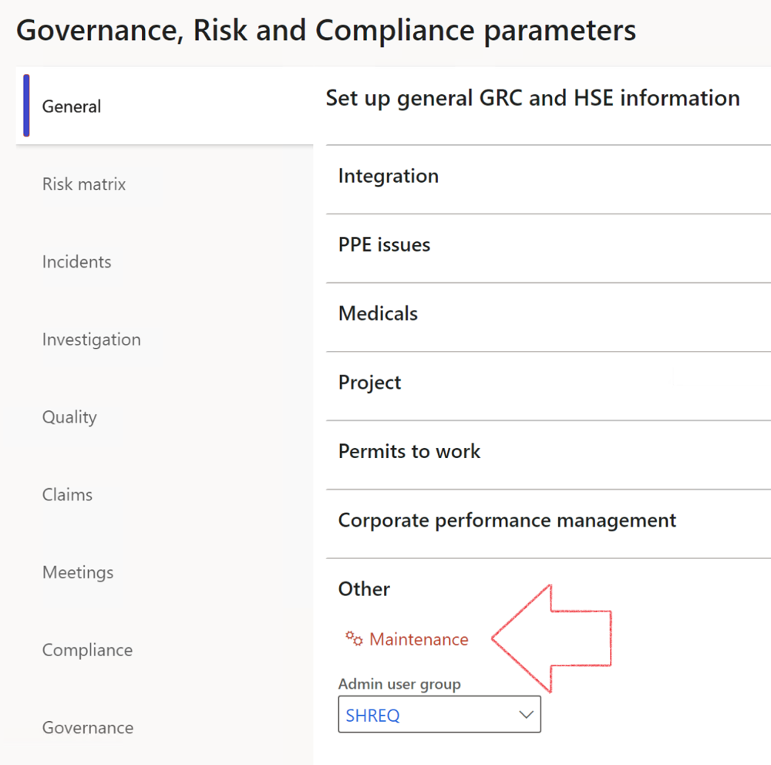

|  |  |
| --- | --- |
|  | The **Maintenance** button is there for designated user. This button repairs any possible data issues. For a full history of all Data related repairs; see table below: |

The information contained in this document represents the current view of Axnosis and Microsoft Corporation on the issues discussed as of the date of publication. Because Axnosis and Microsoft must respond to changing market conditions, this document should not be interpreted to be a commitment on the part of Axnosis and Microsoft, and Axnosis and Microsoft cannot guarantee the accuracy of any information presented after the date of publication.

This test script is for informational purposes only. AXNOSIS AND MICROSOFT MAKE NO WARRANTIES, EXPRESS, IMPLIED, OR STATUTORY, AS TO THE INFORMATION IN THIS DOCUMENT.

Complying with all applicable copyright laws is the responsibility of the user. Without limiting the rights under copyright, no part of this document may be reproduced, stored in or introduced into a retrieval system, or transmitted in any form or by any means (electronic, mechanical, photocopying, recording, or otherwise), or for any purpose, without the express written permission of Axnosis and Microsoft Corporation.

Axnosis and Microsoft may have patents, patent applications, trademarks, copyrights, or other intellectual property rights covering subject matter in this document. Except as expressly provided in any written license agreement from Axnosis and Microsoft, the furnishing of this document does not give you any license to these patents, trademarks, copyrights, or other intellectual property.

© 2021 Microsoft Corporation. All rights reserved. Any use or distribution of these materials without express authorization of Microsoft Corp. is strictly prohibited.

Microsoft and Windows are both registered trademarks of Microsoft Corporation in the United States and/or other countries.

The names of actual companies and products mentioned herein may be the trademarks of their respective owners.

|  |  |  |
| --- | --- | --- |
| **Process** | **Description/notes** | **Release** |
| Fix location vs. work centres | Populate the new **LocationRecID** field with the related location associated with previously used work centre location (Location) fields on the following tables:   * OHSHazardLocations, * OHSRiskHazard, * OHSRiskHazardWizard, * OHSRiskRegister, * OHSRisksWizard, * OHSSafetyLocations, * OHSSafetyPermit, * OHSSafetyPermitLocations * OHSSafetyPermitOverlap, * OHSSafetyPlan, * OHSInvestigation | 10.0.80.10 |
| Fix risk hazards | Assigning the value "Default Risk" to the new mandatory field **RiskID** (Key field) where empty | 10.0.80.10 |
| Fix incident HRM injury link | Delete all orphaned records from the **OHSIncidentHRMInjuryLnk** table | 10.0.11785.3 |
| Populate SRS analysis enums | Still in concept phase. To provide a link between enum numerical value and value name for use with BYOD data entities. Enums available:   * OHSIncidentType, * OHSIncidentSeverityType.   Table populated: **SRSAnalysisEnums** | 10.0.11785.3 |
| Fix budget transaction lines stock\item dimension | Set **OHSInventDimId** field value to "**AllBlank**" on table **BudgetTransactionLine**, where no value was recorded. This will solve the issue of records not displaying in the form.  **Note: this step will only fix existing budget transaction records in the system. Should any new transactions be uploaded or changed via the data entity Budget Account Entries, special care needs to be taken to specify the Stock dimension = AllBlank and the Item on the excel sheet to import.** | 10.1.1366.6 |
| Update existing incidents with the new **Incident types** | Update existing incidents with the **Incident types** that are setup on the new **Incident type** setup form. (IncidentTypeRecId) | 10.17.1250.5 |
| Update existing risks with the new **Control types** | Update existing risks with the **Control types** that are setup on the new **Control type** setup form. | 10.17.1250.6 |
| Re-number GRC Question and Answer **Group lines** | Re-number GRC Question and Answer **Group line numbers** | 10.22.1561.3 |
| Fix Inspection locations: Replace Work centre-based locations with HSE locations | Populate the new **ObjectLocation** field with the related HSE location associated with previously used work centre location (**Location**) field on the following tables:   * OHSInspectionJournalName * OHSInspectionJournalTable * OHSInspectionJournalTrans * OHSInspectionHistory * OHSSchedule | 10.24.1114.3 |
| **Process** | **Description/notes** | **Release** |
| Display of non-calculation lines | Run this job to ensure data consistency and correct display of historical data. |  |
| Fix Asset counter stock dimensions  Fix Line types on Data repository lines  Delete Orphan Data repositories | Replace empty stock dimension values with a blank dimension value  Populate missing line types from reporting templates on Data repository lines  Delete data repositories for which no template, year, site, period name or month was defined. | 10.26.1087.3  10.28.1080.6  10.30.2459.4 |
| Equivalent Functional location fields | The equivalent Functional location fields will be populated where an HSE Location exists on the permit to work pool header and linked Permit to work table. | 10.30.2459.12 |