

Dynamics GRC/HSE Release notes



Governance Risk & Compliance

Health, Safety & Environment

for

**Microsoft Dynamics 365 for Finance & Operations™**

*Dynamics GRC/HSE version* 10.33.1620.1

2025-01-31



|  |  |
| --- | --- |
| Dynamics 365 FO GRC module GRC is an add-on for Dynamics 365 suite of business application software.  This software provides compelling functionality to support Governance, Risk management and Compliance. |  |
| Dynamics 365 FO HSE/OHS OHS/HSE is an add-on for Dynamics 365 suite of business application software.  This software adds to GRC in that compliance is now deeper with explicit functionality for Health, Safety and Environment as per the depicted sub-modules below. | |
|  | |

Release version

**GRC/HSE Package version:** OHSDeployablePackage_10_33_1620_1

This package was created on Microsoft Dynamics 365 for Finance and Operations:

|  |  |  |
| --- | --- | --- |
| **Release** | **Version** | **Build number** |
| Application release | 10.0.42 | 10.33.1620 |
| Platform release | Platform update 66 | 7.0.7452.66 |

# Enhancements:

|  |  |
| --- | --- |
| Module | Description |
| Business continuity | * On the **Business impact assessment**:   + Under the **General** Fast tab:     - A new lookup was added to the **Business process template header**     - A new **Indicators** Field group was added with the following fields:       * **MAO**, **RPO value** and **RTO value**   + Under the **Overall impact** Fast tab: A new **Category impact** lookup was added   + Under the **Assessment** Fast tab:     - A new **Downtime** **impact** Index tab was added with 5 “rating” fields.   + The BC/DR is now referenced under the **Continuity and recovery plan** Fast tab.   + **Approved** records cannot be deleted. * On the **Continuity and disaster recovery**:   + The manager of the selected **Department** selected under the General Fast tab, now populates the **Responsible user** field under the **RACI** Fast tab.   + Under the **Target** Fast tab: In the **Key contracts** grid, a **BC/DR in place** column was added which displays a tick if the **Vendor** on the Contract has the new **BC/DR in place** slider (under the Profile Fast tab) on **Yes**.   + The **Review tasks checklist** field is now hidden.   + **Multiple Review actions** can now be created form the BC/DR:     - The **Create checklist** button was renamed to **Create review actions**.     - This button opens a new **Create review actions** dialog where the user can use **filters** and define **rules** for creating these review actions.   + The **Reviewer** and **Review date** field under the **Approval** Fast tab, are now hidden.   + **Approved** records cannot be deleted. * The following values are copied when the **Copy** button is clicked on the **Business process template**:   + **Minimum workers**, **Total workers** and **Type**   + **Accounting area** and **Critical** (slider) * On the **GRC parameters**: * Under the **Governance** Tab, a new **Business continuity** Fast tab was added where a default **Signature type** can be selected. * Under the **Notifications** Tab, a new **BC/DR review** lookup was added. * A new **Impact assessment: Downtime report** was created. |

|  |  |
| --- | --- |
| **Module** | **Description** |
| Tender management | On the RFQ header, under the Governance Fast tab, Negotiation Index tab, the **Expected date** field on the **Request** drop-dialog is now a **date and time** field. |
| Contracts management | * When a contract has a **Change request,** with status “**In progress**” linked to it, the **Create CR** button on the contract will be disabled. This is to avoid conflict in the revised value. * On the **Contract classification**, a new **Investment** column was added. * “Parent” contracts cannot be deleted while “child” contracts are linked to it. * The status of a **Contract** created from a **Purchase requisition**, is **Draft**. |
| Management of change | * A new **Investment** column was added to the **Event type** setup form. * On the Change request, under the Changes to Fast tab, a new display was added with label **Investment**. |
| Vendor collaboration | A new **Duplicate check on contact email address** was added on the **Procurement and sourcing parameters**, Vendor collaboration Tab, **General** Fast tab. |
| Enterprise legal management | * The **Name** field on the **Legal register i**s now editable to users in the **Admin user group**. |
| General | * The **All planned Governance, risk and compliance actions** list page was changed to a new **Workspace** with tiles and a grid. * A new **My actions** filter was added to the **All planned Governance, risk and compliance actions** grid. |

*Bug fixes:*

|  |  |
| --- | --- |
| **Module** | **Description** |
| Operational risk | There was an issue selecting a **Works order item** on a **Risk register** under the **Associations** Fast tab.  The issue has been resolved. |
| Contracts management | A dialog came up when the **Copy** button on a **Contract** was clicked.  The issue has been resolved. |

Release Data impact

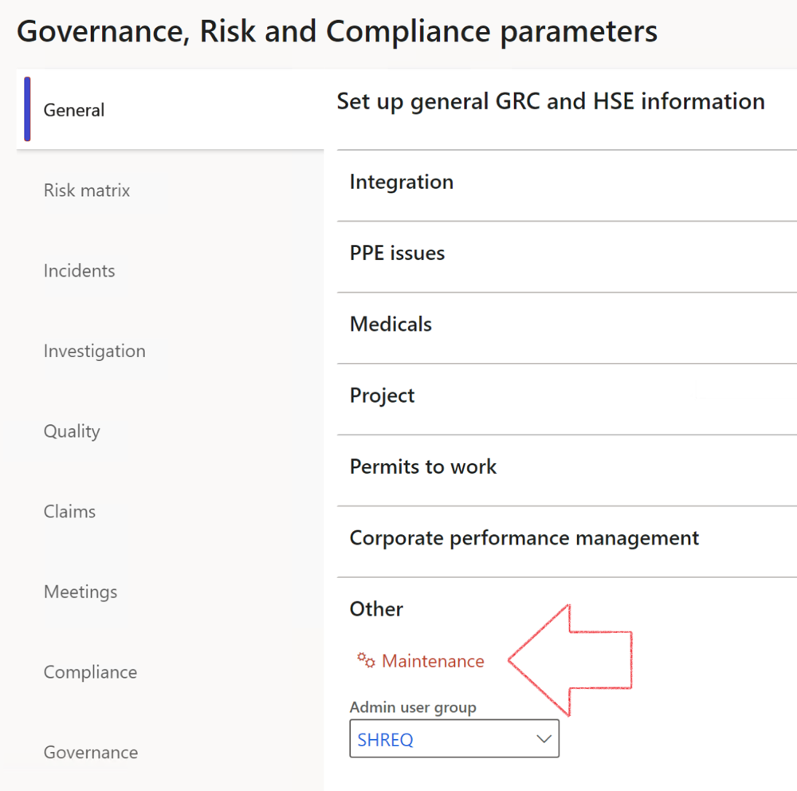

|  |  |
| --- | --- |
|  | The **Maintenance** button is there for designated user. This button repairs any possible data issues. For a full history of all Data related repairs; see table below: |

The information contained in this document represents the current view of Axnosis and Microsoft Corporation on the issues discussed as of the date of publication. Because Axnosis and Microsoft must respond to changing market conditions, this document should not be interpreted to be a commitment on the part of Axnosis and Microsoft, and Axnosis and Microsoft cannot guarantee the accuracy of any information presented after the date of publication.

This test script is for informational purposes only. AXNOSIS AND MICROSOFT MAKE NO WARRANTIES, EXPRESS, IMPLIED, OR STATUTORY, AS TO THE INFORMATION IN THIS DOCUMENT.

Complying with all applicable copyright laws is the responsibility of the user. Without limiting the rights under copyright, no part of this document may be reproduced, stored in or introduced into a retrieval system, or transmitted in any form or by any means (electronic, mechanical, photocopying, recording, or otherwise), or for any purpose, without the express written permission of Axnosis and Microsoft Corporation.

Axnosis and Microsoft may have patents, patent applications, trademarks, copyrights, or other intellectual property rights covering subject matter in this document. Except as expressly provided in any written license agreement from Axnosis and Microsoft, the furnishing of this document does not give you any license to these patents, trademarks, copyrights, or other intellectual property.

© 2021 Microsoft Corporation. All rights reserved. Any use or distribution of these materials without express authorization of Microsoft Corp. is strictly prohibited.

Microsoft and Windows are both registered trademarks of Microsoft Corporation in the United States and/or other countries.

The names of actual companies and products mentioned herein may be the trademarks of their respective owners.

|  |  |  |
| --- | --- | --- |
| **Process** | **Description/notes** | **Release** |
| Fix location vs. work centres | Populate the new **LocationRecID** field with the related location associated with previously used work centre location (Location) fields on the following tables:   * OHSHazardLocations, * OHSRiskHazard, * OHSRiskHazardWizard, * OHSRiskRegister, * OHSRisksWizard, * OHSSafetyLocations, * OHSSafetyPermit, * OHSSafetyPermitLocations * OHSSafetyPermitOverlap, * OHSSafetyPlan, * OHSInvestigation | 10.0.80.10 |
| Fix risk hazards | Assigning the value "Default Risk" to the new mandatory field **RiskID** (Key field) where empty | 10.0.80.10 |
| Fix incident HRM injury link | Delete all orphaned records from the **OHSIncidentHRMInjuryLnk** table | 10.0.11785.3 |
| Populate SRS analysis enums | Still in concept phase. To provide a link between enum numerical value and value name for use with BYOD data entities. Enums available:   * OHSIncidentType, * OHSIncidentSeverityType.   Table populated: **SRSAnalysisEnums** | 10.0.11785.3 |
| Fix budget transaction lines stock\item dimension | Set **OHSInventDimId** field value to "**AllBlank**" on table **BudgetTransactionLine**, where no value was recorded. This will solve the issue of records not displaying in the form.  **Note: this step will only fix existing budget transaction records in the system. Should any new transactions be uploaded or changed via the data entity Budget Account Entries, special care needs to be taken to specify the Stock dimension = AllBlank and the Item on the excel sheet to import.** | 10.1.1366.6 |
| Update existing incidents with the new **Incident types** | Update existing incidents with the **Incident types** that are setup on the new **Incident type** setup form. (IncidentTypeRecId) | 10.17.1250.5 |
| Update existing risks with the new **Control types** | Update existing risks with the **Control types** that are setup on the new **Control type** setup form. | 10.17.1250.6 |
| Re-number GRC Question and Answer **Group lines** | Re-number GRC Question and Answer **Group line numbers** | 10.22.1561.3 |
| Fix Inspection locations: Replace Work centre-based locations with HSE locations | Populate the new **ObjectLocation** field with the related HSE location associated with previously used work centre location (**Location**) field on the following tables:   * OHSInspectionJournalName * OHSInspectionJournalTable * OHSInspectionJournalTrans * OHSInspectionHistory * OHSSchedule | 10.24.1114.3 |
| **Process** | **Description/notes** | **Release** |
| Display of non-calculation lines | Run this job to ensure data consistency and correct display of historical data. |  |
| Fix Asset counter stock dimensions  Fix Line types on Data repository lines  Delete Orphan Data repositories | Replace empty stock dimension values with a blank dimension value  Populate missing line types from reporting templates on Data repository lines  Delete data repositories for which no template, year, site, period name or month was defined. | 10.26.1087.3  10.28.1080.6  10.30.2459.4 |
| Equivalent Functional location fields | The equivalent Functional location fields will be populated where an HSE Location exists on the permit to work pool header and linked Permit to work table. | 10.30.2459.12 |