

Dynamics GRC/HSE Release notes



Governance Risk & Compliance

Health, Safety & Environment

for

**Microsoft Dynamics 365 for Finance & Operations™**

*Dynamics GRC/HSE version* 10.31.2111.6

2024-09-02



|  |  |
| --- | --- |
| Dynamics 365 FO GRC module GRC is an add-on for Dynamics 365 suite of business application software.  This software provides compelling functionality to support Governance, Risk management and Compliance. |  |
| Dynamics 365 FO HSE/OHS OHS/HSE is an add-on for Dynamics 365 suite of business application software.  This software adds to GRC in that compliance is now deeper with explicit functionality for Health, Safety and Environment as per the depicted sub-modules below. | |
|  | |

Release version

**GRC/HSE Package version:** OHSDeployablePackage_10_31_2111_6

This package was created on Microsoft Dynamics 365 for Finance and Operations:

|  |  |  |
| --- | --- | --- |
| **Release** | **Version** | **Build number** |
| Application release | 10.0.40 | 10.31.2111 |
| Platform release | Platform update 64 | 7.0.7279.51 |

# Enhancements:

|  |  |
| --- | --- |
| **Module** | **Description** |
| Contract management | * When the **Update purchase agreement** button under the **Item lines** Fast tab is clicked, a new dialog opens. The selected **PA** is updated with **new line items**, and **quantities** on existing line items are added/deducted. * An enhancement was done on the **Contract report** when **Amendments** are added. * When a **new version** of a Contract is created, the **references to Purchase agreements** under the following Fast tabs, are **cleared** on the new version:   + **Trading partners**   + **Item lines**   + **Projects, SOW grid** * A validation was added so that **“on hold” Vendors** cannot be added on a Contract under the **Trading partners** Fast tab. * On the Contract, Content Fast tab, S**tatement of final account** Index tab:   + The "**Print the statement of final account**" button is now only enabled when the contract stage = **Terminated**   + The **Sofa status** field is available when the record is **terminated**.   + A record with a tick in the **Sofa column**, is added under the **Sign off** Fast tab when the "**Print the statement of final account**" button is clicked. * On the **Legal, contracts and tender management workspace**, the **Baseline contracts** tile was moved to the end of the row, and an additional filter was added to the following tiles to exclude **Baseline** contracts:   + **Review contracts**   + **Contracts flagged for follow up**   + **Supply chain contracts**   + **Worker contracts** |

|  |  |
| --- | --- |
| **Module** | **Description** |
| Tender management | * The **Tender register** menu item’s label was changed to **Purchase agreement register**. The **New** and **Delete** buttons are disabled on this list page. * A new **Tender register**, with a new **menu item**, was created. * A new **Bid start date** field was added on the **RFQ header**, under the **Governance** Fast tab. * Users can now request a **Best and final offer** for individual items quoted on, from the **RFQ** detail form.   + The following was added on the **RFQ header**, under the **Governance** Fast tab, **Negotiations** Index tab:     - **Bid line attachments** button     - **Item number** and **Item name** displays   + On the **Manage replies**:     - When the user clicks on the **Negotiation** button, a new **Negotiation** dialog opens where the user can enter detail for the request.     - The **Send email to vendor** button is now enabled.     - **Help text** was changed on the **Technical** and **Commercial** buttons. * To ensure that only relevant users see incoming responses (via attachments) from **Vendors**, the **attachment icon** on the **RFQ manage replies** will only be available if the **Bid opening** enum on the **Solicitation type** via the RFQ = "**Not required**" (the default). |
| Master data management | **Past experiences** and **references** can now be added on **Vendors**. |

*Bug fixes:*

|  |  |
| --- | --- |
| **Module** | **Description** |
| Contract management | * The stage of a **Contract** was changed to **Review** after the **Cancel** button was clicked on the **New case** dialog. * On the **Contract**, under the **Trading partners** Fast tab, the **Prime** box could be ticked for more than one record. * When additional **Purchase agreements** are created form a contract, the first Pa’s **item lines** were replaced with the second PA’s item lines.   These issues have been resolved. |
| Tender management | * On the **Mange replies** header, under the Bid scoring Fast tab, when None was selected in the View filter, all records were displayed.   The issue has been resolved. |

Release Data impact

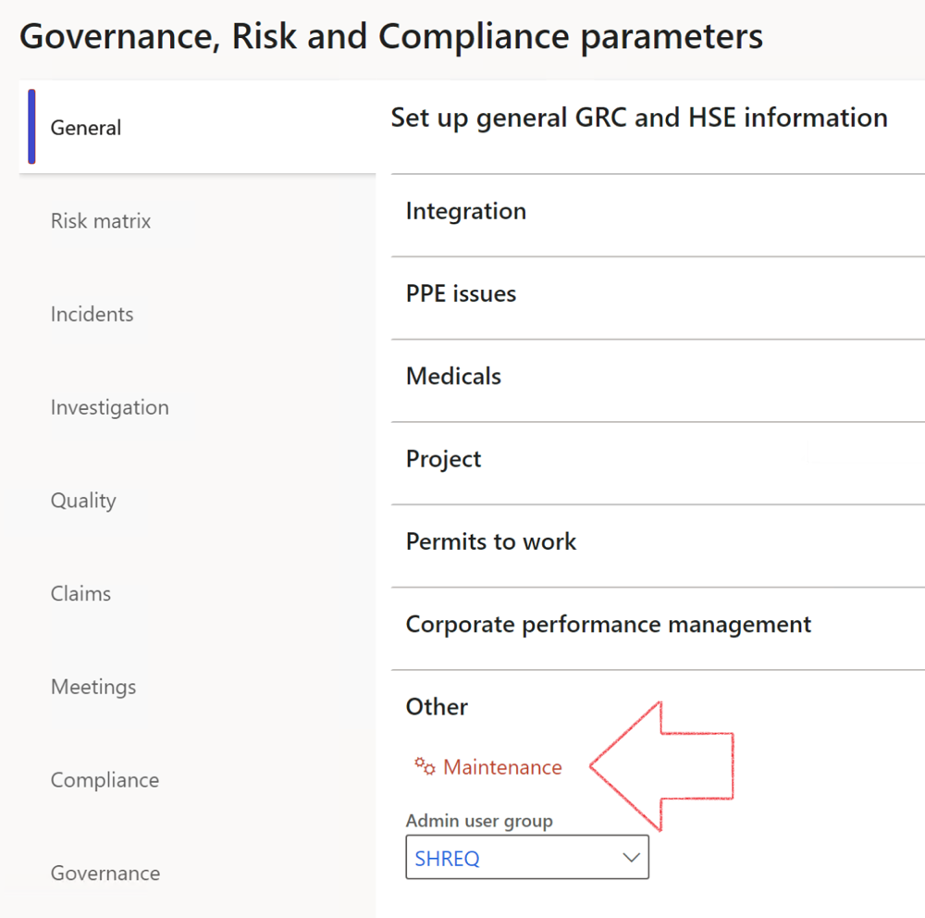

|  |  |
| --- | --- |
|  | The **Maintenance** button is there for designated user. This button repairs any possible data issues. For a full history of all Data related repairs; see table below: |

The information contained in this document represents the current view of Axnosis and Microsoft Corporation on the issues discussed as of the date of publication. Because Axnosis and Microsoft must respond to changing market conditions, this document should not be interpreted to be a commitment on the part of Axnosis and Microsoft, and Axnosis and Microsoft cannot guarantee the accuracy of any information presented after the date of publication.

This test script is for informational purposes only. AXNOSIS AND MICROSOFT MAKE NO WARRANTIES, EXPRESS, IMPLIED, OR STATUTORY, AS TO THE INFORMATION IN THIS DOCUMENT.

Complying with all applicable copyright laws is the responsibility of the user. Without limiting the rights under copyright, no part of this document may be reproduced, stored in or introduced into a retrieval system, or transmitted in any form or by any means (electronic, mechanical, photocopying, recording, or otherwise), or for any purpose, without the express written permission of Axnosis and Microsoft Corporation.

Axnosis and Microsoft may have patents, patent applications, trademarks, copyrights, or other intellectual property rights covering subject matter in this document. Except as expressly provided in any written license agreement from Axnosis and Microsoft, the furnishing of this document does not give you any license to these patents, trademarks, copyrights, or other intellectual property.

© 2021 Microsoft Corporation. All rights reserved. Any use or distribution of these materials without express authorization of Microsoft Corp. is strictly prohibited.

Microsoft and Windows are both registered trademarks of Microsoft Corporation in the United States and/or other countries.

The names of actual companies and products mentioned herein may be the trademarks of their respective owners.

|  |  |  |
| --- | --- | --- |
| **Process** | **Description/notes** | **Release** |
| Fix location vs. work centres | Populate the new **LocationRecID** field with the related location associated with previously used work centre location (Location) fields on the following tables:   * OHSHazardLocations, * OHSRiskHazard, * OHSRiskHazardWizard, * OHSRiskRegister, * OHSRisksWizard, * OHSSafetyLocations, * OHSSafetyPermit, * OHSSafetyPermitLocations * OHSSafetyPermitOverlap, * OHSSafetyPlan, * OHSInvestigation | 10.0.80.10 |
| Fix risk hazards | Assigning the value "Default Risk" to the new mandatory field **RiskID** (Key field) where empty | 10.0.80.10 |
| Fix incident HRM injury link | Delete all orphaned records from the **OHSIncidentHRMInjuryLnk** table | 10.0.11785.3 |
| Populate SRS analysis enums | Still in concept phase. To provide a link between enum numerical value and value name for use with BYOD data entities. Enums available:   * OHSIncidentType, * OHSIncidentSeverityType.   Table populated: **SRSAnalysisEnums** | 10.0.11785.3 |
| Fix budget transaction lines stock\item dimension | Set **OHSInventDimId** field value to "**AllBlank**" on table **BudgetTransactionLine**, where no value was recorded. This will solve the issue of records not displaying in the form.  **Note: this step will only fix existing budget transaction records in the system. Should any new transactions be uploaded or changed via the data entity Budget Account Entries, special care needs to be taken to specify the Stock dimension = AllBlank and the Item on the excel sheet to import.** | 10.1.1366.6 |
| Update existing incidents with the new **Incident types** | Update existing incidents with the **Incident types** that are setup on the new **Incident type** setup form. (IncidentTypeRecId) | 10.17.1250.5 |
| Update existing risks with the new **Control types** | Update existing risks with the **Control types** that are setup on the new **Control type** setup form. | 10.17.1250.6 |
| Re-number GRC Question and Answer **Group lines** | Re-number GRC Question and Answer **Group line numbers** | 10.22.1561.3 |
| Fix Inspection locations: Replace Work centre-based locations with HSE locations | Populate the new **ObjectLocation** field with the related HSE location associated with previously used work centre location (**Location**) field on the following tables:   * OHSInspectionJournalName * OHSInspectionJournalTable * OHSInspectionJournalTrans * OHSInspectionHistory * OHSSchedule | 10.24.1114.3 |
| **Process** | **Description/notes** | **Release** |
| Display of non-calculation lines | Run this job to ensure data consistency and correct display of historical data. |  |
| Fix Asset counter stock dimensions  Fix Line types on Data repository lines  Delete Orphan Data repositories | Replace empty stock dimension values with a blank dimension value  Populate missing line types from reporting templates on Data repository lines  Delete data repositories for which no template, year, site, period name or month was defined. | 10.26.1087.3  10.28.1080.6  10.30.2459.4 |
| Equivalent Functional location fields | The equivalent Functional location fields will be populated where an HSE Location exists on the permit to work pool header and linked Permit to work table. | 10.30.2459.12 |