

Dynamics GRC/HSE Release notes



Governance Risk & Compliance

Health, Safety & Environment

for

**Microsoft Dynamics 365 for Finance & Operations™**

*Dynamics GRC/HSE version* 10.31.2111.2

2024-08-12



|  |  |
| --- | --- |
| Dynamics 365 FO GRC module GRC is an add-on for Dynamics 365 suite of business application software.  This software provides compelling functionality to support Governance, Risk management and Compliance. |  |
| Dynamics 365 FO HSE/OHS OHS/HSE is an add-on for Dynamics 365 suite of business application software.  This software adds to GRC in that compliance is now deeper with explicit functionality for Health, Safety and Environment as per the depicted sub-modules below. | |
|  | |

Release version

**GRC/HSE Package version:** OHSDeployablePackage_10_31_2111_2

This package was created on Microsoft Dynamics 365 for Finance and Operations:

|  |  |  |
| --- | --- | --- |
| **Release** | **Version** | **Build number** |
| Application release | 10.0.40 | 10.31.2111 |
| Platform release | Platform update 64 | 7.0.7279.51 |

# Enhancements:

|  |  |
| --- | --- |
| **Module** | **Description** |
| Permits to work | * The **Permits to work administrator** security roll was enhanced. * The **MS label file** translation to Dutch was updated. * A **View only** watermark was added to the reports printed from the **Permit in columns** menu item. (This replaces the **Copy** and **Draft** watermarks). * A **Printing sequence** column was added to the **Process and activities** setup form (For the **Print in columns** report) |
| Tender management | * On the **Approval authority** setup form:   + The Export to Excel, **Tender evaluation** label was changed to **Approval authority**.   + A new **Data entity** was created so that users can manipulate data inside Excel and then update (via the Excel add-in publish button). |
| Management of change | * A few enhancements were made to the **Change request reports**. * **Contract amendment** functionality added (Change lines includes references to contract clauses) * **Change requests** can now also be done from a **Purchase order**:   + A **Change request** button was added in the Action pane on the Purchase order.   + A new **Enable CAR** slider was added on the **GRC parameters**, **Governance** tab, **Sourcing and tender governance** Fast tab.   + This will give users the option to populate the Change request form in addition to the standard Request change functionality. * On the **Change request**:   + The **References** field group under the **General** Fast tab was moved to a new **Changes to** Fast tab. Lookups to **Projects** and **Assets** were also added under this new Fast tab.   + A new **Assumptions** Fast tab was added with two memo boxes for **Inclusions** and **Exclusions**.   + Under the **Scope of change (lines)** Fast tab:     - **New** was added as a value on the **State** enum     - On the **Element type** enum, the **Project** label was changed to **WBS**     - The **Element** lookup is now to the **WBS ID/Task name**     - **Clause** was added as a value on the **Element type** enum |

|  |  |
| --- | --- |
| **Module** | **Description** |
| Contract management | * When a **Purchase agreement** is created form a **Contract**, the **add** and **remove** buttons on the **PA lines** are disabled. * The **Change stage** button is now also available on **Baseline contacts**. |
| Corporate performance management | * Monthly fuel qty was added to the filter on the Procurement plan lines. * On the Asset counters form, a jump reference was added to the Movement journal lookup. |
| Compliance audits | A few enhancements were made on the **Area of compliance report**. |

*Bug fixes:*

|  |  |
| --- | --- |
| **Module** | **Description** |
| Contract management | * When a **Purchase agreement** is created form a **Contract**, the **vendor** is now also passed to the create dialog. * The **Purchase agreement amount** was not displayed on the linked **Contract** under the **Trading partners** Fast tab. * The **Contract value** was not displayed on the linked **Purchase agreement**. * When a **Purchase agreement** that was created from a contract, is deleted, the item lines on the contract are also deleted.   These issues have been resolved. |
| Management of change | The **Scope of change lines** of type item (on the **Change request)** were not added to the Contract items lines after the CR was approved and the user chose not to create a Purchase agreement. |

Release Data impact

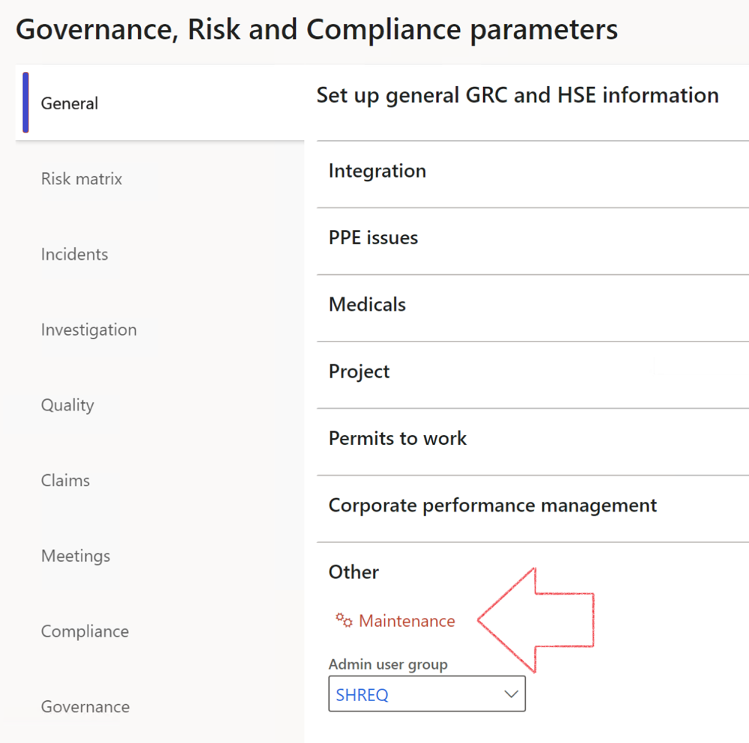

|  |  |
| --- | --- |
|  | The **Maintenance** button is there for designated user. This button repairs any possible data issues. For a full history of all Data related repairs; see table below: |

The information contained in this document represents the current view of Axnosis and Microsoft Corporation on the issues discussed as of the date of publication. Because Axnosis and Microsoft must respond to changing market conditions, this document should not be interpreted to be a commitment on the part of Axnosis and Microsoft, and Axnosis and Microsoft cannot guarantee the accuracy of any information presented after the date of publication.

This test script is for informational purposes only. AXNOSIS AND MICROSOFT MAKE NO WARRANTIES, EXPRESS, IMPLIED, OR STATUTORY, AS TO THE INFORMATION IN THIS DOCUMENT.

Complying with all applicable copyright laws is the responsibility of the user. Without limiting the rights under copyright, no part of this document may be reproduced, stored in or introduced into a retrieval system, or transmitted in any form or by any means (electronic, mechanical, photocopying, recording, or otherwise), or for any purpose, without the express written permission of Axnosis and Microsoft Corporation.

Axnosis and Microsoft may have patents, patent applications, trademarks, copyrights, or other intellectual property rights covering subject matter in this document. Except as expressly provided in any written license agreement from Axnosis and Microsoft, the furnishing of this document does not give you any license to these patents, trademarks, copyrights, or other intellectual property.

© 2021 Microsoft Corporation. All rights reserved. Any use or distribution of these materials without express authorization of Microsoft Corp. is strictly prohibited.

Microsoft and Windows are both registered trademarks of Microsoft Corporation in the United States and/or other countries.

The names of actual companies and products mentioned herein may be the trademarks of their respective owners.

|  |  |  |
| --- | --- | --- |
| **Process** | **Description/notes** | **Release** |
| Fix location vs. work centres | Populate the new **LocationRecID** field with the related location associated with previously used work centre location (Location) fields on the following tables:   * OHSHazardLocations, * OHSRiskHazard, * OHSRiskHazardWizard, * OHSRiskRegister, * OHSRisksWizard, * OHSSafetyLocations, * OHSSafetyPermit, * OHSSafetyPermitLocations * OHSSafetyPermitOverlap, * OHSSafetyPlan, * OHSInvestigation | 10.0.80.10 |
| Fix risk hazards | Assigning the value "Default Risk" to the new mandatory field **RiskID** (Key field) where empty | 10.0.80.10 |
| Fix incident HRM injury link | Delete all orphaned records from the **OHSIncidentHRMInjuryLnk** table | 10.0.11785.3 |
| Populate SRS analysis enums | Still in concept phase. To provide a link between enum numerical value and value name for use with BYOD data entities. Enums available:   * OHSIncidentType, * OHSIncidentSeverityType.   Table populated: **SRSAnalysisEnums** | 10.0.11785.3 |
| Fix budget transaction lines stock\item dimension | Set **OHSInventDimId** field value to "**AllBlank**" on table **BudgetTransactionLine**, where no value was recorded. This will solve the issue of records not displaying in the form.  **Note: this step will only fix existing budget transaction records in the system. Should any new transactions be uploaded or changed via the data entity Budget Account Entries, special care needs to be taken to specify the Stock dimension = AllBlank and the Item on the excel sheet to import.** | 10.1.1366.6 |
| Update existing incidents with the new **Incident types** | Update existing incidents with the **Incident types** that are setup on the new **Incident type** setup form. (IncidentTypeRecId) | 10.17.1250.5 |
| Update existing risks with the new **Control types** | Update existing risks with the **Control types** that are setup on the new **Control type** setup form. | 10.17.1250.6 |
| Re-number GRC Question and Answer **Group lines** | Re-number GRC Question and Answer **Group line numbers** | 10.22.1561.3 |
| Fix Inspection locations: Replace Work centre-based locations with HSE locations | Populate the new **ObjectLocation** field with the related HSE location associated with previously used work centre location (**Location**) field on the following tables:   * OHSInspectionJournalName * OHSInspectionJournalTable * OHSInspectionJournalTrans * OHSInspectionHistory * OHSSchedule | 10.24.1114.3 |
| Display of non-calculation lines | Run this job to ensure data consistency and correct display of historical data. |  |
| Fix Asset counter stock dimensions  Fix Line types on Data repository lines  Delete Orphan Data repositories | Replace empty stock dimension values with a blank dimension value  Populate missing line types from reporting templates on Data repository lines  Delete data repositories for which no template, year, site, period name or month was defined. | 10.26.1087.3  10.28.1080.6  10.30.2459.4 |
| Equivalent Functional location fields | The equivalent Functional location fields will be populated where an HSE Location exists on the permit to work pool header and linked Permit to work table. | 10.30.2459.12 |