

Dynamics GRC/HSE Release notes



Governance Risk & Compliance

Health, Safety & Environment

for

**Microsoft Dynamics 365 for Finance & Operations™**

*Dynamics GRC/HSE version* 10.31.2111.18

2024-12-03



|  |  |
| --- | --- |
| Dynamics 365 FO GRC module GRC is an add-on for Dynamics 365 suite of business application software.  This software provides compelling functionality to support Governance, Risk management and Compliance. |  |
| Dynamics 365 FO HSE/OHS OHS/HSE is an add-on for Dynamics 365 suite of business application software.  This software adds to GRC in that compliance is now deeper with explicit functionality for Health, Safety and Environment as per the depicted sub-modules below. | |
|  | |

Release version

**GRC/HSE Package version:** OHSDeployablePackage_10_31_2111_18

This package was created on Microsoft Dynamics 365 for Finance and Operations:

|  |  |  |
| --- | --- | --- |
| **Release** | **Version** | **Build number** |
| Application release | 10.0.40 | 10.31.2111 |
| Platform release | Platform update 64 | 7.0.7279.51 |

# Enhancements:

|  |  |
| --- | --- |
| Module | Description |
| Tender management | * A new **Bid event package ID list** menu item and form were added under **Tender management**. This enables users to do a look up to a **predefined** list of **Package ID** numbers. * A new **Tender cycle inquiry** was created and can be found under the **Governance Reports and inquiries** menu item. This inquiry looks for all Purchase requisitions, Procurement plans and Contract records where the **Package ID** is used. * Multiple **Negotiation rounds** can now be done on an RFQ. * For future use, bulk downloading of **Attachments** will be supported when envelopes are opened:   + Two **Export from table** lookups were added on the **Open envelope** dialog; one for downloading **all bid attachments**, and   + one for downloading **all bid line attachments**. * The **Vendor name** is now displayed in the cards on the **RFQ manage replies.** |
| Vendor portal | * Vendors can now add attachments while completing **questionnaires** via the **Vendor portal**. An **Add attachments** button was added on the questionnaire. * The **Rounds** field on the **Bafo response** dialog is now hidden. * On the **Request for quotation bid**, under the **Negotiation** Fast tab, the fields were arranged under two new field groups: **Request** and **Response**. A **Round number** display was also added under this Fast tab. * The **RFQ case ID** is now displayed on the **Vendor portal** under the **Bids** tabs. |
| Contracts | * **Contract classification** records cannot be deleted when **Contracts** which reference these records, exist. * **AP invoices** can now be created directly from a Contract. * Contracts can now be created from a **Purchase requisition**:   + A **Create contract** button was added in the Action pane on the **Purchase requisition**. |
| Management of change | * On the **Change request**, under the **Scope of change lines** Fast tab, a new column for **Unit price** was added. |

|  |  |
| --- | --- |
| **Module** | **Description** |
| Document management | * A new **PDF repository** table/grid was added to GRC. This allows users to upload/attach PDF documents, submit them for approval and then send the pdf to DocuSign for electronic signatures. |
| General | * On the **Approval authority**:   + The **Role** and **Responsible worker** columns were moved to the end of the grid.   + The following labels were changed:     - **Responsible worker** is now **Commercial owner**.     - **Owner** is now **Dimension owner.**     - **User group** is now **Dimension user group**.   + The unique key now includes:     - **Target**     - **Dimension** * **Dimension value** |

*Bug fixes:*

|  |  |
| --- | --- |
| **Module** | **Description** |
| Contracts | The **workflow status** and **contract stage** now remain unchanged until final approval. |
| Management of change | * When a new version of a **contract** is created, the **Change request** values under the **Line items** Fast tab are not cleared. * When the user neglects to enter details under the **Information** Fast tab on the CR, and tries to **approve** the record, the approval fails, but a record is still created on the **Contract** under the **Item lines** Fast tab. * The **Unit of measure** on the **Contract**, under the **Item lines** Fast tab is not defaulted in when a **Procurement category** is entered manually.   These issues have been resolved. |
| Tender management | An error message popped up when a **Bafo request** was created. The issue has been resolved. |
| Corporate performance management | On the **Performance transactions** inquiry, the **Year** filter defaulted to 2023. This was changed so that the system’s date **current year** is the default value. |
| Internal audit | The **OHS Approval** field was missing on the **MS Projects** data entity. |

Release Data impact

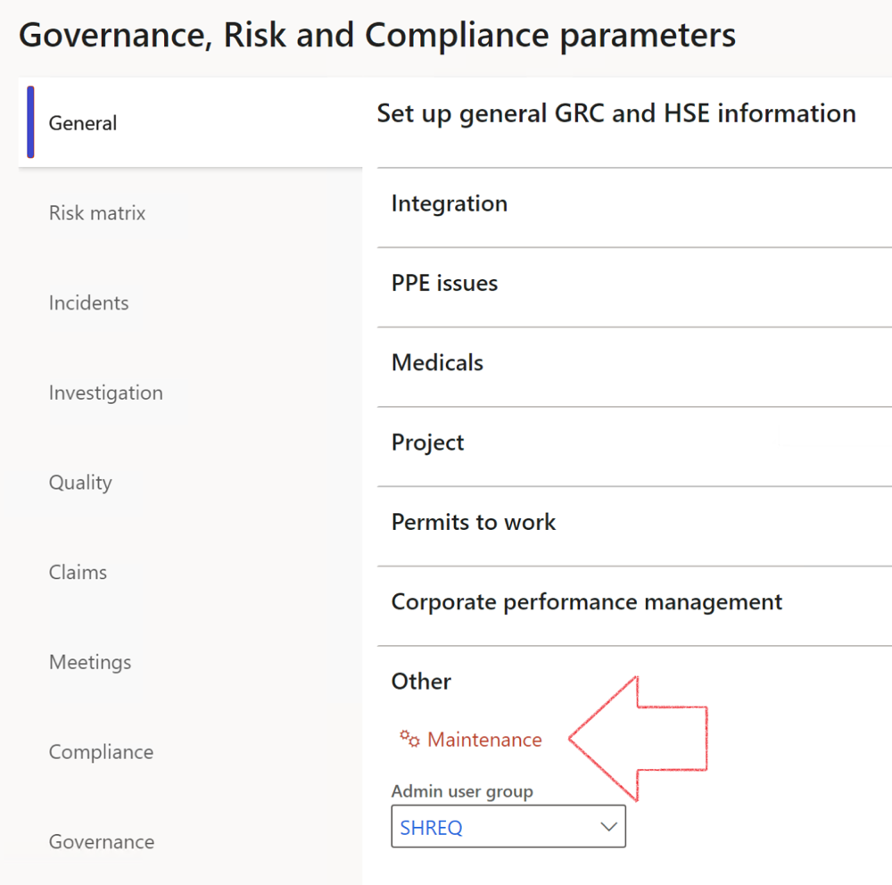

|  |  |
| --- | --- |
|  | The **Maintenance** button is there for designated user. This button repairs any possible data issues. For a full history of all Data related repairs; see table below: |

The information contained in this document represents the current view of Axnosis and Microsoft Corporation on the issues discussed as of the date of publication. Because Axnosis and Microsoft must respond to changing market conditions, this document should not be interpreted to be a commitment on the part of Axnosis and Microsoft, and Axnosis and Microsoft cannot guarantee the accuracy of any information presented after the date of publication.

This test script is for informational purposes only. AXNOSIS AND MICROSOFT MAKE NO WARRANTIES, EXPRESS, IMPLIED, OR STATUTORY, AS TO THE INFORMATION IN THIS DOCUMENT.

Complying with all applicable copyright laws is the responsibility of the user. Without limiting the rights under copyright, no part of this document may be reproduced, stored in or introduced into a retrieval system, or transmitted in any form or by any means (electronic, mechanical, photocopying, recording, or otherwise), or for any purpose, without the express written permission of Axnosis and Microsoft Corporation.

Axnosis and Microsoft may have patents, patent applications, trademarks, copyrights, or other intellectual property rights covering subject matter in this document. Except as expressly provided in any written license agreement from Axnosis and Microsoft, the furnishing of this document does not give you any license to these patents, trademarks, copyrights, or other intellectual property.

© 2021 Microsoft Corporation. All rights reserved. Any use or distribution of these materials without express authorization of Microsoft Corp. is strictly prohibited.

Microsoft and Windows are both registered trademarks of Microsoft Corporation in the United States and/or other countries.

The names of actual companies and products mentioned herein may be the trademarks of their respective owners.

|  |  |  |
| --- | --- | --- |
| **Process** | **Description/notes** | **Release** |
| Fix location vs. work centres | Populate the new **LocationRecID** field with the related location associated with previously used work centre location (Location) fields on the following tables:   * OHSHazardLocations, * OHSRiskHazard, * OHSRiskHazardWizard, * OHSRiskRegister, * OHSRisksWizard, * OHSSafetyLocations, * OHSSafetyPermit, * OHSSafetyPermitLocations * OHSSafetyPermitOverlap, * OHSSafetyPlan, * OHSInvestigation | 10.0.80.10 |
| Fix risk hazards | Assigning the value "Default Risk" to the new mandatory field **RiskID** (Key field) where empty | 10.0.80.10 |
| Fix incident HRM injury link | Delete all orphaned records from the **OHSIncidentHRMInjuryLnk** table | 10.0.11785.3 |
| Populate SRS analysis enums | Still in concept phase. To provide a link between enum numerical value and value name for use with BYOD data entities. Enums available:   * OHSIncidentType, * OHSIncidentSeverityType.   Table populated: **SRSAnalysisEnums** | 10.0.11785.3 |
| Fix budget transaction lines stock\item dimension | Set **OHSInventDimId** field value to "**AllBlank**" on table **BudgetTransactionLine**, where no value was recorded. This will solve the issue of records not displaying in the form.  **Note: this step will only fix existing budget transaction records in the system. Should any new transactions be uploaded or changed via the data entity Budget Account Entries, special care needs to be taken to specify the Stock dimension = AllBlank and the Item on the excel sheet to import.** | 10.1.1366.6 |
| Update existing incidents with the new **Incident types** | Update existing incidents with the **Incident types** that are setup on the new **Incident type** setup form. (IncidentTypeRecId) | 10.17.1250.5 |
| Update existing risks with the new **Control types** | Update existing risks with the **Control types** that are setup on the new **Control type** setup form. | 10.17.1250.6 |
| Re-number GRC Question and Answer **Group lines** | Re-number GRC Question and Answer **Group line numbers** | 10.22.1561.3 |
| Fix Inspection locations: Replace Work centre-based locations with HSE locations | Populate the new **ObjectLocation** field with the related HSE location associated with previously used work centre location (**Location**) field on the following tables:   * OHSInspectionJournalName * OHSInspectionJournalTable * OHSInspectionJournalTrans * OHSInspectionHistory * OHSSchedule | 10.24.1114.3 |
| **Process** | **Description/notes** | **Release** |
| Display of non-calculation lines | Run this job to ensure data consistency and correct display of historical data. |  |
| Fix Asset counter stock dimensions  Fix Line types on Data repository lines  Delete Orphan Data repositories | Replace empty stock dimension values with a blank dimension value  Populate missing line types from reporting templates on Data repository lines  Delete data repositories for which no template, year, site, period name or month was defined. | 10.26.1087.3  10.28.1080.6  10.30.2459.4 |
| Equivalent Functional location fields | The equivalent Functional location fields will be populated where an HSE Location exists on the permit to work pool header and linked Permit to work table. | 10.30.2459.12 |