

Dynamics GRC/HSE Release notes



Governance Risk & Compliance

Health, Safety & Environment

for

**Microsoft Dynamics 365 for Finance & Operations™**

*Dynamics GRC/HSE version* 10.31.2111.14

2024-11-04



|  |  |
| --- | --- |
| Dynamics 365 FO GRC module GRC is an add-on for Dynamics 365 suite of business application software.  This software provides compelling functionality to support Governance, Risk management and Compliance. |  |
| Dynamics 365 FO HSE/OHS OHS/HSE is an add-on for Dynamics 365 suite of business application software.  This software adds to GRC in that compliance is now deeper with explicit functionality for Health, Safety and Environment as per the depicted sub-modules below. | |
|  | |

Release version

**GRC/HSE Package version:** OHSDeployablePackage_10_31_2111_14

This package was created on Microsoft Dynamics 365 for Finance and Operations:

|  |  |  |
| --- | --- | --- |
| **Release** | **Version** | **Build number** |
| Application release | 10.0.40 | 10.31.2111 |
| Platform release | Platform update 64 | 7.0.7279.51 |

# Enhancements:

|  |  |
| --- | --- |
| Module | Description |
| Tender management | * **Weighted scoring** can now be done on the RFQ. * On the **RFQ manage replies** header, under the **Quotation** Fast tab, a new **Bafo price** field was added. * A new **Overall pricing** button was added in the Action pane on the RFQ.   + This looks at the lowest vendor pricing and lowest **Bafo pricing** and does a suggested scoring.   + A dedicated **Pricing** identifier was added on the **Scoring criteria** lines. This is used to auto populate the commercial score value (for all team members using the new Overall pricing enquiry) when the commercial envelope is opened. * On the **Evaluation setup**:   + The **date** field is now non-editable and is populated with the system date on which the record is **approved**.   + Under the **Lines** Fast tab, **Bafo price** was added as a new value on the **Display** enum. * Vendors/bidders can now enter their **Bafo** via the **Vendor portal**. * A new **Show prices** slider was added on the **Tender score summary**. When moved to **Yes**, the following columns are displayed as well:   + Total net price   + Bafo price   + Currency * The following buttons were added on the **Tender score summary**:   + **Scoring criteria** – opens the form/menu item that is found on the RFQ.   + **Evaluators scores** – for future use.   + **Evaluation report** - launches the current SSRS report that is also on the RFQ. * The **RFQ wizard** menu item is now hidden. |

|  |  |
| --- | --- |
| Module | Description |
| Contracts | * When a **Baseline** **contract** is selected on the **Create new contract** dialog, the Contract classification field will be populated with the value specified on the baseline. * The following fields on the **Contract** are now editable when the contract is **Approved**:   + **SharePoint URL**   + **Master** (slider) * A new **Data entity** was created forimporting **Contract Item lines** |

*Bug fixes:*

|  |  |
| --- | --- |
| **Module** | **Description** |
| Tender management | * The **Recommend** button on the RFQ is now only available when at least one vendor has a status of **Received/received**. * The **Quotation** Fast tab on the RFQ manage replies header was missing * The **Commercial envelope** button was displaying the header level attachments instead of line level attachments. * The **Technical scores** entered on the checklist feedback form were missing on the RFQ manage replies.   These issues have been resolved. |

Release Data impact

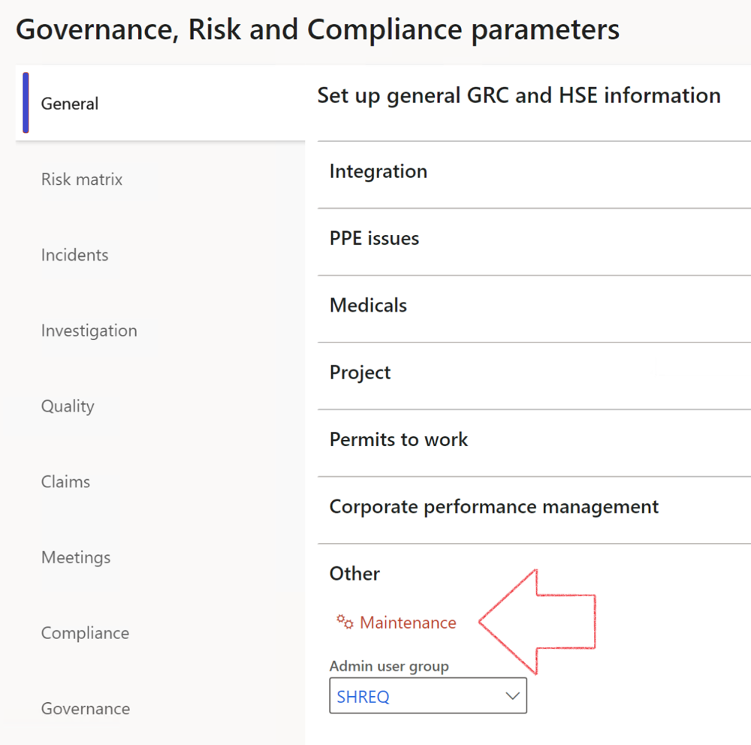

|  |  |
| --- | --- |
|  | The **Maintenance** button is there for designated user. This button repairs any possible data issues. For a full history of all Data related repairs; see table below: |

The information contained in this document represents the current view of Axnosis and Microsoft Corporation on the issues discussed as of the date of publication. Because Axnosis and Microsoft must respond to changing market conditions, this document should not be interpreted to be a commitment on the part of Axnosis and Microsoft, and Axnosis and Microsoft cannot guarantee the accuracy of any information presented after the date of publication.

This test script is for informational purposes only. AXNOSIS AND MICROSOFT MAKE NO WARRANTIES, EXPRESS, IMPLIED, OR STATUTORY, AS TO THE INFORMATION IN THIS DOCUMENT.

Complying with all applicable copyright laws is the responsibility of the user. Without limiting the rights under copyright, no part of this document may be reproduced, stored in or introduced into a retrieval system, or transmitted in any form or by any means (electronic, mechanical, photocopying, recording, or otherwise), or for any purpose, without the express written permission of Axnosis and Microsoft Corporation.

Axnosis and Microsoft may have patents, patent applications, trademarks, copyrights, or other intellectual property rights covering subject matter in this document. Except as expressly provided in any written license agreement from Axnosis and Microsoft, the furnishing of this document does not give you any license to these patents, trademarks, copyrights, or other intellectual property.

© 2021 Microsoft Corporation. All rights reserved. Any use or distribution of these materials without express authorization of Microsoft Corp. is strictly prohibited.

Microsoft and Windows are both registered trademarks of Microsoft Corporation in the United States and/or other countries.

The names of actual companies and products mentioned herein may be the trademarks of their respective owners.

|  |  |  |
| --- | --- | --- |
| **Process** | **Description/notes** | **Release** |
| Fix location vs. work centres | Populate the new **LocationRecID** field with the related location associated with previously used work centre location (Location) fields on the following tables:   * OHSHazardLocations, * OHSRiskHazard, * OHSRiskHazardWizard, * OHSRiskRegister, * OHSRisksWizard, * OHSSafetyLocations, * OHSSafetyPermit, * OHSSafetyPermitLocations * OHSSafetyPermitOverlap, * OHSSafetyPlan, * OHSInvestigation | 10.0.80.10 |
| Fix risk hazards | Assigning the value "Default Risk" to the new mandatory field **RiskID** (Key field) where empty | 10.0.80.10 |
| Fix incident HRM injury link | Delete all orphaned records from the **OHSIncidentHRMInjuryLnk** table | 10.0.11785.3 |
| Populate SRS analysis enums | Still in concept phase. To provide a link between enum numerical value and value name for use with BYOD data entities. Enums available:   * OHSIncidentType, * OHSIncidentSeverityType.   Table populated: **SRSAnalysisEnums** | 10.0.11785.3 |
| Fix budget transaction lines stock\item dimension | Set **OHSInventDimId** field value to "**AllBlank**" on table **BudgetTransactionLine**, where no value was recorded. This will solve the issue of records not displaying in the form.  **Note: this step will only fix existing budget transaction records in the system. Should any new transactions be uploaded or changed via the data entity Budget Account Entries, special care needs to be taken to specify the Stock dimension = AllBlank and the Item on the excel sheet to import.** | 10.1.1366.6 |
| Update existing incidents with the new **Incident types** | Update existing incidents with the **Incident types** that are setup on the new **Incident type** setup form. (IncidentTypeRecId) | 10.17.1250.5 |
| Update existing risks with the new **Control types** | Update existing risks with the **Control types** that are setup on the new **Control type** setup form. | 10.17.1250.6 |
| Re-number GRC Question and Answer **Group lines** | Re-number GRC Question and Answer **Group line numbers** | 10.22.1561.3 |
| Fix Inspection locations: Replace Work centre-based locations with HSE locations | Populate the new **ObjectLocation** field with the related HSE location associated with previously used work centre location (**Location**) field on the following tables:   * OHSInspectionJournalName * OHSInspectionJournalTable * OHSInspectionJournalTrans * OHSInspectionHistory * OHSSchedule | 10.24.1114.3 |
| **Process** | **Description/notes** | **Release** |
| Display of non-calculation lines | Run this job to ensure data consistency and correct display of historical data. |  |
| Fix Asset counter stock dimensions  Fix Line types on Data repository lines  Delete Orphan Data repositories | Replace empty stock dimension values with a blank dimension value  Populate missing line types from reporting templates on Data repository lines  Delete data repositories for which no template, year, site, period name or month was defined. | 10.26.1087.3  10.28.1080.6  10.30.2459.4 |
| Equivalent Functional location fields | The equivalent Functional location fields will be populated where an HSE Location exists on the permit to work pool header and linked Permit to work table. | 10.30.2459.12 |