

Dynamics GRC/HSE Release notes



Governance Risk & Compliance

Health, Safety & Environment

for

**Microsoft Dynamics 365 for Finance & Operations™**

*Dynamics GRC/HSE version* 10.31.2111.12

2024-10-21



|  |  |
| --- | --- |
| Dynamics 365 FO GRC module GRC is an add-on for Dynamics 365 suite of business application software.  This software provides compelling functionality to support Governance, Risk management and Compliance. |  |
| Dynamics 365 FO HSE/OHS OHS/HSE is an add-on for Dynamics 365 suite of business application software.  This software adds to GRC in that compliance is now deeper with explicit functionality for Health, Safety and Environment as per the depicted sub-modules below. | |
|  | |

Release version

**GRC/HSE Package version:** OHSDeployablePackage_10_31_2111_12

This package was created on Microsoft Dynamics 365 for Finance and Operations:

|  |  |  |
| --- | --- | --- |
| **Release** | **Version** | **Build number** |
| Application release | 10.0.40 | 10.31.2111 |
| Platform release | Platform update 64 | 7.0.7279.51 |

# Enhancements:

|  |  |
| --- | --- |
| Module | Description |
| Tender management | * The following filters were added to the dropdown list when linking a Procurement plan to an already existing RFQ:   + Only procurement plans that **do not have an RFQ** linked   + Only **approved** procurement plans   + Only procurement plans where the **Solicitation type** is the same as on the RFQ * A new **Other document** (baseline) lookup was added on the RFQ, **Recommendation** dialog. This field is to be used to create a **Letter of intent** and is now now displayed under the **Recommendation** Index tab on the RFQ. * The **RFQ envelope opening** functionality was enhanced * The **Allow due date extension** slider op the RFQ header, under the General Fast tab, was removed. The **Extend due date** button in the RFQ Action pane is now only available when the vendor status on the RFQ = **Sent-sent**. * A new **Delete submission** slider was added on the GRC parameters under the **Governance** tab. When this slider is set to **No**, responses submitted by Vendors will no longer be deleted when an **amendment** is done on the RFQ. * A new heading, **List of RFQ bidders** was added on the PIF report and the list of vendors/suppliers on the RFQ is listed here. |
| Contracts | An additional column with label **Email address**, was added on the **Integration template for pdf services** setup form. |
| Compliance audits | The following enhancements were done to accommodate **Self-assessments** type audits:   * This was added to the **Legal register** detail form:   + A new **General** Fast tab with two new Field groups: **Risks** and **Other**   + Under the **Organization applications**, a new **Create self-assessment** button was added as well as a **Compliance requirements** memo box. * An additional column for **Self-assessment** (SA) was added on the **Audit type** * On the **Area of compliance**, the **Compliance obligation** lookup was replaced with a new **Legal register** lookup. |
| Incidents | To enhance KPIs on Incidents, the **Hours worked** key was increased to accommodate information per **Site**, **Department** and **Location**. |

*Bug fixes:*

|  |  |
| --- | --- |
| **Module** | **Description** |
| Tender management | * An error message popped up when the **Award** button was clicked on the **RFQ**. * The **Create checklist** button on the RFQ was (in error) greyed out after a Committee member was added. * The **Initial value** field and the Item lines' **Net amount** and **Unit price** on the contract and the linked purchase agreement header showed "0,00" and not the value of the awarded RFQ.   These issues have been resolved. |

Release Data impact

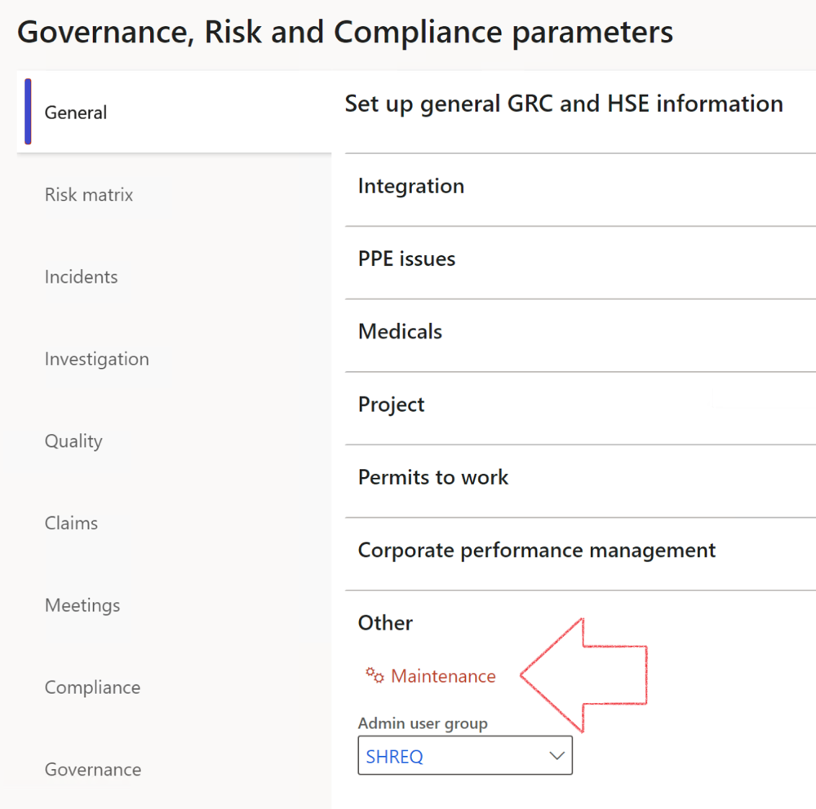

|  |  |
| --- | --- |
|  | The **Maintenance** button is there for designated user. This button repairs any possible data issues. For a full history of all Data related repairs; see table below: |

The information contained in this document represents the current view of Axnosis and Microsoft Corporation on the issues discussed as of the date of publication. Because Axnosis and Microsoft must respond to changing market conditions, this document should not be interpreted to be a commitment on the part of Axnosis and Microsoft, and Axnosis and Microsoft cannot guarantee the accuracy of any information presented after the date of publication.

This test script is for informational purposes only. AXNOSIS AND MICROSOFT MAKE NO WARRANTIES, EXPRESS, IMPLIED, OR STATUTORY, AS TO THE INFORMATION IN THIS DOCUMENT.

Complying with all applicable copyright laws is the responsibility of the user. Without limiting the rights under copyright, no part of this document may be reproduced, stored in or introduced into a retrieval system, or transmitted in any form or by any means (electronic, mechanical, photocopying, recording, or otherwise), or for any purpose, without the express written permission of Axnosis and Microsoft Corporation.

Axnosis and Microsoft may have patents, patent applications, trademarks, copyrights, or other intellectual property rights covering subject matter in this document. Except as expressly provided in any written license agreement from Axnosis and Microsoft, the furnishing of this document does not give you any license to these patents, trademarks, copyrights, or other intellectual property.

© 2021 Microsoft Corporation. All rights reserved. Any use or distribution of these materials without express authorization of Microsoft Corp. is strictly prohibited.

Microsoft and Windows are both registered trademarks of Microsoft Corporation in the United States and/or other countries.

The names of actual companies and products mentioned herein may be the trademarks of their respective owners.

|  |  |  |
| --- | --- | --- |
| **Process** | **Description/notes** | **Release** |
| Fix location vs. work centres | Populate the new **LocationRecID** field with the related location associated with previously used work centre location (Location) fields on the following tables:   * OHSHazardLocations, * OHSRiskHazard, * OHSRiskHazardWizard, * OHSRiskRegister, * OHSRisksWizard, * OHSSafetyLocations, * OHSSafetyPermit, * OHSSafetyPermitLocations * OHSSafetyPermitOverlap, * OHSSafetyPlan, * OHSInvestigation | 10.0.80.10 |
| Fix risk hazards | Assigning the value "Default Risk" to the new mandatory field **RiskID** (Key field) where empty | 10.0.80.10 |
| Fix incident HRM injury link | Delete all orphaned records from the **OHSIncidentHRMInjuryLnk** table | 10.0.11785.3 |
| Populate SRS analysis enums | Still in concept phase. To provide a link between enum numerical value and value name for use with BYOD data entities. Enums available:   * OHSIncidentType, * OHSIncidentSeverityType.   Table populated: **SRSAnalysisEnums** | 10.0.11785.3 |
| Fix budget transaction lines stock\item dimension | Set **OHSInventDimId** field value to "**AllBlank**" on table **BudgetTransactionLine**, where no value was recorded. This will solve the issue of records not displaying in the form.  **Note: this step will only fix existing budget transaction records in the system. Should any new transactions be uploaded or changed via the data entity Budget Account Entries, special care needs to be taken to specify the Stock dimension = AllBlank and the Item on the excel sheet to import.** | 10.1.1366.6 |
| Update existing incidents with the new **Incident types** | Update existing incidents with the **Incident types** that are setup on the new **Incident type** setup form. (IncidentTypeRecId) | 10.17.1250.5 |
| Update existing risks with the new **Control types** | Update existing risks with the **Control types** that are setup on the new **Control type** setup form. | 10.17.1250.6 |
| Re-number GRC Question and Answer **Group lines** | Re-number GRC Question and Answer **Group line numbers** | 10.22.1561.3 |
| Fix Inspection locations: Replace Work centre-based locations with HSE locations | Populate the new **ObjectLocation** field with the related HSE location associated with previously used work centre location (**Location**) field on the following tables:   * OHSInspectionJournalName * OHSInspectionJournalTable * OHSInspectionJournalTrans * OHSInspectionHistory * OHSSchedule | 10.24.1114.3 |
| **Process** | **Description/notes** | **Release** |
| Display of non-calculation lines | Run this job to ensure data consistency and correct display of historical data. |  |
| Fix Asset counter stock dimensions  Fix Line types on Data repository lines  Delete Orphan Data repositories | Replace empty stock dimension values with a blank dimension value  Populate missing line types from reporting templates on Data repository lines  Delete data repositories for which no template, year, site, period name or month was defined. | 10.26.1087.3  10.28.1080.6  10.30.2459.4 |
| Equivalent Functional location fields | The equivalent Functional location fields will be populated where an HSE Location exists on the permit to work pool header and linked Permit to work table. | 10.30.2459.12 |