

Dynamics GRC/HSE Release notes



Governance Risk & Compliance

Health, Safety & Environment

for

**Microsoft Dynamics 365 for Finance & Operations™**

*Dynamics GRC/HSE version* 10.30.2459.6

2024-06-10



|  |  |
| --- | --- |
| Dynamics 365 FO GRC module GRC is an add-on for Dynamics 365 suite of business application software.  This software provides compelling functionality to support Governance, Risk management and Compliance. |  |
| Dynamics 365 FO HSE/OHS OHS/HSE is an add-on for Dynamics 365 suite of business application software.  This software adds to GRC in that compliance is now deeper with explicit functionality for Health, Safety and Environment as per the depicted sub-modules below. | |
|  | |

Release version

**GRC/HSE Package version:** OHSDeployablePackage_10_30_2459_6

This package was created on Microsoft Dynamics 365 for Finance and Operations:

|  |  |  |
| --- | --- | --- |
| **Release** | **Version** | **Build number** |
| Application release | 10.0.39 | 10.30.2459 |
| Platform release | Platform update 63 | 7.0.7198.66 |

# Enhancements:

|  |  |
| --- | --- |
| **Module** | **Description** |
| Contract management | * On the **Contracts** detail form, the following was added under the **Payment schedule** Fats tab:   + **Customer** lookup and display method of the **customer’s name**   + A **Percentage** field. * On click of the **Create project** button, the user is given the normal **Create new project** dialog. * On all **Contracts, policies** and **reports** detail forms:   + The **State** labels were changed to **Stage** to align with the label of the button.   + The **Version** field is now read only   + A new **+New** button group was created in the Action pane, which gives the user the option to create either a new **document**, or a new **version** of the selected document (**Version** is for future use). * An additional filter was added for the “**All contracts for my department**” list page: **Document type** = **Contract**. * A **Show closed** filter was added on the print dialog of the **Contract register report**. * In order to keep track of expiring vendor certifications, the following was added on the **Legal, contracts and tender management workspace**:   + A new **Vendor certifications** tile   + A new **Vendor certifications** mini list page under the **Documents that will expire in 30 days** Fast tab. * On the Invoice journal, a new **Contract** button group was created. The **Accrue** button was moved into this new button group, and a new **Show fulfilment** button was created. This new button opens a dialog which displays **contract fulfilment** details. |
| Compliance audits | A new **Corrections report** was created and can be printed from the **Non conformances Audit** button group. |
| Meetings | * An **Approve** tick box was added tot the **Directors fee structure** setup form * The following menu items were added under **GRC, Meetings**:   + **Board meetings**   + **Shareholder meetings** |

|  |  |
| --- | --- |
| **Module** | **Description** |
| Tender management | * **RFQ due date extension** enhancement:   + On the RFQ, under the Governance Fast tab, Committee Index tab, **Approvals** was added to the **Role** enum.   + Three new displays were added into the grid of the **Amendments** Fast tab on the RFQ:     - **Status**     - **Date and time**     - **Approved by** (Worker)   + On the **Solicitation type**, under the Governance Fast tab, a new **Lock amendments** yes/no slider was added to govern the above functionality. * In order to track the flow of the **Evaluation report**, a record is now created on the RFQ under the **Sign off** Fast tab, whenever the report is printed. The report is also added as an attachment to the RFQ. |
| Corporate performance management | * Additional fields are now under change control for performance management. * **Fuel cap** can now be entered per month, on the **Procurement plan** lines. |
| Operational and sustainability reporting | YTD **Actual/target** values can now be used to calculate field formulas instead of **actual/target** values. |
| Safety and security | * The **Worker** lookup on the **QR code generator** was enhanced to include the worker’s **position**. * A new **Gate pass report** was created which prints the access card with the generated **QR code**. |
| Occupational health | * On the **All medical results** inquiry, the **Expiry date** field is now exposed in the grid, and **Worker exposure test** was added to the **Result group** enum. * A new **All medical results reports** was created which can be printed from the inquiry. |
| Medicals | * The **Exposure test** button on **Applicants** is now hidden as it is not required. |

# Bug fixes:

|  |  |
| --- | --- |
| **Module** | **Description** |
| Contracts management | * All **Contracts, policies** and **reports** list pages are now non editable. * On the **Contract**, under the Projects Fast tab, the **Create projects** button is now also available when the **contract stage** = **Approved**. |
| Tender management | * The **Recommend** button on the RFQ could be clicked for vendors where the status was not **Received-received**. * A currency error popped up when the **Evaluation report** was printed.   These issues have been resolved. |
| Operational and sustainability reporting | * The **Quarterly display methods** were fixed so that the other calculation methods are also considered on the **Reporting data** form, as well as on the **Quarterly report**. * To include “quarterly” the **YTD calculation method** label on the template lines was renamed to **Calculation method**. |
| Permits to work | The **Permit to work report** was printing over three pages when the language was changed to NL. The issue has been resolved. |
| Occupational health | On the **Medical consultation**, **Past medical history** Fast tab, the current record was displayed instead of past records. The issue has been resolved. |

Release Data impact

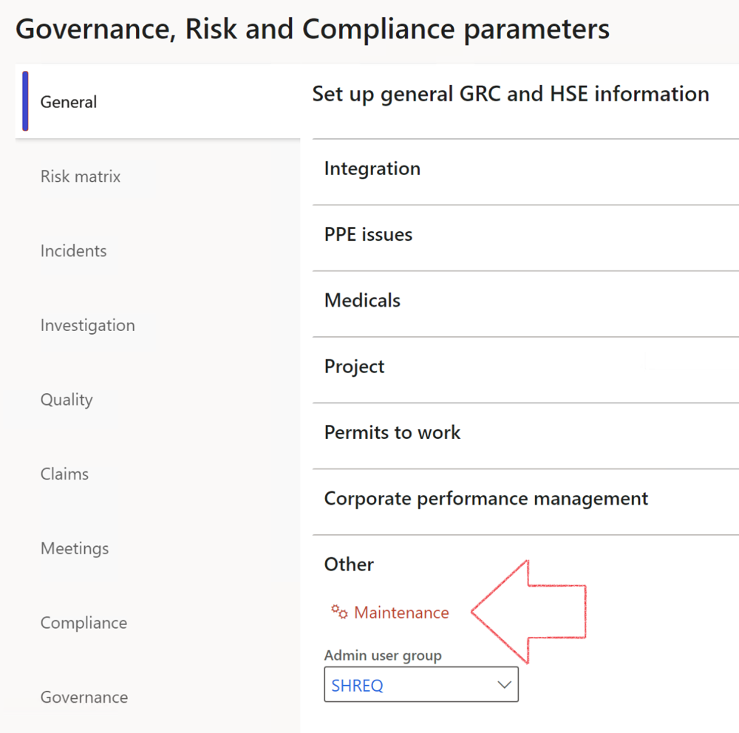

|  |  |
| --- | --- |
|  | The **Maintenance** button is there for designated user. This button repairs any possible data issues. For a full history of all Data related repairs; see table below: |

The information contained in this document represents the current view of Axnosis and Microsoft Corporation on the issues discussed as of the date of publication. Because Axnosis and Microsoft must respond to changing market conditions, this document should not be interpreted to be a commitment on the part of Axnosis and Microsoft, and Axnosis and Microsoft cannot guarantee the accuracy of any information presented after the date of publication.

This test script is for informational purposes only. AXNOSIS AND MICROSOFT MAKE NO WARRANTIES, EXPRESS, IMPLIED, OR STATUTORY, AS TO THE INFORMATION IN THIS DOCUMENT.

Complying with all applicable copyright laws is the responsibility of the user. Without limiting the rights under copyright, no part of this document may be reproduced, stored in or introduced into a retrieval system, or transmitted in any form or by any means (electronic, mechanical, photocopying, recording, or otherwise), or for any purpose, without the express written permission of Axnosis and Microsoft Corporation.

Axnosis and Microsoft may have patents, patent applications, trademarks, copyrights, or other intellectual property rights covering subject matter in this document. Except as expressly provided in any written license agreement from Axnosis and Microsoft, the furnishing of this document does not give you any license to these patents, trademarks, copyrights, or other intellectual property.

© 2021 Microsoft Corporation. All rights reserved. Any use or distribution of these materials without express authorization of Microsoft Corp. is strictly prohibited.

Microsoft and Windows are both registered trademarks of Microsoft Corporation in the United States and/or other countries.

The names of actual companies and products mentioned herein may be the trademarks of their respective owners.

|  |  |  |
| --- | --- | --- |
| **Process** | **Description/notes** | **Release** |
| Fix location vs. work centres | Populate the new **LocationRecID** field with the related location associated with previously used work centre location (Location) fields on the following tables:   * OHSHazardLocations, * OHSRiskHazard, * OHSRiskHazardWizard, * OHSRiskRegister, * OHSRisksWizard, * OHSSafetyLocations, * OHSSafetyPermit, * OHSSafetyPermitLocations * OHSSafetyPermitOverlap, * OHSSafetyPlan, * OHSInvestigation | 10.0.80.10 |
| Fix risk hazards | Assigning the value "Default Risk" to the new mandatory field **RiskID** (Key field) where empty | 10.0.80.10 |
| Fix incident HRM injury link | Delete all orphaned records from the **OHSIncidentHRMInjuryLnk** table | 10.0.11785.3 |
| Populate SRS analysis enums | Still in concept phase. To provide a link between enum numerical value and value name for use with BYOD data entities. Enums available:   * OHSIncidentType, * OHSIncidentSeverityType.   Table populated: **SRSAnalysisEnums** | 10.0.11785.3 |
| Fix budget transaction lines stock\item dimension | Set **OHSInventDimId** field value to "**AllBlank**" on table **BudgetTransactionLine**, where no value was recorded. This will solve the issue of records not displaying in the form.  **Note: this step will only fix existing budget transaction records in the system. Should any new transactions be uploaded or changed via the data entity Budget Account Entries, special care needs to be taken to specify the Stock dimension = AllBlank and the Item on the excel sheet to import.** | 10.1.1366.6 |
| Update existing incidents with the new **Incident types** | Update existing incidents with the **Incident types** that are setup on the new **Incident type** setup form. (IncidentTypeRecId) | 10.17.1250.5 |
| Update existing risks with the new **Control types** | Update existing risks with the **Control types** that are setup on the new **Control type** setup form. | 10.17.1250.6 |
| Re-number GRC Question and Answer **Group lines** | Re-number GRC Question and Answer **Group line numbers** | 10.22.1561.3 |
| Fix Inspection locations: Replace Work centre-based locations with HSE locations | Populate the new **ObjectLocation** field with the related HSE location associated with previously used work centre location (**Location**) field on the following tables:   * OHSInspectionJournalName * OHSInspectionJournalTable * OHSInspectionJournalTrans * OHSInspectionHistory * OHSSchedule | 10.24.1114.3 |
| Display of non-calculation lines | Run this job to ensure data consistency and correct display of historical data. |  |
| Fix Asset counter stock dimensions  Fix Line types on Data repository lines  Delete Orphan Data repositories | Replace empty stock dimension values with a blank dimension value  Populate missing line types from reporting templates on Data repository lines  Delete data repositories for which no template, year, site, period name or month was defined. | 10.26.1087.3  10.28.1080.6  10.30.2459.4 |