

Dynamics GRC/HSE Release notes



Governance Risk & Compliance

Health, Safety & Environment

for

**Microsoft Dynamics 365 for Finance & Operations™**

*Dynamics GRC/HSE version* 10.30.2459.5

2024-05-30



|  |  |
| --- | --- |
| Dynamics 365 FO GRC module GRC is an add-on for Dynamics 365 suite of business application software.  This software provides compelling functionality to support Governance, Risk management and Compliance. |  |
| Dynamics 365 FO HSE/OHS OHS/HSE is an add-on for Dynamics 365 suite of business application software.  This software adds to GRC in that compliance is now deeper with explicit functionality for Health, Safety and Environment as per the depicted sub-modules below. | |
|  | |

Release version

**GRC/HSE Package version:** OHSDeployablePackage_10_30_2459_5

This package was created on Microsoft Dynamics 365 for Finance and Operations:

|  |  |  |
| --- | --- | --- |
| **Release** | **Version** | **Build number** |
| Application release | 10.0.39 | 10.30.2459 |
| Platform release | Platform update 63 | 7.0.7198.66 |

# Enhancements:

|  |  |
| --- | --- |
| **Module** | **Description** |
| Tender management | * Enhancements on the **Bid evaluation report**. * Only **approved** risk registers can now be selected on the **Procurement plan** under the **Governance** Fast tab. * Help text was added to the **Any thing to declare** tick box on the **Declaration of interest**. |
| Contract management | * A few minor enhancements were made to the **Contracts register report**. * The following **Data entities** were updated: **Vendors V2** and **Vendor certificates**. |
| Meetings | * On the **Meetings** form:   + On the Action pane, the **Pre-meeting checklist** button’s label was changed to **Meeting checklist.**   + The **order** of the line numbers on the meeting checklist drop dialog, is now sorted.   + Under the **Scope and administration** Fast tab, a display for the created **Checklist ID**, as well as a checklist **Feedback** button, were added. * A new menu item was added under GRC, Meetings, **Meeting checklists**. * The **Board meeting accrual** menu item under GRC, Governance, Reports and inquiries, was copied to GRC, Meetings, Periodic. * In order to auto calculate what a Board of directors earn, new menu item and setup form were added under GRC, Governance, Setup for governance, **Directors’ fee structure.**   + A new **Directors group** setup form was also added under GRC, Governance, Setup for governance. |

|  |  |
| --- | --- |
| **Module** | **Description** |
| Medicals | * On the **All medicals results:**   + **Exposure test** was added as a new value on the **Results group** enum, and the **Applicant medicals** label was changed to **Applicant fitness**.   + The **Result** grid at the bottom of the screen is now hidden, as it is not used. * On the worker/applicant **Fitness** dialog:   + The fields under the **Incapacity outcome** **options** field group are now grouped under a new **Incapacity outcome options** Fast tab.   + The fields under the **Workflow** field group are now grouped under a new **Workflow** Fast tab. * Two new setup forms were added under **Setup for occupational health**: **Diseases** and **Disease groups**. * On the **Medical consultation** form:   + The header information is now grouped into the following **field groups**:     - **Identification**     - **Demarcation** (a **Site** lookup was added)     - **Medical record**     - **Status**   + A new **Diagnosis** Fast tab was added, and above diseases exposed.   + The **Surgical history** Fast tab was moved to under the **Vaccinations** Fast tab.   + A new **Costs** Fast tab was added.   + A **Show closed** filter, as well as **icons** to indicate open/closed records, were added to the left hand side cards. * A new **Medical fitness certificate** report was created. |

# Bug fixes:

|  |  |
| --- | --- |
| **Module** | **Description** |
| Medicals | The filter on the **Current worker fitness** inquiry was not excluding expired records. The issue has been resolved. |
| Contract management | * The rules regarding editable fields where the **State** = **Approved**, were fixed. * When **unsuccessfully** attempting to change contract state to approved, a signature record was added with the **Approved** checkbox ticked.   The above issues have been resolved. |
| Tender management | * The **Default item** selected on the **Solicitation type**, did not create an **RFQ** item line. * On creation of a **Pre-qualification** **checklist**, the due date was not pulled through to the checklist. * An error popped up when the **Evaluation report** was printed.   The above issues have been resolved. |
| Meetings | The **Send email notification** button was only available when the status of meetings was **closed**. The issue has been resolved. |
| Operational and sustainability reporting | When **Attribute** records were deleted, the system gave an error. A cascade delete action was added to allow these records to be deleted. |
| Permits to work | **Inactive** **permit to work types** could be selected when a Permit was being created. The issue has been resolved. |

Release Data impact

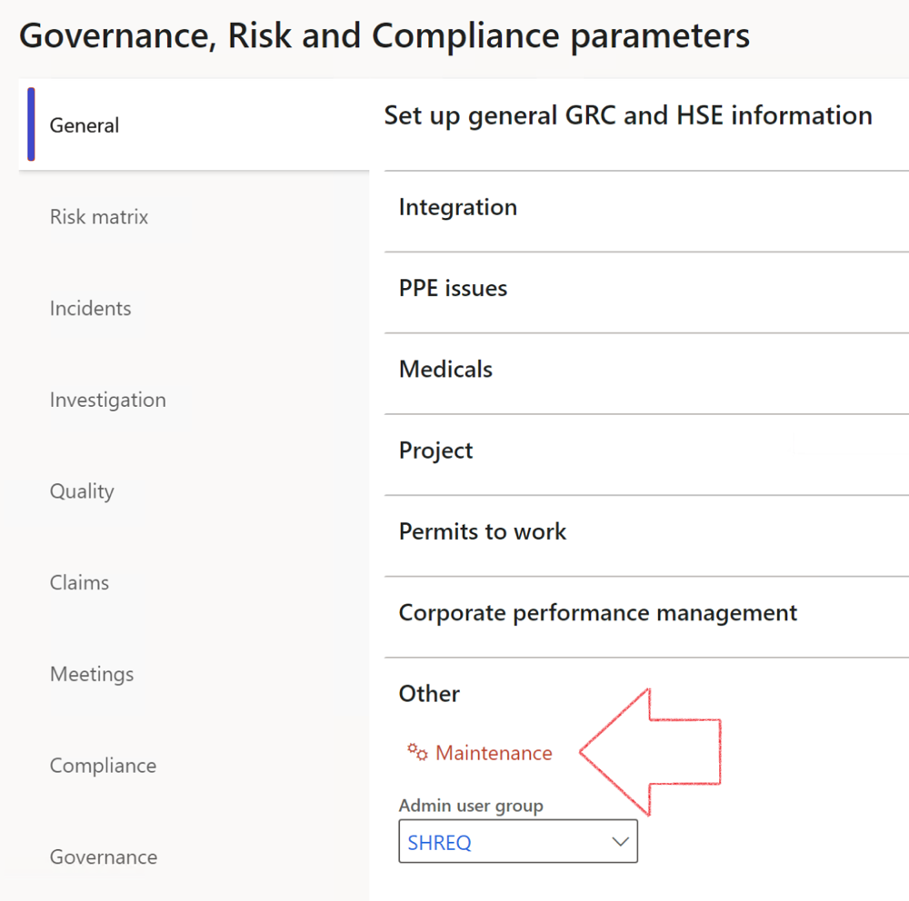

|  |  |
| --- | --- |
|  | The **Maintenance** button is there for designated user. This button repairs any possible data issues. For a full history of all Data related repairs; see table below: |

The information contained in this document represents the current view of Axnosis and Microsoft Corporation on the issues discussed as of the date of publication. Because Axnosis and Microsoft must respond to changing market conditions, this document should not be interpreted to be a commitment on the part of Axnosis and Microsoft, and Axnosis and Microsoft cannot guarantee the accuracy of any information presented after the date of publication.

This test script is for informational purposes only. AXNOSIS AND MICROSOFT MAKE NO WARRANTIES, EXPRESS, IMPLIED, OR STATUTORY, AS TO THE INFORMATION IN THIS DOCUMENT.

Complying with all applicable copyright laws is the responsibility of the user. Without limiting the rights under copyright, no part of this document may be reproduced, stored in or introduced into a retrieval system, or transmitted in any form or by any means (electronic, mechanical, photocopying, recording, or otherwise), or for any purpose, without the express written permission of Axnosis and Microsoft Corporation.

Axnosis and Microsoft may have patents, patent applications, trademarks, copyrights, or other intellectual property rights covering subject matter in this document. Except as expressly provided in any written license agreement from Axnosis and Microsoft, the furnishing of this document does not give you any license to these patents, trademarks, copyrights, or other intellectual property.

© 2021 Microsoft Corporation. All rights reserved. Any use or distribution of these materials without express authorization of Microsoft Corp. is strictly prohibited.

Microsoft and Windows are both registered trademarks of Microsoft Corporation in the United States and/or other countries.

The names of actual companies and products mentioned herein may be the trademarks of their respective owners.

|  |  |  |
| --- | --- | --- |
| **Process** | **Description/notes** | **Release** |
| Fix location vs. work centres | Populate the new **LocationRecID** field with the related location associated with previously used work centre location (Location) fields on the following tables:   * OHSHazardLocations, * OHSRiskHazard, * OHSRiskHazardWizard, * OHSRiskRegister, * OHSRisksWizard, * OHSSafetyLocations, * OHSSafetyPermit, * OHSSafetyPermitLocations * OHSSafetyPermitOverlap, * OHSSafetyPlan, * OHSInvestigation | 10.0.80.10 |
| Fix risk hazards | Assigning the value "Default Risk" to the new mandatory field **RiskID** (Key field) where empty | 10.0.80.10 |
| Fix incident HRM injury link | Delete all orphaned records from the **OHSIncidentHRMInjuryLnk** table | 10.0.11785.3 |
| Populate SRS analysis enums | Still in concept phase. To provide a link between enum numerical value and value name for use with BYOD data entities. Enums available:   * OHSIncidentType, * OHSIncidentSeverityType.   Table populated: **SRSAnalysisEnums** | 10.0.11785.3 |
| Fix budget transaction lines stock\item dimension | Set **OHSInventDimId** field value to "**AllBlank**" on table **BudgetTransactionLine**, where no value was recorded. This will solve the issue of records not displaying in the form.  **Note: this step will only fix existing budget transaction records in the system. Should any new transactions be uploaded or changed via the data entity Budget Account Entries, special care needs to be taken to specify the Stock dimension = AllBlank and the Item on the excel sheet to import.** | 10.1.1366.6 |
| Update existing incidents with the new **Incident types** | Update existing incidents with the **Incident types** that are setup on the new **Incident type** setup form. (IncidentTypeRecId) | 10.17.1250.5 |
| Update existing risks with the new **Control types** | Update existing risks with the **Control types** that are setup on the new **Control type** setup form. | 10.17.1250.6 |
| Re-number GRC Question and Answer **Group lines** | Re-number GRC Question and Answer **Group line numbers** | 10.22.1561.3 |
| Fix Inspection locations: Replace Work centre-based locations with HSE locations | Populate the new **ObjectLocation** field with the related HSE location associated with previously used work centre location (**Location**) field on the following tables:   * OHSInspectionJournalName * OHSInspectionJournalTable * OHSInspectionJournalTrans * OHSInspectionHistory * OHSSchedule | 10.24.1114.3 |
| Display of non-calculation lines | Run this job to ensure data consistency and correct display of historical data. |  |
| Fix Asset counter stock dimensions  Fix Line types on Data repository lines  Delete Orphan Data repositories | Replace empty stock dimension values with a blank dimension value  Populate missing line types from reporting templates on Data repository lines  Delete data repositories for which no template, year, site, period name or month was defined. | 10.26.1087.3  10.28.1080.6  10.30.2459.4 |