

Dynamics GRC/HSE Release notes



Governance Risk & Compliance

Health, Safety & Environment

for

**Microsoft Dynamics 365 for Finance & Operations™**

*Dynamics GRC/HSE version* 10.30.2459.3

2024-05-20



|  |  |
| --- | --- |
| Dynamics 365 FO GRC module GRC is an add-on for Dynamics 365 suite of business application software.  This software provides compelling functionality to support Governance, Risk management and Compliance. |  |
| Dynamics 365 FO HSE/OHS OHS/HSE is an add-on for Dynamics 365 suite of business application software.  This software adds to GRC in that compliance is now deeper with explicit functionality for Health, Safety and Environment as per the depicted sub-modules below. | |
|  | |

Release version

**GRC/HSE Package version:** OHSDeployablePackage_10_30_2459_3

This package was created on Microsoft Dynamics 365 for Finance and Operations:

|  |  |  |
| --- | --- | --- |
| **Release** | **Version** | **Build number** |
| Application release | 10.0.39 | 10.30.2459 |
| Platform release | Platform update 63 | 7.0.7198.66 |

# Enhancements:

|  |  |
| --- | --- |
| **Module** | **Description** |
| Tender management | * Users can now indicate how vendors have registered for tenders. On the RFQ header, under the Vendor Fast tab, a new **Registered** column was added. * The following labels were changed:   + On the RFQ, under the **Governance** Fast tab, on the Role enum: **Adjudication** is now **Moderation.**   + On the **Manage replies**: **Adjudicator’s score** is now **Moderator score.** * On the RFQ **Manage replies:**   + Under the **Quotation** Fast tab, a new **Fail** Yes/no slider was added to indicate if the reference call/site visit failed the expectation.   + A new **Disqualify** button was added in the Action pane, Functions button group (the same button as on the RFQ, Vendor Fast tab)     - The **Evaluation disqualified** label on the drop dialog, was changed to **Disqualification type**. * On the **Evaluation** setup form:   + Under the **Lines** Fast tab, **Site visit** was added as a value to the **Display** enum.   + An Evaluation setup can now be copied. A **Copy** button was added in the Action pane. * The following was added on the **Corrections** form: **Date of effectiveness check** field, and a worker lookup with label **Checked by**. * On the **Legal, contracts and tender management workspace**, under the Tender management Index tab, anew **My evaluation checklists** tile was added. * An additional filter was added to the GRC, Governance, Tender management, **Meetings** list page to show only tender management related meetings. (**Meeting type** = **Procurement bid**) |

|  |  |
| --- | --- |
| **Module** | **Description** |
| Contracts | * When the status of a **Purchase agreement** = **Expired**, and the **effective date** is moved forward, the status now changes to **On-hold**. * A new **Item lines** Fast tab was added to the **Contracts** detailform. (Similar to the Purchase agreement lines) * Users now also have the option to auto create item lines when the **BOM** field is modified. * On the **Contract classification** setup form, a new **Enforce** yes/no enum was added. * When a Contract is flagged for **review**, details form the contract are now passed to the **request for review** dialog in order to create a formal review case. * On the **Legal, contracts and tender management workspace**, under the **Enterprise legal and contracts** Index tab, anew **My change requests** tile was added. |
| Meetings | * Meetings can now be **Closed**:   + A **Closed** button was added in the Action pane, Status button group.   + A **Closed** column was added to the **Meetings list page**. * To avoid confusion, the **Approval status** enum value, **Rejected**, was changed to **Not approved**. * A new menu item was added under GRC, Governance, Reports and inquiries, **Board meeting accrual**. This menu item opens a new inquiry to indicate what the Board of directors are going to be paid based on meeting attendance. * A **Meeting date** field was added to the **Meeting** detail form to relate to the **Date** field on the **Meetings list page**. |
| Management of change | When a **Change request** is approved, a new Purchase agreement can be created with the approved lines under the **Scope of change** Fast tab. |
| Compliance audits | On the **Area of compliance**, under the **Compliance functions** Fast tab, the help text for the **Manual audit** button was improved. |

# Bug fixes:

|  |  |
| --- | --- |
| **Module** | **Description** |
| Contracts | On the **Contract**, when all vendors were deleted under the **Trading partners** Fast tab, the **primary vendor** was still displayed on the list page (header). The issue has been resolved. |

Release Data impact

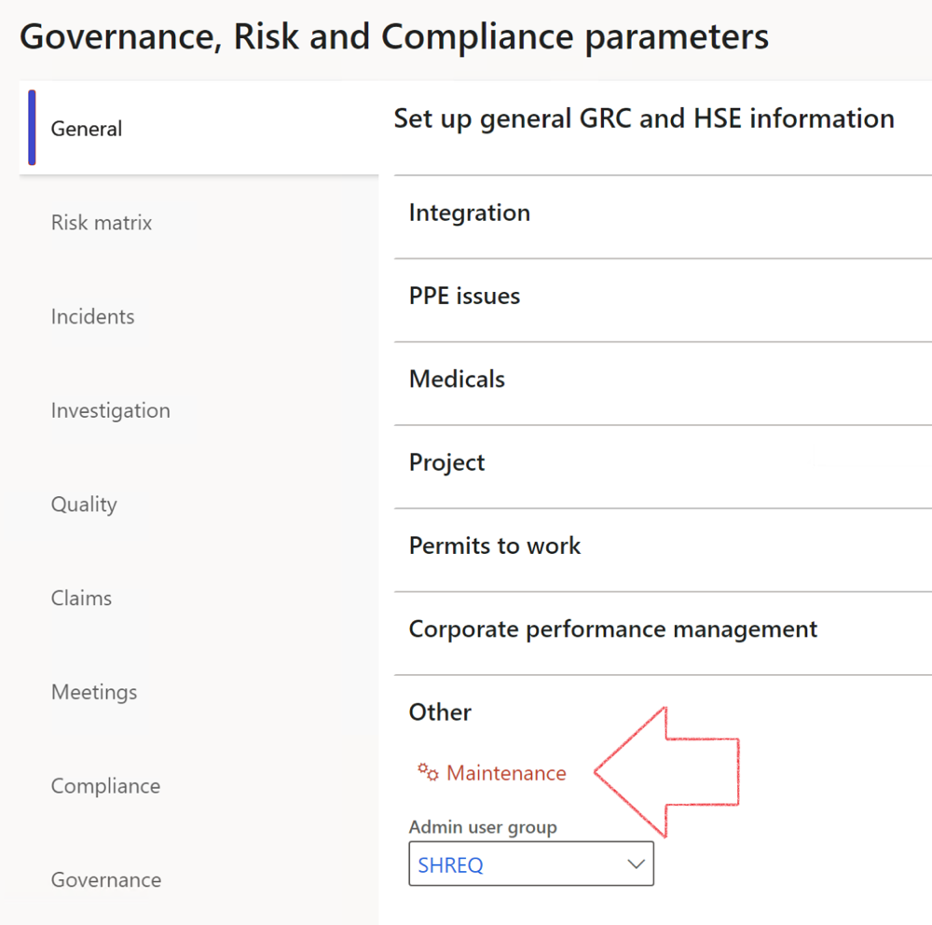

|  |  |
| --- | --- |
|  | The **Maintenance** button is there for designated user. This button repairs any possible data issues. For a full history of all Data related repairs; see table below: |

The information contained in this document represents the current view of Axnosis and Microsoft Corporation on the issues discussed as of the date of publication. Because Axnosis and Microsoft must respond to changing market conditions, this document should not be interpreted to be a commitment on the part of Axnosis and Microsoft, and Axnosis and Microsoft cannot guarantee the accuracy of any information presented after the date of publication.

This test script is for informational purposes only. AXNOSIS AND MICROSOFT MAKE NO WARRANTIES, EXPRESS, IMPLIED, OR STATUTORY, AS TO THE INFORMATION IN THIS DOCUMENT.

Complying with all applicable copyright laws is the responsibility of the user. Without limiting the rights under copyright, no part of this document may be reproduced, stored in or introduced into a retrieval system, or transmitted in any form or by any means (electronic, mechanical, photocopying, recording, or otherwise), or for any purpose, without the express written permission of Axnosis and Microsoft Corporation.

Axnosis and Microsoft may have patents, patent applications, trademarks, copyrights, or other intellectual property rights covering subject matter in this document. Except as expressly provided in any written license agreement from Axnosis and Microsoft, the furnishing of this document does not give you any license to these patents, trademarks, copyrights, or other intellectual property.

© 2021 Microsoft Corporation. All rights reserved. Any use or distribution of these materials without express authorization of Microsoft Corp. is strictly prohibited.

Microsoft and Windows are both registered trademarks of Microsoft Corporation in the United States and/or other countries.

The names of actual companies and products mentioned herein may be the trademarks of their respective owners.

|  |  |  |
| --- | --- | --- |
| **Process** | **Description/notes** | **Release** |
| Fix location vs. work centres | Populate the new **LocationRecID** field with the related location associated with previously used work centre location (Location) fields on the following tables:   * OHSHazardLocations, * OHSRiskHazard, * OHSRiskHazardWizard, * OHSRiskRegister, * OHSRisksWizard, * OHSSafetyLocations, * OHSSafetyPermit, * OHSSafetyPermitLocations * OHSSafetyPermitOverlap, * OHSSafetyPlan, * OHSInvestigation | 10.0.80.10 |
| Fix risk hazards | Assigning the value "Default Risk" to the new mandatory field **RiskID** (Key field) where empty | 10.0.80.10 |
| Fix incident HRM injury link | Delete all orphaned records from the **OHSIncidentHRMInjuryLnk** table | 10.0.11785.3 |
| Populate SRS analysis enums | Still in concept phase. To provide a link between enum numerical value and value name for use with BYOD data entities. Enums available:   * OHSIncidentType, * OHSIncidentSeverityType.   Table populated: **SRSAnalysisEnums** | 10.0.11785.3 |
| Fix budget transaction lines stock\item dimension | Set **OHSInventDimId** field value to "**AllBlank**" on table **BudgetTransactionLine**, where no value was recorded. This will solve the issue of records not displaying in the form.  **Note: this step will only fix existing budget transaction records in the system. Should any new transactions be uploaded or changed via the data entity Budget Account Entries, special care needs to be taken to specify the Stock dimension = AllBlank and the Item on the excel sheet to import.** | 10.1.1366.6 |
| Update existing incidents with the new **Incident types** | Update existing incidents with the **Incident types** that are setup on the new **Incident type** setup form. (IncidentTypeRecId) | 10.17.1250 |
| Update existing risks with the new **Control types** | Update existing risks with the **Control types** that are setup on the new **Control type** setup form. | 10.17.1250 |
| Fix Inspection locations: Replace Work centre-based locations with HSE locations | Populate the new **ObjectLocation** field with the related HSE location associated with previously used work centre location (**Location**) field on the following tables:   * OHSInspectionJournalName * OHSInspectionJournalTable * OHSInspectionJournalTrans * OHSInspectionHistory * OHSSchedule | 10.24.1114.3 |
| Display of non-calculation lines | Run this job to ensure data consistency and correct display of historical data. |  |