

Dynamics GRC/HSE Release notes



Governance Risk & Compliance

Health, Safety & Environment

for

**Microsoft Dynamics 365 for Finance & Operations™**

*Dynamics GRC/HSE version* 10.30.2459.2

2024-05-13



|  |  |
| --- | --- |
| Dynamics 365 FO GRC module GRC is an add-on for Dynamics 365 suite of business application software.  This software provides compelling functionality to support Governance, Risk management and Compliance. |  |
| Dynamics 365 FO HSE/OHS OHS/HSE is an add-on for Dynamics 365 suite of business application software.  This software adds to GRC in that compliance is now deeper with explicit functionality for Health, Safety and Environment as per the depicted sub-modules below. | |
|  | |

Release version

**GRC/HSE Package version:** OHSDeployablePackage_10_30_2459_2

This package was created on Microsoft Dynamics 365 for Finance and Operations:

|  |  |  |
| --- | --- | --- |
| **Release** | **Version** | **Build number** |
| Application release | 10.0.39 | 10.30.2459 |
| Platform release | Platform update 63 | 7.0.7198.66 |

# Enhancements:

|  |  |
| --- | --- |
| **Module** | **Description** |
| Tender management | * All the GRC functionality will be hidden on the RFQs, when **Contracts governance** is not enabled for purchase/sales agreements on the **GRC parameters**, Governance tab (under the Contracts governance Fast tab). * A new menu item was added under **GRC, Governance, Periodic, All my tender checklists**. This will open checklist list page that are to be actioned by **the logged in user.** * When **Technical** or **Commercial** **checklists** are “**frozen**”, a record is added on the RFQ under the **Sign off** Fast tab. This includes a new, non-editable **Frozen** enum was added under the **Sign off** Fast tab for the abovementioned function. * On the RFQ **Manage replies** header, under the **Quotation** Fast tab, a **Site visit** lookup to **Meetings** was added, filtered on **type** = **Procurement bid** and **Used for** = **Site visit**. * On the **Checklist feedback** form:   + The **Void** button was moved to the **Maintain** button group in the Action pane.   + A **Re-open** button was added to the Action pane in the **Function** button group.   + The **Delete** button is greyed out for **Closed** and **Voided** checklists. |
| Contracts management | * All **Approved** records are now **locked** on the **Contracts register** list page. * The **Contracts register** menu item was renamed to **Contracts register in legal entity**. * A new menu item for **Group contracts register** was added which lists contracts across all legal entities. * On the **Contract** detail form, under the **Trading partners** Fast tab, the **Purchase agreement** and **Sales agreement** fields are now read only as these fields will be populated when a PA or SA is created from the contract. * The **Contract value** field on the **Purchase agreement** is now read only. |

|  |  |
| --- | --- |
| **Module** | **Description** |
| Compliance audit | * A new **Area of compliance report** was created under GRC, Compliance, Reports, and inquiries. * The following was added on the Non-conformance **Corrections** form:   + Validations were added to not allow deletion of locked records.   + **Type** column (Preventative/corrective)   + **Action to be performed** memo box.   + **Effectiveness verification of action performed** memo box. * On the **Compliance scoring** form:   + The grid is now sorted on the **Date and time** column. The **latest** record is now at the top.   + Under the **Findings** Fast tab, the **Recommendations** Index tab was renamed to **Recommendations and strengths**, and a new **Strength** memo box was added.   + Some values from the grid are passed to the **Findings** Fast tab when scoring is done.   + When an **Audit name** is selected on the **Scoring** form, a validation is done to make sure that the linked **Audit file** has been **started**.   + When the scores are **posted**, the user now has the option to automatically create **corrections**. * On the **Audit file lines**, under the **Scores detail** Fast tab, the following displays were added: **Suggested** **improvements** and **Strength**. * On the **Completed compliance scores** form, the **Scope and objective** column was moved to under the grid. * The **Audit meetings** menu item under Internal audit, was copied to **GRC, Compliance** |
| Management of change | On the **Change request:**   * + Under the **Scope of change** (MoC lines) Fast tab, users can now also select **items**.   + A new **Update totals** button was added in the Action pane.   + A new **View cost impact** button was added in the Action pane.     - Opens a new dialog displaying the **Cost impact** lines in a summarized grid. |

# Bug fixes:

|  |  |
| --- | --- |
| **Module** | **Description** |
| Tender management | * The **Post zero scores** validation on the **Compliance scoring** form did not work for all types of scoring methods. The issue has been resolved. * The **Show closed** filter on the **Checklist feedback** form was not working. The issue has been resolved. * A **Currency conversion** error popped up when the **Evaluation** button on the RFQ was clicked. The issue has been resolved. |

Release Data impact

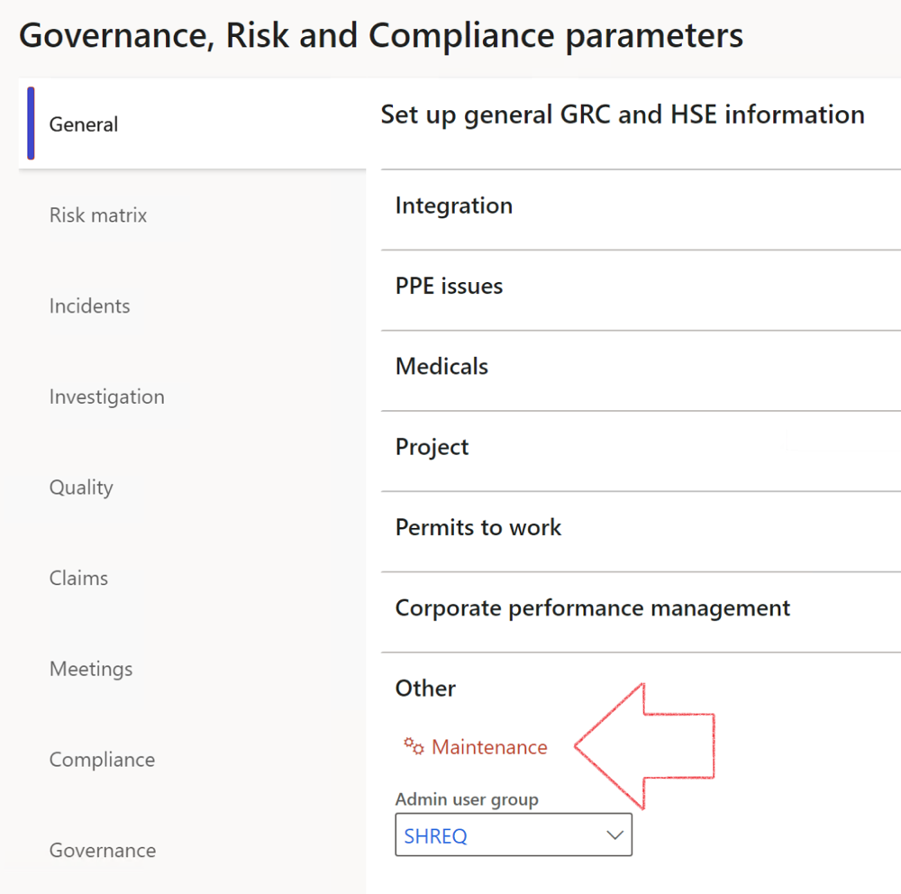

|  |  |
| --- | --- |
|  | The **Maintenance** button is there for designated user. This button repairs any possible data issues. For a full history of all Data related repairs; see table below: |

The information contained in this document represents the current view of Axnosis and Microsoft Corporation on the issues discussed as of the date of publication. Because Axnosis and Microsoft must respond to changing market conditions, this document should not be interpreted to be a commitment on the part of Axnosis and Microsoft, and Axnosis and Microsoft cannot guarantee the accuracy of any information presented after the date of publication.

This test script is for informational purposes only. AXNOSIS AND MICROSOFT MAKE NO WARRANTIES, EXPRESS, IMPLIED, OR STATUTORY, AS TO THE INFORMATION IN THIS DOCUMENT.

Complying with all applicable copyright laws is the responsibility of the user. Without limiting the rights under copyright, no part of this document may be reproduced, stored in or introduced into a retrieval system, or transmitted in any form or by any means (electronic, mechanical, photocopying, recording, or otherwise), or for any purpose, without the express written permission of Axnosis and Microsoft Corporation.

Axnosis and Microsoft may have patents, patent applications, trademarks, copyrights, or other intellectual property rights covering subject matter in this document. Except as expressly provided in any written license agreement from Axnosis and Microsoft, the furnishing of this document does not give you any license to these patents, trademarks, copyrights, or other intellectual property.

© 2021 Microsoft Corporation. All rights reserved. Any use or distribution of these materials without express authorization of Microsoft Corp. is strictly prohibited.

Microsoft and Windows are both registered trademarks of Microsoft Corporation in the United States and/or other countries.

The names of actual companies and products mentioned herein may be the trademarks of their respective owners.

|  |  |  |
| --- | --- | --- |
| **Process** | **Description/notes** | **Release** |
| Fix location vs. work centres | Populate the new **LocationRecID** field with the related location associated with previously used work centre location (Location) fields on the following tables:   * OHSHazardLocations, * OHSRiskHazard, * OHSRiskHazardWizard, * OHSRiskRegister, * OHSRisksWizard, * OHSSafetyLocations, * OHSSafetyPermit, * OHSSafetyPermitLocations * OHSSafetyPermitOverlap, * OHSSafetyPlan, * OHSInvestigation | 10.0.80.10 |
| Fix risk hazards | Assigning the value "Default Risk" to the new mandatory field **RiskID** (Key field) where empty | 10.0.80.10 |
| Fix incident HRM injury link | Delete all orphaned records from the **OHSIncidentHRMInjuryLnk** table | 10.0.11785.3 |
| Populate SRS analysis enums | Still in concept phase. To provide a link between enum numerical value and value name for use with BYOD data entities. Enums available:   * OHSIncidentType, * OHSIncidentSeverityType.   Table populated: **SRSAnalysisEnums** | 10.0.11785.3 |
| Fix budget transaction lines stock\item dimension | Set **OHSInventDimId** field value to "**AllBlank**" on table **BudgetTransactionLine**, where no value was recorded. This will solve the issue of records not displaying in the form.  **Note: this step will only fix existing budget transaction records in the system. Should any new transactions be uploaded or changed via the data entity Budget Account Entries, special care needs to be taken to specify the Stock dimension = AllBlank and the Item on the excel sheet to import.** | 10.1.1366.6 |
| Update existing incidents with the new **Incident types** | Update existing incidents with the **Incident types** that are setup on the new **Incident type** setup form. (IncidentTypeRecId) | 10.17.1250 |
| Update existing risks with the new **Control types** | Update existing risks with the **Control types** that are setup on the new **Control type** setup form. | 10.17.1250 |
| Fix Inspection locations: Replace Work centre-based locations with HSE locations | Populate the new **ObjectLocation** field with the related HSE location associated with previously used work centre location (**Location**) field on the following tables:   * OHSInspectionJournalName * OHSInspectionJournalTable * OHSInspectionJournalTrans * OHSInspectionHistory * OHSSchedule | 10.24.1114.3 |
| Display of non-calculation lines | Run this job to ensure data consistency and correct display of historical data. |  |