

Dynamics GRC/HSE Release notes



Governance Risk & Compliance

Health, Safety & Environment

for

**Microsoft Dynamics 365 for Finance & Operations™**

*Dynamics GRC/HSE version* 10.30.2459.12

2024-07-16



|  |  |
| --- | --- |
| Dynamics 365 FO GRC module GRC is an add-on for Dynamics 365 suite of business application software.  This software provides compelling functionality to support Governance, Risk management and Compliance. |  |
| Dynamics 365 FO HSE/OHS OHS/HSE is an add-on for Dynamics 365 suite of business application software.  This software adds to GRC in that compliance is now deeper with explicit functionality for Health, Safety and Environment as per the depicted sub-modules below. | |
|  | |

Release version

**GRC/HSE Package version:** OHSDeployablePackage_10_30_2459_12

This package was created on Microsoft Dynamics 365 for Finance and Operations:

|  |  |  |
| --- | --- | --- |
| **Release** | **Version** | **Build number** |
| Application release | 10.0.39 | 10.30.2459 |
| Platform release | Platform update 63 | 7.0.7198.66 |

# Enhancements:

|  |  |
| --- | --- |
| **Module** | **Description** |
| Permits to work | * A new **Approvers** Fact box was added in the **Related information pane** on the PTW. All **Approvers**, specified on the selected **Safety plan**, are listed in this new Fact box. * The **All work order maintenance jobs** menu item was copied from Asset management to under **HSE, Permits to work**.   + This new menu item opens a list page of **all work order maintenance jobs** and has a **Location focus** slider to give the user the option to change the focus of the list page. * On the **PTW pool**:   + A **Focus on functional location** slider was added under the **General** Fast tab   + A **Functional location** column was added under the **Permits to work** Fast tab * On the **PTW header**, under the **Applicable areas** Fast tab, a **Primary** tick box was added under the **Objects**- and **Location** Index tab. * On the **Work breakdown structure**, when the **Permit, Add to existing** button is clicked, the list of permits that can be selected now includes:   + Permits with the same **Functional location** and or **Asset** as the **WBS**   + **Approved** and **not issued** permits * A new **All project WBS with permit** menu item was added under **HSE, Permits to work**. * The following columns were added on the **PTW in columns report**:   + **Work method**, **Precautions sequence** and **PPE sequence** * A **Permit to work type** can now be indicated as **high risk** on the Permit to work type setup form. These high-risk permit types are also indicated on the **Permit in columns** **report**. * **Permit to work type** is now also printed on the report. * A **Work order** can now be linked to a **PTW** when a **PTW** is created from the **Safety portal.** * A new **Include in-active** slider was added to the **Permit to work type group.** Userscan now suppress the **active** filter on the **Permit to work type** by moving this slider to **Yes.** |

|  |  |
| --- | --- |
| **Module** | **Description** |
| Contracts management | * On the **Contract, Lines Fast tab**: the **Value** label was changed to **Initial value** * On the **Purchase agreement header**, **General** Fast tab:   + The **Contract value** label was changed to **Initial value**   + The **Approved CRs** label was changed to **Approved CR**. Help text was added to this field as well.   + A new **CR number** display method was added   + The following was changed under the **Contract administration** Fast tab:     - The **Statement of work value** and **Currency** fields are now hidden     - The **Insurance value** and **Currency** fields are now hidden   + A few **Workflow labels** were also changed |
| Management of change | * On the **Change request**, **Scope of change** Fast tab:   + The **Scope of change** Fast tab's label was changed to **Scope of change (lines)**   + The **Cost impact** label to **Total cost impact**   + **Expiry date** and **Purchase agreement** columns were added to the grid * On the **CAR** report, under the **Budget transfer** heading: The **Yes/No** as well as **To** (budget), is now printed. * On the **Engineers instructions change request** report:   + Hard coded text under **Signatures** was removed   + The correct text is now displayed in the **Instructions** field   + The correct text is displayed in the **Title** field   + Scope of change lines that have **no linked vendors** are ignored on the report. * On the **Employers instructions change request** report:   + The correct text is displayed in the **Title** field   + The correct text is now displayed in the **Instructions** field   + Hard coded text under **Signatures** was removed |
| Tender management | * When a **Procurement plan** is created and a **Solicitation type** is selected where the currency is specified, the **Currency** field on the New Procurement plan dialog is populated with the same currency. * On the **RFQ** header, **Governance** Fast tab, **Committee** Index tab **Name** is now also displayed in the **Team** dropdown list * The **Audit file ID** field on the **Create new checklist**dialog (When a **Qualification checklist** is created from the RFQ) is now hidden. * On the RFQ, a warning is given to the user when scoring is done on **Qualification** and the score entered is higher than the **Max score** specified on the **Job plan**. * The **Technical** and **Commercial** average scores are now printing on the **Tender evaluation report**. |
| Compliance audits | * On the **Area of compliance Header**, under the **General** Fast tab, the **Actual % of last score** label was changed to **Average % of last score**. |
| Business continuity | * **MAO** (Maximum Acceptable Outage) was added to the **Business impact assessment** form: A new **MOA** column was added to the list page, as well as on the **BIA** under the **General** Fast tab |
| Risk management | A filter was added to all the **Risk worksheets** to filter out all closed records. |

|  |  |
| --- | --- |
| **Module** | **Description** |
| Corporate performance management | A **Fuel management** create dialog was added to the **Asset counters**. |
| Master data management | A new **Expired vendor certification report** was created and can be printed form the **Vendor certification inquiry**. |

Release Data impact

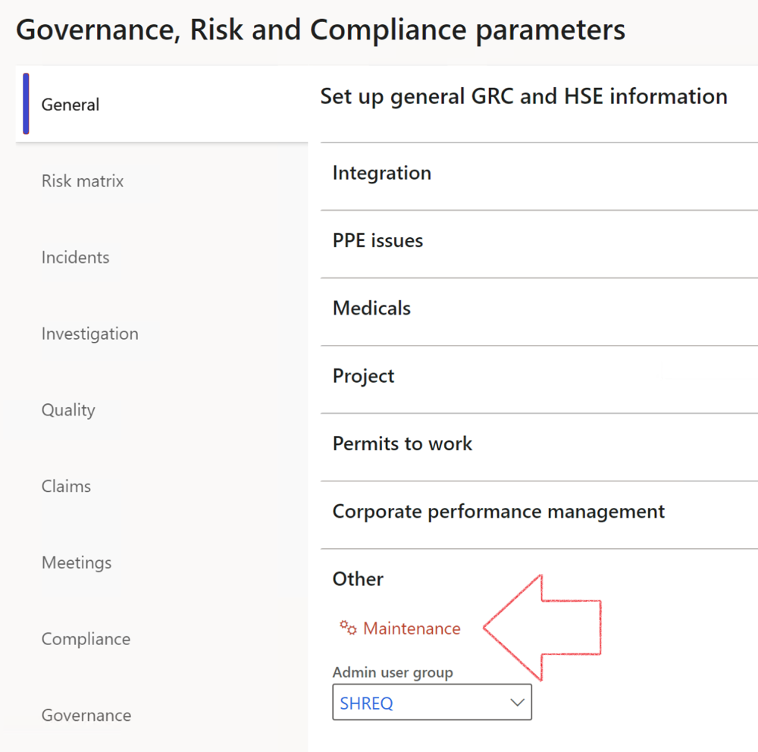

|  |  |
| --- | --- |
|  | The **Maintenance** button is there for designated user. This button repairs any possible data issues. For a full history of all Data related repairs; see table below: |

The information contained in this document represents the current view of Axnosis and Microsoft Corporation on the issues discussed as of the date of publication. Because Axnosis and Microsoft must respond to changing market conditions, this document should not be interpreted to be a commitment on the part of Axnosis and Microsoft, and Axnosis and Microsoft cannot guarantee the accuracy of any information presented after the date of publication.

This test script is for informational purposes only. AXNOSIS AND MICROSOFT MAKE NO WARRANTIES, EXPRESS, IMPLIED, OR STATUTORY, AS TO THE INFORMATION IN THIS DOCUMENT.

Complying with all applicable copyright laws is the responsibility of the user. Without limiting the rights under copyright, no part of this document may be reproduced, stored in or introduced into a retrieval system, or transmitted in any form or by any means (electronic, mechanical, photocopying, recording, or otherwise), or for any purpose, without the express written permission of Axnosis and Microsoft Corporation.

Axnosis and Microsoft may have patents, patent applications, trademarks, copyrights, or other intellectual property rights covering subject matter in this document. Except as expressly provided in any written license agreement from Axnosis and Microsoft, the furnishing of this document does not give you any license to these patents, trademarks, copyrights, or other intellectual property.

© 2021 Microsoft Corporation. All rights reserved. Any use or distribution of these materials without express authorization of Microsoft Corp. is strictly prohibited.

Microsoft and Windows are both registered trademarks of Microsoft Corporation in the United States and/or other countries.

The names of actual companies and products mentioned herein may be the trademarks of their respective owners.

|  |  |  |
| --- | --- | --- |
| **Process** | **Description/notes** | **Release** |
| Fix location vs. work centres | Populate the new **LocationRecID** field with the related location associated with previously used work centre location (Location) fields on the following tables:   * OHSHazardLocations, * OHSRiskHazard, * OHSRiskHazardWizard, * OHSRiskRegister, * OHSRisksWizard, * OHSSafetyLocations, * OHSSafetyPermit, * OHSSafetyPermitLocations * OHSSafetyPermitOverlap, * OHSSafetyPlan, * OHSInvestigation | 10.0.80.10 |
| Fix risk hazards | Assigning the value "Default Risk" to the new mandatory field **RiskID** (Key field) where empty | 10.0.80.10 |
| Fix incident HRM injury link | Delete all orphaned records from the **OHSIncidentHRMInjuryLnk** table | 10.0.11785.3 |
| Populate SRS analysis enums | Still in concept phase. To provide a link between enum numerical value and value name for use with BYOD data entities. Enums available:   * OHSIncidentType, * OHSIncidentSeverityType.   Table populated: **SRSAnalysisEnums** | 10.0.11785.3 |
| Fix budget transaction lines stock\item dimension | Set **OHSInventDimId** field value to "**AllBlank**" on table **BudgetTransactionLine**, where no value was recorded. This will solve the issue of records not displaying in the form.  **Note: this step will only fix existing budget transaction records in the system. Should any new transactions be uploaded or changed via the data entity Budget Account Entries, special care needs to be taken to specify the Stock dimension = AllBlank and the Item on the excel sheet to import.** | 10.1.1366.6 |
| Update existing incidents with the new **Incident types** | Update existing incidents with the **Incident types** that are setup on the new **Incident type** setup form. (IncidentTypeRecId) | 10.17.1250.5 |
| Update existing risks with the new **Control types** | Update existing risks with the **Control types** that are setup on the new **Control type** setup form. | 10.17.1250.6 |
| Re-number GRC Question and Answer **Group lines** | Re-number GRC Question and Answer **Group line numbers** | 10.22.1561.3 |
| Fix Inspection locations: Replace Work centre-based locations with HSE locations | Populate the new **ObjectLocation** field with the related HSE location associated with previously used work centre location (**Location**) field on the following tables:   * OHSInspectionJournalName * OHSInspectionJournalTable * OHSInspectionJournalTrans * OHSInspectionHistory * OHSSchedule | 10.24.1114.3 |
| Display of non-calculation lines | Run this job to ensure data consistency and correct display of historical data. |  |
| Fix Asset counter stock dimensions  Fix Line types on Data repository lines  Delete Orphan Data repositories | Replace empty stock dimension values with a blank dimension value  Populate missing line types from reporting templates on Data repository lines  Delete data repositories for which no template, year, site, period name or month was defined. | 10.26.1087.3  10.28.1080.6  10.30.2459.4 |
| Equivalent Functional location fields | The equivalent Functional location fields will be populated where an HSE Location exists on the permit to work pool header and linked Permit to work table. | 10.30.2459.12 |