

Dynamics GRC/HSE Release notes



Governance Risk & Compliance

Health, Safety & Environment

for

**Microsoft Dynamics 365 for Finance & Operations™**

*Dynamics GRC/HSE version* 10.29.1675.8

2024-04-22



|  |  |
| --- | --- |
| Dynamics 365 FO GRC module GRC is an add-on for Dynamics 365 suite of business application software.  This software provides compelling functionality to support Governance, Risk management and Compliance. |  |
| Dynamics 365 FO HSE/OHS OHS/HSE is an add-on for Dynamics 365 suite of business application software.  This software adds to GRC in that compliance is now deeper with explicit functionality for Health, Safety and Environment as per the depicted sub-modules below. | |
|  | |

Release version

**GRC/HSE Package version:** OHSDeployablePackage_10_29_1675_8

This package was created on Microsoft Dynamics 365 for Finance and Operations:

|  |  |  |
| --- | --- | --- |
| **Release** | **Version** | **Build number** |
| Application release | 10.0.38 | 10.29.1675 |
| Platform release | Platform update 62 | 7.0.7120.53 |

*Bug fixes:*

|  |  |
| --- | --- |
| **Module** | **Description** |
| Tender management | * The **Baseline contract value** entered on the **Solicitation type** was not displayed on the **RFQ** in the **Baseline contract value** field. The issue has been resolved. * When a **new Procurement plan** was created with no contract value, the **Actual value of contract** field was populated with a value. The issue has been resolved. |
| Operational and sustainability reporting | While uploading **monthly data**, a **validation** **error** message was popping up. The issue has been resolved. |

# Enhancements:

|  |  |
| --- | --- |
| **Module** | **Description** |
| Permits to work | * On the **PTW pool list page**, a **Site and Location** fields were added. The **Location** selected on the Site, is now displayed next to the Site. * On the **PTW detail form**, a **Location** lookup, which filters on the selected **Site**, was added |
| Safety and security | QR codes can now be generated for workers. On the **QR code generator** form, “**Worker**” was added as a value to the **Element type** enum. |
| Meetings | The following columns are now hidden on the **Meeting types** setup form:   * Performance review * Audit |
| Document management | **Watermarks** were added for when documents with the following states are printed:   * **Draft** * **Terminated** * **Archived** |

|  |  |
| --- | --- |
| **Module** | **Description** |
| Tender management | * The wording on the pop-ups, when **checklists** are created from an **RFQ**, was changed. The user now has the option to create a checklist for **each team member**, **only** for the **team leaders**. * On the **RFQ checklist feedback** list pages (header):   + Drop-dialogs were added to the **Closed** and **Void** buttons in the Action pane.   + The text entered in the memo boxes on these new drop-dialogs, is displayed in the new memo box that was added below the grid. * On the **RFQ checklist feedback** lines:   + The **Note** column’s label was changed to **Comment**.   + The **Note** box’s label was changed to **Comments**.   + New **Note** box was added to display the notes added on the Job plan/Scoring criteria. * A new **Prospective vendor results** table and form were created. The table is populated when a checklist is **closed**. On this table, one prospective vendor is linked to many results. * On the **Vendor pre-qualification checklist feedback** form:   + The following columns are now hidden: **Required**, **Ready**, **Continuous**.   + A **Score** column was added after the **Worker** column. This is based on the option selected on the Job plan.   + The **Worker** and **Date checked** fields are now auto-populate when the user changes the **Task status** field. * On the RFQ, **Change team member** dialog, the **Mobile user** column is now hidden. * On the **RFQ Action pane**, in the **Score** button group, the **Freeze** button was changed to be a **Menu button**. On click, the user now has the option to freeze scoring on one of the following:   + **Scoring criteria setups**   + **Technical checklist**   + **Commercial checklist** * When the **Approve** button, or the **Send** button is clicked on the RFQ, a **warning message** appears if there are less vendors than specified on the Solicitation type in the **Minimum number of bids** field. * The **Action plan ID** selected when an **Activity** is created from an RFQ, is now populating the **Action plan** field under the **Governance** Fast tab on the **RFQ.** * On the RFQ, **Process and activities** dialog, the lines are now sorted on the **SOP**# column. * On the **RFQ** header, under the **Vendor** Fast tab, “**Blank**” was added as a value to the **Evaluation disqualified** enum. * A new **Evaluation setup** form was created. * The following was done on the **Solicitation type**:   + The **Criteria 2nd element** field was hidden**.**   + An **Evaluation setup** lookup was added.   + The **Baseline contract** lookup was moved to be above the **Task list** lookup. |

Release Data impact

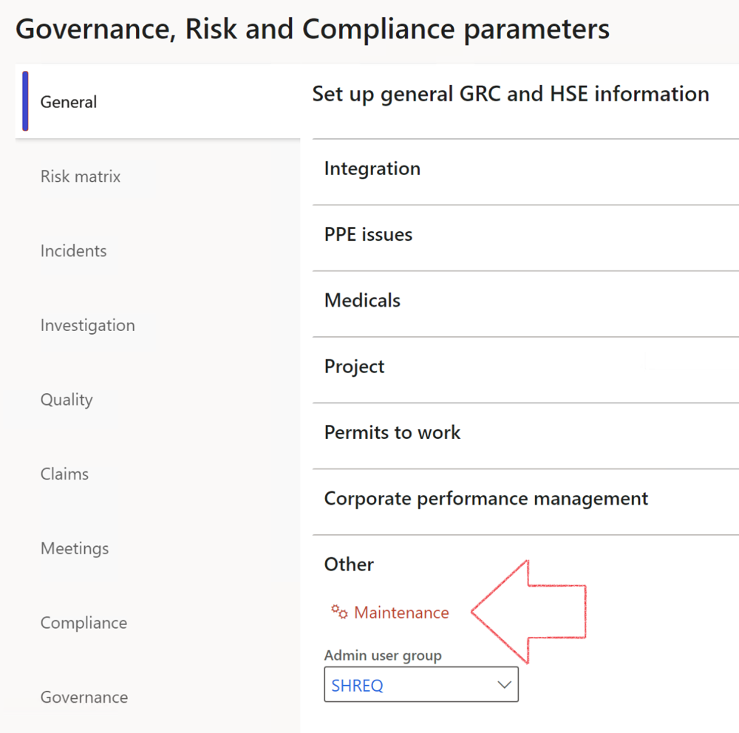

|  |  |
| --- | --- |
|  | The **Maintenance** button is there for designated user. This button repairs any possible data issues. For a full history of all Data related repairs; see table below: |

The information contained in this document represents the current view of Axnosis and Microsoft Corporation on the issues discussed as of the date of publication. Because Axnosis and Microsoft must respond to changing market conditions, this document should not be interpreted to be a commitment on the part of Axnosis and Microsoft, and Axnosis and Microsoft cannot guarantee the accuracy of any information presented after the date of publication.

This test script is for informational purposes only. AXNOSIS AND MICROSOFT MAKE NO WARRANTIES, EXPRESS, IMPLIED, OR STATUTORY, AS TO THE INFORMATION IN THIS DOCUMENT.

Complying with all applicable copyright laws is the responsibility of the user. Without limiting the rights under copyright, no part of this document may be reproduced, stored in or introduced into a retrieval system, or transmitted in any form or by any means (electronic, mechanical, photocopying, recording, or otherwise), or for any purpose, without the express written permission of Axnosis and Microsoft Corporation.

Axnosis and Microsoft may have patents, patent applications, trademarks, copyrights, or other intellectual property rights covering subject matter in this document. Except as expressly provided in any written license agreement from Axnosis and Microsoft, the furnishing of this document does not give you any license to these patents, trademarks, copyrights, or other intellectual property.

© 2021 Microsoft Corporation. All rights reserved. Any use or distribution of these materials without express authorization of Microsoft Corp. is strictly prohibited.

Microsoft and Windows are both registered trademarks of Microsoft Corporation in the United States and/or other countries.

The names of actual companies and products mentioned herein may be the trademarks of their respective owners.

|  |  |  |
| --- | --- | --- |
| **Process** | **Description/notes** | **Release** |
| Fix location vs. work centres | Populate the new **LocationRecID** field with the related location associated with previously used work centre location (Location) fields on the following tables:   * OHSHazardLocations, * OHSRiskHazard, * OHSRiskHazardWizard, * OHSRiskRegister, * OHSRisksWizard, * OHSSafetyLocations, * OHSSafetyPermit, * OHSSafetyPermitLocations * OHSSafetyPermitOverlap, * OHSSafetyPlan, * OHSInvestigation | 10.0.80.10 |
| Fix risk hazards | Assigning the value "Default Risk" to the new mandatory field **RiskID** (Key field) where empty | 10.0.80.10 |
| Fix incident HRM injury link | Delete all orphaned records from the **OHSIncidentHRMInjuryLnk** table | 10.0.11785.3 |
| Populate SRS analysis enums | Still in concept phase. To provide a link between enum numerical value and value name for use with BYOD data entities. Enums available:   * OHSIncidentType, * OHSIncidentSeverityType.   Table populated: **SRSAnalysisEnums** | 10.0.11785.3 |
| Fix budget transaction lines stock\item dimension | Set **OHSInventDimId** field value to "**AllBlank**" on table **BudgetTransactionLine**, where no value was recorded. This will solve the issue of records not displaying in the form.  **Note: this step will only fix existing budget transaction records in the system. Should any new transactions be uploaded or changed via the data entity Budget Account Entries, special care needs to be taken to specify the Stock dimension = AllBlank and the Item on the excel sheet to import.** | 10.1.1366.6 |
| Update existing incidents with the new **Incident types** | Update existing incidents with the **Incident types** that are setup on the new **Incident type** setup form. (IncidentTypeRecId) | 10.17.1250 |
| Update existing risks with the new **Control types** | Update existing risks with the **Control types** that are setup on the new **Control type** setup form. | 10.17.1250 |
| Fix Inspection locations: Replace Work centre-based locations with HSE locations | Populate the new **ObjectLocation** field with the related HSE location associated with previously used work centre location (**Location**) field on the following tables:   * OHSInspectionJournalName * OHSInspectionJournalTable * OHSInspectionJournalTrans * OHSInspectionHistory * OHSSchedule | 10.24.1114.3 |
| Display of non-calculation lines | Run this job to ensure data consistency and correct display of historical data. |  |