

Dynamics GRC/HSE Release notes



Governance Risk & Compliance

Health, Safety & Environment

for

**Microsoft Dynamics 365 for Finance & Operations™**

*Dynamics GRC/HSE version* 10.29.1675.7

2024-04-15



|  |  |
| --- | --- |
| Dynamics 365 FO GRC module GRC is an add-on for Dynamics 365 suite of business application software.  This software provides compelling functionality to support Governance, Risk management and Compliance. |  |
| Dynamics 365 FO HSE/OHS OHS/HSE is an add-on for Dynamics 365 suite of business application software.  This software adds to GRC in that compliance is now deeper with explicit functionality for Health, Safety and Environment as per the depicted sub-modules below. | |
|  | |

Release version

**GRC/HSE Package version:** OHSDeployablePackage_10_29_1675_7

This package was created on Microsoft Dynamics 365 for Finance and Operations:

|  |  |  |
| --- | --- | --- |
| **Release** | **Version** | **Build number** |
| Application release | 10.0.38 | 10.29.1675 |
| Platform release | Platform update 62 | 7.0.7120.53 |

# Enhancements:

|  |  |
| --- | --- |
| **Module** | **Description** |
| Tender management | * On the **RFQ**, help text was added for the **Bid opening** field to describe the different options. * On the **RFQ scores**, a **Validate** button was added to the **Technical** and the **Commercial** grids to check that all checklists have been **closed**. * A **Qualification team** lookup was added on the **Solicitation type**. * On the RFQ, before **Technical** or **Commercial** **checklists** can be created, the system now does a check for the following: A highest status of Received/Sent for at least one supplier/vendor. * A new **Team leader** display was added to the **Change teams** dialog. * Enhancements on the **Bid evaluation report**. * On the **Job plan**, the **Pass threshold** label was changed to **Max score**. |
| Contract management | * A “**Template**” **watermark** was added for when a **Baseline contract** is printed. * When a Contract is marked as **Baseline**:   + Text was added to the warning pop-up.   + The **Value** field is cleared/changed to **0**.   + **Breach and remedies** records are deleted.   + **Renewals and terminations** records are deleted. |
| Meetings | * **Board of directors’** functionality introduced. |
| Compliance audit | On the **Operational risk register**, under the **Associations** Fast tab, a value was added to the **Entity type** = **Compliance function**. When a Compliance function is selected in this grid, the **Risk** Fast tab on the **Compliance function** detail form is updated with the Risk register and risk line details. |
| Operational and sustainability reporting | The **YTD calculations** were simplified and the “**Use YTD values**” tick box is now hidden as it is no longer required for the calculations. |
| Incidents | Users now have the option to have the **department** from the **worker position** entered by default on the creation of an incident:   * On The **HSE parameters**, under the **Incident** tab, under the **Default site and department** Fast tab, a Yes/No slider was added with label **Department from worker position**. |

*Bug fixes:*

|  |  |
| --- | --- |
| **Module** | **Description** |
| Tender management | * All checklists were displayed on the **All tender checklists** list page. The issue has been resolved. Only checklists linked to **RFQs** are now displayed on this list page. * **Qualification checklists** were not created when the **Create qualification checklist** button was clicked on the RFQ. The issue has been resolved. * On creation of an RFQ, **empty** records were created on the RFQ,Governance Fast tab, under the **Committee** index tab. The issue has been resolved. * The **scoring** on the Qualification, Technical and Commercial checklists was not considering the lines where **zeros** are entered. The issue has been resolved. * **Duplicate** lines were created form the **Scoring criteria** form. The issue has been resolved. * On the **RFQ**, the **Create commercial checklist** button was greyed out before it was clicked. The issue has been resolved. |
| Contract management | The **contract value** was not displaying on the **Purchase agreement** when a **Contract** was linked to a **PA**. The issue has been resolved. |
| Management of change | On the **Change request,** the C**hange total** on the **header** was not updating with the total of the change lines. The issue has been resolved. |
| Operational and sustainability reporting | Records were missing on the **Data repository**. The issue has been resolved. |

Release Data impact

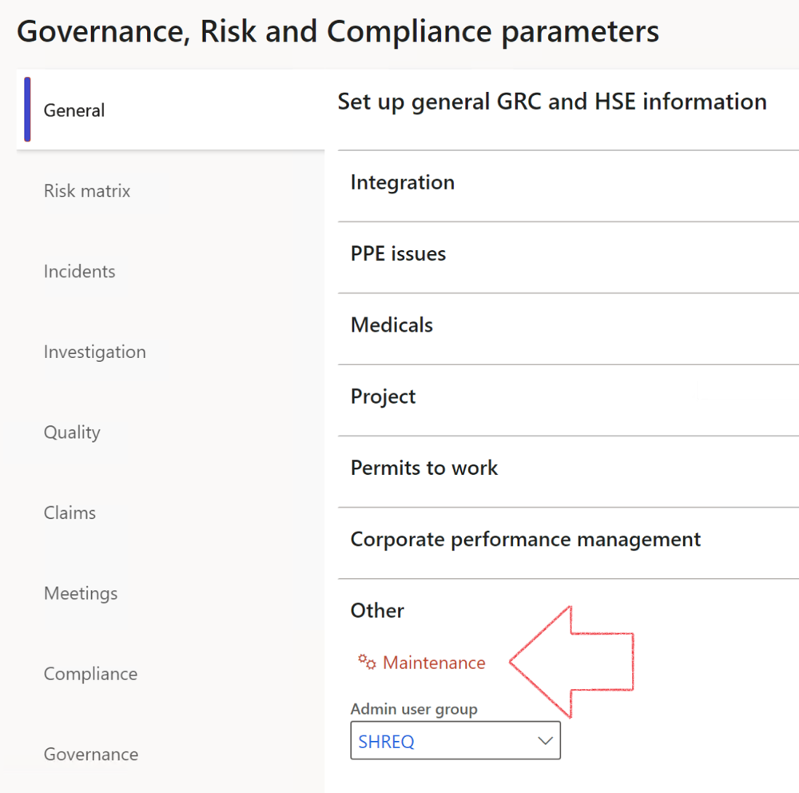

|  |  |
| --- | --- |
|  | The **Maintenance** button is there for designated user. This button repairs any possible data issues. For a full history of all Data related repairs; see table below: |

The information contained in this document represents the current view of Axnosis and Microsoft Corporation on the issues discussed as of the date of publication. Because Axnosis and Microsoft must respond to changing market conditions, this document should not be interpreted to be a commitment on the part of Axnosis and Microsoft, and Axnosis and Microsoft cannot guarantee the accuracy of any information presented after the date of publication.

This test script is for informational purposes only. AXNOSIS AND MICROSOFT MAKE NO WARRANTIES, EXPRESS, IMPLIED, OR STATUTORY, AS TO THE INFORMATION IN THIS DOCUMENT.

Complying with all applicable copyright laws is the responsibility of the user. Without limiting the rights under copyright, no part of this document may be reproduced, stored in or introduced into a retrieval system, or transmitted in any form or by any means (electronic, mechanical, photocopying, recording, or otherwise), or for any purpose, without the express written permission of Axnosis and Microsoft Corporation.

Axnosis and Microsoft may have patents, patent applications, trademarks, copyrights, or other intellectual property rights covering subject matter in this document. Except as expressly provided in any written license agreement from Axnosis and Microsoft, the furnishing of this document does not give you any license to these patents, trademarks, copyrights, or other intellectual property.

© 2021 Microsoft Corporation. All rights reserved. Any use or distribution of these materials without express authorization of Microsoft Corp. is strictly prohibited.

Microsoft and Windows are both registered trademarks of Microsoft Corporation in the United States and/or other countries.

The names of actual companies and products mentioned herein may be the trademarks of their respective owners.

|  |  |  |
| --- | --- | --- |
| **Process** | **Description/notes** | **Release** |
| Fix location vs. work centres | Populate the new **LocationRecID** field with the related location associated with previously used work centre location (Location) fields on the following tables:   * OHSHazardLocations, * OHSRiskHazard, * OHSRiskHazardWizard, * OHSRiskRegister, * OHSRisksWizard, * OHSSafetyLocations, * OHSSafetyPermit, * OHSSafetyPermitLocations * OHSSafetyPermitOverlap, * OHSSafetyPlan, * OHSInvestigation | 10.0.80.10 |
| Fix risk hazards | Assigning the value "Default Risk" to the new mandatory field **RiskID** (Key field) where empty | 10.0.80.10 |
| Fix incident HRM injury link | Delete all orphaned records from the **OHSIncidentHRMInjuryLnk** table | 10.0.11785.3 |
| Populate SRS analysis enums | Still in concept phase. To provide a link between enum numerical value and value name for use with BYOD data entities. Enums available:   * OHSIncidentType, * OHSIncidentSeverityType.   Table populated: **SRSAnalysisEnums** | 10.0.11785.3 |
| Fix budget transaction lines stock\item dimension | Set **OHSInventDimId** field value to "**AllBlank**" on table **BudgetTransactionLine**, where no value was recorded. This will solve the issue of records not displaying in the form.  **Note: this step will only fix existing budget transaction records in the system. Should any new transactions be uploaded or changed via the data entity Budget Account Entries, special care needs to be taken to specify the Stock dimension = AllBlank and the Item on the excel sheet to import.** | 10.1.1366.6 |
| Update existing incidents with the new **Incident types** | Update existing incidents with the **Incident types** that are setup on the new **Incident type** setup form. (IncidentTypeRecId) | 10.17.1250 |
| Update existing risks with the new **Control types** | Update existing risks with the **Control types** that are setup on the new **Control type** setup form. | 10.17.1250 |
| Fix Inspection locations: Replace Work centre-based locations with HSE locations | Populate the new **ObjectLocation** field with the related HSE location associated with previously used work centre location (**Location**) field on the following tables:   * OHSInspectionJournalName * OHSInspectionJournalTable * OHSInspectionJournalTrans * OHSInspectionHistory * OHSSchedule | 10.24.1114.3 |
| Display of non-calculation lines | Run this job to ensure data consistency and correct display of historical data. |  |