

Dynamics GRC/HSE Release notes



Governance Risk & Compliance

Health, Safety & Environment

for

**Microsoft Dynamics 365 for Finance & Operations™**

*Dynamics GRC/HSE version* 10.29.1675.6

2024-04-08



|  |  |
| --- | --- |
| Dynamics 365 FO GRC module GRC is an add-on for Dynamics 365 suite of business application software.  This software provides compelling functionality to support Governance, Risk management and Compliance. |  |
| Dynamics 365 FO HSE/OHS OHS/HSE is an add-on for Dynamics 365 suite of business application software.  This software adds to GRC in that compliance is now deeper with explicit functionality for Health, Safety and Environment as per the depicted sub-modules below. | |
|  | |

Release version

**GRC/HSE Package version:** OHSDeployablePackage_10_29_1675_6

This package was created on Microsoft Dynamics 365 for Finance and Operations:

|  |  |  |
| --- | --- | --- |
| **Release** | **Version** | **Build number** |
| Application release | 10.0.38 | 10.29.1675 |
| Platform release | Platform update 62 | 7.0.7120.53 |

*Bug fixes:*

|  |  |
| --- | --- |
| **Module** | **Description** |
| Tender management | * The wrong checklist was being used to create the **Qualification checklist** on the RFQ. The issue has been resolved. * When the status of an RFQ is changed to **Closed**, all the Vendor records are now set to **Rejected**. This was not previously working. * The **Create RFQ** button on the Procurement plan list page and detail form was available even when an RFQ already existed on the Procurement plan. The issue has been resolved. * A **Closed** record could be deleted on the **Qualification checklist** list page. The issue has been resolved. |

# Enhancements:

|  |  |
| --- | --- |
| **Module** | **Description** |
| Tender management | * On the **RFQ replies**, on the Action pane, in the **Related information** button group, a new **Waiver answers** button was added. This button opens and displays the answers given for the **RFQ waived** questions. * The **Status** field is now displayed on the **RFQ list pages**, just before the **Waiver** column. * A new **Evaluation disqualified**, enum was added to the grid under the **Vendors** Fast tab on the RFQ header. * The **Reason code** field on the **Comply** and **Disqualify** drop dialogs was changed to a memo box. * On the RFQ, under the **Sign off** Fast tab, the **Freezed** label was fixed to **Frozen**. * **Help text** was added to the following fields:   + **GRC parameters**, Governance tab, Tender management Fast tab, **Default job**   + **Solicitation type**, Governance Fast tab, **Qualification job plan** * On the **Qualification** checklist list page, the **Status** button group in the Action pane was hidden and the three **status buttons** moved into the Button strip, and symbols were added to these buttons. * A new **Qualification scores** form was created for viewing **Qualification checklists**. * A new **View scores** button was added in the RFQ action pane. This button has a dropdown list which gives the user the option to view one of the following:   + **Qualification**/**Technical**/**Commercial scores** * Records on the **Technical** and **Commercial analysis** forms can now be deleted. * Only **header records** are now shown on the **Technical scores** form. * A new menu item was added under **Governance > Periodic**, label = **All tender checklists.** * Enhancements to the **RFQ audit trail**. * The buttons on the **RFQ list page** and **RFQ detail** form were aligned. * On the **Procurement plan**:   + The **Re-open** button is now only accessible for users in the **Admin user group**   + The **Sub status** field is now read only and is driven by the status of the RFQ.   + When the **Mining** tick is on, the **Sub status** field will be **blank**. * On the **GRC parameters**, under the **Governance** tab, the **Tender management** Fast tab's label was changed to **Sourcing and tender governance** * On the **Teams** setup form, a column with label **Temporary**, was added. |
| Contract management | A new **Declaration of interest report** was created |

Release Data impact

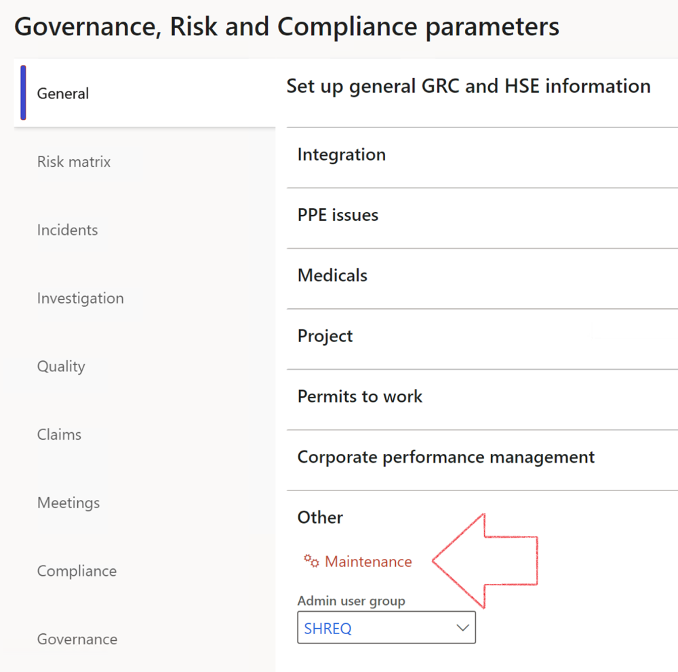

|  |  |
| --- | --- |
|  | The **Maintenance** button is there for designated user. This button repairs any possible data issues. For a full history of all Data related repairs; see table below: |

The information contained in this document represents the current view of Axnosis and Microsoft Corporation on the issues discussed as of the date of publication. Because Axnosis and Microsoft must respond to changing market conditions, this document should not be interpreted to be a commitment on the part of Axnosis and Microsoft, and Axnosis and Microsoft cannot guarantee the accuracy of any information presented after the date of publication.

This test script is for informational purposes only. AXNOSIS AND MICROSOFT MAKE NO WARRANTIES, EXPRESS, IMPLIED, OR STATUTORY, AS TO THE INFORMATION IN THIS DOCUMENT.

Complying with all applicable copyright laws is the responsibility of the user. Without limiting the rights under copyright, no part of this document may be reproduced, stored in or introduced into a retrieval system, or transmitted in any form or by any means (electronic, mechanical, photocopying, recording, or otherwise), or for any purpose, without the express written permission of Axnosis and Microsoft Corporation.

Axnosis and Microsoft may have patents, patent applications, trademarks, copyrights, or other intellectual property rights covering subject matter in this document. Except as expressly provided in any written license agreement from Axnosis and Microsoft, the furnishing of this document does not give you any license to these patents, trademarks, copyrights, or other intellectual property.

© 2021 Microsoft Corporation. All rights reserved. Any use or distribution of these materials without express authorization of Microsoft Corp. is strictly prohibited.

Microsoft and Windows are both registered trademarks of Microsoft Corporation in the United States and/or other countries.

The names of actual companies and products mentioned herein may be the trademarks of their respective owners.

|  |  |  |
| --- | --- | --- |
| **Process** | **Description/notes** | **Release** |
| Fix location vs. work centres | Populate the new **LocationRecID** field with the related location associated with previously used work centre location (Location) fields on the following tables:   * OHSHazardLocations, * OHSRiskHazard, * OHSRiskHazardWizard, * OHSRiskRegister, * OHSRisksWizard, * OHSSafetyLocations, * OHSSafetyPermit, * OHSSafetyPermitLocations * OHSSafetyPermitOverlap, * OHSSafetyPlan, * OHSInvestigation | 10.0.80.10 |
| Fix risk hazards | Assigning the value "Default Risk" to the new mandatory field **RiskID** (Key field) where empty | 10.0.80.10 |
| Fix incident HRM injury link | Delete all orphaned records from the **OHSIncidentHRMInjuryLnk** table | 10.0.11785.3 |
| Populate SRS analysis enums | Still in concept phase. To provide a link between enum numerical value and value name for use with BYOD data entities. Enums available:   * OHSIncidentType, * OHSIncidentSeverityType.   Table populated: **SRSAnalysisEnums** | 10.0.11785.3 |
| Fix budget transaction lines stock\item dimension | Set **OHSInventDimId** field value to "**AllBlank**" on table **BudgetTransactionLine**, where no value was recorded. This will solve the issue of records not displaying in the form.  **Note: this step will only fix existing budget transaction records in the system. Should any new transactions be uploaded or changed via the data entity Budget Account Entries, special care needs to be taken to specify the Stock dimension = AllBlank and the Item on the excel sheet to import.** | 10.1.1366.6 |
| Update existing incidents with the new **Incident types** | Update existing incidents with the **Incident types** that are setup on the new **Incident type** setup form. (IncidentTypeRecId) | 10.17.1250 |
| Update existing risks with the new **Control types** | Update existing risks with the **Control types** that are setup on the new **Control type** setup form. | 10.17.1250 |
| Fix Inspection locations: Replace Work centre-based locations with HSE locations | Populate the new **ObjectLocation** field with the related HSE location associated with previously used work centre location (**Location**) field on the following tables:   * OHSInspectionJournalName * OHSInspectionJournalTable * OHSInspectionJournalTrans * OHSInspectionHistory * OHSSchedule | 10.24.1114.3 |
| Display of non-calculation lines | Run this job to ensure data consistency and correct display of historical data. |  |