

Dynamics GRC/HSE Release notes



Governance Risk & Compliance

Health, Safety & Environment

for

**Microsoft Dynamics 365 for Finance & Operations™**

*Dynamics GRC/HSE version* 10.29.1675.5

2024-04-02



|  |  |
| --- | --- |
| Dynamics 365 FO GRC module GRC is an add-on for Dynamics 365 suite of business application software.  This software provides compelling functionality to support Governance, Risk management and Compliance. |  |
| Dynamics 365 FO HSE/OHS OHS/HSE is an add-on for Dynamics 365 suite of business application software.  This software adds to GRC in that compliance is now deeper with explicit functionality for Health, Safety and Environment as per the depicted sub-modules below. | |
|  | |

Release version

**GRC/HSE Package version:** OHSDeployablePackage_10_29_1675_5

This package was created on Microsoft Dynamics 365 for Finance and Operations:

|  |  |  |
| --- | --- | --- |
| **Release** | **Version** | **Build number** |
| Application release | 10.0.38 | 10.29.1675 |
| Platform release | Platform update 62 | 7.0.7120.53 |

# Enhancements:

|  |  |
| --- | --- |
| **Module** | **Description** |
| Checklists | * The **Status** buttons in the Action pane were grouped under the **Function** button. These have now been flattened to reduce the number of clicks that a user needs to do before feedback is done. |
| Contract management | * A few enhancements were made to the new **Statement of final account (SOFA)** report. * On the contract, the **Status** label was changed to **State**. * When a new **Contract request** is created, the details of the logged in user’s legal entity, defaults into the **Party 1** field. * A new value was added to the **Contract** **State** enum = **Terminated**. The rules/controls for this state were enabled. * On the **Contract**, under the **Sign off** Fast tab, the following records cannot be removed:   + When the **SOFA** tick is on   + When the **Approved** tick is on |
| Inspections | The **Number sequence column** that was added on the **Inspection type** setup form, can now be used to define the number sequence for **BBS** and **PJO** inspection journals. |

|  |  |
| --- | --- |
| **Module** | **Description** |
| Tender management | * On the **GRC parameters**, under the Governance tab, Contracts governance Fast tab, a new enum list was added as well as a new free text field with label = **Numbering**. The user can now select the Numbering format to be used for contracts. A contract will then be created using the RFQ number. * A **Choose template** slider was added on the **GRC parameters**, Governance tab, Contracts governance Fast tab, to allow manual selection of a baseline contract when awarding an RFQ. * Changes on the **RFQ Action pane**:   + The **Start**, **Pause** and **Stop** buttons on the **RFQ** are now hidden.   + The **Send** and **Qualification** buttons were swapped.   + The **Bid documents** button is now hidden on the list page as it was moved into the detail form.   + The **Recommend** button was added to the list page.   + Two buttons were added for future use (**Qualifications** and **DOI**) * On the **RFQ header**, under the **Governance** Fast tab, **Committee** Index tab, a new **Change team member** button was added. This gives the user the option to make changes to the members of the selected **Team**. * On the **RFQ header**, under the **Sign off** Fast tab:   + When record is added manually, the **Envelope opened** field will be greyed out, value = **Blank**.   + No changes are allowed to a record when the value in the **Envelope opened** field = **Technical**/**Commercial**.   + The **Risk assessed** label was changed to **Qualification**.   + The **Approved** column was moved forward in the grid and is now read only.   + The **Freezed** column was moved forward in the grid. * On the **Solicitation type**, the **Pre-qualification job plan** label was changed to **Qualification job plan**. * On the **RFQ** under the **Governance** Fast tab:   + A new **Qualification job plan** display was added.   + The **Currency** field was moved and is now next to the **Maximum value of bid field.**   + The **Action plan** field was moved to the new **OTHER** field group. * The Microsoft **Open requests for quotations** menu item was copied to the **GRC** menu under **Tender management**. |

*Bug fixes:*

|  |  |
| --- | --- |
| **Module** | **Description** |
| Contract management | * When a contract’s state was changed to **Terminated**, it was moved to the **All archived contracts** list page. * On creation of a new **Contract**, the list page opened instead of the detail form.   These issues have been resolved. |
| Tender management | * On the **Procurement plan**, under the Planning and approvals Fast tab, when parallel is selected in the Bid opening field, the date selected in the **Technical envelope** field, now also populates the **Commercial envelope** field. * On the **RFQ**, under the **Sign off** Fast tab, the **Envelope opened** field is now read only. |
| Operational and sustainability reporting | The **Notes** added on the **Reporting template** were only pulled through to the Reporting data for month one. The issue has been resolved. |
| Inspections | The **Number sequence column** that was added on the **Inspection type** setup form, can now be used to define the number sequence for **BBS** and **PJO** inspection journals. |

Release Data impact

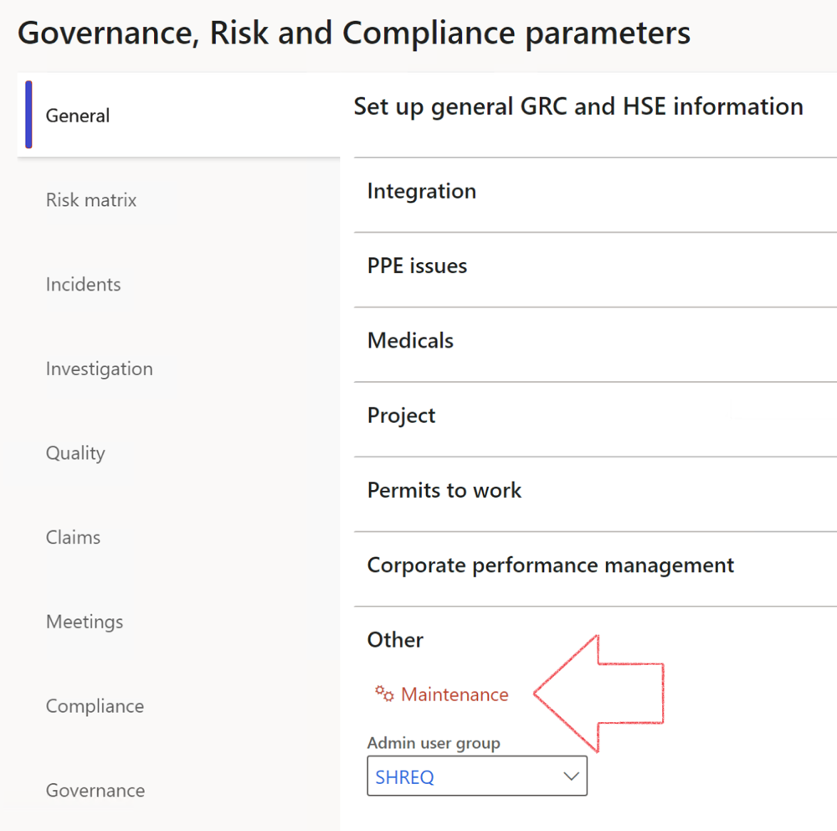

|  |  |
| --- | --- |
|  | The **Maintenance** button is there for designated user. This button repairs any possible data issues. For a full history of all Data related repairs; see table below: |

|  |  |  |
| --- | --- | --- |
| **Process** | **Description/notes** | **Release** |
| Fix location vs. work centres | Populate the new **LocationRecID** field with the related location associated with previously used work centre location (Location) fields on the following tables:   * OHSHazardLocations, * OHSRiskHazard, * OHSRiskHazardWizard, * OHSRiskRegister, * OHSRisksWizard, * OHSSafetyLocations, * OHSSafetyPermit, * OHSSafetyPermitLocations * OHSSafetyPermitOverlap, * OHSSafetyPlan, * OHSInvestigation | 10.0.80.10 |
| Fix risk hazards | Assigning the value "Default Risk" to the new mandatory field **RiskID** (Key field) where empty | 10.0.80.10 |
| Fix incident HRM injury link | Delete all orphaned records from the **OHSIncidentHRMInjuryLnk** table | 10.0.11785.3 |
| Populate SRS analysis enums | Still in concept phase. To provide a link between enum numerical value and value name for use with BYOD data entities. Enums available:   * OHSIncidentType, * OHSIncidentSeverityType.   Table populated: **SRSAnalysisEnums** | 10.0.11785.3 |
| Fix budget transaction lines stock\item dimension | Set **OHSInventDimId** field value to "**AllBlank**" on table **BudgetTransactionLine**, where no value was recorded. This will solve the issue of records not displaying in the form.  **Note: this step will only fix existing budget transaction records in the system. Should any new transactions be uploaded or changed via the data entity Budget Account Entries, special care needs to be taken to specify the Stock dimension = AllBlank and the Item on the excel sheet to import.** | 10.1.1366.6 |
| Update existing incidents with the new **Incident types** | Update existing incidents with the **Incident types** that are setup on the new **Incident type** setup form. (IncidentTypeRecId) | 10.17.1250 |
| Update existing risks with the new **Control types** | Update existing risks with the **Control types** that are setup on the new **Control type** setup form. | 10.17.1250 |
| Fix Inspection locations: Replace Work centre-based locations with HSE locations | Populate the new **ObjectLocation** field with the related HSE location associated with previously used work centre location (**Location**) field on the following tables:   * OHSInspectionJournalName * OHSInspectionJournalTable * OHSInspectionJournalTrans * OHSInspectionHistory * OHSSchedule | 10.24.1114.3 |
| Display of non-calculation lines | Run this job to ensure data consistency and correct display of historical data. |  |

The information contained in this document represents the current view of Axnosis and Microsoft Corporation on the issues discussed as of the date of publication. Because Axnosis and Microsoft must respond to changing market conditions, this document should not be interpreted to be a commitment on the part of Axnosis and Microsoft, and Axnosis and Microsoft cannot guarantee the accuracy of any information presented after the date of publication.

This test script is for informational purposes only. AXNOSIS AND MICROSOFT MAKE NO WARRANTIES, EXPRESS, IMPLIED, OR STATUTORY, AS TO THE INFORMATION IN THIS DOCUMENT.

Complying with all applicable copyright laws is the responsibility of the user. Without limiting the rights under copyright, no part of this document may be reproduced, stored in or introduced into a retrieval system, or transmitted in any form or by any means (electronic, mechanical, photocopying, recording, or otherwise), or for any purpose, without the express written permission of Axnosis and Microsoft Corporation.

Axnosis and Microsoft may have patents, patent applications, trademarks, copyrights, or other intellectual property rights covering subject matter in this document. Except as expressly provided in any written license agreement from Axnosis and Microsoft, the furnishing of this document does not give you any license to these patents, trademarks, copyrights, or other intellectual property.

© 2021 Microsoft Corporation. All rights reserved. Any use or distribution of these materials without express authorization of Microsoft Corp. is strictly prohibited.

Microsoft and Windows are both registered trademarks of Microsoft Corporation in the United States and/or other countries.

The names of actual companies and products mentioned herein may be the trademarks of their respective owners.