

Dynamics GRC/HSE Release notes



Governance Risk & Compliance

Health, Safety & Environment

for

**Microsoft Dynamics 365 for Finance & Operations™**

*Dynamics GRC/HSE version* 10.29.1675.2

2024-03-04



|  |  |
| --- | --- |
| Dynamics 365 FO GRC module GRC is an add-on for Dynamics 365 suite of business application software.  This software provides compelling functionality to support Governance, Risk management and Compliance. |  |
| Dynamics 365 FO HSE/OHS OHS/HSE is an add-on for Dynamics 365 suite of business application software.  This software adds to GRC in that compliance is now deeper with explicit functionality for Health, Safety and Environment as per the depicted sub-modules below. | |
|  | |

Release version

**GRC/HSE Package version:** OHSDeployablePackage_10_29_1675_2

This package was created on Microsoft Dynamics 365 for Finance and Operations:

|  |  |  |
| --- | --- | --- |
| **Release** | **Version** | **Build number** |
| Application release | 10.0.38 | 10.29.1675 |
| Platform release | Platform update 62 | 7.0.7120.53 |

# Enhancements:

|  |  |
| --- | --- |
| **Module** | **Description** |
| Contract management | * Vendors can now receive notifications before certifications are about to expire:   + A **Vendor certificate batch alert** menu item was added under Accounts payable, Periodic tasks.   + An **Email template** lookup was added on the **Certificate type** setup form.   + A **Contract register reference** lookup was added on the **Certifications** header.   + On the **Vendor contacts** list page, a **Certification** type lookup was added, as well as an **All** tick box. * **Workflow** will be enabled on the **Policies, contracts and reports** form.   + The **Change status** button in the action pane was renamed to **Change state**, and two enum values were changed.   + A **Workflow status** (enum) field was added under the **Content** Fast tab, **Cover page** Index tab. * On the **Contract register**, the **Indemnities** Fast tab was renamed to **Indemnities & liabilities**. A **Type** (enum) column was added to the grid with the following values:   + **Public**   + **Employers**   + **Other** * On the **Approval authority** setup form, the following values were added to the **Role** enum:   + **Chief executor officer**   + **Chief operating officer**   + **Chief information officer** * **Statement of final account (SOFA)** was added to the Contract register:   + On the **Termination of contract** drop dialog, an **Agreed final account** field was added.   + Under the **Content** Fast tab, a **Statement of termination** Index tab was added.   + Under the **Sign off** Fast tab, a **SOFA** column (yes/no tick box) was added. * **Automated email alerts/notifications** capability was added to **GRC Contract register** records. * A **PDF integration** log form and table were created. |

|  |  |
| --- | --- |
| **Module** | **Description** |
| Contract management | * The **Print** button on the **Policies, contracts and reports** form was changed to a button group. The following options are now available under this **Print** button group: * **Print document** (Prints the report as usual * **Send document** (For future use)   The **help text** for this button was improved. |
| Tender management | * **Workflow** is now enabled on the **Procurement plan.**   The following changes were made to the **Procurement plan**:   * + The **Change status** enum values have been changed. The values are now: Approved, Submitted, Returned and Rejected.   + A new **Sub status** read only field was added under the **General** Fast tab. When the header record is approved, this field becomes available for selection.   + The **Planned dates** Fast tab was renamed to **Planning and approvals**.   + A few new fields were added under the **Planning and approvals** Fast tab. The fields were grouped into **Field groups**. * **Scoring** on the RFQ can now be “frozen”:   + The **Comments on vendor reply** field was moved up to be next to the **Description** field.   + A new **Freeze** button was added on the **RFQ** Action pane in the **Score** button group.   + A **Status** column was added to the **Scoring criteria** grid.   + A **Status** column was added to the **RFQ manage replies header**, **Bid scoring** grid. * On the **RFQ manage replies header**, under the **Bid scoring** Fast tab:   + The **Total** score field was moved to be in line with the **Rank** field.   + A new **View** filter was added to enable the user to choose which checklist records he/she wants to see in the grid:     - **All**     - **Technical**     - **Commercial**     - **None** * A **Safety plan** lookup was added under the **Governance** Fast tab for **Mine plan** Procurement plans. * On the **Procurement plan:**   + Under the **Reporting** Fast tab, a **Presentation** yes/no slider was added.   + Under the **Governance** Fast tab, two memo boxes were added: **Internal** **comments** and **external comments**.   + Under the Budget details fast tab, a free text field for Source of budget was added.   + A new **Process** button was added in the Action pane. This button opens a dialog displaying the list of **linked process activities**.   + The **Request for quote details** Fast tab and the **Budget details** Fast tab were swapped. * The **Recommend** button in the Action pane of the **RFQ** is now only available when the RFQ header status = **Received – Received**. * A **Generic checklists** menu item was added under **HR, Task management**. |

|  |  |
| --- | --- |
| **Module** | **Description** |
| Permits to work | * Three new (role based) menu items were added under **HSE, Permits to work, Permit to work list pages:**   + **Permits to be prepared**   + **Permits to be issued**   + **Permits to be approved** * The same was added on the **Safety management workspace**, but as **tiles**. |
| Risk management | The blue heading on the **Enterprise risk profile and controls report** is now repeated on every page. |

Release Data impact

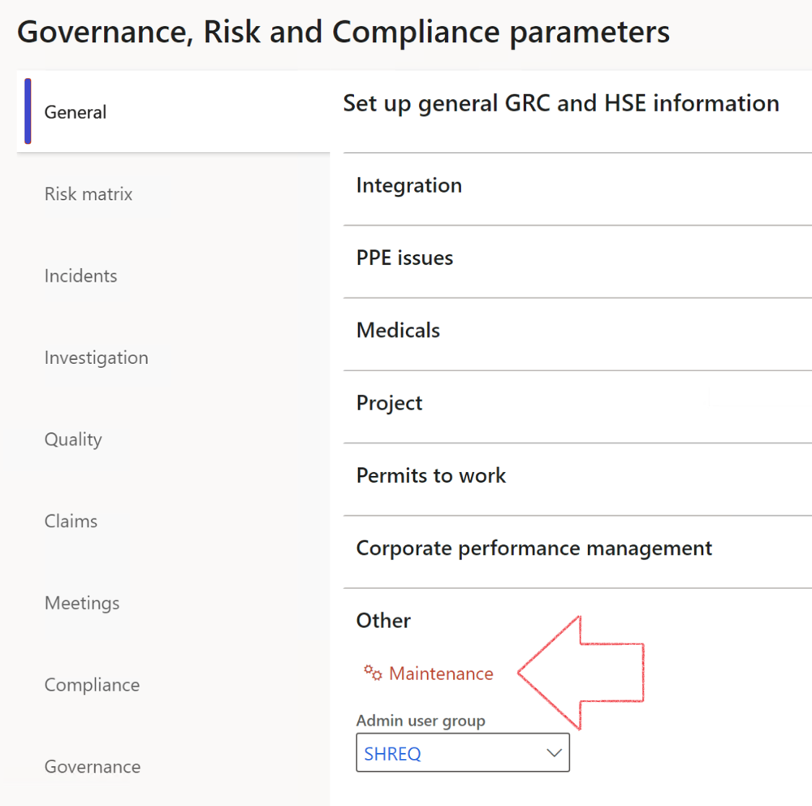

|  |  |
| --- | --- |
|  | The **Maintenance** button is there for designated user. This button repairs any possible data issues. For a full history of all Data related repairs; see table below: |

|  |  |  |
| --- | --- | --- |
| **Process** | **Description/notes** | **Release** |
| Fix location vs. work centres | Populate the new **LocationRecID** field with the related location associated with previously used work centre location (Location) fields on the following tables:   * OHSHazardLocations, * OHSRiskHazard, * OHSRiskHazardWizard, * OHSRiskRegister, * OHSRisksWizard, * OHSSafetyLocations, * OHSSafetyPermit, * OHSSafetyPermitLocations * OHSSafetyPermitOverlap, * OHSSafetyPlan, * OHSInvestigation | 10.0.80.10 |
| Fix risk hazards | Assigning the value "Default Risk" to the new mandatory field **RiskID** (Key field) where empty | 10.0.80.10 |
| Fix incident HRM injury link | Delete all orphaned records from the **OHSIncidentHRMInjuryLnk** table | 10.0.11785.3 |
| Populate SRS analysis enums | Still in concept phase. To provide a link between enum numerical value and value name for use with BYOD data entities. Enums available:   * OHSIncidentType, * OHSIncidentSeverityType.   Table populated: **SRSAnalysisEnums** | 10.0.11785.3 |
| Fix budget transaction lines stock\item dimension | Set **OHSInventDimId** field value to "**AllBlank**" on table **BudgetTransactionLine**, where no value was recorded. This will solve the issue of records not displaying in the form.  **Note: this step will only fix existing budget transaction records in the system. Should any new transactions be uploaded or changed via the data entity Budget Account Entries, special care needs to be taken to specify the Stock dimension = AllBlank and the Item on the excel sheet to import.** | 10.1.1366.6 |
| Update existing incidents with the new **Incident types** | Update existing incidents with the **Incident types** that are setup on the new **Incident type** setup form. (IncidentTypeRecId) | 10.17.1250 |
| Update existing risks with the new **Control types** | Update existing risks with the **Control types** that are setup on the new **Control type** setup form. | 10.17.1250 |
| Fix Inspection locations: Replace Work centre-based locations with HSE locations | Populate the new **ObjectLocation** field with the related HSE location associated with previously used work centre location (**Location**) field on the following tables:   * OHSInspectionJournalName * OHSInspectionJournalTable * OHSInspectionJournalTrans * OHSInspectionHistory * OHSSchedule | 10.24.1114.3 |
| Display of non-calculation lines | Run this job to ensure data consistency and correct display of historical data. |  |

The information contained in this document represents the current view of Axnosis and Microsoft Corporation on the issues discussed as of the date of publication. Because Axnosis and Microsoft must respond to changing market conditions, this document should not be interpreted to be a commitment on the part of Axnosis and Microsoft, and Axnosis and Microsoft cannot guarantee the accuracy of any information presented after the date of publication.

This test script is for informational purposes only. AXNOSIS AND MICROSOFT MAKE NO WARRANTIES, EXPRESS, IMPLIED, OR STATUTORY, AS TO THE INFORMATION IN THIS DOCUMENT.

Complying with all applicable copyright laws is the responsibility of the user. Without limiting the rights under copyright, no part of this document may be reproduced, stored in or introduced into a retrieval system, or transmitted in any form or by any means (electronic, mechanical, photocopying, recording, or otherwise), or for any purpose, without the express written permission of Axnosis and Microsoft Corporation.

Axnosis and Microsoft may have patents, patent applications, trademarks, copyrights, or other intellectual property rights covering subject matter in this document. Except as expressly provided in any written license agreement from Axnosis and Microsoft, the furnishing of this document does not give you any license to these patents, trademarks, copyrights, or other intellectual property.

© 2021 Microsoft Corporation. All rights reserved. Any use or distribution of these materials without express authorization of Microsoft Corp. is strictly prohibited.

Microsoft and Windows are both registered trademarks of Microsoft Corporation in the United States and/or other countries.

The names of actual companies and products mentioned herein may be the trademarks of their respective owners.