

Dynamics GRC/HSE Release notes



Governance Risk & Compliance

Health, Safety & Environment

for

**Microsoft Dynamics 365 for Finance & Operations™**

*Dynamics GRC/HSE version* 10.28.1080.9

2024-02-12



|  |  |
| --- | --- |
| Dynamics 365 FO GRC module GRC is an add-on for Dynamics 365 suite of business application software.  This software provides compelling functionality to support Governance, Risk management and Compliance. |  |
| Dynamics 365 FO HSE/OHS OHS/HSE is an add-on for Dynamics 365 suite of business application software.  This software adds to GRC in that compliance is now deeper with explicit functionality for Health, Safety and Environment as per the depicted sub-modules below. | |
|  | |

Release version

**GRC/HSE Package version:** OHSDeployablePackage_10_28_1080_9

This package was created on Microsoft Dynamics 365 for Finance and Operations:

|  |  |  |
| --- | --- | --- |
| **Release** | **Version** | **Build number** |
| Application release | 10.0.37 | 10.28.1080 |
| Platform release | Platform update 61 | 7.0.7068.67 |

# Enhancements:

|  |  |
| --- | --- |
| **Module** | **Description** |
| Internal audit | * Some label changes were made on the **Audit three year plan** report. * Op the **Internal audit workspace**, **Audit universes**Index tab, the column displaying colours is now hidden. |
| Operational and sustainability reporting | On the **GRC parameters**, **OSR tab**, under the **Default settings** Fast tab, a new **Divide by zero** dropdown was added. The user can choose one of the following as the default setting for handling a **divide by zero calculation** error:   * **Error**: will stop the program and show an error message to the user, who will have to fix the values before continuing. * **Warning**: will replace the calculated value by zero and display a warning message to the user, who can continue. * **None**: will replace the calculated value by zero without any message to the user. |
| Tender management | * The **Teams** menu item was copied to the **Setup for governance** folder on the **GRC menu.** * The following was added on the **Solicitation type** setup form, under the **Governance** Fast tab:   + A **Task list** lookup to the Microsoft checklist header.   + A **Pre-qualification job plan** lookup to Job plans. * The **status** of the RFQ is now also displayed in the top right hand side of the RFQ. * On the **RFQ header,** under the **Governance** Fast tab:   + The **Checklist** field group label was changed to **Job plan lines to be used in checklist**, under the **Technical** and **Commercial** **checklist** Index tabs.   + Under the **Committee** Index tab, **Observer** was added to the **Role** enum.   + The **Bid documents** button was moved from the Action pane to under the **Governance** Fast tab, **Bid document** Index tab. * The following was added for the **Pre-qualification of prospective vendors**:   + On the **GRC parameters**, a new **Pre-qualification** field group was added where a **Default team** and **Default job plan** can be selected.   + A new **Pre-qualification checklists** menu item was added under **Vendor collaboration requests** folder on the **Procurement and sourcing** menu.   + A **Pre-qualification** button group was added on the **Prospective vendor registration requests** form. |

|  |  |
| --- | --- |
| **Module** | **Description** |
| Permits to work | * The user now has the option to **include/exclude** permits that have been suspended to a **Permits to work pool**. An **Include suspended permits** slider was added on the **Auto add permits** **with these attributes** dialog. * On the **Permits to work pool**:   + The **Integration** field group is now hidden.   + The following buttons are now hidden: * **Bulk approve** * **Bulk issue** * **Bulk cancel** * **Bulk print** * A **Permits to work** Fast tab was added to the Related information pane on the **All maintenance jobs** list page. |

# Bug fixes:

|  |  |
| --- | --- |
| **Module** | **Description** |
| Tender management | On the **RFQ**, additional **Technical** and **Commercial checklists** were created for the **Team leader**. The issue has been resolved. |
| Contract management | * The record relationships on the **Integration template for pdf services** form were fixed, and the **Show/hide list** button was added. * On approval, the validation for a **Primary trading partner** is now only done on **Contracts** |
| Compliance audit | The filter on the **Completed compliance scores** inquiry was fixed to only show **Compliance audit** records |
| Permits to work | Some labels on the **Print permit in columns** report were fixed |
| Environmental | An error popped up when the **Waste register report** was run. The issue has been resolved. |

Release Data impact

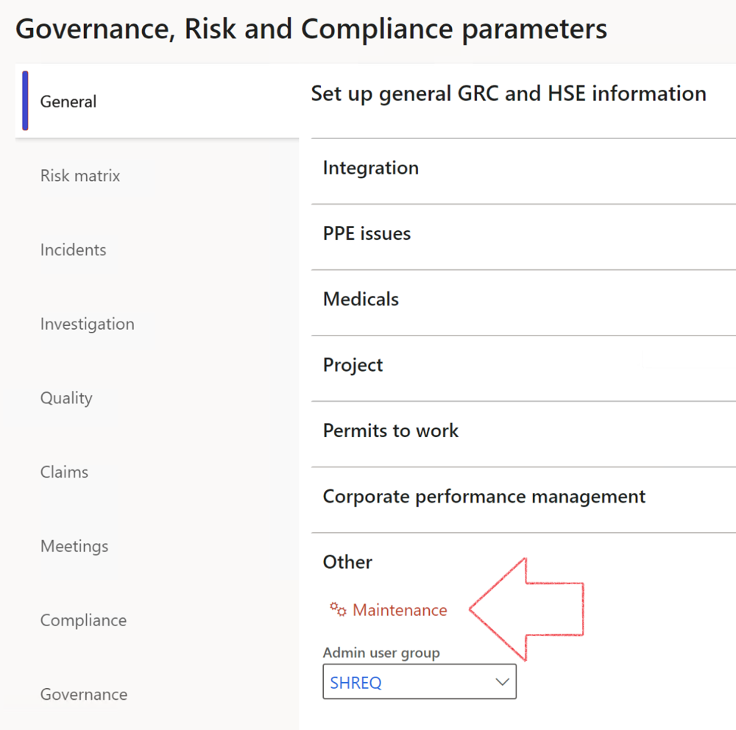

|  |  |
| --- | --- |
|  | The **Maintenance** button is there for designated user. This button repairs any possible data issues. For a full history of all Data related repairs; see table below: |

|  |  |  |
| --- | --- | --- |
| **Process** | **Description/notes** | **Release** |
| Fix location vs. work centres | Populate the new **LocationRecID** field with the related location associated with previously used work centre location (Location) fields on the following tables:   * OHSHazardLocations, * OHSRiskHazard, * OHSRiskHazardWizard, * OHSRiskRegister, * OHSRisksWizard, * OHSSafetyLocations, * OHSSafetyPermit, * OHSSafetyPermitLocations * OHSSafetyPermitOverlap, * OHSSafetyPlan, * OHSInvestigation | 10.0.80.10 |
| Fix risk hazards | Assigning the value "Default Risk" to the new mandatory field **RiskID** (Key field) where empty | 10.0.80.10 |
| Fix incident HRM injury link | Delete all orphaned records from the **OHSIncidentHRMInjuryLnk** table | 10.0.11785.3 |
| Populate SRS analysis enums | Still in concept phase. To provide a link between enum numerical value and value name for use with BYOD data entities. Enums available:   * OHSIncidentType, * OHSIncidentSeverityType.   Table populated: **SRSAnalysisEnums** | 10.0.11785.3 |
| Fix budget transaction lines stock\item dimension | Set **OHSInventDimId** field value to "**AllBlank**" on table **BudgetTransactionLine**, where no value was recorded. This will solve the issue of records not displaying in the form.  **Note: this step will only fix existing budget transaction records in the system. Should any new transactions be uploaded or changed via the data entity Budget Account Entries, special care needs to be taken to specify the Stock dimension = AllBlank and the Item on the excel sheet to import.** | 10.1.1366.6 |
| Update existing incidents with the new **Incident types** | Update existing incidents with the **Incident types** that are setup on the new **Incident type** setup form. (IncidentTypeRecId) | 10.17.1250 |
| Update existing risks with the new **Control types** | Update existing risks with the **Control types** that are setup on the new **Control type** setup form. | 10.17.1250 |
| Fix Inspection locations: Replace Work centre-based locations with HSE locations | Populate the new **ObjectLocation** field with the related HSE location associated with previously used work centre location (**Location**) field on the following tables:   * OHSInspectionJournalName * OHSInspectionJournalTable * OHSInspectionJournalTrans * OHSInspectionHistory * OHSSchedule | 10.24.1114.3 |
| Display of non-calculation lines | Run this job to ensure data consistency and correct display of historical data. |  |

The information contained in this document represents the current view of Axnosis and Microsoft Corporation on the issues discussed as of the date of publication. Because Axnosis and Microsoft must respond to changing market conditions, this document should not be interpreted to be a commitment on the part of Axnosis and Microsoft, and Axnosis and Microsoft cannot guarantee the accuracy of any information presented after the date of publication.

This test script is for informational purposes only. AXNOSIS AND MICROSOFT MAKE NO WARRANTIES, EXPRESS, IMPLIED, OR STATUTORY, AS TO THE INFORMATION IN THIS DOCUMENT.

Complying with all applicable copyright laws is the responsibility of the user. Without limiting the rights under copyright, no part of this document may be reproduced, stored in or introduced into a retrieval system, or transmitted in any form or by any means (electronic, mechanical, photocopying, recording, or otherwise), or for any purpose, without the express written permission of Axnosis and Microsoft Corporation.

Axnosis and Microsoft may have patents, patent applications, trademarks, copyrights, or other intellectual property rights covering subject matter in this document. Except as expressly provided in any written license agreement from Axnosis and Microsoft, the furnishing of this document does not give you any license to these patents, trademarks, copyrights, or other intellectual property.

© 2021 Microsoft Corporation. All rights reserved. Any use or distribution of these materials without express authorization of Microsoft Corp. is strictly prohibited.

Microsoft and Windows are both registered trademarks of Microsoft Corporation in the United States and/or other countries.

The names of actual companies and products mentioned herein may be the trademarks of their respective owners.