

Dynamics GRC/HSE Release notes



Governance Risk & Compliance

Health, Safety & Environment

for

**Microsoft Dynamics 365 for Finance & Operations™**

*Dynamics GRC/HSE version* 10.28.1080.7

2024-01-29



|  |  |
| --- | --- |
| Dynamics 365 FO GRC module GRC is an add-on for Dynamics 365 suite of business application software.  This software provides compelling functionality to support Governance, Risk management and Compliance. |  |
| Dynamics 365 FO HSE/OHS OHS/HSE is an add-on for Dynamics 365 suite of business application software.  This software adds to GRC in that compliance is now deeper with explicit functionality for Health, Safety and Environment as per the depicted sub-modules below. | |
|  | |

Release version

**GRC/HSE Package version:** OHSDeployablePackage_10_28_1080_7

This package was created on Microsoft Dynamics 365 for Finance and Operations:

|  |  |  |
| --- | --- | --- |
| **Release** | **Version** | **Build number** |
| Application release | 10.0.37 | 10.28.1080 |
| Platform release | Platform update 61 | 7.0.7068.67 |

# Enhancements:

|  |  |
| --- | --- |
| **Module** | **Description** |
| Contract management | * Contracts can now be marked as **Master contracts**, and their **Sub documents** (contracts) can be viewed in the **Related information pane**.   + A new **Related** field group was added on the contract under the **Content** Fast tab, **Cover page** index tab.   + A few fields were moved around to accommodate the additional field group.   + A new **Consolidate** button was added on the Action pane. The totals of the **Master contract** and the **Sub documents** can now be consolidated. * A **Contract** lookup was added on the **New change request** createdialog. * A new **Contracts register report** was created which provides a single integrated view of contract data. * **Vendor on-off boarding**:   + The **Task list** that opens when the **Task maintenance** button is clicked on the Vendor, is now filtered on the **Employee responsible** selected on the Vendor.   + The **Checklist** button is now hidden. |
| Internal audit | * A new **Internal audit planning report** was created. * On the **Audit universe** lines:   + The **Limited** column is now hidden.   + **Help text** was added to the **SP** and **IA** fields. |
| Operational and sustainability reporting | * A new menu item was added on the OSR menu under the Periodic folder for Reporting data calculation. The user can filter on Accounting year, Template ID and Site. * A new Admin user group parameter was added on the GRC parameters. * On the Data repository form:   + A Repository admin field was added to the Header.   + A Periods Fast tab was added.   + Line calculations are done in the background when a repository is closed.   + The batch process for line calculations is now only done on open repositories. * The Template ID and status are now displayed in the header of the Reporting template. |

|  |  |
| --- | --- |
| **Module** | **Description** |
| Safety and security | On the **Safety view workspace:**   * A new **Work orders** button was added. This button opens the **Work orders** for the selected object. * The number of **open work orders** for the selected object is now displayed in the graph as well as in the displays below the graph. |
| Permits to work | * A new Print permit in columns (admin) button was added on the Action pane of the PTW. This button allows the printing of **un-watermarked** permits, unlimited times, when the report status = **Issued**. (The use of this button is controlled by privileges added to security roles.) * The **Risk register** lookup was moved to the **Permit to work Header**, under the **Possible risk impact on other work** Fast tab. The following two fields were also added under this Fast tab:   + **Task and job risk assessment nr.**   + **Assessment date** |

# Bug fixes:

|  |  |
| --- | --- |
| **Module** | **Description** |
| Permits to work | Only permits with status = **Approved**, can now be suspended on the **Permits to work pool.** |

Release Data impact

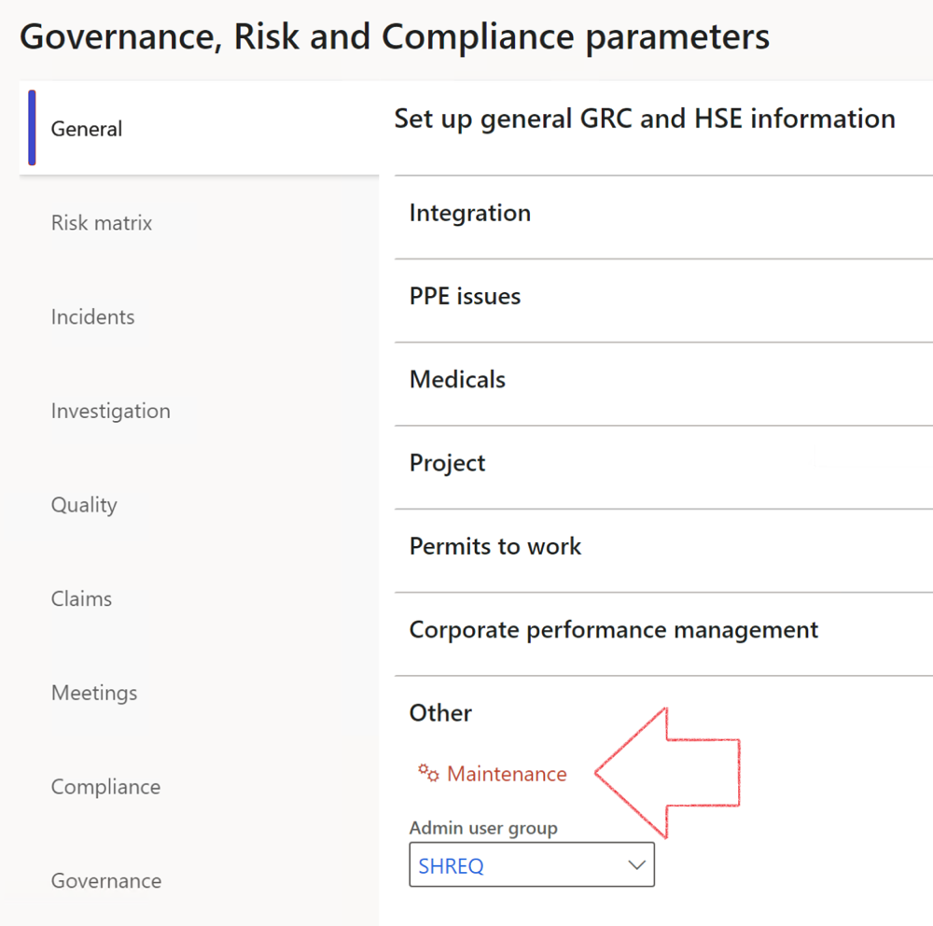

|  |  |
| --- | --- |
|  | The **Maintenance** button is there for designated user. This button repairs any possible data issues. For a full history of all Data related repairs; see table below: |

|  |  |  |
| --- | --- | --- |
| **Process** | **Description/notes** | **Release** |
| Fix location vs. work centres | Populate the new **LocationRecID** field with the related location associated with previously used work centre location (Location) fields on the following tables:   * OHSHazardLocations, * OHSRiskHazard, * OHSRiskHazardWizard, * OHSRiskRegister, * OHSRisksWizard, * OHSSafetyLocations, * OHSSafetyPermit, * OHSSafetyPermitLocations * OHSSafetyPermitOverlap, * OHSSafetyPlan, * OHSInvestigation | 10.0.80.10 |
| Fix risk hazards | Assigning the value "Default Risk" to the new mandatory field **RiskID** (Key field) where empty | 10.0.80.10 |
| Fix incident HRM injury link | Delete all orphaned records from the **OHSIncidentHRMInjuryLnk** table | 10.0.11785.3 |
| Populate SRS analysis enums | Still in concept phase. To provide a link between enum numerical value and value name for use with BYOD data entities. Enums available:   * OHSIncidentType, * OHSIncidentSeverityType.   Table populated: **SRSAnalysisEnums** | 10.0.11785.3 |
| Fix budget transaction lines stock\item dimension | Set **OHSInventDimId** field value to "**AllBlank**" on table **BudgetTransactionLine**, where no value was recorded. This will solve the issue of records not displaying in the form.  **Note: this step will only fix existing budget transaction records in the system. Should any new transactions be uploaded or changed via the data entity Budget Account Entries, special care needs to be taken to specify the Stock dimension = AllBlank and the Item on the excel sheet to import.** | 10.1.1366.6 |
| Update existing incidents with the new **Incident types** | Update existing incidents with the **Incident types** that are setup on the new **Incident type** setup form. (IncidentTypeRecId) | 10.17.1250 |
| Update existing risks with the new **Control types** | Update existing risks with the **Control types** that are setup on the new **Control type** setup form. | 10.17.1250 |
| Fix Inspection locations: Replace Work centre-based locations with HSE locations | Populate the new **ObjectLocation** field with the related HSE location associated with previously used work centre location (**Location**) field on the following tables:   * OHSInspectionJournalName * OHSInspectionJournalTable * OHSInspectionJournalTrans * OHSInspectionHistory * OHSSchedule | 10.24.1114.3 |
| Display of non-calculation lines | Run this job to ensure data consistency and correct display of historical data. |  |

The information contained in this document represents the current view of Axnosis and Microsoft Corporation on the issues discussed as of the date of publication. Because Axnosis and Microsoft must respond to changing market conditions, this document should not be interpreted to be a commitment on the part of Axnosis and Microsoft, and Axnosis and Microsoft cannot guarantee the accuracy of any information presented after the date of publication.

This test script is for informational purposes only. AXNOSIS AND MICROSOFT MAKE NO WARRANTIES, EXPRESS, IMPLIED, OR STATUTORY, AS TO THE INFORMATION IN THIS DOCUMENT.

Complying with all applicable copyright laws is the responsibility of the user. Without limiting the rights under copyright, no part of this document may be reproduced, stored in or introduced into a retrieval system, or transmitted in any form or by any means (electronic, mechanical, photocopying, recording, or otherwise), or for any purpose, without the express written permission of Axnosis and Microsoft Corporation.

Axnosis and Microsoft may have patents, patent applications, trademarks, copyrights, or other intellectual property rights covering subject matter in this document. Except as expressly provided in any written license agreement from Axnosis and Microsoft, the furnishing of this document does not give you any license to these patents, trademarks, copyrights, or other intellectual property.

© 2021 Microsoft Corporation. All rights reserved. Any use or distribution of these materials without express authorization of Microsoft Corp. is strictly prohibited.

Microsoft and Windows are both registered trademarks of Microsoft Corporation in the United States and/or other countries.

The names of actual companies and products mentioned herein may be the trademarks of their respective owners.